***😊 BADOODLE 😊***

**TERM PROJECT REPORT**

Version *2.0*

*05/02/2020*

**TABLE OF CONTENTS**

**1** **PROJECT DESCRIPTION 3**

**2** **ER DIAGRAM 3**

**3** **ASSUMPTION AND LIMITATIONS FOR THE DESIGN 3**

**4** **CARDINALITY RELATIONSHIPS 5**

**5** **DATA DICTIONARY 5**

**6** **TEAM CONTRIBUTION 8**

**7** **SAMPLE DATA 9**

**8** **SQL QUERIES 11**

8.1 Table creation queries 11

8.2 Data Insertion Queries 16

8.3 Screenshot of DB tables and data instances 18

**9** **OWN SQL QUERIES 20**

# **PROJECT DESCRIPTION**

The *Badoodle*project demonstrates data collection from various manufacturers for vehicles relating to diagnostic codes for both generic manufacturer specific. The vehicle manufacturers used in the *Badoodle* project were Mercedes-Benz, BMW, and Volkswagen. Group members include Aleksandar Kljaic, Noah Lindon, and Jacob Turner.

# **ER DIAGRAM**

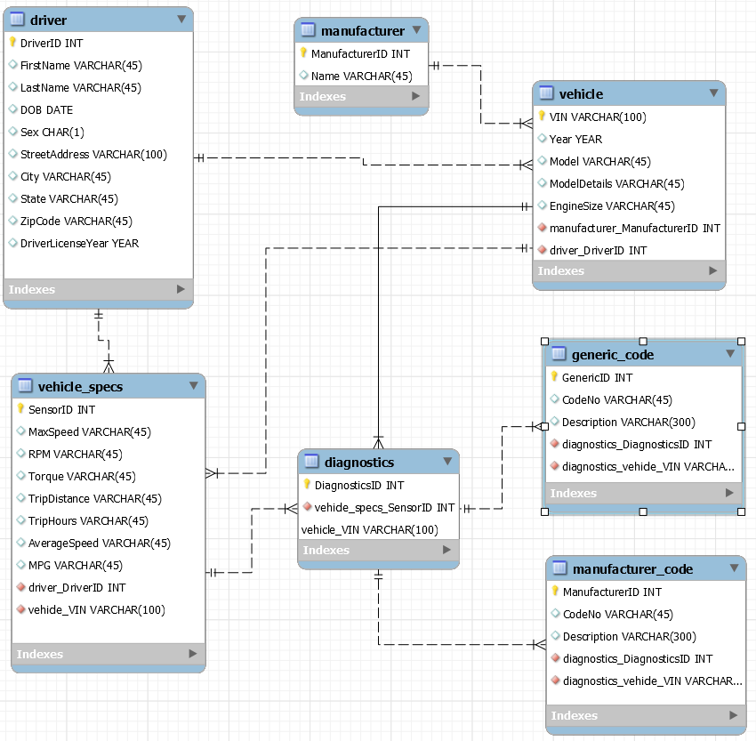

# **ASSUMPTION AND LIMITATIONS FOR THE DESIGN**

Certain limitations to the *Badoodle* project don’t include all vehicle manufacturers. The assumption is that the data includes Mercedes-Benz, BMW, and Volkswagen. The other assumption is that all available generic diagnostic codes are utilized as well.

# **CARDINALITY RELATIONSHIPS**

# 

# **DATA DICTIONARY**

# 

# 

# 

# 

# 

# 

# 

# 

# **TEAM CONTRIBUTION**

# 

# 

# **SAMPLE DATA**

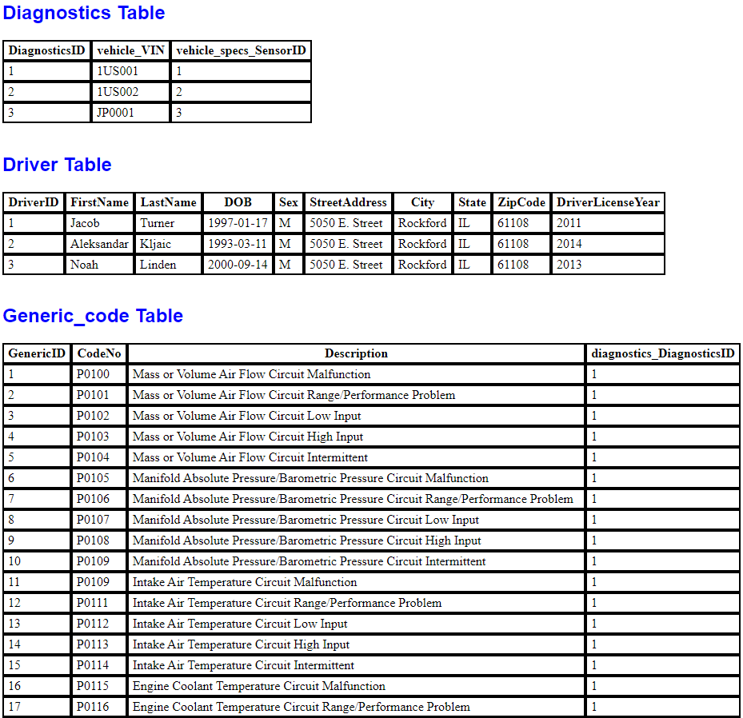

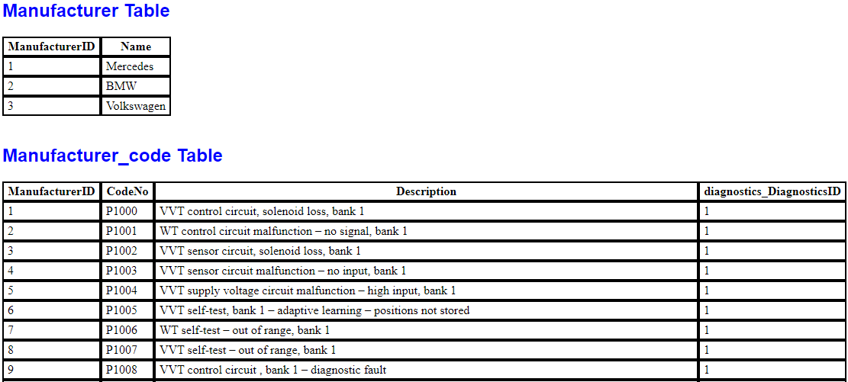

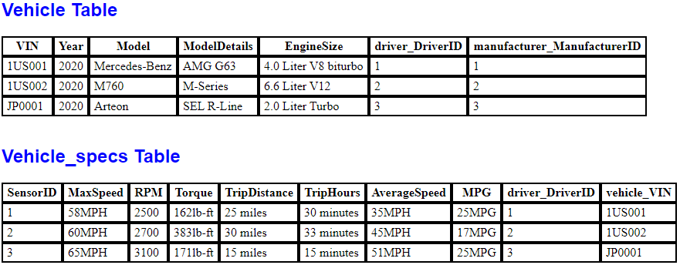

# **SQL QUERIES**

## **TABLE CREATION QUERIES**

-- MySQL Workbench Forward Engineering

SET @OLD_UNIQUE_CHECKS=@@UNIQUE_CHECKS, UNIQUE_CHECKS=0;

SET @OLD_FOREIGN_KEY_CHECKS=@@FOREIGN_KEY_CHECKS, FOREIGN_KEY_CHECKS=0;

SET @OLD_SQL_MODE=@@SQL_MODE, SQL_MODE='ONLY_FULL_GROUP_BY,STRICT_TRANS_TABLES,NO_ZERO_IN_DATE,NO_ZERO_DATE,ERROR_FOR_DIVISION_BY_ZERO,NO_ENGINE_SUBSTITUTION';

-- -----------------------------------------------------

-- Schema term_project

-- -----------------------------------------------------

-- -----------------------------------------------------

-- Schema term_project

-- -----------------------------------------------------

CREATE SCHEMA IF NOT EXISTS `term_project` DEFAULT CHARACTER SET utf8 ;

USE `term_project` ;

-- -----------------------------------------------------

-- Table `term_project`.`driver`

-- -----------------------------------------------------

CREATE TABLE IF NOT EXISTS `term_project`.`driver` (

`DriverID` INT NOT NULL,

`FirstName` VARCHAR(45) NULL,

`LastName` VARCHAR(45) NULL,

`DOB` DATE NULL,

`Sex` CHAR(1) NULL,

`StreetAddress` VARCHAR(100) NULL,

`City` VARCHAR(45) NULL,

`State` VARCHAR(45) NULL,

`ZipCode` VARCHAR(45) NULL,

`DriverLicenseYear` YEAR NULL,

PRIMARY KEY (`DriverID`))

ENGINE = InnoDB;

-- -----------------------------------------------------

-- Table `term_project`.`manufacturer`

-- -----------------------------------------------------

CREATE TABLE IF NOT EXISTS `term_project`.`manufacturer` (

`ManufacturerID` INT NOT NULL,

`Name` VARCHAR(45) NULL,

PRIMARY KEY (`ManufacturerID`))

ENGINE = InnoDB;

-- -----------------------------------------------------

-- Table `term_project`.`vehicle`

-- -----------------------------------------------------

CREATE TABLE IF NOT EXISTS `term_project`.`vehicle` (

`VIN` VARCHAR(100) NOT NULL,

`Year` YEAR NULL,

`Model` VARCHAR(45) NULL,

`ModelDetails` VARCHAR(45) NULL,

`EngineSize` VARCHAR(45) NULL,

`driver_DriverID` INT NOT NULL,

`manufacturer_ManufacturerID` INT NOT NULL,

PRIMARY KEY (`VIN`),

INDEX `fk_vehicle_driver_idx` (`driver_DriverID` ASC),

INDEX `fk_vehicle_manufacturer1_idx` (`manufacturer_ManufacturerID` ASC),

CONSTRAINT `fk_vehicle_driver`

FOREIGN KEY (`driver_DriverID`)

REFERENCES `term_project`.`driver` (`DriverID`)

ON DELETE NO ACTION

ON UPDATE NO ACTION,

CONSTRAINT `fk_vehicle_manufacturer1`

FOREIGN KEY (`manufacturer_ManufacturerID`)

REFERENCES `term_project`.`manufacturer` (`ManufacturerID`)

ON DELETE NO ACTION

ON UPDATE NO ACTION)

ENGINE = InnoDB;

-- -----------------------------------------------------

-- Table `term_project`.`vehicle_specs`

-- -----------------------------------------------------

CREATE TABLE IF NOT EXISTS `term_project`.`vehicle_specs` (

`SensorID` INT NOT NULL,

`MaxSpeed` VARCHAR(45) NULL,

`RPM` VARCHAR(45) NULL,

`Torque` VARCHAR(45) NULL,

`TripDistance` VARCHAR(45) NULL,

`TripHours` VARCHAR(45) NULL,

`AverageSpeed` VARCHAR(45) NULL,

`MPG` VARCHAR(45) NULL,

`driver_DriverID` INT NOT NULL,

`vehicle_VIN` VARCHAR(100) NOT NULL,

PRIMARY KEY (`SensorID`),

INDEX `fk_vehicle_specs_driver1_idx` (`driver_DriverID` ASC),

INDEX `fk_vehicle_specs_vehicle1_idx` (`vehicle_VIN` ASC),

CONSTRAINT `fk_vehicle_specs_driver1`

FOREIGN KEY (`driver_DriverID`)

REFERENCES `term_project`.`driver` (`DriverID`)

ON DELETE NO ACTION

ON UPDATE NO ACTION,

CONSTRAINT `fk_vehicle_specs_vehicle1`

FOREIGN KEY (`vehicle_VIN`)

REFERENCES `term_project`.`vehicle` (`VIN`)

ON DELETE NO ACTION

ON UPDATE NO ACTION)

ENGINE = InnoDB;

-- -----------------------------------------------------

-- Table `term_project`.`diagnostics`

-- -----------------------------------------------------

CREATE TABLE IF NOT EXISTS `term_project`.`diagnostics` (

`DiagnosticsID` INT NOT NULL,

`vehicle_VIN` VARCHAR(100) NOT NULL,

`vehicle_specs_SensorID` INT NOT NULL,

PRIMARY KEY (`DiagnosticsID`),

INDEX `fk_diagnostics_vehicle1_idx` (`vehicle_VIN` ASC),

INDEX `fk_diagnostics_vehicle_specs1_idx` (`vehicle_specs_SensorID` ASC),

CONSTRAINT `fk_diagnostics_vehicle1`

FOREIGN KEY (`vehicle_VIN`)

REFERENCES `term_project`.`vehicle` (`VIN`)

ON DELETE NO ACTION

ON UPDATE NO ACTION,

CONSTRAINT `fk_diagnostics_vehicle_specs1`

FOREIGN KEY (`vehicle_specs_SensorID`)

REFERENCES `term_project`.`vehicle_specs` (`SensorID`)

ON DELETE NO ACTION

ON UPDATE NO ACTION)

ENGINE = InnoDB;

-- -----------------------------------------------------

-- Table `term_project`.`generic_code`

-- -----------------------------------------------------

CREATE TABLE IF NOT EXISTS `term_project`.`generic_code` (

`GenericID` INT NOT NULL,

`CodeNo` VARCHAR(45) NULL,

`Description` VARCHAR(300) NULL,

`diagnostics_DiagnosticsID` INT NOT NULL,

PRIMARY KEY (`GenericID`),

INDEX `fk_generic_code_diagnostics1_idx` (`diagnostics_DiagnosticsID` ASC),

CONSTRAINT `fk_generic_code_diagnostics1`

FOREIGN KEY (`diagnostics_DiagnosticsID`)

REFERENCES `term_project`.`diagnostics` (`DiagnosticsID`)

ON DELETE NO ACTION

ON UPDATE NO ACTION)

ENGINE = InnoDB;

-- -----------------------------------------------------

-- Table `term_project`.`manufacturer_code`

-- -----------------------------------------------------

CREATE TABLE IF NOT EXISTS `term_project`.`manufacturer_code` (

`ManufacturerID` INT NOT NULL,

`CodeNo` VARCHAR(45) NULL,

`Description` VARCHAR(300) NULL,

`diagnostics_DiagnosticsID` INT NOT NULL,

PRIMARY KEY (`ManufacturerID`),

INDEX `fk_manufacturer_code_diagnostics1_idx` (`diagnostics_DiagnosticsID` ASC),

CONSTRAINT `fk_manufacturer_code_diagnostics1`

FOREIGN KEY (`diagnostics_DiagnosticsID`)

REFERENCES `term_project`.`diagnostics` (`DiagnosticsID`)

ON DELETE NO ACTION

ON UPDATE NO ACTION)

ENGINE = InnoDB;

SET SQL_MODE=@OLD_SQL_MODE;

SET FOREIGN_KEY_CHECKS=@OLD_FOREIGN_KEY_CHECKS;

SET UNIQUE_CHECKS=@OLD_UNIQUE_CHECKS;

## **DATA INSERTION QUERIES**

**Driver Table:**

INSERT INTO `term_project`.`driver` (`DriverID`, `FirstName`, `LastName`, `DOB`, `Sex`, `StreetAddress`, `City`, `State`, `ZipCode`, `DriverLicenseYear`)

VALUES ('1', 'Jacob', 'Turner', '1997-01-17', 'M', '5050 E. Street', 'Rockford', 'IL', '61108', 2011);

INSERT INTO `term_project`.`driver` (`DriverID`, `FirstName`, `LastName`, `DOB`, `Sex`, `StreetAddress`, `City`, `State`, `ZipCode`, `DriverLicenseYear`)

VALUES ('2', 'Aleksandar', 'Kljaic', '1993-03-11', 'M', '5050 E. Street', 'Rockford', 'IL', '61108', 2014);

INSERT INTO `term_project`.`driver` (`DriverID`, `FirstName`, `LastName`, `DOB`, `Sex`, `StreetAddress`, `City`, `State`, `ZipCode`, `DriverLicenseYear`)

VALUES ('3', 'Noah', 'Linden', '2000-09-14', 'M', '5050 E. Street', 'Rockford', 'IL', '61108', 2013);

**Manufacturer Table:**

INSERT INTO `term_project`.`manufacturer` (`ManufacturerID`, `Name`)

VALUES ('1', 'Mercedes');

INSERT INTO `term_project`.`manufacturer` (`ManufacturerID`, `Name`)

VALUES ('2', 'BMW');

INSERT INTO `term_project`.`manufacturer` (`ManufacturerID`, `Name`)

VALUES ('3', 'Volkswagen');

**Vehicle Table:**

INSERT INTO `term_project`.`vehicle` (`VIN`, `Year`, `Model`, `ModelDetails`, `EngineSize`, `driver_DriverID`, `manufacturer_ManufacturerID`)

VALUES ('1US001', 2020, 'Mercedes-Benz', 'AMG G63', '4.0 Liter V8 biturbo', '1', '1');

INSERT INTO `term_project`.`vehicle` (`VIN`, `Year`, `Model`, `ModelDetails`, `EngineSize`, `driver_DriverID`, `manufacturer_ManufacturerID`)

VALUES ('1US002', 2020, 'M760', 'M-Series', '6.6 Liter V12', '2', '2');

INSERT INTO `term_project`.`vehicle` (`VIN`, `Year`, `Model`, `ModelDetails`, `EngineSize`, `driver_DriverID`, `manufacturer_ManufacturerID`)

VALUES ('JP0001', 2020, 'Arteon', 'SEL R-Line', '2.0 Liter Turbo', '3', '3');

**Vehicle Specs Table:**

INSERT INTO `term_project`.`vehicle_specs` (`SensorID`, `MaxSpeed`, `RPM`, `Torque`, `TripDistance`, `TripHours`, `AverageSpeed`, `MPG`, `driver_DriverID`, `vehicle_VIN`)

VALUES ('1', '58MPH', '2500', '162lb-ft', '25 miles', '30 minutes', '35MPH', '25MPG', '1', '1US001');

INSERT INTO `term_project`.`vehicle_specs` (`SensorID`, `MaxSpeed`, `RPM`, `Torque`, `TripDistance`, `TripHours`, `AverageSpeed`, `MPG`, `driver_DriverID`, `vehicle_VIN`)

VALUES ('2', '60MPH', '2700', '383lb-ft', '30 miles', '33 minutes', '45MPH', '17MPG', '2', '1US002');

INSERT INTO `term_project`.`vehicle_specs` (`SensorID`, `MaxSpeed`, `RPM`, `Torque`, `TripDistance`, `TripHours`, `AverageSpeed`, `MPG`, `driver_DriverID`, `vehicle_VIN`)

VALUES ('3', '65MPH', '3100', '171lb-ft', '15 miles', '15 minutes', '51MPH', '25MPG', '3', 'JP0001');

**Diagnostics Table:**

INSERT INTO `term_project`.`diagnostics` (`DiagnosticsID`, `vehicle_VIN`, `vehicle_specs_SensorID`)

VALUES ('1', '1US001', '1');

INSERT INTO `term_project`.`diagnostics` (`DiagnosticsID`, `vehicle_VIN`, `vehicle_specs_SensorID`)

VALUES ('2', '1US002', '2');

INSERT INTO `term_project`.`diagnostics` (`DiagnosticsID`, `vehicle_VIN`, `vehicle_specs_SensorID`)

VALUES ('3', 'JP0001', '3');

**Generic Code Table:**

Data insertion was performed by data import wizard, so there are no insert statements.

**Manufacturer Code Table:**

Data insertion was performed by data import wizard, so there are no insert statements. Imported for Mercedes, BMW and Volkswagen.

## **SCREENSHOT OF DB TABLES AND DATA INSTANCES**

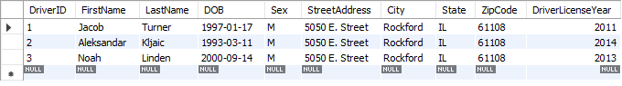

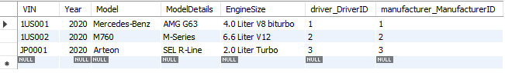

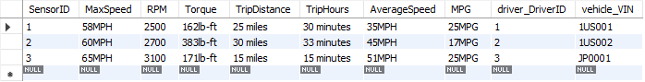

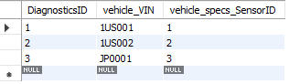

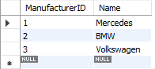

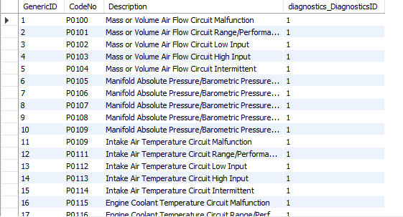

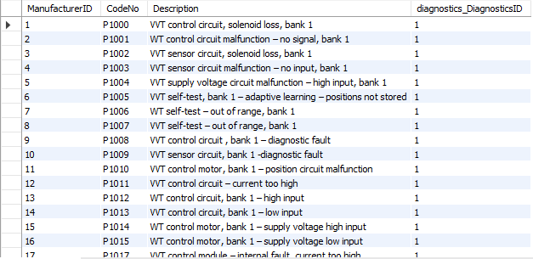

## 

# **OWN SQL QUERIES**

***Jacob Turner:***

# List what car each user has

SELECT FirstName as "First Name", LastName as "Last Name", DriverLicenseYear as "License Year", Model, ModelDetails as "Model Details", Year

FROM driver, vehicle

WHERE driver.DriverID = vehicle.driver_DriverID

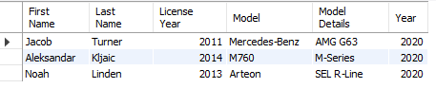

# Find all code numbers for 'P1137' and then list their description and affected car

SELECT CodeNo as 'Code Number', Description as 'Code Description', Name as 'Vehicle Name'

FROM manufacturer man, manufacturer_code manc

WHERE CodeNo = 'P1137' AND man.ManufacturerID = manc.diagnostics_DiagnosticsID

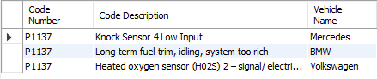

# List all US car Vins from the year 2020

SELECT VIN, Year, Model, ModelDetails, EngineSize

FROM vehicle

WHERE VIN LIKE '1US%' AND Year = '2020'

ORDER BY VIN ASC

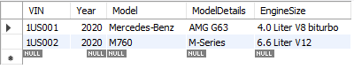

# List name and car specs for the vin 1US001

SELECT VIN, FirstName, LastName, Year, Model, MaxSpeed, RPM, Torque, AverageSpeed, MPG

FROM vehicle, vehicle_specs vc, driver dri

WHERE VIN = '1US001' AND vehicle_VIN = '1US001' AND dri.DriverID = vc.driver_DriverID



***Aleksandar Kljaic:***

# List the name and vehicle details for a person with the last name Kljaic

SELECT FirstName as "First Name", LastName as "Last Name", Year, Name as "Manufacturer" , Model, ModelDetails as "Model Details"

FROM driver, vehicle, manufacturer

WHERE LastName = 'Kljaic' AND driver.DriverID = vehicle.driver_DriverID AND manufacturer.Name = "BMW"



SELECT VIN, FirstName, LastName, Year, Model, MaxSpeed, RPM, Torque, AverageSpeed, MPG

FROM vehicle, vehicle_specs, driver

WHERE VIN = '1US002' AND vehicle_VIN = '1US002' AND driver.DriverID = vehicle_specs.driver_DriverID AND LastName like 'Kl%'



SELECT VIN, Year, Model, ModelDetails, EngineSize

FROM vehicle

WHERE Year > '2000'

ORDER BY Year ASC

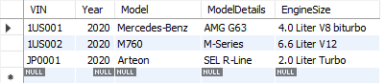

SELECT CodeNo as 'Diagnostic Code', Description as 'Description', Name as 'Manufacturer'

FROM manufacturer man, manufacturer_code manc

WHERE CodeNo like 'P%' AND man.ManufacturerID = manc.diagnostics_DiagnosticsID AND Name = "BMW"

ORDER BY CodeNo ASC

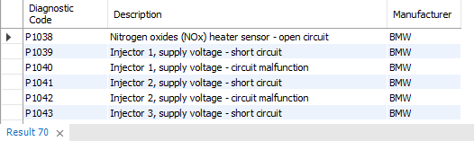

***Noah Lindon:***

# List all code numbers and their id’s regarding “Camshaft Position”

SELECT CodeNo as 'Code Number', Description as 'Code Description', diagnostics_DiagnosticsID as 'ID'

FROM manufacturer_code

WHERE Description LIKE'%Camshaft Position%'

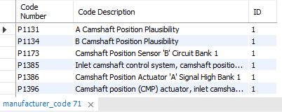

Select CodeNo as 'Code Number', Description as 'Code Description', GenericID as 'Generic ID'

from generic_code

Where Description LIKE 'Cylinder%' AND CodeNo >= 'P0265' AND CodeNo <= 'P0290'

ORDER BY GenericID ASC

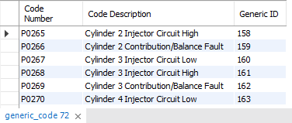

select FirstName as 'First Name', LastName as 'Last Name'

from driver

where driver.state = 'IL'

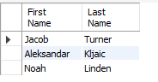

#Retrieve all drivers who were born during the 1990s

select FirstName as 'First Name', LastName as 'Last Name'

From driver

where DOB like '%199_%'

