Fusion Tree Project — Work Log
10 September 2026 · STEM Lab 2026–27 · session with Claude

1. Summary
- The project is now under git, results/machine.txt records the hardware (it was empty), and CHECKPOINT 2 passes: 1,720,312 node checks and 4,800,000 structure checks, zero failures, with both the PEXT and the loop sketch.
- The benchmark harness was hardened. The warm-up can no longer be optimised away, runs are pinned to a named core from inside the program, and the order of structures is shuffled every repetition. Two additions: a latency mode beside the original throughput mode, and a stronger branch-free B-tree baseline.
- The fusion tree loses to both B-trees at every size measured, 2⁸ to 2²⁵ keys, in both modes. Against the branch-free B-tree in throughput, the gap does not narrow: 1.7–3.2×, with a rising slope.
- In latency mode the gap to the B-trees does narrow, from 1.6× to 1.2×. A straight-line fit reaches 1.0 near 2³⁹ keys, 128 times more keys than this machine's memory holds. That figure is an extrapolation, and the last three points look flat.
- The fusion tree does beat plain binary search at very large n: from 2²⁴ keys in throughput and 2²² in latency. This is a layout effect, not the fusion node. The ordinary B-tree beats binary search at the same sizes, and by more.
- Two sensitivities belong in the report. The core type (performance vs efficiency) and the run order (shuffled vs blocked) each move results by 10–60%, and both change the ratios, not just the absolute times.

2. Where the project stood this morning
The folder held the starter tree plus the 9 September outputs: a smoke run, an unpinned run, a “lab” run, timing_raw.csv, spread.csv, and three figures. Four problems:
- It was not a git repository, although the manual asks for a commit after every step.
- results/machine.txt existed but was 0 bytes. The hardware was never recorded.
- timing_lab.csv and timing_raw.csv are byte-identical: the same run saved twice.
- The figures and summary.csv were built from that run, whose core placement was not recorded.

3. Setup

3.1 Version control
git init on branch main. The starting state (code plus all 9 September results) was committed unchanged first, so every later change shows as a diff. A .gitignore excludes build/ and executables.

3.2 The machine
Item | Value
Laptop | Lenovo 83F3, Windows 11 Home 10.0.26200, Balanced power plan
CPU | Intel Core Ultra 7 255HX (Arrow Lake-HX), 20 cores, no SMT
Core types | Hybrid. Performance cores = logical CPUs 0, 1, 6, 7, 8, 9, 18, 19. Efficiency cores = 2–5, 10–17.
Memory | 32 GB DDR5-5600; L2 36 MB total; L3 30 MB shared
ISA | BMI2 (native PEXT), POPCNT, LZCNT, AVX2. No AVX-512.
Compiler | g++ 16.1.0 (MSYS2 ucrt64); -march=native = arrowlake-s. clang++ not installed.

The core map was read with the Windows GetSystemCpuSetInformation call. It matters because the manual’s example taskset -c 2 would, on this laptop, pin the benchmark to an efficiency core.

3.3 Build environment gotchas
- From Git Bash, make test fails with “Cannot create temporary file in C:\Windows\”. Running make from PowerShell with TMP/TEMP set to a writable folder works.
- With C:\msys64\usr\bin first on PATH, cmd resolves to an MSYS shell script, not Windows’ cmd.exe. Scripts should call $env:ComSpec. This silently broke my first campaign attempt; no data was lost.
- A -Warray-bounds warning from std::sort inside FusionNode::build is present in the code as received. It is a false positive: the sorted range never exceeds 7 elements.

4. Review findings
The code and manual were read against each other and against this machine. Each finding below was checked by measurement or by inspection.
# | Finding | Evidence | Action
1 | The CPU is hybrid; which core type a run lands on changes the answer. | Efficiency core vs performance core at n = 256: binary search 7.3 vs 4.5 ns (+62%), fusion tree 42.7 vs 38.3 ns (+11%). At 2²², fusion ÷ branch-free B-tree is 2.94 on a performance core and 1.74 on an efficiency core. | Pinning built into the benchmark (default CPU 8, a performance core); Makefile documents the core map.
2 | The manual’s “one cache line” and “identical layout” claims are false. | sizeof: B-tree node 112 B (1.75 lines), fusion node 184 B (2.9 lines). The fusion tree moves about 64% more bytes per level. | Comment in structures.hpp corrected. Worth stating in the report.
3 | The warm-up result was discarded (checksum ^ sink * 0). | GCC 16 happened to keep the warm-up loop (checked in the assembly), but nothing guaranteed it. | Warm-up result now written to a volatile.
4 | The B-tree baseline is not the strongest opponent. | Its node scan exits early on a data-dependent branch; the comment said it “vectorises”. A fixed-count, branch-free scan is up to 2.3× faster in throughput. | Added BTree<8, true> (btree8_bl), kept the original for continuity, and added it to the tests.
5 | The harness measured throughput; the manual’s mechanism (Part II.2) is about latency. | Binary search at n = 256: 4.5 ns in throughput, 13.1 ns in latency. Most of its apparent lead comes from several independent queries overlapping inside the CPU. | Added lat mode: each query depends on the previous answer. Same queries, same checksums.
6 | The order of runs changes the ratios. | Blocked (the original order) vs shuffled, at 2²²: B-trees +18–34%, fusion tree +11%. Blocked order reproduces 9 September to within 1% (fusion tree at 2²⁰: 290.2 vs 291.0 ns). | Order is shuffled by default; blocked is an option. The report should give both.
7 | Experiment 1 reports “fields fit” by r, but whether fields fit depends on the node size K. | Per K (2,000 random sets each): K ≤ 4 fits 100%, K = 5 23%, K = 6 8%, K ≥ 7 0%. The r = 7 window has a median of 60 bits and a maximum of 91 (the manual says 63 and 80). | analyse.R now prints a per-K table.
8 | Minor issues. | In find_multiplier the second collision check can never fire; it is harmless. Two comments pointed to a sketch_mult.hpp that does not exist. | Comments fixed; the dead check is noted here only.

A correction to my own first guess. I first suspected that the 9 September “lab” run was pinned to an efficiency core. The data rules that out: that run gave binary search 4.5 ns at n = 256, the performance-core figure. The run was on a performance core; its large-n numbers differ from today’s because of run order (finding 6).

5. Code changes
File | Change
bench/bench_pred.cpp | Volatile warm-up sink; [cpu] argument with in-program pinning (Windows and Linux); tput/lat modes; shuffled/blocked order; branch-free B-tree added; keys generated by draw-sort-dedupe, which uses the same random draws as before (identical keys and checksums) and is fast enough for 2²⁵.
include/structures.hpp | BTree<B, Branchless> template parameter; node-size comment corrected.
tests/test_structures.cpp | Also checks the branch-free B-tree (3.6M → 4.8M checks).
Makefile | test-loop, bench-lat, bench-loop targets; CPU, REPS, MAXLOG variables; core-map note.
analysis/analyse.R | Tagged inputs; stops if checksums disagree; bootstrap 95% intervals on every ratio; a crossover is reported only when the slope’s 95% interval excludes zero; per-K fit table; log-scale plots.
results/machine.txt | Written (it was empty).
include/*.hpp comments, README.md | Stale references fixed; README documents the new targets and the Windows build.

6. Measurements
Conditions: performance core 8, pinned; 15 repetitions; 65,536 random queries per repetition; median reported. g++ 16.1.0 -O3 -march=native; PEXT sketch unless noted; shuffled order unless noted. Turbo on, Balanced power plan. The machine was not idle (this session was running), so these are good indications, not final data.

6.1 Throughput (independent queries)
n | binary search | B-tree | B-tree (branch-free) | fusion | fusion ÷ BF B-tree | fusion ÷ binary
2⁸ | 4.5 | 20.9 | 17.7 | 38.3 | 2.16 | 8.5
2¹² | 7.3 | 34.1 | 19.4 | 53.3 | 2.75 | 7.3
2¹⁶ | 21.8 | 57.3 | 34.0 | 97.6 | 2.87 | 4.48
2²⁰ | 100.5 | 247.3 | 143.7 | 375.9 | 2.62 | 3.74
2²² | 267.3 | 266.1 | 131.4 | 385.8 | 2.94 | 1.44
2²⁴ | 631.8 | 425.9 | 221.1 | 610.6 | 2.76 | 0.97
2²⁵ | 727.4 | 461.7 | 205.6 | 618.9 | 3.01 | 0.85
Median ns per query. Ratio model vs branch-free B-tree: slope +0.041 per doubling, 95% CI [+0.008, +0.074]. The gap widens, so no crossover is implied.
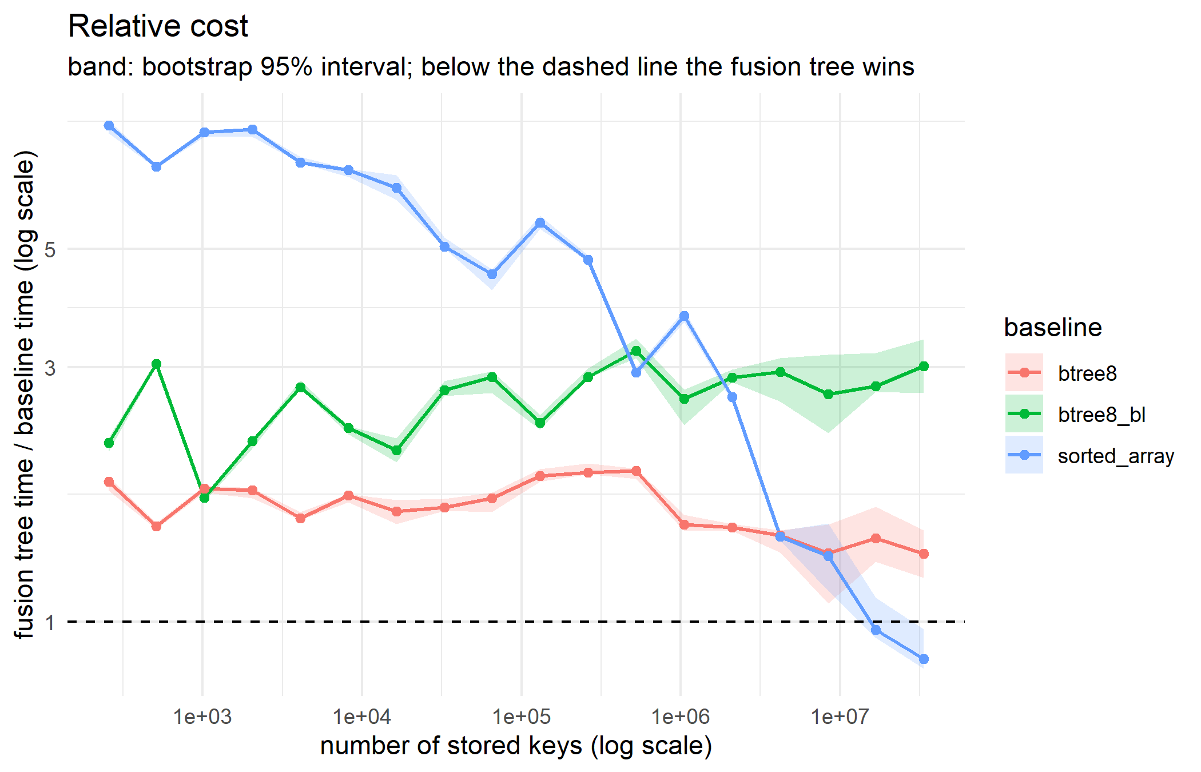
Figure 1. Throughput: fusion time ÷ each baseline, with bootstrap 95% bands. Only the binary-search curve crosses 1.0.

6.2 Latency (each query waits for the previous answer)
n | binary search | B-tree | B-tree (branch-free) | fusion | fusion ÷ BF B-tree | fusion ÷ binary
2⁸ | 13.1 | 21.4 | 27.2 | 40.3 | 1.48 | 3.08
2¹² | 18.7 | 34.3 | 35.8 | 57.3 | 1.60 | 3.06
2¹⁶ | 48.8 | 56.6 | 60.4 | 93.8 | 1.55 | 1.92
2²⁰ | 225.7 | 267.5 | 256.6 | 371.6 | 1.45 | 1.65
2²² | 571.4 | 285.2 | 312.1 | 382.6 | 1.23 | 0.67
2²⁴ | 1252.9 | 498.8 | 511.4 | 615.6 | 1.20 | 0.49
2²⁵ | 1435.2 | 492.2 | 520.8 | 625.7 | 1.20 | 0.44
Ratio model vs branch-free B-tree: slope −0.020 [−0.030, −0.010]; extrapolated crossover at 2^39.2 keys. Vs early-exit B-tree: crossover at 2^35.7.
In latency mode the early-exit B-tree is slightly faster than the branch-free one, the reverse of throughput. When the scan exits early, branch prediction lets the CPU guess the answer and start the next level. The branch-free sum has to finish first. Which baseline counts as “strongest” depends on which question you ask.
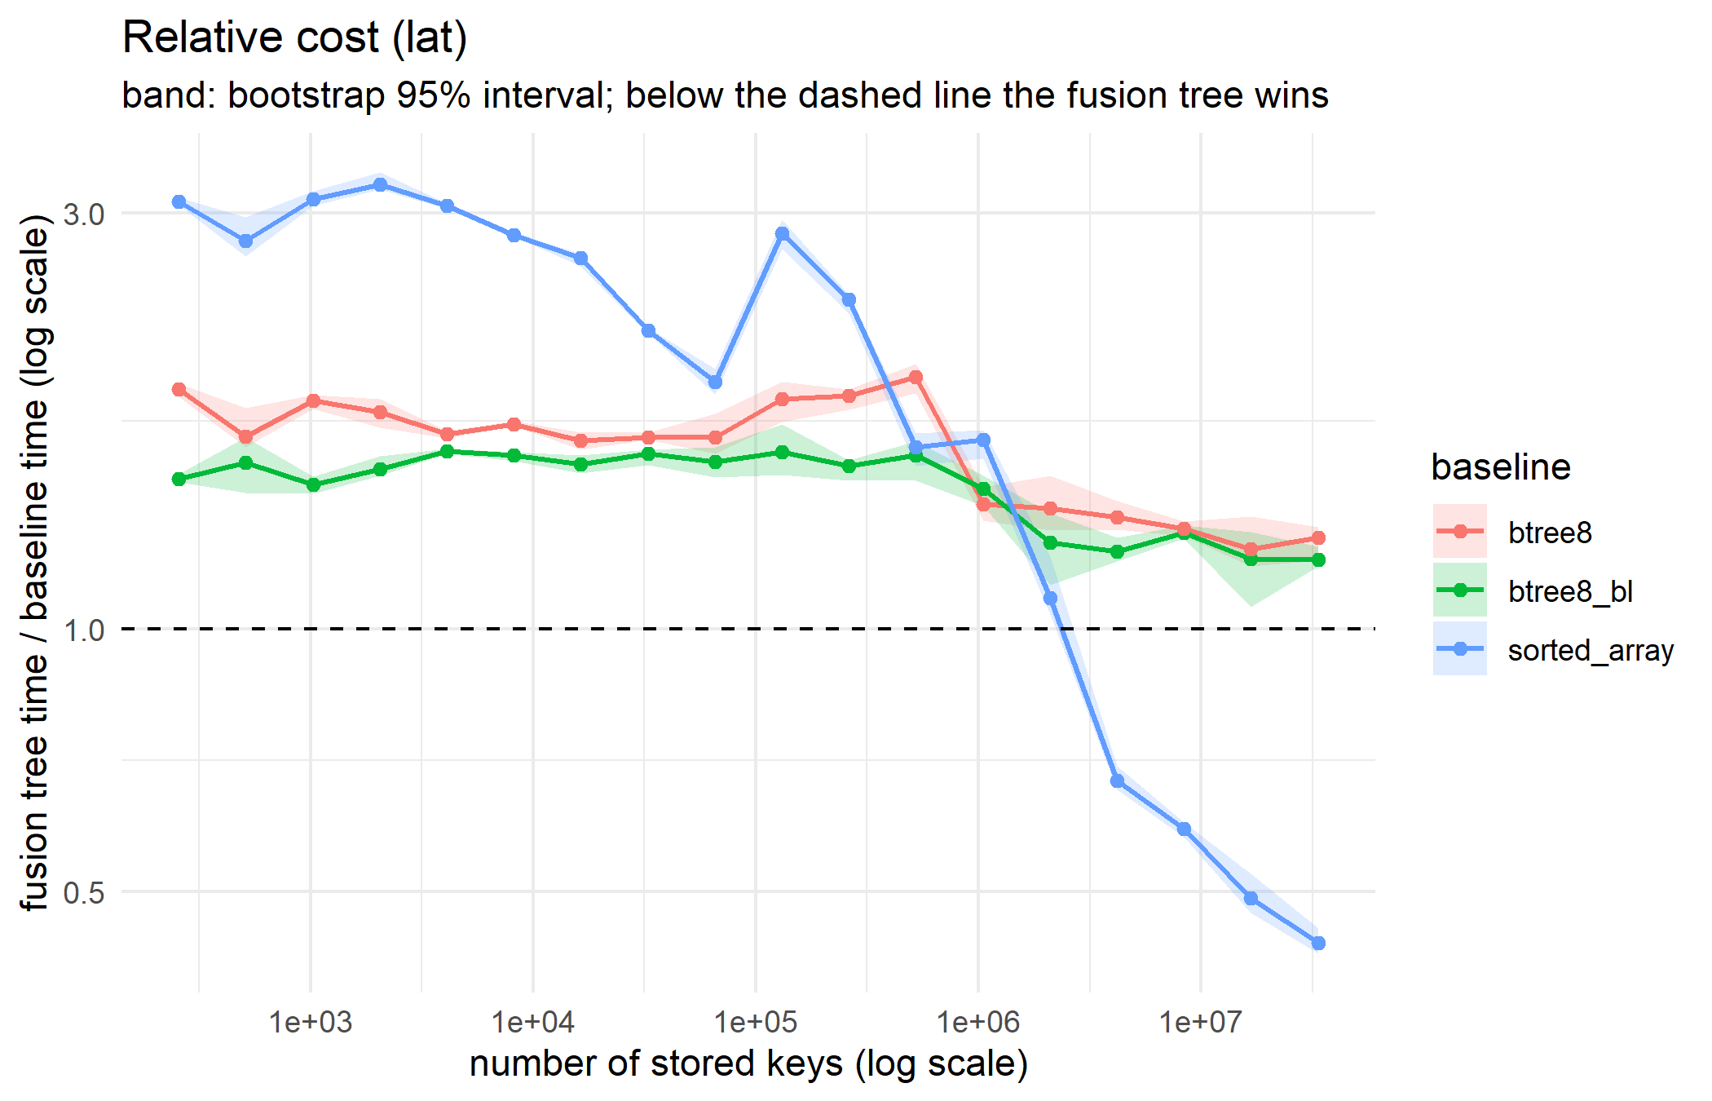
Figure 2. Latency: fusion time ÷ each baseline. The gap to both B-trees narrows but stays above 1.0 through 2^25.

6.3 What the one-instruction sketch buys
n | loop sketch (ns) | PEXT (ns) | saving
2⁸ | 44.2 | 38.3 | 13%
2¹² | 67.3 | 53.3 | 21%
2¹⁶ | 109.4 | 97.6 | 11%
2²⁰ | 384.0 | 375.9 | 2%
2²² | 407.8 | 385.8 | 5%
Fusion tree only, throughput, performance core. The manual’s prediction holds: the sketch matters when the data is in cache and hardly at all once memory dominates.

6.4 Run order: blocked vs shuffled
n | structure | blocked | shuffled | change
2¹⁶ | B-tree (branch-free) | 29.8 | 32.8 | +10%
2¹⁶ | fusion | 83.7 | 87.8 | +5%
2²⁰ | binary search | 77.4 | 95.2 | +23%
2²⁰ | B-tree | 175.3 | 224.9 | +28%
2²⁰ | B-tree (branch-free) | 105.1 | 134.5 | +28%
2²⁰ | fusion | 290.2 | 320.5 | +10%
2²² | B-tree (branch-free) | 90.2 | 120.4 | +34%
2²² | fusion | 305.4 | 338.8 | +11%
Back-to-back runs on core 8. In blocked order each structure re-reads its own cached data; in shuffled order it inherits another structure’s cache contents.
Session-to-session variation is also larger than the within-run spread suggests. The same shuffled throughput campaign, run twice in the same evening, gave the fusion tree 375.9 and 320.5 ns at 2²⁰, a 15% difference, while each run’s IQR was under 5%. Repeating whole campaigns in separate sessions is the only way to measure this.

7. What this means for the research question
- Against the strongest practical baseline there is no crossover in throughput. The gap to the branch-free B-tree grows with n.
- In latency the gap narrows. Taken at face value, the fitted line reaches parity at about 2³⁹ keys, 128 times more keys than this laptop’s 32 GB can hold (2³²). This is exactly the quantitative form the manual asks for. It rests on a straight-line model and on data that flattens at the end, so it should be reported as an order-of-magnitude estimate, not a prediction.
- Beating binary search is not evidence for the fusion node. The fusion tree overtakes binary search because it is shaped like a B-tree: fewer levels, and so fewer cache misses per query. The early-exit B-tree does the same thing, sooner and by more. The report should avoid presenting the fusion-vs-binary crossover as the result.
- The mechanism is not identified yet. The size difference (184 vs 112 bytes per node) and the dependency chain are both candidates. Separating them needs hardware counters (Experiment 3).

8. Caveats
- The machine was in use during the runs; turbo was on; Balanced power plan; power source not recorded.
- One compiler (g++ 16.1). The manual asks for clang as well.
- No hardware counters yet. All mechanism statements above are hypotheses.
- The loop-sketch and efficiency-core campaigns stop at 2²², so their fitted slopes are not directly comparable with the 2²⁵ campaigns.
- The branch-free B-tree has a reproducible dip at n = 512 (11.9 ns, against 17.7 at 256 and 27.5 at 1,024) that is not yet explained.

9. Suggested next steps
- Experiment 3: try perf stat in the WSL2 Ubuntu install (check the core map again inside WSL), or Intel VTune on Windows. Measure instructions, cycles, branch misses and cache misses per query for all four structures in both modes.
- Install clang (pacman -S mingw-w64-ucrt-x86_64-clang) and repeat the throughput and latency campaigns.
- Final data: at least three separate sessions on an idle, plugged-in machine, pinned to a performance core, both run orders. Report the session-to-session spread.
- Test the layout hypothesis directly. With PEXT the fusion node doesn’t need its 32-byte important-bit array at query time. Splitting it out and aligning nodes to 64 bytes would shrink the per-level footprint; if the gap shrinks with it, memory traffic is part of the mechanism.
- Make the fusion node’s rank branch-free (its high/low branch is a coin toss on random queries) and see whether the throughput gap closes.
- Experiment 4 is limited to AVX2 on this machine: 256-bit words, so K² ≤ 256 and K ≤ 16.
- Manual updates: the Checkpoint 2 count for test_structures is now 4,800,000; the taskset -c 2 example should name a performance core.

