Fusion Tree Project — All Experiments
10–11 September 2026 · STEM Lab 2026–27 · session with Claude

The answer, in plain words
A correctly built fusion tree never beat a correctly built B-tree on this laptop — not at any size from 256 to 33.5 million keys, not with either compiler, not in either way of timing. When searches can overlap (throughput), the fusion tree was 2.0–4.4× slower. When each search must wait for the previous one (latency), it was 1.83× slower at 256 keys and 1.23× slower at 33.5 million.
It does beat binary search at large sizes, which is where the theory says it should — but a plain B-tree does so sooner, and that says why. From 2²² keys in latency and 2²⁴ in throughput, the fusion tree is faster than binary search (0.41× and 0.80× its time at 2²⁵). Binary search is the method the Ω(log n) comparison lower bound describes, and the one Fredman and Willard set out to beat, so the 1993 claim is visible on real hardware. But the early-exit B-tree is also purely comparison-based, bound by the same Ω(log n), and it overtakes binary search earlier (from 2²¹ in latency and 2²³ in throughput) and by more. What beats binary search here is a multiway node a few cache lines long, not an escape from the comparison model: the lower bound counts comparisons, while the time on this machine goes into moving memory, and in the external-memory model B-trees are already optimal. At w = 64 the fusion tree’s own advantage cannot show at all. Its asymptotic gain is a factor of log w in tree height, but K ≤ 8 gives it exactly the height of an 8-key B-tree, which leaves only the cost of searching one node, and that it loses.
That shrinking latency ratio is not the fusion tree catching up. In absolute terms the fusion tree falls further behind as the data grows — from 18.0 ns per search at 256 keys to 102.2 ns at 33.5 million. The ratio shrinks only because both trees spend ever more time waiting for memory, which swamps the difference. A slower method whose deficit grows cannot cross over. There is no crossover point, at any size.
The reason is measurable. One fusion-node search is a chain of about 60.3 clock cycles, each step waiting for the last; one B-tree node search is about 27.6. When searches overlap, the difference is starker: 37.1 cycles against 3.5, because the B-tree compares its 8 keys in two vector instructions. The fusion tree’s trick saves comparisons, and comparisons were already almost free.

1. What this session did
Every next step listed in the first work log, and every experiment in the manual:
step | status
Experiment 1 — sketch width | Done, extended to K = 16 and a 256-bit word.
Experiment 2 — timing campaign | Done: each run times 10 structures × 18 sizes (2⁸–2²⁵) × 15 repetitions = 2,700 timings; 6 configurations × 3 sessions = 18 runs, 48,600 timings. The 6 configurations are g++ in both modes and both run orders, and clang in both modes in shuffled order only: 6 of the 8 cells of a fully crossed compiler × mode × order design. Plus your own replication run.
Experiment 3 — why (hardware counters) | Done, twice over. WSL2 on this laptop exposes no counters, so the mechanism was first established by substitute methods: one-node timing in cycles, an exact count of memory touched with a cache model, and ablations that remove one cause at a time. Intel VTune was then installed and the counters measured directly (§5.5); the two agree.
Experiment 4 — a wider word | Done with AVX2 (256 bits, K = 16). The laptop has no AVX-512.
Install clang and repeat | Done: clang 22.1.7; every test and campaign run with both compilers.
Final data, several sessions | Done: 3 sessions, each with its own key sets, pinned to a performance core, on mains power.
Test the layout hypothesis | Done: a compact fusion node the same size as a B-tree node (128 bytes).
Branch-free fusion rank | Done, and measured: it does not help.
Manual corrections | Done, marked [Correction] / [Update] in the manual.
The B-tree “dip” at 512 keys | Explained (§8).
Your run_remaining_experiments.sh | Independent replication of the sweep, plus a 2×2 factorial of run order × pinning (§8).
Publish the repository | Done by you: pushed to GitHub with a LICENSE; the manual is deliberately kept out of the repository.

One serious problem was found and fixed on the way, and it changed an answer; §7 describes it.

2. The structures
name | what it is | node | what comparing it isolates
sorted_array | branchless binary search | — | the simplest baseline
btree8 | B-tree, 8 keys, stops at the first larger key | 112 B | the original baseline
btree8_bl | B-tree, 8 keys, compares all 8 at once (AVX2) | 112 B | the strongest 8-key baseline
btree8_bl_a64 | the same, aligned to 64 bytes | 128 B | same size as fusion8_c
btree16_bl_a64 | B-tree, 16 keys (AVX2) | 256 B | Experiment 4 baseline
fusion8 | the original fusion tree | 184 B | the structure under test
fusion8_bf | same, rank without branches | 184 B | do branches matter?
fusion8_c | only what a search reads | 128 B | equal memory footprint
fusion16_w | 16 keys on a 256-bit word | 320 B | Experiment 4

Every pair differs in one thing. The fusion trees and B-trees share arity, separators, build and descent loop; only the search inside a node differs.

Correctness
Differential tests against a brute-force oracle and std::lower_bound: 8,483,288 node checks and 12,000,000 tree checks, zero failures, under both g++ 16.1 and clang 22.1. In every timing run all ten structures returned the same checksum at every size, so they answered identical questions.

3. Experiment 1 — can the 1993 sketch even be built?
Fredman and Willard compute a sketch with one multiplication, which scatters the important bits into a “window”. For K fields to share one machine word, K × (window + 1) must fit. The greedy multiplier search was run on 2,000 random key sets for every node size K from 2 to 16.
K (keys per node) | median window (bits) | largest window | fits 64-bit word | fits 256-bit word
2 | 1 | 1 | 100.0% | 100.0%
3 | 4 | 12 | 100.0% | 100.0%
4 | 11 | 19 | 99.8% | 100.0%
5 | 16 | 30 | 22.6% | 100.0%
6 | 20 | 50 | 8.1% | 99.3%
7 | 25 | 66 | 0.0% | 85.8%
8 | 30 | 91 | 0.0% | 55.5%
9 | 35 | 88 | 0.0% | 30.3%
10 | 36 | 120 | 0.0% | 3.0%
11 | 42 | 117 | 0.0% | 1.5%
12 | 48 | 126 | 0.0% | 0.3%
13 | 49 | 144 | 0.0% | 0.1%
14 | 49 | 144 | 0.0% | 0.1%
15 | 56 | 135 | 0.0% | 0.0%
16 | 56 | 180 | 0.0% | 0.0%
Window widths from the multiplier search; “fits” is the share of key sets whose K fields fit in one word.
On a 64-bit word the classical node works only up to K = 4 (K = 5: 22.6%; K = 8: 0%). Even a 256-bit word only reaches K ≈ 6 reliably with this sketch (K = 8: 55.5%; K = 16: 0.0%). The fusion trees measured below exist only because of PEXT, an instruction added in 2013 that computes the sketch exactly.
These limits belong to the multiplication sketch, not to fusion nodes in general. A PEXT sketch packs the important bits side by side, K − 1 bits per field, so the only limit is K² ≤ w: K = 8 on a 64-bit word and K = 16 on a 256-bit word. That is why the 16-key node of §6 can exist even though the 1993 construction stops near K = 6 at 256 bits. The two claims do not conflict; they describe two different ways of computing a sketch.

4. Experiment 2 — the timing campaign
Conditions: performance core 8, pinned from inside the program; mains power; 15 repetitions per size, 65,536 queries each; 3 sessions (11 September, 16:04–16:33; session 2 was rerun after a profiling run overlapped it), each with its own random keys (seeds 20260909–20260911). Figures show the median of the three session medians; bands and ranges show the spread across sessions, which is a more honest error bar than the spread within one run.
The design is not fully crossed. Each session ran 6 configurations: g++ in throughput and latency, each in shuffled and blocked order, and clang in throughput and latency in shuffled order only. So 6 configurations × 3 sessions = 18 runs, each 10 structures × 18 sizes × 15 repetitions = 2,700 timings, for 48,600 in all. A full compiler × mode × order design would have 8 configurations (64,800 timings); the missing cells are clang in blocked order, so run-order effects are measured under g++ only.

4.1 Throughput (searches can overlap), g++, ns per search
structure | 2⁸ | 2¹² | 2¹⁶ | 2²⁰ | 2²⁴ | 2²⁵
binary search | 4.4 | 7.3 | 21.4 | 101.1 | 598.6 | 723.0
B-tree, early-exit | 21.1 | 34.2 | 56.1 | 220.9 | 399.7 | 442.1
B-tree, branch-free | 13.3 | 14.6 | 27.7 | 119.2 | 187.5 | 186.0
B-tree, branch-free, aligned | 11.8 | 12.7 | 26.7 | 126.6 | 195.8 | 186.2
B-tree, 16 keys | 4.6 | 8.2 | 17.3 | 63.6 | 134.2 | 253.3
fusion, original | 35.2 | 53.1 | 88.2 | 309.3 | 564.7 | 578.8
fusion, branch-free rank | 37.8 | 56.7 | 95.5 | 327.3 | 568.1 | 586.8
fusion, compact 128 B | 37.3 | 55.3 | 96.8 | 304.7 | 518.2 | 526.8
fusion, 16 keys (AVX2) | 27.1 | 47.2 | 79.8 | 170.3 | 349.0 | 576.1

4.2 Latency (each search waits for the previous one), g++, ns per search
structure | 2⁸ | 2¹² | 2¹⁶ | 2²⁰ | 2²⁴ | 2²⁵
binary search | 13.0 | 18.7 | 48.3 | 206.2 | 1193.5 | 1407.4
B-tree, early-exit | 20.9 | 33.9 | 56.8 | 240.7 | 452.0 | 467.6
B-tree, branch-free | 22.0 | 29.3 | 50.8 | 220.1 | 471.1 | 474.6
B-tree, branch-free, aligned | 20.3 | 26.6 | 49.9 | 213.0 | 452.0 | 451.4
B-tree, 16 keys | 14.0 | 21.5 | 39.3 | 153.2 | 353.0 | 496.8
fusion, original | 39.9 | 58.1 | 95.1 | 332.2 | 574.6 | 576.8
fusion, branch-free rank | 43.3 | 64.3 | 103.3 | 340.5 | 608.7 | 608.0
fusion, compact 128 B | 41.9 | 61.2 | 100.1 | 309.7 | 531.5 | 536.8
fusion, 16 keys (AVX2) | 38.4 | 59.5 | 94.4 | 227.7 | 438.2 | 611.2

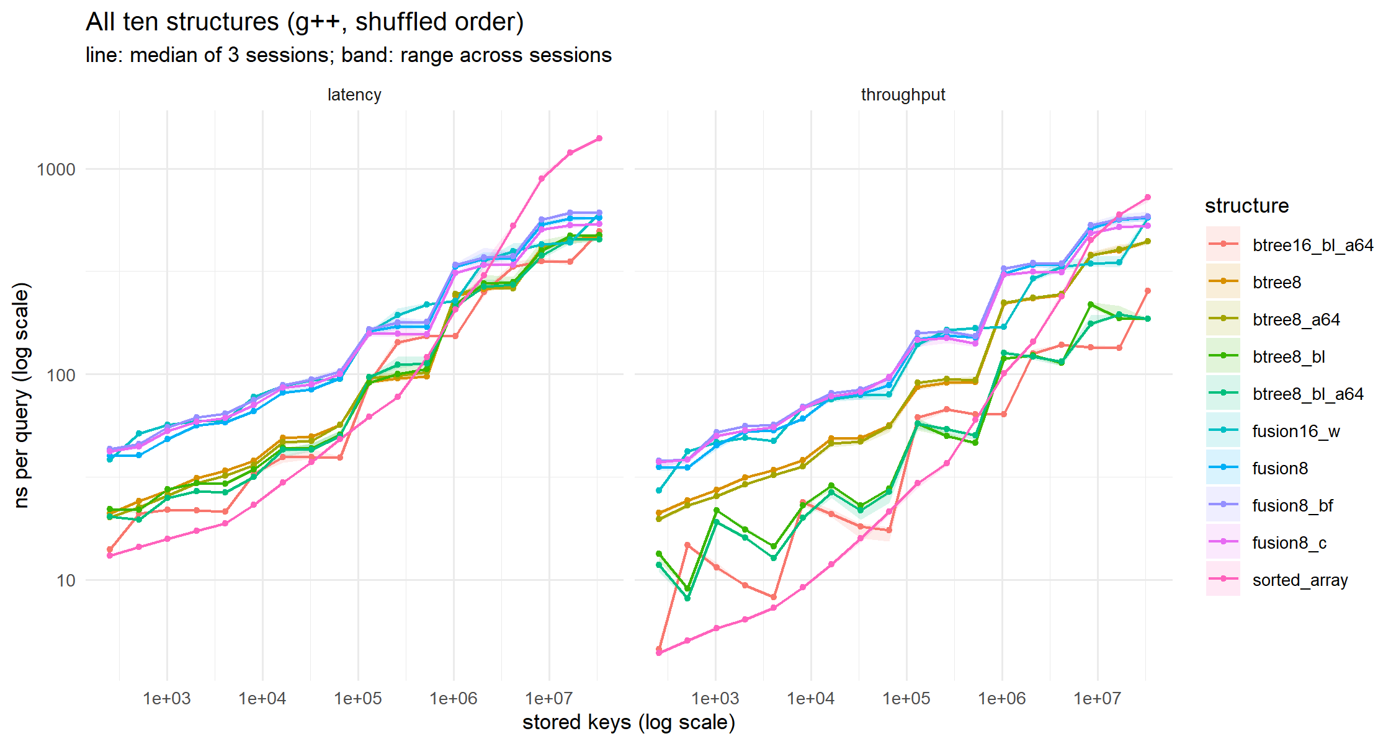
Figure 1. All ten structures, g++, shuffled order. Line: median of 3 sessions; band: range across sessions.

4.3 The comparisons that answer the question
Ratio of fusion time to baseline time; below 1 the fusion variant wins. Brackets: lowest and highest of the three sessions.
Throughput:
comparison (g++, shuffled) | 2⁸ | 2¹⁶ | 2²⁰ | 2²⁵
original fusion ÷ branch-free B-tree | 2.70 (2.65–2.77) | 3.18 (3.17–3.27) | 2.60 (2.59–2.61) | 3.09 (3.02–3.11)
compact fusion ÷ aligned B-tree (equal size) | 3.16 (3.15–3.23) | 3.62 (3.58–3.85) | 2.34 (2.33–2.44) | 2.78 (2.78–2.93)
16-key fusion ÷ best B-tree | 5.92 (5.50–5.95) | 4.61 (4.43–4.88) | 2.67 (2.66–2.68) | 3.11 (3.08–3.30)
original fusion ÷ binary search | 8.04 (7.88–8.06) | 4.04 (4.03–4.24) | 3.08 (3.04–3.10) | 0.80 (0.78–0.81)

Latency:
comparison (g++, shuffled) | 2⁸ | 2¹⁶ | 2²⁰ | 2²⁵
original fusion ÷ branch-free B-tree | 1.83 (1.81–1.85) | 1.87 (1.81–1.88) | 1.48 (1.48–1.51) | 1.23 (1.22–1.24)
compact fusion ÷ aligned B-tree (equal size) | 2.09 (2.07–2.09) | 1.97 (1.91–2.01) | 1.45 (1.45–1.46) | 1.19 (1.16–1.19)
16-key fusion ÷ best B-tree | 2.72 (2.70–2.76) | 2.38 (2.38–2.40) | 1.49 (1.45–1.53) | 1.36 (1.33–1.37)
original fusion ÷ binary search | 3.06 (3.05–3.08) | 1.98 (1.97–1.99) | 1.61 (1.59–1.61) | 0.41 (0.40–0.42)

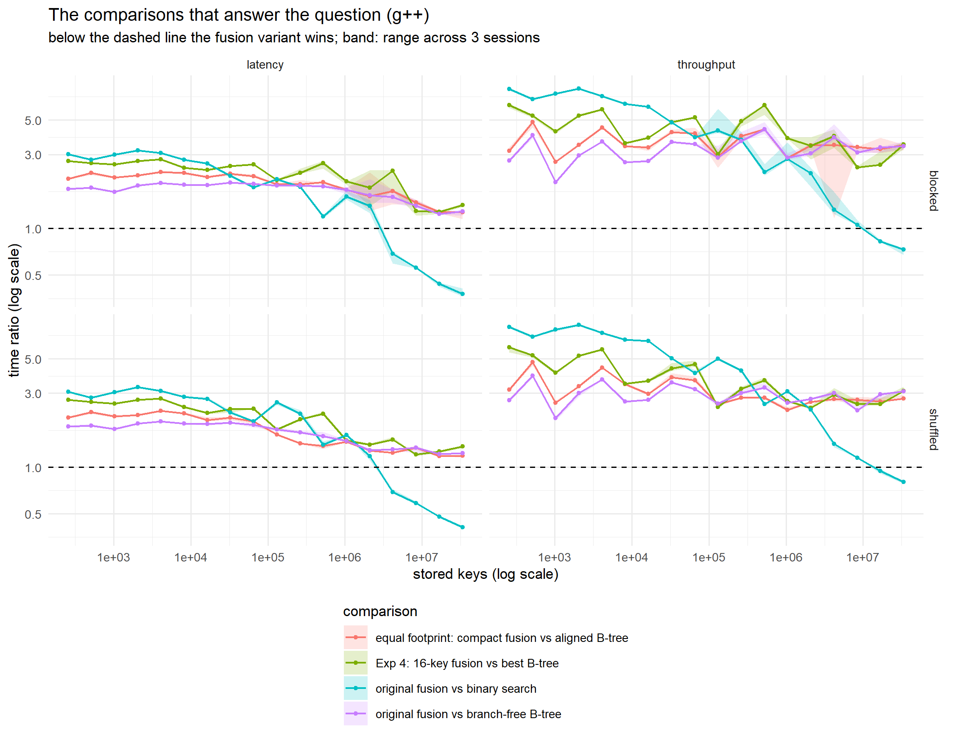
Figure 2. The main comparisons, g++, by mode (columns) and run order (rows). Only the comparison with binary search ever crosses the dashed line.

5. Experiment 3 — why the fusion tree loses

5.1 One node search, in clock cycles
64 nodes of each type — everything in the fastest cache, so memory plays no part. Cycles come from timing a chain of 1-cycle ADD instructions on the same core (about 5.07 GHz).
node search | keys | g++ throughput | g++ latency | clang throughput | clang latency
B-tree scan, early-exit | 8 | 34.4 | 41.2 | 36.3 | 38.9
B-tree scan, branch-free | 8 | 3.5 | 27.6 | 3.2 | 31.4
B-tree scan, branch-free | 16 | 5.2 | 30.1 | 5.2 | 33.7
fusion, original | 8 | 40.5 | 59.5 | 43.0 | 58.2
fusion, branch-free | 8 | 37.1 | 60.3 | 37.5 | 60.7
fusion, compact | 8 | 42.7 | 62.9 | 40.8 | 61.7
fusion, 16 keys (AVX2) | 16 | 44.7 | 84.4 | 44.1 | 84.8
Latency = one search’s dependency chain; throughput = cost per search when many overlap.
The manual estimated the fusion node’s chain at about 11 cycles; the whole search actually takes about 60.3, because it sketches twice, compares twice, and reloads two keys in between. The B-tree’s 8-key scan is 27.6 cycles of latency and only 3.5 cycles of throughput. Removing the fusion node’s branches does not help (59.5 → 60.3 cycles): its branches were predictable.

5.2 Memory touched per search
Each structure reports the exact bytes every search reads. The table gives the distinct 64-byte cache lines per search, and the modelled trips to main memory (DRAM) per search from replaying those addresses through a model of this CPU’s caches. The line counts are exact; the DRAM counts are a model in the manner of cachegrind — no prefetcher, assumed associativities.
structure | lines 2¹⁶ | lines 2²⁰ | lines 2²⁵ | DRAM 2¹⁶ | DRAM 2²⁰ | DRAM 2²⁵
B-tree, branch-free | 12.0 | 16.5 | 18.9 | 0.00 | 0.01 | 1.73
B-tree, branch-free, aligned | 10.4 | 14.0 | 16.0 | 0.00 | 0.01 | 0.55
B-tree, 16 keys | 14.8 | 18.8 | 25.3 | 0.00 | 0.00 | 5.54
fusion, original | 17.3 | 23.8 | 27.4 | 0.00 | 0.37 | 6.83
fusion, compact 128 B | 10.4 | 14.0 | 16.0 | 0.00 | 0.01 | 0.55
fusion, 16 keys | 17.1 | 21.6 | 28.5 | 0.00 | 0.00 | 7.26
binary search | 13.0 | 17.0 | 22.0 | 0.00 | 0.00 | 13.62
Lines = distinct cache lines per search (exact). DRAM = modelled main-memory trips per search.
The original fusion tree touches 27.4 lines per search at 2²⁵ against 18.9 for the B-tree, and makes 6.83 modelled DRAM trips against 1.73. The compact fusion node and the aligned B-tree touch exactly the same memory (16.0 lines, 0.55 DRAM trips each) — so any remaining gap between those two is computation, nothing else.

5.3 Ablations: remove one cause at a time
ablation (g++, shuffled) | 2⁸ | 2¹⁶ | 2²⁰ | 2²⁵
branch-free rank ÷ original rank (throughput) | 1.06 (1.05–1.07) | 1.07 (1.06–1.08) | 1.04 (1.04–1.06) | 1.01 (1.01–1.07)
compact node ÷ original node (throughput) | 0.98 (0.98–0.99) | 1.01 (1.00–1.04) | 0.93 (0.93–0.94) | 0.90 (0.85–0.93)
16-key fusion ÷ 8-key fusion (throughput) | 0.73 (0.70–0.76) | 0.84 (0.82–0.85) | 0.52 (0.52–0.53) | 0.96 (0.93–1.08)
branch-free rank ÷ original rank (latency) | 1.08 (1.08–1.09) | 1.08 (1.07–1.12) | 1.04 (1.02–1.05) | 1.04 (1.04–1.07)
compact node ÷ original node (latency) | 0.97 (0.97–0.97) | 0.95 (0.94–0.97) | 0.91 (0.90–0.91) | 0.89 (0.87–0.90)
16-key fusion ÷ 8-key fusion (latency) | 0.89 (0.86–0.90) | 0.91 (0.89–0.91) | 0.67 (0.66–0.67) | 1.00 (1.00–1.03)
Ratio after the change ÷ before; below 1 the change helps. g++, shuffled; brackets: session range.
- Branches: removing them makes the fusion tree 7.2% slower at 2¹⁶ and changes nothing at 2²⁵. Not the cause.
- Memory footprint: shrinking the node from 184 to 128 bytes makes it 9.6% faster at 2²⁵. A real but minor cause.
- Computation: at equal footprint the fusion tree is still 2.78× slower in throughput and 1.19× in latency at 2²⁵. This is the main cause.
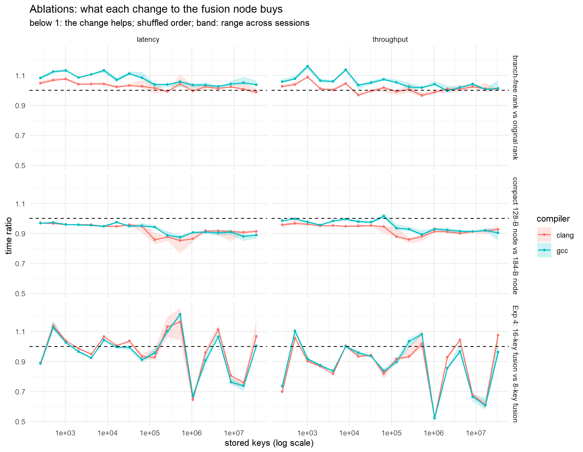
Figure 3. What each change to the fusion node buys, both compilers.

5.4 Why there is no crossover
fusion minus B-tree, g++, shuffled | 2⁸ | 2¹² | 2¹⁶ | 2²⁰ | 2²⁴ | 2²⁵
original fusion − branch-free B-tree, latency | 18.0 ns (1.82×) | 28.8 ns (1.98×) | 44.3 ns (1.87×) | 112.1 ns (1.51×) | 103.5 ns (1.22×) | 102.2 ns (1.22×)
compact fusion − aligned B-tree, latency | 21.7 ns (2.07×) | 34.6 ns (2.30×) | 50.2 ns (2.01×) | 96.7 ns (1.45×) | 79.5 ns (1.18×) | 85.4 ns (1.19×)
original fusion − branch-free B-tree, throughput | 21.9 ns (2.65×) | 38.6 ns (3.65×) | 60.4 ns (3.18×) | 190.0 ns (2.59×) | 377.2 ns (3.01×) | 392.8 ns (3.11×)
compact fusion − aligned B-tree, throughput | 25.5 ns (3.16×) | 42.5 ns (4.34×) | 70.1 ns (3.62×) | 178.0 ns (2.41×) | 322.4 ns (2.65×) | 340.5 ns (2.83×)
Absolute gap in ns (and ratio), g++, shuffled.
The ratio falls in latency mode, but the absolute deficit rises. At equal memory footprint the fusion tree loses roughly 10 ns per tree level — the same order as the extra 30-odd cycles its node search costs (§5.1). As the tree grows, each level also waits longer for memory, so the ratio creeps towards 1 from above; it cannot pass 1 while the fusion node does more work per level than the B-tree node. A straight line fitted through the latency ratios does cross 1 (near 2³¹ keys), but the line is the wrong model for data shaped like this, and this report does not use it.

5.5 Measured hardware counters
Intel VTune was installed afterwards and both structures were profiled directly: 40 repetitions over 2⁸ to 2²² keys, throughput mode, pinned to core 8, 39.3 million searches each, on an otherwise idle machine. These come from the CPU's own counters — not from the model in §5.2.
measured, per search (39.3 million searches each) | fusion | B-tree | ratio
instructions | 441 | 200 | 2.20×
cycles | 730 | 291 | 2.51×
cycles per instruction | 1.66 | 1.45 | 1.14×
retiring (% of pipeline slots) | 6.7% | 7.7%
bad speculation | 18.2% | 11.7%
back-end bound | 66.3% | 64.4%
of which memory bound | 43.8% | 30.3%
of which core bound | 22.5% | 34.2%
stalled on main memory (DRAM) | 20.5% | 17.5%
VTune uarch-exploration, one structure per run, same binary as the campaign.
The fusion tree executes 441 instructions per search against the B-tree's 200 — 2.2 times more work — and it stalls harder on each one (1.657 cycles per instruction against 1.453). Multiply the two and the fusion tree spends 2.5× the cycles, which is what the stopwatch said over that range of sizes. Two independent methods, the same answer.
This is the sharpest refutation of the structure's own selling point. The fusion tree exists to do less work per node than a comparison search. Measured on the hardware, it does more than twice as much.
Which profiles count, and why. Four collections were made and two are used. The exclusion rule is: a collection is excluded if it ran while another benchmark was pinned to the same core, judged from its timestamps against the campaign log. That rule was not fixed in advance. It was applied after the first pair’s counters had been seen, when the fusion collection turned out to have overlapped session 2 of the timing campaign on core 8; its wall clock was 82.8 s against 6.3 s for the re-collection. Two things limit the damage. The rule looks only at timestamps, never at counter values. And the excluded data points the same way: 443 instructions per search against 441 (within 1%), and 831 cycles against 730, which would have made the fusion tree look worse, not better (cycle ratio 2.87× against 2.51×). The B-tree collection of that pair showed no sign of overlap (2.952 s against 2.947 s, instructions and cycles within 1%) but was re-collected too, so both structures come from the same idle window. Given the rule came late, read the instruction and cycle counts as solid, because they barely differ between the excluded and the used runs, and everything below them as indicative. results/vtune_counters.csv keeps all four runs, marked.
How precisely should the lower rows be read? Instructions and cycles repeat to within half a per cent between collections, so the top three rows are solid. The pipeline breakdown underneath is sampled by multiplexing many counters through a run of a few seconds, and repeat collections of the identical binary moved bad speculation by several points. Read those rows as showing where the time goes, not as exact shares.

6. Experiment 4 — does a wider word help?
A 256-bit AVX2 register allows K = 16 keys per fusion node (K² ≤ w) when the sketch is computed with PEXT, as it is here; the K ≈ 6 limit of §3 applies only to the 1993 multiplication sketch. This does help the fusion tree against its own 8-key version in the middle sizes (ratio 0.52 at 2²⁰: fewer levels), but not at 2²⁵ (0.96). It never approaches a B-tree: against the best B-tree it is 3.11× slower in throughput and 1.36× in latency at 2²⁵, and against a 16-key B-tree built the same way 2.27× and 1.23×. Its node search is the slowest measured (84.4 cycles of latency): moving data between the ordinary and the vector registers costs more than the wider comparison saves. And without PEXT it could not be built at all: §3 showed the multiplication sketch stops near K = 6 on 256 bits. A wider word does not rescue the fusion tree.

7. A problem found and fixed — and why it mattered
The first final campaign (18 runs, 17:48–18:11) reported the fusion tree only 1.2× slower than the branch-free B-tree at 2²⁵ in throughput, where an earlier run had given 3.0×. Rebuilding the earlier program showed why. g++ had compiled the branch-free B-tree’s scan differently in the two programs from identical source: in one it used AVX2 vector instructions (two instructions for 8 keys), in the other eight separate scalar comparisons. The scalar version took 443 ns per search at 2²⁵; the vector version 193 ns. The first campaign had therefore compared the fusion tree against a baseline that the compiler had quietly weakened.
The fix was to write the scan with explicit AVX2 instructions, so no compiler decision can change it, and to rerun every campaign. The fusion nodes already use explicit instructions (PEXT, POPCNT, AVX2), so both sides are now spelled out. The flawed data is kept in results/final and results/final_v1_* as a record and is used for no conclusion. This is exactly the failure the manual warns about — “always compare against the strongest reasonable opponent” — arriving by an unexpected route.

8. Your own run: replication, and a 2×2 factorial
run_remaining_experiments.sh (10 September, 19:31–19:35) re-ran the node-cycle and sketch-width experiments, swept all ten structures once more, and added a factorial the campaign did not cover: run order crossed with pinning.

8.1 Replication
A single fresh session, 15 repetitions, against the median of the three campaign sessions:
structure (mode) | your run 2²⁰ | 3-session 2²⁰ | diff | your run 2²⁵ | 3-session 2²⁵ | diff
btree8_bl (throughput) | 121.2 | 119.2 | 2% | 177.1 | 186.0 | -5%
fusion8 (throughput) | 309.7 | 309.3 | 0% | 566.9 | 578.8 | -2%
fusion8_c (throughput) | 300.7 | 304.7 | -1% | 525.9 | 526.8 | -0%
fusion16_w (throughput) | 169.0 | 170.3 | -1% | 551.2 | 576.1 | -4%
btree8_bl (latency) | 233.6 | 220.1 | 6% | 503.4 | 474.6 | 6%
fusion8 (latency) | 357.0 | 332.2 | 7% | 593.0 | 576.8 | 3%
fusion8_c (latency) | 328.5 | 309.7 | 6% | 559.6 | 536.8 | 4%
fusion16_w (latency) | 235.8 | 227.7 | 4% | 632.9 | 611.2 | 4%
Your single-session medians against the 3-session medians, g++, shuffled. Positive = your run was slower.
Throughput agrees to within a few per cent; latency runs a few per cent slow, which is the ordinary difference between one session and the median of three. Nothing in the conclusions moves. The sketch-width file came out byte-identical, as it should: that experiment is deterministic.

8.2 Run order × pinning
Three structures (binary search, early-exit B-tree, original fusion), throughput, 2⁸–2²⁵, in all four combinations of blocked/shuffled order and pinned/unpinned:
order · pinning | fusion ns 2¹⁶ | fusion ns 2²⁰ | fusion ns 2²² | fusion ns 2²⁵ | ratio 2¹⁶ | ratio 2²⁰ | ratio 2²² | ratio 2²⁵
blocked · pinned | 79.1 | 340.6 | 298.7 | 553.5 | 1.49 | 1.76 | 1.54 | 1.30
blocked · unpinned | 82.9 | 293.3 | 351.6 | 564.8 | 1.55 | 1.58 | 1.48 | 1.39
shuffled · pinned | 84.9 | 319.6 | 350.8 | 572.0 | 1.57 | 1.43 | 1.40 | 1.30
shuffled · unpinned | 85.3 | 330.9 | 404.2 | 659.9 | 1.54 | 1.43 | 1.34 | 1.25
Fusion time and the fusion ÷ early-exit-B-tree ratio in each cell, single session.
The absolute times swing widely — at 2²⁵ binary search ranged from 633.6 to 1285.8 ns across the four cells, a factor of two — but the ratio that answers the research question barely moves (1.25–1.39 at 2²⁵). Two things follow. First, the earlier impression that unpinned runs were faster was run-to-run noise, not a systematic effect: unpinned is faster in one cell and much slower in another. Second, pinning is worth doing for comparability rather than for speed, and absolute nanosecond figures should never be quoted without saying how the run was arranged.

9. Other findings worth a sentence in the report
- Against binary search the fusion tree wins at large sizes (see “The answer”). Counting a crossover only where the ratio is below 1 in every session: from 2²² keys in latency and 2²⁴ in throughput. The comparison-based B-trees get there sooner: both B-trees beat binary search at every size from 2²¹ in latency.
- The result holds with both compilers and both run orders. At 2²⁵ the fusion ÷ branch-free-B-tree ratio ranges over 3.09–3.83 (throughput) and 1.20–1.29 (latency) across the six configurations (table below).
- Core type matters. The laptop mixes performance and efficiency cores; on an efficiency core binary search was 62% slower but the fusion tree only 11%, so an unpinned run can change the ratios, not just the times.
- The B-tree “dip” at 512 keys is two effects. At 256 and 512 keys every search visits exactly 3 nodes, while at 1,024 only 59% visit the most common number, so the loop’s exit becomes unpredictable — that explains the jump after 512. The unusually deep dip first seen (11.9 ns) appeared only when particular other structures shared memory and did not reproduce otherwise; with fresh key sets a mild dip (≈17 → 15.5 ns) remains.

configuration (n = 2²⁵) | original ÷ BF B-tree | compact ÷ aligned B-tree | 16-key ÷ best B-tree | original ÷ binary
g++ · throughput · shuffled | 3.09 (3.02–3.11) | 2.78 (2.78–2.93) | 3.11 (3.08–3.30) | 0.80 (0.78–0.81)
g++ · throughput · blocked | 3.39 (3.26–3.63) | 3.46 (3.21–3.49) | 3.48 (3.24–3.65) | 0.73 (0.68–0.74)
g++ · latency · shuffled | 1.23 (1.22–1.24) | 1.19 (1.16–1.19) | 1.36 (1.33–1.37) | 0.41 (0.40–0.42)
g++ · latency · blocked | 1.29 (1.21–1.32) | 1.28 (1.15–1.29) | 1.41 (1.38–1.45) | 0.38 (0.36–0.41)
clang · throughput · shuffled | 3.83 (3.83–3.84) | 3.73 (3.52–3.81) | 4.33 (4.22–4.35) | 0.73 (0.71–0.73)
clang · latency · shuffled | 1.20 (1.20–1.28) | 1.16 (1.15–1.18) | 1.41 (1.38–1.49) | 0.59 (0.51–0.67)
Ratios at 2²⁵ (33.5 million keys) in every configuration; brackets: session range.

comparison | configuration | slope per doubling [95% CI] | ratio at 2²⁵ | fusion wins from
original ÷ BF B-tree | g++ · throughput | -0.012 [-0.036, 0.012] | 3.08 | never
original ÷ BF B-tree | g++ · latency | -0.045 [-0.052, -0.038] | 1.23 | never
original ÷ BF B-tree | clang · throughput | +0.064 [0.038, 0.090] | 3.83 | never
original ÷ BF B-tree | clang · latency | -0.036 [-0.043, -0.028] | 1.23 | never
compact ÷ aligned B-tree | g++ · throughput | -0.072 [-0.099, -0.044] | 2.83 | never
compact ÷ aligned B-tree | g++ · latency | -0.074 [-0.083, -0.066] | 1.18 | never
compact ÷ aligned B-tree | clang · throughput | +0.033 [0.008, 0.057] | 3.68 | never
compact ÷ aligned B-tree | clang · latency | -0.057 [-0.063, -0.051] | 1.16 | never
16-key ÷ best B-tree | g++ · throughput | -0.173 [-0.209, -0.137] | 3.16 | never
16-key ÷ best B-tree | g++ · latency | -0.099 [-0.109, -0.088] | 1.35 | never
16-key ÷ best B-tree | clang · throughput | -0.084 [-0.123, -0.044] | 4.30 | never
16-key ÷ best B-tree | clang · latency | -0.079 [-0.091, -0.068] | 1.43 | never
Straight-line trend of each ratio against log2(n), all sessions pooled. “Never” means the fusion variant lost in every session at every size. As §5.4 explains, a negative slope here is the ratio approaching 1 from above, not a coming crossover.

10. Limits of what was measured
- Counters came last, and their sub-metrics are noisy. WSL2 exposes no performance-monitoring unit, so the mechanism was established first by timing and modelling (§5.1–§5.4) and confirmed by hardware counters afterwards (§5.5). Instruction and cycle counts are reliable; the top-down percentage breakdown moves by a few points between repeat collections.
- One laptop. One CPU family (Arrow Lake), one operating system.
- Not fully crossed. Run order was varied under g++ only; clang ran in shuffled order only (§4). The g++ blocked runs and the factorial in §8.2 are the evidence that order does not move the ratios.
- The VTune exclusion rule was set after the first counters were seen (§5.5). It depends only on timestamps, and the excluded runs agree on instructions, so the conclusion does not rest on it.
- Static trees only. No insertion or deletion, as the manual specifies.
- The machine was not otherwise idle during the campaign (this session was open), though no other heavy work ran during timing.

11. The result, as one sentence for your report
*“On a 2025 laptop CPU, a correctly implemented fusion tree beat binary search, the comparison-based method its lower-bound argument targets, from 2²² keys when searches cannot overlap and from 2²⁴ when they can. It never beat a cache-conscious B-tree: it was 2.0–4.4 times slower when searches overlap and 1.2–2.0 times slower when they cannot, at every size from 2⁸ to 2²⁵ keys, with a deficit that grows in absolute terms. A plain comparison-based B-tree beats binary search sooner, so the win over binary search comes from multiway, cache-line-sized nodes rather than from word-level parallelism; the fusion node’s own search has a dependency chain about twice as long as a vectorised B-tree node’s, and memory traffic accounts for only 5–17 percent of the gap.”*

12. What is left for you
- Write the report (8–12 pages, due 4 December), in your own words. This document and the first work log are the lab notebook it draws on.
- Be able to explain every section without notes. The best test: explain §5.4 — why a shrinking ratio is not a crossover — to someone who has not seen it.
- Optional: a vtune -collect memory-access profile would give measured cache misses per structure, replacing the modelled figures in §5.2. Nothing in the conclusions depends on it.
- Optional: fill the two missing cells (clang in blocked order) if a reviewer asks for a fully crossed design. Nothing in §8.2 suggests they would change a ratio.
- Quote the repository and commit in the paper (the code is already pushed to GitHub with a LICENSE; the manual is excluded from it), so a reader can reproduce every figure.

