Project M6
SnapTag


VU Students Group 4
- Direk Anker (3079058)
- Timo van Ovost (3285219)
- Berend van Bolhuis (3281841)
- Noah van Potten (3277194)
- Ryan van Beek (3265994)

Abstract
This project explores the development of SnapTag, a mobile application designed to address sedentary behaviour among adolescents by encouraging physical activity through social engagement. Drawing inspiration from the childhood game called "Tag," the app integrates modern technologies such as facial recognition, location tracking, and social media-like features to create a dynamic and enjoyable experience.
Key design elements include competitive leaderboards, customizable game settings and a social media feed. Through Lo-Fi and Hi-Fi prototyping and user testing, the project found that combining nostalgia, mobile games, and social interactions effectively motivates physical activity.
While short-term testing demonstrated increased movement and social interactions, further research is needed to assess long-term behavioural changes.
SnapTag demonstrates strong potential as a playful, accessible solution to promote healthier lifestyles in a digital age.

Table of Contents
Abstract 2
Chapter 1: Introduction 5
Chapter 2: Context analysis and concept 7
2.1 Research Question/s 7
Main Research Question 7
Sub-Research Questions 7
2.2 Approach 8
Different methods 8
Usage 9
2.3 Context Analysis: Literature and Related Work 10
Literature research: 10
Related work: 11
2.4 Context Analysis: Interviews and Observations 12
Insights derived per sub-question 12
Complementary to literature research 13
2.5 Description of Target User Group and Domain 14
Target User Group: 14
User Activities and Domain: 14
Technological Familiarity: 14
Typical Scenarios: 14
2.6 Product Concept and Global Requirements 15
Key takeaways from interviews 15
Key takeaways from literature research 15
Product concept: SnapTag 15
Global Requirements 16
3.1 Lo-Fi Prototype 18
Research questions 18
Test setup 18
Mechanism 1 19
Mechanism 2 20
Mechanism 3 21
Mechanism 4: 22
3.2 Revised Product Concept and Requirements 23
Chapter 4: Hi-Fi Prototype Overview 24
High-level Design Overview 24
System Architecture 25
Design decisions and rationale 27
Colouring 28
Game lobby 28
Log in screen 28
Symbols 28
Logo 29
Ethical considerations 29
Chapter 5: Evaluation – Experimental Research Study 30
5.1 Evaluation Plans 30
The Goal of the Research Experiment 30
Research Questions 30
Hypotheses 30
Methods 31
Constructs and Measurement Instruments 32
Potential Validity Concerns 32
Analysis Plan 32
5.2 User Study 33
Pilot Study 33
User Study 33
Conclusion & Feasibility of the Hi-Fi Prototype: 35
Chapter 6: Discussion: 36
Summary of the Project and Main Outcomes 36
Achieved Global Aims 37
Implications 38
Recommendations for Improvement and Future Work 38
Limitations 39
Conclusion 39
Extra Discussion (own flaws) 39
References 40
Appendix 42
Interviews 42
Brainstorm: 49
Low-Fi Testing Pictures 52

Chapter 1: Introduction
One-third of the global population aged 15 and older engage in insufficient physical activity, (Jung Ha Park, 2020) with one in eight having obesity (World Health Organization, 2024). In 2023, over 30 per cent of the Dutch population was overweight, and just under 16 per cent was obese which means that they have a body mass index (BMI) of 25-30 and 30 and up, respectively (Stewart, 2023).
Being overweight or obese can be due to various reasons. One of which is sedentary behaviour which refers to any activity that involves low energy expenditure consisting of playing a video game, watching television, using a computer, sitting on the bus or reading a book on the couch (Jung Ha Park, 2020). A prolonged sedentary lifestyle does not only result in obesity but in several other health risks, including cardiovascular disease, type 2 diabetes, and even premature mortality (Jung Ha Park, 2020) (Warburton, 2006).
The shift from an active lifestyle in childhood to a sedentary lifestyle as a modern adult and even children is due to several reasons. The most significant factor is the increase in mobile phone and other screen technology usages, which encourage prolonged periods of inactivity and screen time due to algorithms that are designed by social media apps to keep people on their phones (Rajeshwari, 2023).
Needless to say, some physical activity is needed to maintain a healthy body. Even at modest levels, such as walking, has positive benefits for the physical and mental well-being of people. Any regular physical movement that is above the sedentary behaviour category will help maintain a healthy body weight, reduce the risks of chronic illnesses such as cardiovascular diseases and type 2 diabetes and strengthen the bones and muscles (Warburton, 2006).
However, the health benefits of physical activities are not enough to reduce sedentary behaviour which can be seen by the increasing percentage of overweight people (Stewart, 2023). The challenge of this project is thus how it could make physical activities more attractive than sedentary activities.
Research also shows that behaviour like physical activity often spreads within social groups. Individuals are strongly influenced by the actions of their friends, so when one of them starts engaging in an activity, others are more likely to join due to the interconnection between them (Nicholas A. Christakis, 2011). By targeting adult friend groups, the project aims to leverage this effect to increase the chance of individual participation and motivation.
Therefore, the project aims to address sedentary behaviour by using different technologies to reintroduce physical activity through a modern version of a childhood game. With inspiration from the childhood game “Tag”, the projects will try to develop an interactive experience that uses technologies such as facial recognition, location tracking and mobile phones to create a modern and engaging version of the game. By targeting adult friend groups, this project will combine the feelings of nostalgia with knowledge about group dynamics to motivate the people in those groups to engage more in physical activities, thus leading to a less sedentary lifestyle which would lead to better health (Jung Ha Park, 2020).
Thus, our proposed solution is a modernized version of the childhood game called Tag, which uses mobile phones, location tracking and facial recognition to make a dynamic game that can be played with friend groups to encourage physical activity on any level by introducing a bit of nostalgia and modern technology.
The main research question that comes out of this is as follows:
How can the combination of technologies such as facial recognition, location tracking, and smartphones be used to get individual- and/or (friend)groups of adolescents to live a less sedentary lifestyle by moving around more?
By answering this main research question, the project aims to find the solution to achieve a healthier and more active community.
This project could contribute to society in two ways. First, regardless of whether the project succeeds or fails, it will contribute to all the research on gamifying physical activity. An increase in any field will increase the understanding of that topic. Not only on gamifying physical activity but also on the topic of how social interactions could influence behaviour and physical activity.
However, the most desired contribution to society would be to promote living a healthier lifestyle. By contributing to an increase in physical activity with the game and by increasing awareness of the health risks that come with a sedentary lifestyle, the project tries to address the global challenge of physical activity on a smaller scale.
Unlike other initiatives like fitness apps, our project emphasizes social bonding and friendly competition to motivate users. This differentiates from the personal/solo progress tracking on other apps.
Our project also addresses physical activity barriers by making it an app which is accessible to everyone for free and making it easy to engage with friends.
The ultimate goal is a long-term behaviour change that promotes healthier and more active lifestyles however, the closer and more achievable goal is to create an enjoyable activity that discreetly encourages players to move more without making exercise making like a chore.

Chapter 2: Context analysis and concept

2.1 Research Question/s

Main Research Question
How can the combination of technologies such as facial recognition, location tracking, and smartphones be used to get individual- and/or (friend)groups of adolescents to live a less sedentary lifestyle by moving around more?
This research question is interesting because it addresses a pressing issue: the decline in physical activity among adolescents in a technology-driven and urbanized world. By mixing up-and-coming technologies such as facial recognition, location tracking, and smartphone integration with the nostalgia and simplicity of a classic game like Tag, we aim to create a unique solution that resonates with young people and ultimately lets them rekindle that love they had for physical activities.
Traditional forms of exercise, such as a gym workout or a team sport, already are an effective way to make people move around more. These forms of exercise have a higher barrier to take part in because they often require prior experience, discipline/motivation, time and a structured environment with the supplies for the sport. In contrast, our approach is made in such a way, that the barrier for entry is very low and most people with a smartphone can participate.
This approach not only encourages physical movement but also fosters social interaction, creativity, and a sense of community—elements that are often lost in the digital age.
The exploration of this research question strives to transform technology from a sedentary distraction to a useful resource for promoting healthy behaviour.

Sub-Research Questions
1. How do adolescent (friend)groups interact with each other online compared to in person?
Understanding how adolescent groups interact online compared to in-person is very important for designing a solution that has to make people move around more because, in our own experience, we noticed that our phone and the “online world” often was the factor that makes us live a sedentary lifestyle. Over the internet it is very easy to contact your friends, so we noticed that the pressure to get out there to have social interaction decreased. We want to know the differences between online and in-person interactions, to bridge the gap and use the best of both to improve physical activity.
2. How can products be designed and marketed to achieve social engagement?
Researching how products can be designed and marketed to achieve social engagement is important for understanding the factors that drive the user to adopt or sustain interaction. By identifying these factors, we can use these to ensure the product’s widespread adoption and long-term engagement, especially among adolescents who are often drawn to and influenced by trends and social validation.
3. What factors contribute to a smooth, secure and enjoyable experience for adolescents in trying a new app?
Seamless onboarding is essential for engaging users, especially teenagers who are less patient with cumbersome setups. Addressing negative factors like complicated registration, unclear instructions, or difficulties in inviting friends. The positive factors which give users a positive feeling ensure the game is accessible and enjoyable from the start. To make sure users feel safe, factors regarding privacy should also be considered. This is directly connected to the main question as it ensures technology is not a barrier but an enabler for increasing physical activity through the game.

2.2 Approach
In order to answer the Research questions there will be research done through several methods. These different methods are necessary to find solutions for ethical-, technical- and social problems that arise in this project.

Different methods
- Interview:
These interviews will mainly happen before usability testing and will give us insights into adolescents’ attitudes, motivations and concerns regarding physical activity and technology, and the way adolescents behave towards each other. By speaking directly with users, we can get better insights into what excites them, because interviewing gives you more than just answers. The interviewer can also observe the reaction of the interviewee and go more in-depth on certain questions.
This makes it a more suitable method than a survey because a survey often has a low response rate and there is no room for improvisation.
- Observing:
Observing the user in their natural environment provides non-biased and authentic information about their behaviour and interactions that might be missed in an interview, survey or literature research.
- Literature research:
Literature research involves reviewing existing studies and reports and it will contribute to this project by uncovering more general and factual factors that were discovered or tested by other researchers. It takes time but it provides a lot of in-depth information.
- Questionnaire: This method will be used later in the evaluation of the product. This method is helpful to get quick and fast feedback after a user study and it is vital for improving the design.
- Pilot testing: This method will be used later in the development of the product, likely when a working prototype has been made. This method is helpful to find bugs, if it is user friendly and if it is appealing etc. This is focused on the interaction with technology.

Usage
Sub-Question 1:
How do adolescent (friend)groups interact with each other online compared to in person?

Observing: We (the researchers) are all part of a friend group, and all communicate online and in person with our friends, during these interactions, we started to observe how they went, excluding interactions we had on our own, so it would not interfere with the validity of the results.
Interview: We asked the interviewee questions regarding the interactions they have with their friends online and in person and what their thoughts are regarding this because using only observations would not give enough data.
Social media analysis: In order to find out how adolescents communicate with each other on social media and what gets a lot of likes this will be analysed, because social media is very fast-paced and is constantly changing we think this a helpful addition to the top of the literature review.
Sub-question 2:
How can products be designed and marketed to achieve social engagement?
Literature research on product hype: There have been countless hyped products, so a lot of information is available on this topic. For our research, we will focus mainly on social media trends, viral marketing campaigns and gamification.
Interview: ask questions about how prone our target users are to products promoted by influencers and or other marketing.
Sub-question 3:
What factors contribute to a smooth, secure and enjoyable experience for adolescents in trying a new app?
Literature research on human-computer interaction: Literature research would contribute to this project by giving broad and more general information about human-computer interaction which will be useful for design considerations.
Interview: By doing an interview, the users will provide more in-depth information about personal experiences of other apps or information about preferences, which could give insight into our design choices.
Questionnaire: This will be done after testing to collect feedback from the participants. The questionnaire will involve open questions and questions with a scale to measure satisfaction.

2.3 Context Analysis: Literature and Related Work

Literature research:
Literature research would give valuable insights into the design choices of the product and thus it was conducted to help answer 2 out of the 3 sub-questions.

Product Hype
Product hype is crucial to the success of a product on the market. A study from Binghamton University emphasizes that the way companies announce new products has a significant impact on their success (Binghamton University, 2024). Strategic preannouncement marketing is a very effective way to create interest in the product because this creates an interest among the target users and leads to stronger initial sales (Binghamton University, 2024). This approach calls upon the curiosity of the user and it is perceived as more exclusive, which often contributes to the hype of a product (Binghamton University, 2024)

Human-computer Interaction
Creating a positive app experience for adolescents requires attention to key factors identified through Human-Computer Interaction (HCI) principles.
The first one is a user-friendly interface. This includes the interface being easy and clear to navigate. Apps with simple layouts reduce cognitive load and thus enhance engagement (MacKenzie, 2012).
Another feature is personal customization. Having teams or being able to change something can be a motivator for the user (MacKenzie, 2012).
Users also value apps that prioritize their privacy. There should be a clear and accessible way to navigate privacy settings and transparency about their data collection and if it is used ethically would make the user trust the app more (MacKenzie, 2012).
The onboarding process should also be smooth and easy such that the user gets a good first impression without being overwhelmed (MacKenzie, 2012). This comes together with an app that performs well and is stable. Poor performance leads to high abandonment rates so fast load times with a crash-free experience are vital for the user, especially the younger ones with less patience (MacKenzie, 2012).

Related work:
To develop the digital version of the childhood game ‘tag’ we can also investigate existing theories and frameworks related to facial recognition, location tracking and physical transformation of childhood games. Two existing apps, Pokémon GO and Jachtseizoen, provide the existing theories and framework.
Pokémon GO is a location-based augmented reality game developed by Niantic in collaboration with The Pokémon Company and Nintendo. Pokémon GO was launched in 2016 and quickly became one of the most used apps with 500 million downloads from all over the world. Pokémon GO blended the nostalgia of Pokémon with innovative technology that encourages players to come outside and explore the real world.
The unique mix of augmented reality and the nostalgia of Pokémon resulted in more physical activity. A study collected and measured the physical activity of 32.000 Microsoft band (Smart bracelet) users three months before and after the announcement of Pokémon GO. It resulted in a significant increase in physical activity. Light users of Pokémon GO increased their daily number of steps by 192 (3%) and heavy users by 1473 (26%). Non-Pokémon GO users clocked 50 steps decrease in the daily number of steps (Yvette Chong, 2018).
This proves that nostalgia and augmented reality can lead to more physical activity.
The other app is a Dutch app called Jachtseizoen. It combines real-world exploration with strategy and teamwork. The app was launched in 2016 by the popular Dutch YouTube group StukTV. The app is based on the childhood game ‘politie en boefje’ (Cops and Crooks). A group of players takes the role of the fugitives while the others act as hunters. Using location tracking the hunters get through the app updates about the whereabouts of the fugitives every few minutes. The fugitives try to stay out of the hands of the hunters for a set time frame.
The popularity of Jachtseizoen proves again how transformed old childhood games can lead to a feeling of nostalgia and inspire more physical activity. By turning real-world locations into a dynamic playground, the app encourages people to explore the surroundings and get moving.
Both apps’ critics criticised the privacy since it is using the real live location of the users. Jachtseizoen even shut the app down due to a bug that possibly made personal data accessible to third parties. This is a possible effect that we also could expect with our project.

2.4 Context Analysis: Interviews and Observations
In the research context, we aim to get answers to the (sub)research question(s) by interviewing our user group. The interviewee obviously cannot just answer the (sub)research question(s), so we constructed an interview where they will give us useful data for our research.
The interview questions are divided into several sub-research questions and at the beginning we ask general questions about the interviewee, to find out their demographics and basic information (interview questions are available in the appendix). This is also helpful to see if there will be factors which will influence the validity of the data.
We chose to do a semi-structured interview; every interviewer had the freedom to make up their questions to follow up on special answers they had received from interviewees. This often leads to unexpected insights, which can be very helpful. The original plan was to have the interviews recorded and after the interview write the answers, but one interviewee was not comfortable with this, so their answers were written down during the interview.

Insights derived per sub-question
How do adolescent (friend)groups interact with each other online compared to in person?
It is hard to draw a conclusion for all friend groups because every friend group is different. We noticed that a more “introverted” person much prefers being online in their own safe “home” and only meets new people at school or work. While a more “extroverted” person much more appreciates the physical meeting of friends and hanging out with them, because “it feels better”. (Interviews 1,2 appendix) the interviews of an extroverted and introverted person are included where the different results are visible). Despite these differences in personalities, 2 interesting aspects arose during the interviews.
The first is that online interactions with friends strengthen your friendships because it is an easy way of communicating and staying in contact (Interview 1, appendix).
The second conclusion is that seeing faces helps people feel more connected to their friends online. This may be the faces of their friends or emojis (Interview 1,2, appendix).
How can products be designed and marketed to achieve social engagement?
People tend to try new games when it is cheap and they have heard about them from others that are valuable to them, it may either be a friend or an influencer they idolise (interview 1, appendix). Seeing ads on their social media feed has less of an influence on their behaviour. Some examples of recent apps they tried were BeReal and Gartic Phone (Interview 1, appendix). So, we are still going to look at their methods of creating a socially engaging product.
From these question results a good marketing tactic arose, namely, to make influencers or a “normal” friend group play the game in an ad and show to people it is fun, to create the illusion of an app that is already socially accepted, because “cool” people are already playing it.
What are the mechanisms to motivate adolescents to move around?
In the questions we often asked about rewards and if that would influence anything on moving around. The interviewees were not so keen on these kinds of rewards, but what we did notice was that the interviewees are competitive and that they were getting influenced when they saw other people getting rewards when a friend was at a higher level in a game for example (Interview 1,2, appendix). Wanting to be better than other people was a drive for most of the interviewees.
We also found some boundaries for moving around, namely: being busy, having no time, having no energy and having no motivation (Interviews 1,2, appendix).
What factors contribute to a smooth, secure and enjoyable experience for adolescents in trying a new app?
Interviewees already indicated that they are less afraid of data use nowadays than a while back because their data is already used for so much and the quote arose: “They already know everything about me” with “they” talking about big data companies (interview 2, appendix).
Regarding facial recognition, the concerns of the interviewees were: Having the pictures of their faces used for other stuff than the app (Catfishing), and the data of their faces should not be stored longer than necessary. (Interview 1 appendix)
Regarding location, the interviewees were a little uncomfortable with being tracked non-stop, but during a game, they were less uncomfortable, because they chose on their own to do this, but outside of games they do not want to be tracked. (Interview 2, appendix)

Complementary to literature research
The interview and the literature research emphasize the power of social influence. Adolescents are more likely to try new things when their friends or important influencers are trying them. For instance, Pokémon GO’s strength lies in its ability to foster communal engagement, while Jachtseizoen’s strength lies in the credibility of the influencers group StukTV. The interview complements this and adds another layer, suggesting that showcasing “cool” people already enjoying the app. Could give the illusion of social acceptance.

2.5 Description of Target User Group and Domain

Target User Group:
Before interviewing we asked the interviewees demographic questions, to be able to discover some factors which could influence the validity of the data and to get more details on the target user group. Out of these questions, the following properties arose:
The primary users are adolescents aged 17–20, especially those less physically active than before. They attend high school or college. Their interest in gaming ranges from “familiar with online (mobile) gaming” to “quite competitive gaming” (Interviews 1, appendix). They face barriers to physical activity like academic pressure and screen time on their phone.

User Activities and Domain:
Out of the interviews (Interviews 1,2, appendix) we also got some insights on the behaviour of our user group. They like their digital entertainment interactions, these include sending selfies on Snapchat, liking each other’s posts on Instagram, reacting on each other's BeReals, and sharing TikTok or a call on Discord. They like to do physical activities together but often are not motivated to take initiative because the barrier to initiating this lies too high. And they find it more comfortable and easier to interact with their friends online.
Games such as Pokémon GO have demonstrated how game-like, technology-enhanced interactions can stimulate outdoor movement and make them interact with their friends and even strangers.

Technological Familiarity:
The group is comfortable with computer interfaces, facial recognition, location tracking and smartphone applications, but expects such technologies to have a low barrier to use, so it must be seamless, fun, and privacy-conscious. They are not afraid of their data use as long as it is used properly. (Interviews 1,2, appendix) The game should combine their familiarity with those tools into an accessible and enjoyable experience.

Typical Scenarios:
After-School Play: Friends play around the neighbourhood, tagging one another through facial recognition and snapping photos to share in private lobbies.
Team Competitions: Organized events over the weekend, featuring team-based gameplay and leaderboards, encourage collaboration and physical activity.
Passive Play: A month-long, private game with infrequent location updates creates low-pressure yet engaging experiences.
This technology-driven concept targets adolescent preferences for thrill, social connection, and fun while provoking physical activity through modern and accessible tools.

2.6 Product Concept and Global Requirements
Methods used to think of a product concept were brainstorming after a WHAT IF scenario. With a WHAT IF scenario you think of a situation that says: what if... this would suddenly change in the world?
The WHAT IF scenario: what if we still played outside games?
Below are key takeaways (coded in order to find the elements in the concept description), which we thought were necessary for a good solution. The ideas in the brainstorming- and brain dump session are based on the WHATIF question and or the key takeaways.
The full brain dump and brainstorm are attached in the appendix (brainstorm appendix).

Key takeaways from interviews
- Use faces, the seeing of faces made the interviewees feel more connected with their friends. (KT1)
- Online interactions strengthen friendships (KT2)
- Interviewees often tried new games when free or advised by a person that is high of value to them (KT3)
- Interviewees are competitive (KT4)
- Prefer location tracking to be non-constant (KT5)

Key takeaways from literature research
- Jachtseizoen is currently very successful due to the big network of StukTV and it is a very well-designed game that stimulates to find the opponent. (KT6)
- Pokémon Go was a very successful app, that motivated people to move around more (Yvette Chong, 2018) (KT7)

Product concept: SnapTag
SnapTag is an app where you tag other players by taking a photo of their faces (KT1). The photo should match the photo they uploaded; this is done by facial recognition. When a player is “tagged” the photo in which that happened is uploaded to the private social media within the lobby so that other players can see the snapshot of the person's life (KT2) and know who the tagger is. The game can be played in either a private lobby or an open one with random people. Within the lobby, there will be a leaderboard (KT4).
The host of the lobby has the option to customize settings. Within the game, there is an option that can be enabled to pinpoint the locations of the players every few minutes (KT5). so that the game is more active.
the game can also be played more passively within a private lobby, for example, a whole month can be playtime, without the players knowing where the rest of the player's locations are so that the tagger can come out of nowhere.
Support of the design decisions; Two existing apps, Pokémon GO (KT7) and Jachtseizoen (KT6), this app combines key features of the two into a new proactive app.

Global Requirements
With the product concept comes a set of requirements that are necessary for the safety of the user/designers and the functionality of the product. These requirements are user requirements, system requirements and constraints and are as follows:
Core Functional Requirements
- Facial Recognition: Implement facial recognition to identify and "tag" players. The system should also work in bad lighting.
- Location Tracking: Use GPS-based tracking to update player locations once per a certain amount of time.
User Engagement
- Nostalgia Elements: Incorporate themes that give users a feeling of childhood memories.
- Gamification: Add leaderboards, and rewards for milestones such as most tags, longest survival as "untagged," or highest number of games played. To evoke the competitiveness of users
Privacy and Security
- Data storage: Ensure personal data, including location and facial recognition, is securely stored and not unnecessarily kept.
- User Consent: Request consent for using location and facial recognition features.
Health and Safety
- Encouragement of Physical Activity: Design the gameplay to motivate users to move around and stay active, similar to Pokémon GO and Jachtseizoen.
- Safety Alerts/Disclaimer: Display a safety alert before playing to avoid hazardous areas and that the app is not eligible for any physical/mental harm if the app is misused in any way that it was not designed for.
Scalability
- Server Performance: To keep up with a bigger userbase, there is a need for a stable and secure database
- Cross-Platform Compatibility: not everybody has the same phone so it needs to be on Android and iPhone.
Adaptability and Accessibility
- Customizable Rulesets: The play environments are different for different users so they need to be in control of the game rules for their needs.
Community and Social Features
- Lobby Formation: You need to be able to create and join a lobby with your friends.
- Content commenting: you need to be able to comment under the photos so that the game is a bit more interactive and social.
Compliance with Regulations
- Data Privacy Laws: Ensure compliance with GDPR, or other relevant data privacy regulations, especially when collecting location and facial data.
- Ethical Design: Avoid addictive mechanisms and promote the health benefits of physical activity.

3.1 Lo-Fi Prototype
To explore the different core mechanisms and user experience of the game, we developed a low-fidelity (lo-fi) prototype.
As a low-fidelity prototype of SnapTag, we used a WhatsApp chat group and one of us played the role of “game master”. His job was to mimic an actual app on the phone.
By simulating the game’s features such as facial recognition, location tracking, notifications, leaving reactions and being caught in an easily usable and changeable setup, the goal was to gather insight into the gameplay dynamics, user preferences and areas for improvement.

Research questions
- What winning conditions make the game the most engaging and fair?
- What use of location rules is optimal for gameplay?
- How frequently should the location be shared for optimal gameplay?
- What encourages engagement, fairness and excitement the most among participants?
Test setup
Every prototype iteration maintained consistent baseline conditions such as the testing order and used technologies, while changing and testing different specific aspects of the game (e.g. win/loss conditions).
Each testing process followed a structured approach:
- The first task was to select a small group of friends (the designers themselves were the participants due to lack of time for selecting a test group), consisting of 4 people between the ages of 17-20, with one participant being the initial tagger. The first tagger was chosen randomly using rock-paper-scissors or SWASSI. Each participant was also required to send a selfie of themselves for facial recognition.
- Each game session lasted 10 minutes. While the game is intended to be played stretched over several days, testing would take too long if it were being done that way. By doing it in 10 minutes, small changes could be made and tested faster.
- Moreover, before the start of each session changes would be made to the space restriction and the frequency of location sharing and be shared in the WhatsApp group. The first evaluation started with a restricted area of the ground floor of the building and the location-sharing frequency of the runners being every 2 minutes. The tagger did not send/show his/her location.
- The gameplay was coordinated through a WhatsApp group which served multiple purposes. For pictures of the Low-Fi testing see: Low-Fi testing - appendix
- The taggers could send their photos of players for verification.
- Locations of the runners were sent here using WhatsApp’s inbuild location sharing.
- Runners and taggers could also engage in in-game social interactions by sending messages to people in the chat, commenting emojis on snapshots or even responding with photos themselves.
- One of the designers acted as the “Wizard of Oz”, by being the facial recognition software. He/she would evaluate the photos sent by the taggers to confirm whether the runner was tagged or not. For example, photos of the back of the head (no face visible and therefore cannot be compared to the selfies sent in the beginning) or photos of strangers (people not participating in the game) were deemed invalid.
- After each game, a win/lose condition was set, and a reward was given.
A total of 4 test sessions were done. In every session, the following key mechanisms were tested and changed.
- Mechanism 1: Win/Lose conditions (e.g., longest without being tagged, shortest time being a tagger) were tested.
- Mechanism 2: Location restrictions (e.g., indoor/outdoor, ground floor/whole building) were varied.
- Mechanism 3: Location tracking frequency (e.g., continuously, every 2 minutes).
- Mechanism 4: The reward system to evaluate the motivation of the participants.
Each test session was followed by an evaluation phase to analyse the observed gameplay and the user feedback. The insight gained allowed for the chance of refinement of the design and overall improvement in user experience which will be further mentioned in section 3.2. For every evaluation, the recruitment and selection of the participants stayed the same as they were all done with the same group. Moreover, the setup of each of the iterations is also the same as explained above.

Mechanism 1
The goal of this evaluation is to identify the best way to determine winners and losers.
The research question to be answered was as follows:
- What winning conditions make the game the most engaging and fair?
The targeted user experiences:
- Encouragement of more movement and having fair and clear rules.
There were several options for win/lose conditions. This resulted in the following versions used:
1) Winner: shortest period as the tagger, Loser: longest period as the tagger.
2) Winner: leased tagged person, Loser: most tagged person.
3) Winner: longest time without being tagged, Loser: being the tagger at the end of the game.
Results of the evaluation:
All participants disliked the third option as this would be a bit unfair in their eyes. The user's opinion arose that he could have an amazing game and then at the last second, he could be tagged and then he would be the loser while somebody else was tagged more often.
Winning with the longest time not being tagged meant that most people were hiding and thus they were moving less. This applied to both options 2 and 3. It changed mostly from a tag game to a hind and seek game which did not align with the engagement desired.
Option 1 seemed to be the best as it forced the players to be the tagger and try and set the lowest time being the tagger. The observed engagement was high, and the participants mentioned it being fun and fair.
Conclusion:
These results pointed to the first option being the better choice. It aligned with the main research question of the whole project with the goal of making people more physically active. It also provided a clear condition for winning and it resulted in the following implementation in the product: A leaderboard with the shortest time being the tagger in number 1 and the longest time being last.

Mechanism 2
The goal of this evaluation is to identify the user enjoyment and gameplay dynamics with the impact of location restrictions.
The research question to be answered was as follows:
- What use of location rules is optimal for gameplay?
The targeted user experiences:
Encouragement of more movement and engagement and flexibility to choose.
There were several options for location restrictions. This resulted in the following versions used:
1) Unrestricted location (no borders / no rules).
2) A restricted location with set rules.
3) A restricted location chosen by the participants themselves.
Results of evaluation:
The participants liked version 3 as it gave them the freedom to choose where to play and try to make it a fun location. Moreover, they thought it was nice that they could have some control over the game, but this transformed the game from passive to very active, so the surprise element of suddenly being tagged was dissolved. Option 1 was also not seen as something bad, but the observed interactions became less and less. As the players spread out more, engagement was less noticeable, thus making it a passive game and the surprise element re-entered. Option 2 was also seen as fun for the players as it gave them a bit of a challenge by having to work with a certain restriction.
Conclusion:
These results pointed in the direction of a system which would give the players enough freedom to choose a location and rules but also within a restricted radius. Players tend to be more active when they are in close proximity to each other. To keep players active and keep the surprise element, we think that option 3 is the best because they get to pick the type of game they want to play: active or passive.

Mechanism 3
The goal of this evaluation is to balance the difficulty of tracking players while maintaining fairness.
The research question to be answered was as follows:
- How frequently should the location be shared for optimal gameplay?
The targeted user experiences:
Encouragement of more movement and engagement/fear of being hunted and tension of being found.
There were two options for live location sharing. This resulted in the following versions used:
1) Continuous location sharing of the runners.
2) The locations of the runners are being updated in a set interval.
Results of evaluation:
The participants found that continuous location sharing made it too hard for the runners to still do their normal day-to-day stuff and too easy for the tagger to find people thus making the game unbalanced. An interval helped the runners to get a chance to get away making it more fair and more challenging for the tagger.
They also found it engaging not knowing the location of the tagger as it gave them a bit of fear of being spotted and hunted which made the experience a lot more engaging.
Conclusion:
The results give the necessary insights into how the game could be made balanced in difficulty. Keeping the location of the tagger unknown and sending the location of the runner an interval giving them a chance to escape, will retain the engagement of the participant which resulted in the following idea of implementation in the product: The locations of the runners are sent in an interval (in our games it was 2 minutes) and placed on a map for the tagger to see.

Mechanism 4:
The goal of this evaluation is to identify the best way to determine rewards for the participants.
The research question to be answered was as follows:
- What reward system encourages engagement, fairness and excitement the most among participants?
The targeted user experience:
- Encouragement and excitement to play SnapTag another time.
There were several options for the reward system. This resulted in the following versions used:
1) No one gets a reward, just the end of the game.
2) Every participant gets a reward.
3) Only the top participant gets a reward.
Results of evaluation:
The participants disliked the first option. After playing a game, it was unengaging to get nothing in return for the effort. There was also less motivation to put in extra effort or excitement to play again.
The second option was considered more engaging than the first option. Still, the participants criticized the second option, because it would ignore the fact of competition. Participants mentioned that knowing everyone gets a reward, regardless of their effort, made the reward feel less meaningful.
The third option seemed to be the best as the participants felt a healthy competition, motivating them to try their best. It resulted in higher engagement and excitement levels as participants were trying to improve their performance.
Conclusion:
The results indicated that the third option, rewarding only the top participant, was the most effective at encouraging engagement, fairness, and excitement. This aligns with the targeted user experience of motivating participants to play SnapTag again. With option 2 the top participants felt that it was unfair. Therefore, the final version will implement approach 3. A reward system where only the top participant is rewarded based on performance. What the reward will be is going to be decided later due to the time we have left.

3.2 Revised Product Concept and Requirements
During our Low-Fi tests, we identified some key areas where the initial concept was not optimal yet. We made some refinements which will improve the game, these refinements are based on the participant's feedback of the Low-Fi testing. Below are the most significant changes.
Win/Lose conditions and leaderboard system
Original concept: no clear win/lose condition.
New implementation: The leaderboard system will rank the players based on their time spent as the tagger, where the player with the least time spent as the tagger will be number one.
Defining the playground
Original concept: The playground has no borders
New implementation: The host can choose borders of the playing ground, but there will be advised settings, for example, there will be a note that says: passive – radius 20 km and active – radius 3 km.
Reward system
Original concept: no reward system was included.
New implementation: Participants at the top of the leaderboard will receive a reward.

Chapter 4: Hi-Fi Prototype Overview
The Hi-Fi Prototype is a fully functional app. It includes all the key features outlined in the concept, except for facial recognition and borders on the playing ground. Instead of facial recognition, tagging is done by taking a picture of an opponent. After capturing a photo, users can select the person they’ve tagged and the image will be displayed in the feed.
The purpose of this prototype is to test and evaluate its effectiveness in encouraging movement, which is the main goal of the project. Additionally, we aim to assess user satisfaction with the app’s interface: How well it functions, how intuitive it is to navigate, and how appealing it is to users.

High-level Design Overview
The app offers a lot of options for the user to interact. The give a clear overview of what the user can do in the app is a walkthrough diagram added below.
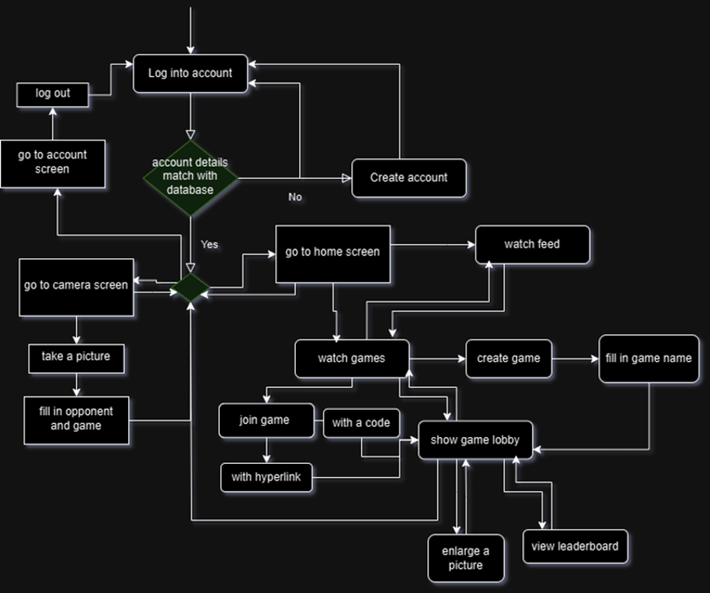
Photo 1: Design Overview

System Architecture
To clearly give an overview of the system architecture of our high-fi prototype we made a sequence diagram. In our high-fi prototype, there are 3 components involved: The user, the React native expo and the database. In the sequence diagram below we show a couple of important interactions between the components of the high-fi prototype.
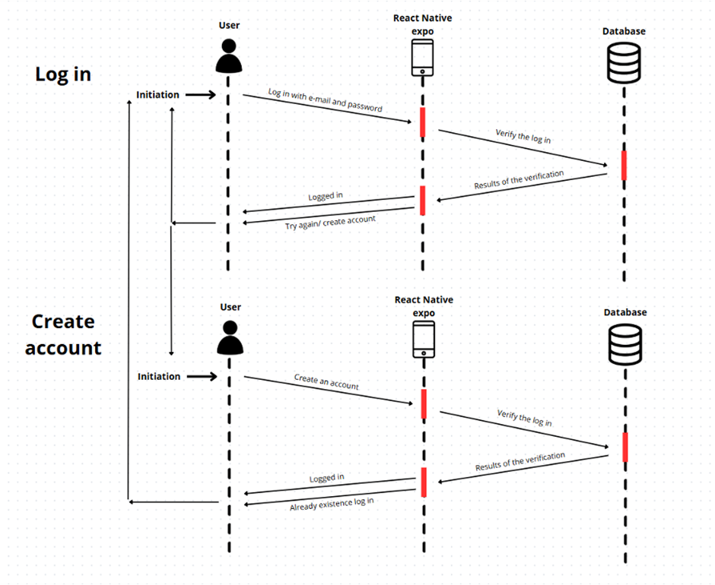
Photo 2: Create an account/log-in interaction between the components
In the sequence diagram for creating an account/login, it becomes clear that the login credentials always need to be checked and saved in the database before returning to the users.
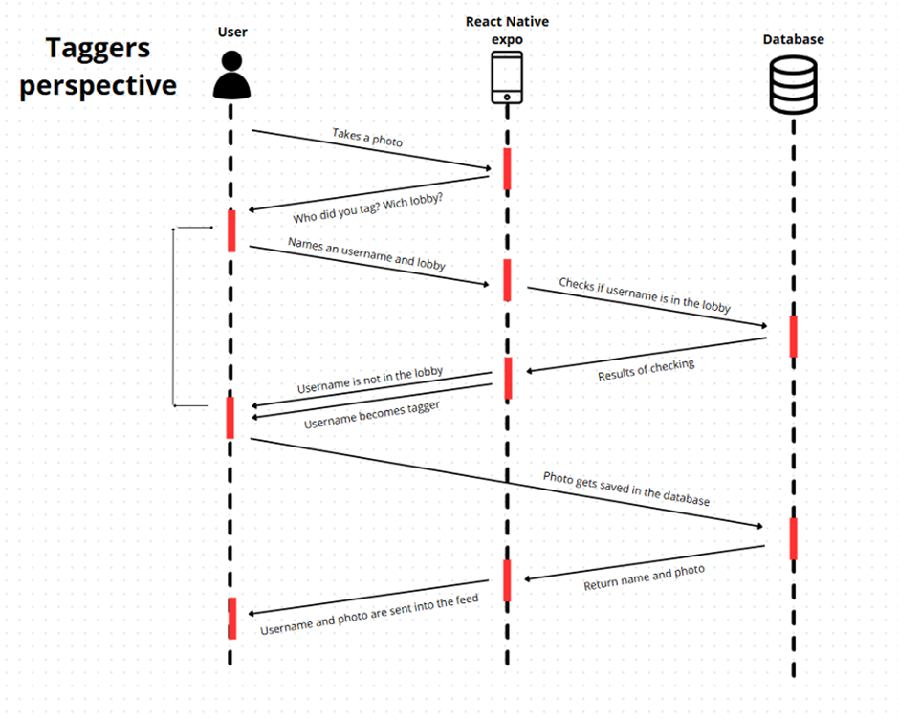
Photo 3: Interaction between components if you want to tag someone
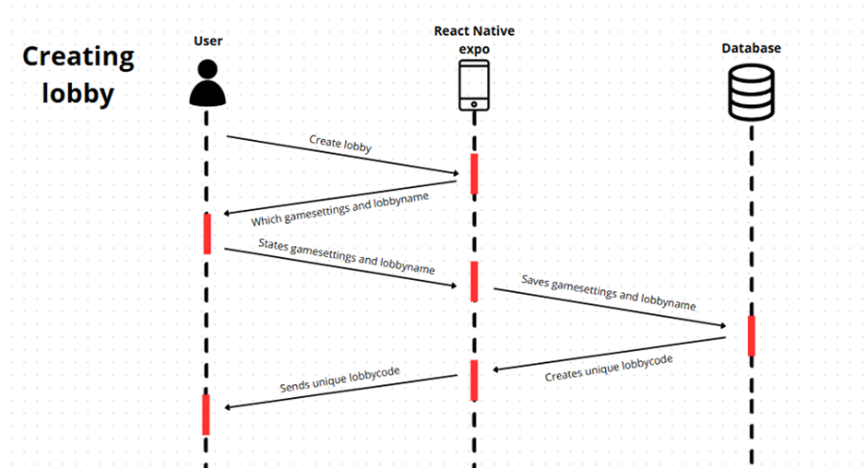
Photo 4: Interaction between components when creating a lobby

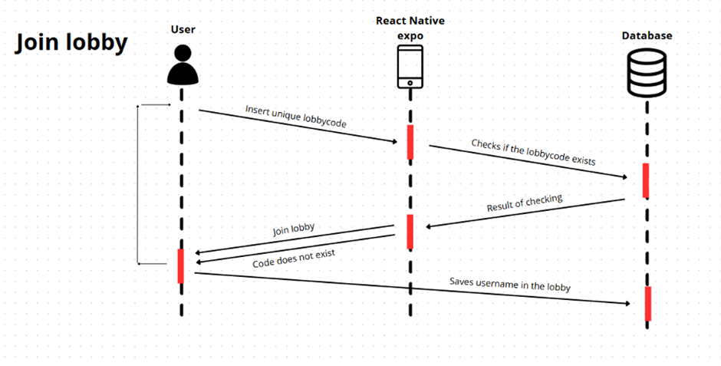Photo 5: Interaction between components when joining a lobby
These are just a couple of important interactions between the components of our high-fi prototype. In these examples, the architecture of our sample is clearly shown and most of the other interactions are almost the same.

Design decisions and rationale
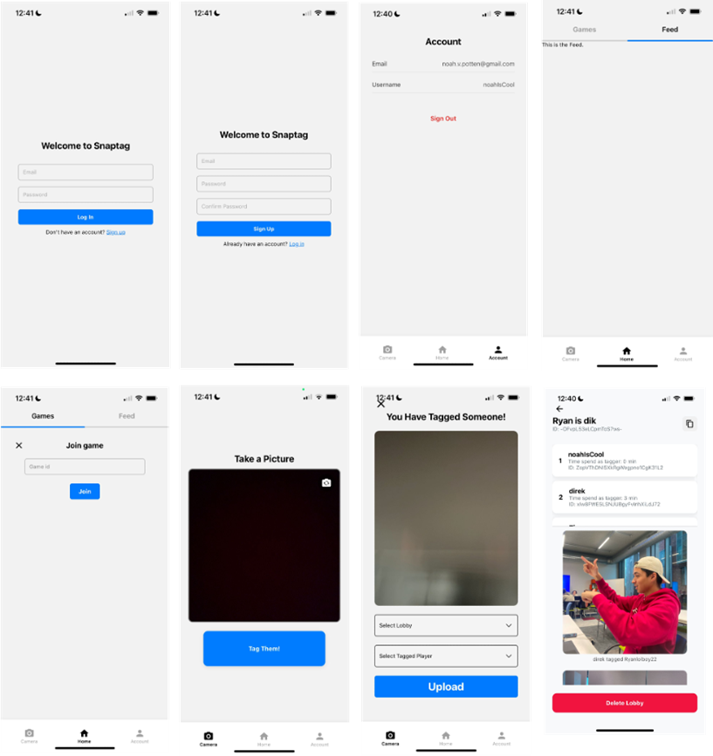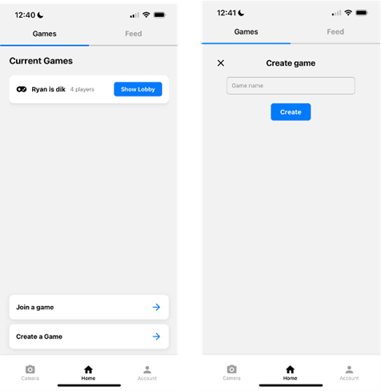
Photo 6: Interface of the app. From left to right top to bottom: Login page, making an account page, account page, feed, join a game page, tag page, select the new tagger page, game lobby page, an overview of games page, create game page.

Colouring
Our colouring choices for the Hi-Fi Prototype were influenced by the Human-Computer Interaction (HCI) principles outlined in Chapter 2.3. A key consideration was ensuring that the app appealed to young adults without making it feel childish or "cringe." We wanted to avoid a typical "game-like" appearance since young adults might perceive it as immature. Instead of using bright, playful colours, we used a minimalistic approach.
We have chosen a very light grey background because we think this aligns with the minimalist design principle which is one of the design principles of Jakob Nielsen. With the white background, we also wanted to resemble other topics, such as simplicity, clarity, accessibility and contrast. White backgrounds are commonly used in app design because they create a clean, uncluttered interface, allowing users to focus on the content or functionality without distraction (Chapman, The Role of Color in UX, n.d.)
For the buttons, we chose to go with bold colours, similar to the white background this keeps it accessible and a good contrast.
Blue often leads to action but is not as aggressive as red. This makes sure the app keeps a calm aesthetic look. We chose to keep this blue consistently in the design, so people will associate SnapTag with that specific colour blue, this colour is also in our logo (Chapman, Color Theory for Designers, Part 1: The Meaning of Color, 2021).
With the colour blue, we also decided to indicate whether you are in the games part of home or in the feed part. This is indicated with a blue line below the word.
The colour red is not used that much as a button, but just for a few buttons to either delete a game or to log out, because buttons like these take caution before pressing, thus with red making sure they stand out and don’t get mistaken for other buttons (FIgma, n.d.)
Game lobby
With the game lobby, we chose to put the leaderboard at the top, emphasising the importance of the game effect and encouraging the users to rise in the leaderboard. Below are the tagged photos, you can view all these by swiping, with the most recent at the top. We wanted the people to see all the pictures taken to be able to enjoy the memories of the game played so far.
Log in screen
For this interface, we decided to indicate clearly what to fill in wherewith the light grey lettering in the input fields. The design itself is a standard login screen because this is what people are familiar with.
Symbols
At the bottom of the interface, we chose to be very clear and use both the words of the pages (camera, home and account) and the symbols. When the page is not selected the word and symbol turn into a light grey to symbolize it faded away. Next to a black symbol it clearly indicates on what page the user is currently on.
Logo
For the logo, we used the same blue as used in the app with a white stickman taking a picture which resembles the tagging of someone.

Photo 7: SnapTag logo

Ethical considerations
In the high-fi prototype are some ethical considerations added, due to some questions asked by the participants during the testing.
First, as was seen in the sequence diagram, the photos are added to the database. All the photos added to the database will be immediately deleted when the game ends.
All the login credentials are also saved in the database but are secured through a firebase.

Chapter 5: Evaluation – Experimental Research Study

5.1 Evaluation Plans

The Goal of the Research Experiment
Assess User Experience:
The experiment aims to determine whether playing SnapTag leads to higher user satisfaction. The focus is on evaluating whether the app delivers a visually and functionally engaging experience that meets user expectations and preferences for modern mobile gaming.
Evaluate Social Engagement:
Investigate whether SnapTag encourages an increase in social activity while using the app. This includes examining whether technological features foster social interaction and meaningful connections among users.
Measure Physical Activity Increase:
The experiment seeks to examine whether regular participation in SnapTag encourages users to increase their physical activity by prompting them to leave the house more frequently. Given the limitations of experimental duration, the focus will be on activity changes within gameplay sessions rather than sustained long-term impacts, which cannot be reliably measured within the scope of the experiment.

Research Questions
- Increase in Activity Over Time: Does playing SnapTag encourage physical activity during the test period?
- Social Engagement: Does using SnapTag encourage an increase in social interactions among participants?
- User Experience/User Satisfaction: How does using SnapTag impact user satisfaction compared to other mobile applications?

Hypotheses
- User Experience:
H₁: Users will report “high” satisfaction while using SnapTag compared to other mobile applications.
H₀: Users will report “low” satisfaction while using SnapTag compared to other mobile applications.
- Social Engagement:
H₁: SnapTag will lead to an increase in social interactions among participants.
H₀: SnapTag will not significantly impact social interactions among participants.
- Increase in Activity Over Time:
H₁: SnapTag will significantly impact users' physical activity levels within gameplay sessions.
H₀: SnapTag will not significantly impact users' physical activity levels within gameplay sessions.
Procedure
- Participants will be introduced and they will play SnapTag for a day.
- The session of SnapTag will follow the gameplay rules, including location tracking, and win/lose conditions. The game’s design will ensure varied gameplay experiences by adjusting certain factors like location restrictions, frequency of location sharing, and player interactions.
- Post-session surveys will be administered to capture subjective user feedback on enjoyment, engagement, and satisfaction with the game
recruitment and selection of participants:
A small group of friends (friends of the designers and the designers themselves), consisting of 6 people between the ages of 18-24. The rationale for this sample size is due to the pilot nature of the study. However, the limitation in sample size may impact the generalizability of the findings.

Methods
Interaction Protocol
Participants will follow a structured protocol throughout the evaluation:
- Gameplay Instructions: Participants will receive detailed instructions on how to download, install, and play SnapTag, including how the game mechanics work and safety guidelines for playing.
- Gameplay Sessions: Participants will play SnapTag for a day, engaging in gameplay sessions at their convenience, while we collect data on activity levels and engagement
- Post-Study Survey: After the gameplay period, participants will fill out a survey capturing their satisfaction, enjoyment, engagement, and perceived physical activity changes.
Compared Conditions
Participants' baseline behaviour before playing SnapTag will be compared to their behaviour during the week of gameplay. However, due to the constraints of self-reporting and limited tracking capabilities, a direct comparison may be influenced by socially desirable answers. A more robust tracking mechanism is recommended for future studies.

Constructs and Measurement Instruments
- User Experience: Measured using the post-study survey, which incorporates Likert scale questions and open-ended responses. The survey design is based on the questionnaire provided (see appendix) and includes the following:
  - Visual appeal
  - Enjoyment of features
  - Ease of navigation
  - Overall satisfaction
- Social Engagement: Measured through:
  - Self-Reported Logs: Participants document instances of social interaction during app usage.
  - Qualitative Feedback: Open-ended survey questions capturing perceived social engagement.
- Increase in Activity: Measured through:
  - Self-Reported Logs: Participants track how many times they leave the house daily.
  - Passive Data Collection: Session frequency and movement data from the app, if available.
  - Pre- and Post-Study Comparisons: Analysis of self-reported activity levels.

Potential Validity Concerns
- Social Desirability Bias: Participants may overstate activity levels in self-reports. To mitigate this, passive data collection from the app is recommended.
- Questionnaire Selection: The chosen survey provides reliable questions for assessing user experience; however, open-ended questions may be subjective.
- Sample Size: A small participant pool may limit the generalizability of findings. Expanding the study to include a larger, more diverse sample is advisable for future research.
By incorporating user feedback and refining measurement instruments, the evaluation will provide valuable insights into SnapTag's potential to engage users and encourage physical activity.

Analysis Plan
- Visual Design Analysis:
  - Responses to the app's visual appeal, modernity, and clean aesthetic will be analyzed to identify key design elements contributing to satisfaction.
- Feature Usability Analysis:
  - Analysis of tagging features, ease of navigation, and error correction will provide insights into usability improvements.
- Engagement and Interaction:
  - Data on whether users were motivated to search for and connect with friends will be correlated with overall app satisfaction.
- Open-Ended Insights:
  - Thematic analysis will categorize qualitative responses about user expectations, challenges, and suggestions for the app's improvement.

5.2 User Study

Pilot Study
Before conducting the full user study, a pilot study was performed with 6 participants from the target audience to evaluate the experimental setup for SnapTag. The pilot study aimed to identify any issues in the study design, user instructions, and data collection methods. (the data collection for frequency of physical activity was not checked due to the time it takes to conduct that study).

Findings from the Pilot Study:
- Participants found the instructions we told them for installing and using the app sometimes unclear.
- Data collection for qualitative analysis is clear.
Adjustments Made:
- Revised the installation guide and provide clearer instructions.

User Study
Data Collection & Analysis
The participants rated various aspects of the app on a scale from 0 (Strongly Disagree) to 10 (Strongly Agree), and their qualitative feedback was also considered.

User Experience (UX) Assessment
Question | Average Score (0-10)
The app’s design and appearance are visually appealing. | 7.5 (6,7,8,7,8,9)
I enjoyed using the photo-tagging feature. | 7.8 (7,8,8,7,8,9)
The app feels modern and engaging. | 7.6 (6,7,7,8,8,9)
The app has a clean aesthetic. | 7.9 (7,8,8,7,8,9)
The app meets my expectations for a photo-tagging game. | 7.4 (6,7,7,7,8,8)
I would recommend this app to a friend or colleague. | 7.7 (7,8,8,7,7,9)
Table 1, Results of User Experience Assessment
Key Insights:
- Participants found the interface visually appealing, but some suggested improvements in design consistency.
- The photo-tagging feature was well-received, though some users found it slightly cumbersome at times.
- A majority of participants stated they would recommend the app, but some noted areas for refinement.

Usability Evaluation
Question | Average Score (0-10)
Tagging people in a photo is easy and intuitive. | 7.6 (6,7,8,7,8,9)
The navigation in the app is simple and straightforward. | 7.8 (7,8,8,7,8,9)
The tagging process feels fast and seamless. | 7.5 (6,7,8,7,7,9)
It was easy to correct mistakes made during tagging. | 7.2 (6,7,7,7,8,8)
I didn’t encounter any difficulties or errors while using the app. | 7.3 (6,7,7,7,8,8)
The app provides sufficient guidance or help when needed. | 7.0 (6,7,7,6,7,8)
Table 2, Results of Usability Evaluation
Key Insights:
- Navigation and usability received positive feedback
- Some participants struggled with correcting tagging mistakes and suggested a more user-friendly undo option.
- The help and guidance features were deemed adequate but could be expanded for greater clarity.

Social Engagement & Physical Activity Impact
Question | Average Score (0-10)
The app motivated me to search for and connect with my friends. | 7.5 (7,8,8,7,7,9)
Using the app helped me interact with my friends more frequently than usual. | 7.2 (6,7,7,7,8,8)
It was always clear to me when I was the person tagging in the app. | 9,3 (9,9,8,10,10,10)
I noticed that I moved around more when I used the app. | 7.3 (6,7,7,7,8,8)
Table 3, Results of Social Engagement & Physical Activity Impact
Key Insights:
- Participants experienced an increase in social interactions, including chatting about the app, planning meetups, and sharing photos on social media. While the increase wasn’t dramatically higher than usual, it showed a positive shift.
- Physical activity levels showed a moderate improvement, with users generally appreciating the app’s ability to motivate movement, although some suggested it could offer more motivation to boost activity.
- The social aspect of the app was well-received, with users eager to connect, but there’s potential to increase engagement further with added incentives.

Conclusion & Feasibility of the Hi-Fi Prototype:
The results indicate that the SnapTag hi-fi prototype holds strong promise, with users enjoying social connections and the encouragement for physical activity. There is ample opportunity to enhance engagement and usability further for an even greater impact. With that none of the hypotheses can be rejected or totally exempted.
Key Takeaways:
- User satisfaction is largely positive, with users expressing appreciation for the app’s concept and functionality.
- Social engagement and physical activity showed promising improvements, with some room for enhancing motivation and interactivity.
- The app is well-positioned to continue growing, with a solid foundation for future success and further versions.
Recommendations for Future Development:
- Refine the tagging and undo features to streamline usability and enhance user experience.
- Introduce more interactive social and movement-based challenges to inspire even greater user activity and interaction.
Overall: SnapTag is on the right track, offering strong potential for user engagement and fitness improvement. With some thoughtful refinements, it can become an even more compelling and seamless experience, driving greater participation and enjoyment.

Chapter 6: Discussion:

Summary of the Project and Main Outcomes
The final Hi-Fi prototype of SnapTag is a mobile app available through the EXPO Go app, that enables users to play a digital version of tag with friends and other players. The app integrates core features such as location tracking, leaderboards, and a photo-based tagging system that updates on a social feed. Additional functionalities, including account creation, game management, and a centralized dashboard.
Initially, the prototype aimed to incorporate facial recognition, but due to technical challenges, inaccuracy, and potential user frustration, this feature was removed. Instead, SnapTag relies on player integrity to maintain fairness, as the game is designed primarily for social enjoyment among friends.
The development of the Hi-Fi prototype was informed by user testing conducted on a Lo-Fi prototype, which consisted of a WhatsApp-based manual version of the game. Early testing revealed that user control over certain game settings, such as duration and playing field size, was crucial for engagement. Other features, including winning conditions, location-sharing frequency, and reward distribution, were predefined to balance gameplay goals with user needs. The finalized game mechanics ensure a fair experience where players compete to spend the least amount of time as the tagger, while the top three players receive rewards.
Although testing confirmed the functionality and satisfaction of the app, further usability testing with first-time users is necessary to assess the overall effectiveness of the app referring to the increased movement and increased social interaction.

Achieved Global Aims
The primary goal of this project is to reduce sedentary behaviour by encouraging adolescents to engage in physical activity through an interactive and enjoyable game. By merging emerging technologies with the simplicity of a childhood game, SnapTag aims to foster habitual movement and social interaction.
While the Hi-Fi prototype has been successfully developed, long-term effects on physical activity remain uncertain, as extensive testing over time is required to measure behavioural change. However, short-term testing conducted with participants has demonstrated increased engagement and moderate improvements in activity levels, indicating promise for future impact.
Answer to the main research question: “How can the combination of technologies such as facial recognition, location tracking, and smartphones be used to get individuals and/or friend groups of adolescents to live a less sedentary lifestyle by moving around more?”
Through the development and testing of SnapTag, we found that location tracking, leaderboards, and social incentives effectively encourage movement and social interactions. However, facial recognition was deemed impractical due to accuracy issues and potential privacy concerns. Instead, a photo-based tagging system was implemented, allowing users to engage in an interactive and fair gameplay experience.
Although short-term results indicate increased activity, long-term adoption and sustained lifestyle changes require further research. The combination of mobile accessibility, competitive features, and social connectivity shows strong potential to reduce sedentary behaviour.
Answers to the sub-research questions:
How do adolescent (friend) groups interact with each other online compared to in person?
Online interactions provide convenience and accessibility but often reduce face-to-face engagement. SnapTag bridges this gap by leveraging social media elements while encouraging real-world activity, fostering both digital and in-person interactions.
How can products be designed and marketed to achieve social engagement?
Based on literature and user testing, elements such as gamification, competitive leaderboards, and social sharing drive engagement. Viral marketing strategies, such as influencer promotion and exclusivity-based pre-launch campaigns, can enhance adoption and retention.
What factors contribute to a smooth, secure, and enjoyable experience for adolescents in trying a new app?
Key factors include a user-friendly interface, clear onboarding instructions, fast performance, and strong privacy measures. Ensuring minimal friction in sign-up and game setup significantly improves user retention.

Implications
SnapTag contributes to the growing field of exergames—interactive games designed to promote physical activity. It aligns with successful predecessors like Pokémon GO and Jachtseizoen, both of which have demonstrated how technology can encourage users to move more. The app has the potential to integrate seamlessly into everyday life, providing an engaging alternative to traditional forms of exercise and reinforcing active habits through social engagement.
Despite these positive indicators, privacy concerns—particularly regarding location tracking—must be carefully managed, as seen in related applications. Ensuring data security and user trust will be essential for widespread adoption.

Recommendations for Improvement and Future Work
- Long-Term Studies: Conduct extended research to assess SnapTag’s effectiveness in sustaining physical activity and behavioural change over time.
- Customizable Game Modes: the introduction of new variations and settings to attract a wider audience and maintain long-term engagement.
- Scalability Enhancements: Improve system architecture to support larger player bases without performance issues.
- Accuracy Improvements: Enhance location tracking precision to minimize frustration and ensure a smoother gameplay experience.
- User Onboarding Enhancements: Expand tutorials and guidance to facilitate a seamless first-time experience.
- Social and Movement-Based Challenges: Implement additional incentives, such as team-based challenges or achievement rewards, to further drive participation.
- Border on playing ground: implement a customizable border for the playing ground with recommendations if the users want to play an “active” or “passive” game mode.

Limitations
Despite its potential, SnapTag in its current state has several limitations:
- Scalability Issues: The current system cannot support large numbers of concurrent players.
- Facial Recognition Constraints: This feature was removed due to technical and user experience challenges.
- Limited Game Modes: The current version supports only one gameplay format, which may restrict long-term appeal.
- Short-Term Testing Scope: The study lacks a scientifically controlled evaluation over an extended period, limiting insights into long-term user engagement.
- No playing ground border: We still want to achieve this but was not reachable in this period of time.
While these limitations exist, future iterations of SnapTag can address them through improved technology, expanded gameplay options, and further research.

Conclusion
SnapTag demonstrates strong potential to promote physical activity among adolescents by leveraging location tracking, gamification, and social engagement. Initial testing indicates that the app is enjoyable and moderately effective in encouraging movement. However, refinements are necessary to enhance usability, security, and scalability.
By addressing identified limitations and incorporating additional engagement strategies, SnapTag could evolve into a widely adopted platform that fosters long-term behavioural change.
With further development, this app has the potential to become a lasting tool for promoting active lifestyles in an increasingly digital world.

Extra Discussion (own flaws)
Research Question
Our project research questions initially were insufficient; thus, we had to change them later on in the project itself. We changed them to what we actually tested. When following the normal structure of researching, this way of working is not correct, but due to the severity, we had to.
Low-Fi Testing
During Low-Fi testing we wanted to test outside our researcher group, but due to lack of time, we were not able to get all the participants together.

References
Binghamton University. (2024, February 20). Generating 'buzz' about new products can influence their success. Retrieved from ScienceDaily: https://www.sciencedaily.com/releases/2024/02/240220144500.htm?utm_source=chatgpt.com
Chapman, C. (2021, May 20). Color Theory for Designers, Part 1: The Meaning of Color. Retrieved from Smashing Magazine: https://www.smashingmagazine.com/2010/01/color-theory-for-designers-part-1-the-meaning-of-color/#:~:text=In%20design%2C%20the%20exact%20shade,strength%20and%20reliability%20are%20important
Chapman, C. (n.d.). The Role of Color in UX. Retrieved from Toptal Designers: https://www.toptal.com/designers/ux/color-in-ux#:~:text=White%20%E2%80%94%20White%20is%20tied%20to,other%20colors%20it's%20used%20with
FIgma. (n.d.). Red. Retrieved from Figma: https://www.figma.com/colors/red/
Jung Ha Park, J. H. (2020, November 19). Sedentary Lifestyle: Overview of Updated Evidence of Potential Health Risks. Retrieved from PMC PubMed Central: https://pmc.ncbi.nlm.nih.gov/articles/PMC7700832/#b4-kjfm-20-0165
MacKenzie, S. (2012). Human-Computer Interaction: An Empirical Research Perspective. Philadelphia USA: Taylor & Francis, Inc.
Nicholas A. Christakis, J. H. (2011, September 24). Social Contagion Theory: Examining Dynamic Social Networks and Human Behavior. Retrieved from Cornell University: https://arxiv.org/abs/1109.5235
Rajeshwari, S. (2023, January 21). The age of doom scrolling – Social media's attractive addiction. Retrieved from Journal of Education and Health Promotion: https://journals.lww.com/jehp/fulltext/2023/01310/the_age_of_doom_scrolling___social_media_s.21.aspx
Stewart, C. (2023, July 5). Share of the population classed as overweight in the Netherlands in 2023. Retrieved from Statista: https://www.statista.com/statistics/544060/share-of-the-population-with-overweight-in-the-netherlands/#:~:text=Share%20of%20the%20population%20overweight%20in%20the%20Netherlands%202023&text=In%202023%2C%20over%2035%20percent,a%20BMI%20greater%20than%2030
Warburton, D. E. (2006, March 14). Health benefits of physical activity: the evidence. Retrieved from CMAJ: https://www.cmaj.ca/content/174/6/801.short
World Health Organization. (2024, March 1). One in eight people are now living with obesity. Retrieved from World Health Organization: https://www.who.int/news/item/01-03-2024-one-in-eight-people-are-now-living-with-obesity#:~:text=New%20study%20released%20by%20the,to%2019%20years%20of%20age
Yvette Chong, D. K. (2018, October 11). Going Forward with Pokemon Go. Retrieved from PMC PubMed Central: https://pmc.ncbi.nlm.nih.gov/articles/PMC6262652/#:~:text=A%20study%2C%20using%20physical%20activity,steps%20for%20light%20and%20heavy
Grammarly and ChatGPT were used for grammar, spelling and structure.

Appendix

Interviews
of chapter 2.4.
This includes the questions and the answers to two of five interviews as they gave the most opposite insights. The other three were very similar to these two and did not give a new insight into our research.
Interview 1:
- Background information of interviewee
  - How old are you? 17
  - How do you identify yourself? male he/him
  - Do you find yourself more introverted or extroverted? introvert
  - How often do you play games, and what types (i.e. video, card)?
daily, all kinds, RPG’s farming, sim, Fortnite online
- And do physical activities mostly alone or together with a friend group?
  - How often does your friend group do any physical activity together?
Never sport with friends, speak to each other daily online
- How often do you engage in physical activity (i.e. a walk or sports)?
Sometimes a late-night walk, and riding the bike to school
  - How many hours of free time do you have?
5hours on average on a school night
- How do adolescent (friend)groups interact with each other online compared to in person?
  - Do you feel more comfortable expressing yourself online or in person and why?
online, alone in a room, nobody is watching you.
But does not post on social media
  - How do you typically meet new people or make friends?
not, school or work
  - Can you describe how you and your friends usually communicate online (e.g., apps, frequency, types of conversations)?
Discord, and Fortnite during gaming in a call.
WhatsApp is used for school
Instagram: send funny reels to each other and react with a like or an emoji, to show you saw it
Snapchat: sometimes to talk/chat, sometimes on picture a day for streaks or just because other people do it. I think that people are not on their phones when they do interesting stuff
  - Do you feel that online interactions strengthen or weaken your in-person friendships? Why?
Strengthen, because you spend more time with each other and talk about other stuff in physical
  - What features of online platforms help you feel connected to your friends even when you’re not meeting in person?
A camera so you can see each other's faces.
- What are the most successful methods to artificially create a socially accepted product for adolescents?
  - Do you often use viral products, services and /or life hacks you find on social media, how do you learn about these products, services and /or life hacks?
nope, social media in shorts and reels on the for you page not from friends.
  - What makes you want to try a new app or game? (e.g., recommendations, hype, rewards, ads)
If it belongs to my interests or if it looks cool. When I see it a lot online. If a friend advises me to download
  - What role do influencers or social media platforms play in getting you to try out new products?
only gamers influence my game-purchasing habits.
  - What makes a product or app popular among you and your friends?
if it is cheap and we can do it together
  - Can you name a recent product or app that became a trend in your group? Why do you think it became so popular?
Gartic phone: a free app similar to Pictionary, because it was free and gave funny stories and we could do it together
scribble.io
  - Let's say you see friends playing tag outside in the park.
    - What would you think about these people?
looks fun, but I wouldn’t join them, because of stranger danger.
    - What do you think they would feel?
They are enjoying their selves because they play it together
    - What would prevent you from participating?
already answered

- What are the mechanisms to motivate adolescents to move around?
  - How often do online conversations lead to doing physical activities together (e.g., sports, walks)?
a while ago a friend was home alone so we visited him, this was because we were on a call together.
  - Have you played Pokemon GO? (yes → i, no → ii) NO, because I was too young
    - What did you like or dislike about it?
like: people go outside and it builds a community
dislike: people were not paying attention to their surroundings
    - What would make you excited or unexcited about trying a game that involves moving around outside?
if it is easy to play when outside.
  - What activities or events motivate you to get up and move around during your free time? And why?
if I sit down too long or am tired of studying, I get bored and walking around is a great way to avoid studying and I don't feel guilty
  - How do online rewards, like points or badges, influence your willingness to participate in physical activities?
with running I don’t care, because I think the points when running are not the initial motivation, but with Pokemon Go, I make progress in a game and it's fun.
    - What role does competition play in motivating you to be active?
I wanna win!
  - Do you find physical activity more enjoyable when you’re doing it alone or with friends? Why?
sport with friends, but walking on my own, I can listen to music without it being weird af
  - Do you have barriers that stop you from being more active? If so, what are they?
Time, the chance at having to talk to someone, have to go all the way outside.
- What are ethical and other considerations needed for using functions on smartphones (facial recognition and location tracking)?
  - If a game used facial recognition to spot other players or other players spot you, would you find that fun or weird? Why?
looks fun to me I don't care about what happens with my face or data.
    - And with location tracking?
if it is logical and necessary, then I don’t mind, but if my camera app wants to know my location that is sussy baka among us.
  - What concerns do you have about your privacy when using facial recognition features?
none
    - What would make you trust an app that uses facial recognition?
if it's logical
    - What about location tracking (for both b and b,i)?
same
  - How important is it to have control over how your data is shared or stored in apps?
not very important, my data is probably already on the internet
  - How do you feel about parental involvement in approving apps that use these features?
Important that young kids have help with the internet, but the protection also means that they are less likely to learn the lesson
_________________________________________________________________________________
Interview 2:
- Background information of interviewee
  - How old are you? 19
  - How do you identify yourself? Woman She/Her
  - Do you find yourself more introverted or extroverted? extrovert
  - How often do you play games, and what types (i.e. video, card)?
I never play games except chess maybe
- And do physical activities mostly alone or together with a friend group?
  - How often does your friend group do any physical activity together?
Never really, speak to each other daily online
- How often do you engage in physical activity (i.e. a walk or sports)?
Sometimes walking with the dog
  - How many hours of free time do you have?
3 hours on average on a school night
- How do adolescent (friend)groups interact with each other online compared to in person?
  - Do you feel more comfortable expressing yourself online or in person and why?
I don’t really have a preference because I do both in the same way
  - How do you typically meet new people or make friends?
not, school, work or via friends
  - Can you describe how you and your friends usually communicate online (e.g., apps, frequency, types of conversations)?
WhatsApp is used for school projects etc
Instagram: send reels to each other
Snapchat: all my texting is via Snapchat, send I send videos and memos as well and seeing them makes me feel good
  - Do you feel that online interactions strengthen or weaken your in-person friendships? Why?
Strengthen, because you keep your bond by staying connected
  - What features of online platforms help you feel connected to your friends even when you’re not meeting in person?
photos so you can see each other

- What are the most successful methods to artificially create a socially accepted product for adolescents?
  - Do you often use viral products, services and /or life hacks you find on social media, how do you learn about these products, services and /or life hacks?
no, but sometimes apps like BeReal come across which everyone does so I also see what that is. So yeah u saw that everywhere on social media so u also saw all your friends do it
  - What makes you want to try a new app or game? (e.g., recommendations, hype, rewards, ads)
The hype I guess, if everyone has it and does something with it.
  - What role do influencers or social media platforms play in getting you to try out new products?
they don’t play a big role for me
  - What makes a product or app popular among you and your friends?
needs to be free and we can do it together
  - Can you name a recent product or app that became a trend in your group? Why do you think it became so popular?
definitely BeReal but nothing else really.
  - Let's say you see friends playing tag outside in the park.
    - What would you think about these people?
looks like they have fun so I would just be neutral I guess.
    - What do you think they would feel?
They enjoy themselves probably idk.
    - What would prevent you from participating?
I'm not really going to join strangers
- What are the mechanisms to motivate adolescents to move around?
  - How often do online conversations lead to doing physical activities together (e.g., sports, walks)?
well not really activities for exercise, maybe shopping so that is walking?
  - Have you played Pokemon GO? (yes → i, no → ii) No, I don’t really play games
    - What did you like or dislike about it?
like: it was I guess nice for the people that they could walk and play games
dislike: I dunno
    - What would make you excited or unexcited about trying a game that involves moving around outside?
if it is a bit competitive
  - What activities or events motivate you to get up and move around during your free time? And why?
I actually wouldn’t know, I just sometimes go the gym but that’s it, it's like I just need to
  - How do online rewards, like points or badges, influence your willingness to participate in physical activities?
well, if there is money I would definitely join aha
    - What role does competition play in motivating you to be active?
I would like to end on top so yeah it plays a big role. Bing better than even my friends would probably be something fun to strive for
  - Do you find physical activity more enjoyable when you’re doing it alone or with friends? Why?
I guess with friends because it is nice that you could spend some time with them
  - Do you have barriers that stop you from being more active? If so, what are they?
Yes, motivation, time and mostly I don’t have the energy after a long day of school
- What are ethical and other considerations needed for using functions on smartphones (facial recognition and location tracking)?
  - If a game used facial recognition to spot other players or other players spot you, would you find that fun or weird? Why?
It is fine, I use my camera also now for other apps but it would be weird if it was a stranger
    - And with location tracking?
well, if it is necessary but yeah I probably would want it to t track me the whole time
  - What concerns do you have about your privacy when using facial recognition features?
I don’t want it to be shared with random people
    - What would make you trust an app that uses facial recognition?
only if it was part of the app
    - What about location tracking (for both b and b, i)?
same….
  - How important is it to have control over how your data is shared or stored in apps?
a bit important, I don’t want to get spammed in my email for example because it was leaked or something but really my data is probably already out there so if someone wanted to find out who I was they already have my whole life there
  - How do you feel about parental involvement in approving apps that use these features?
Yeah valid, underaged kids so yeah

Brainstorm:
These are the ideas from the brainstorming sessions that we conducted.
Ideas for young people, gamers, GenZ:
- tikkertje maar groot met een app (jachtseizoen) (Bankzitters tikkertje)
- Smart Rope Jumping
- Piano tiles in t real life (trap)
- Capture the flag
- Scoreboard street football
Ideas for office people:
- Aggressive ball to throw and pick up again with a timer
- Office competition for fitness
- real Real-life Tinder (sideman)
Ideas for all people:
- gambling (rocket, chicken, mines, blackjack, roulette, multiplier, steps for coins, and then use those coins, custom skins)
Brainstorm 50 ideas:
- Photo Tag: Players "tag" each other using facial recognition.
- Outdoor Hide and Seek: Using AR you can find clues to find your friends.
- Among Us: A popular game among us but you can play it with AR on your phone.
- Smile Points: Earn points by taking pictures of friends smiling outdoors.
- Capture the Flag: "Capture the Flag" is a mobile game.
- Stratego: The game strategy in real life.
- Building Bingo: Find buildings with specific traits in certain cities (promotional for NS)
- Street Detective: Solve mysteries by identifying and photographing "suspects." and “crime scenes” in certain locations.
- Expression Scavenger Hunt: Collect photos of various facial expressions from strangers (with consent). (bad idea (ethics))
- Nature Pairing: Match facial expressions to landmarks or natural features.
- Adventure Roulette: The app assigns random outdoor activities.
- Outdoor Puzzles: Solve location-based puzzles.
- Park Explorer: Gain rewards for finding others playing in designated parks.
- Outdoor Dodgeface: Avoid being photographed outdoors by hiding.
- Graffiti painter: Paint fake online graffiti on buildings and make it look nice.
- RL cluedo: solve a murder on the streets
- living strategy: battle each outside with an app
- side-quest: gain random side-quest to complete
- Trail Tracker: Explore trails while capturing happy outdoor moments
- Face History Hunt: Match famous figures' facial features to outdoor statues.
- Scavenger hunt: Find clues and go to the next locations
- Drawing map: walk and draw on a map and then people can guess what you're drawing.
- AR football: shoot the ball at places
- Smart Football: App that tracks stats and includes mini-games.
- Smart Jumping Rope: automatic modes and rims
- Animal Spotter: collect all animals.
- Time Travel Treasure Hunt: Explore historical sites to uncover AR-based "artefacts" and learn about history.
- Parkour Challenge: Navigate a real-world parkour course with AR obstacles and rewards.
- Virtual Garden Builder: Collect seeds and plants by visiting specific outdoor locations and building a virtual garden.
- Eco Explorer: Complete environmental tasks like identifying plants, picking up trash, or logging clean-up efforts.
- Mystery Maze: Solve puzzles in AR mazes that appear in real-world parks or city squares.
- Invisible Soccer: Play a soccer game where the ball only exists in AR.
- Battle Royale IRL: A real-world tag game where players eliminate each other using AR “powers.”
- Treasure Dig: Find and "dig up" AR treasures hidden in sandy or grassy areas.
- Ghost Tracker: Solve mysteries by following "shadowy figures" that appear only in AR.
- Portal Runner: Enter AR portals that lead to challenges based on their real-world location.
- Giant Hunter: Track down and capture AR giants roaming the city.
- Sky Puzzle: Solve AR puzzles projected onto the sky above specific landmarks or locations.
- Productive Break: A fitness app offering quick challenges like squats or stretches with a leaderboard for your team.
- Coffee Quest: Use AR clues to find the best coffee-making spot in the office.
- Flash Mob: Receive challenges to perform spontaneous activities in groups at designated locations.
- Roulette Walk: Every X steps, spin an AR roulette wheel to earn rewards or challenges.
- Minesweeper: A real-world take on Minesweeper, using your surroundings as the game board.
- Rocket Gamble: Bet virtual coins on AR rockets, chickens, or similar quirky "races."
- Step Coins: Earn virtual coins by walking, which you can gamble or trade for custom skins.
- Interactive Memory Lane: Leave AR messages or objects at specific spots for others to find and interact with.
- Break Timer Challenge: A daily app challenge to perform quick brain teasers or physical activities during breaks.
- Invisible Art: Discover hidden online AR art installations in cities or nature by using your phone.

Low-Fi Testing Pictures
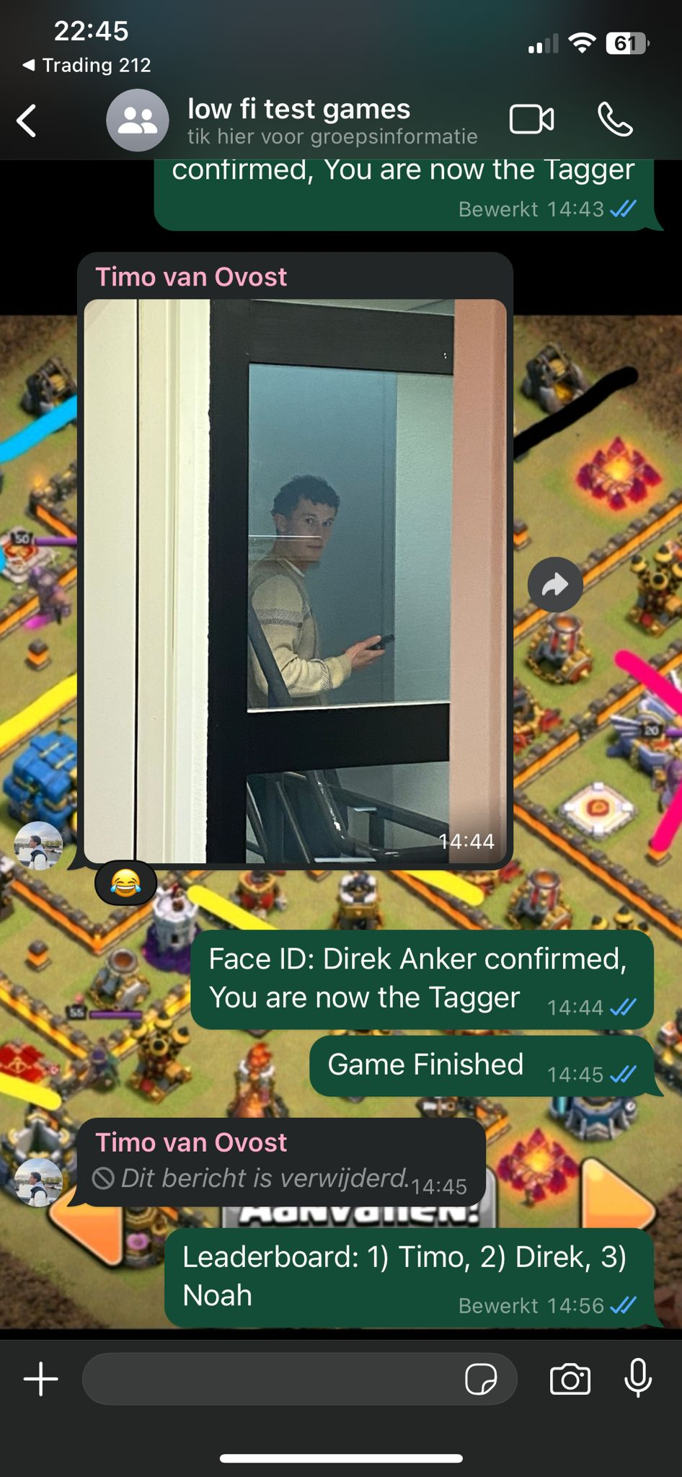
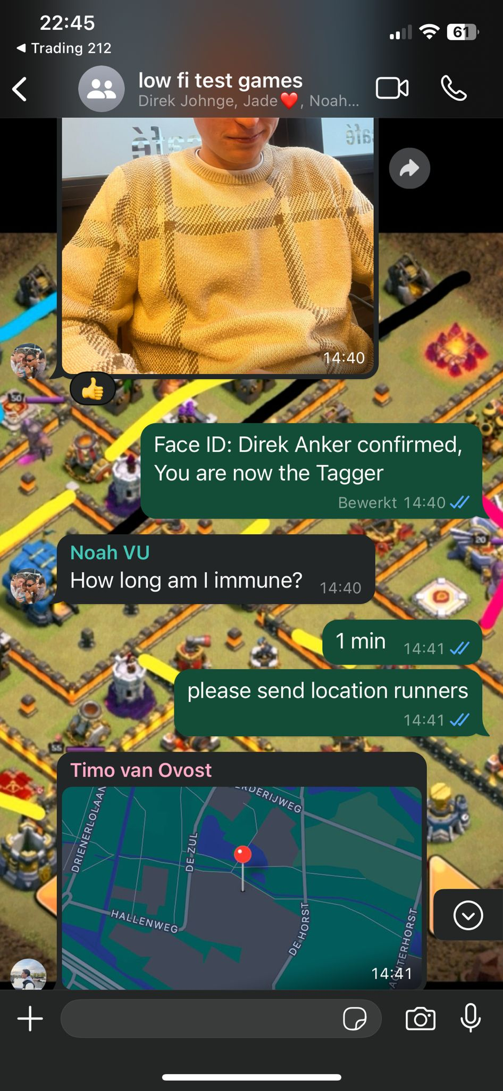
Photos, Mechanics 3 game 2, Testing the frequency location sharing.

