What is Proof of Stake
Proof of stake is a consensus algorithm for public blockchains which is intended to serve as an alternative to proof of work. Proof of work is the mechanism that underpins the security behind Bitcoin, the current version of Ethereum and many other blockchains, however it has been criticized for environmental damage and electricity cost associated with the "mining" process because of the environmentally unfriendly energy sources that some mining operations use. Bitcoin's proof of work has been calculated to consume electricity comparable to Ireland's electricity consumption. Proof of stake attempts to resolve these issues by removing the concept of "mining" entirely, and replacing it with a different mechanism.
The mechanism in proof of stake can be described as a form of "virtual mining". Whereas proof of work relies on computer hardware as the primary form of scarcity to prevent Sybil attacks, proof of stake relies on coins inside of the blockchain itself. In proof of work, a user might take $1000, use it to buy a mining computer, plug it in and start participating in the network and producing blocks and getting rewards, in proof of stake, one could take $1000, convert it into $1000 worth of coins, then deposit the coins into the proof of stake mechanism, which would (pseudo-)randomly assign the owner the right to produce blocks and get rewards. Much like in proof of work, where spending $2000 would get you a miner that is twice as powerful and hence can produce blocks and receive rewards twice as often, in proof of stake a deposit that is twice as large is twice as likely to be assigned the right to produce a block in a given round.
In general, a proof of stake algorithm looks as follows. There exists some set of coin holders that place their coins into a proof of stake mechanism and thereby become validators. Given a particular blockchain "head" (ie. the latest block in a blockchain), the algorithm randomly selects one of these validators (the randomness being weighted by deposit size, so a validator with 10000 coins has 10x the chance of a validator with 1000 coins) and assigns to them the right to create the next block. If that validator does not create a block within some period of time, then a secondary validator is selected that can create the block instead. Just like in proof of work, the "longest chain" is considered to be the canonical one.
Note that there are many deviations from this model. In earlier Peercoin-style algorithms, a different validator was assigned block creation rights every second. Sometimes, there is no explicit mechanism for "becoming a validator"; every coin holder is a potential validator, though if a coin holder is offline or uninterested in validating then they may well "skip their turn". In some algorithms, there is no notion of validator selection; instead, a traditional Byzantine-fault-tolerant consensus algorithm is used to get all validators to agree on the next block. The seed for the pseudorandom algorithm that chooses the next validator can also be chosen in different ways. However, the principle of using coins, deposited or otherwise, as a substitute for miners is invariably there.

What are the benefits?
In short:
- No need to consume large quantities of electricity in order to secure a blockchain.
- Because of the lack of high electricity consumption, there is not as much need to issue as many new coins in order to motivate participants to keep participating in the network. It may theoretically even be possible to have negative net issuance, where a portion of transaction fees is "burned" and so the supply goes down over time.
- Possibly reduced vulnerability to selfish-mining attacks through "co-operative game theory", though proof of work can also do this to some extent.
- Reduced centralization risks, as economies of scale are much less of an issue. $10 million of coins will get you exactly 10 times higher returns than $1 million of coins, without any additional disproportionate gains because at the higher level you can afford better mass-production equipment.
- Ability to use economic penalties to make various forms of 51% attacks vastly more expensive to carry out than proof of work - to paraphrase Vlad Zamfir, "it's as though your ASIC farm burned down if you participated in a 51% attack".

How does proof of stake fit into traditional Byzantine fault tolerance research?
There are several fundamental results from Byzantine fault tolerance research that apply to all consensus algorithms, including traditional consensus algorithms like PBFT but also any proof of stake algorithm and even, contrary to popular opinion, to some extent proof of work.
The key results include:
- CAP theorem - "in the cases that a network partition takes place, you have to choose either consistency or availability, you cannot have both". The intuitive argument is simple: if the network splits in half, and in one half I send a transaction "send my 10 coins to A" and in the other I send a transaction "send my 10 coins to B", then either the system is unavailable, as one or both transactions will not be processed, or it becomes inconsistent, as one half of the network will see the first transaction completed and the other half will see the second transaction completed.
- FLP impossibility - in an asynchronous setting (ie. there are no guaranteed bounds on network latency even between correctly functioning nodes), it is not possible to create an algorithm which is guaranteed to reach consensus in any specific finite amount of time if even a single faulty/dishonest node is present. Note that this does NOT rule out "Las Vegas" algorithms that have some probability each round of achieving consensus and thus will achieve consensus within T second with probability exponentially approaching 1 as T grows; this is in fact the "escape hatch" that many successful consensus algorithms use.
- Bounds on fault tolerance - from the DLS paper we have: (i) protocols running in a partially synchronous network model (ie. there is a bound on network latency but we do not know ahead of time what it is) can tolerate up to 1/3 arbitrary (ie. "Byzantine") faults, (ii) deterministic protocols in an asynchronous model (ie. no bounds on network latency) cannot tolerate faults (although their paper fails to mention that randomized algorithms can with up to 1/3 fault tolerance, (iii) protocols in a synchronous model (ie. network latency is guaranteed to be less than a known d) can, surprisingly, tolerate up to 100% fault tolerance, although there are restrictions on what can happen when more than or equal to 1/2 of nodes are faulty. Note that the "authenticated Byzantine" model is the one worth considering, not the "Byzantine" one; the "authenticated" part essentially means that we can use public key cryptography in our algorithms, which is in modern times very well-researched and very cheap.
Proof of work has been rigorously analyzed by Andrew Miller and others and fits into the picture as an algorithm reliant on a synchronous network model. Bitcoin, for example, has 50% fault tolerance assuming zero network latency, ~49.5% fault tolerance under actually observed conditions, but goes down to 33% if network latency is equal to the block time, and reduces to zero as network latency approaches infinity. We often do not realize this because the Bitcoin block time is so long (10 minutes) and even with Ethereum's 14-second block time fault tolerance is still around 46%, but no fundamental violation of established Byzantine fault tolerance theory is made. It is worth noting that proof of work does not have a concept of there being N nodes, with the network being able to tolerate up to 0.495 * N faults; different nodes may have different computing power, however, abstractions have been made that map computing power onto a Byzantine-fault-tolerance-theoretic framework.
Proof of stake consensus is more clearly a Byzantine fault tolerant consensus problem; just like proof of work, most algorithms achieve up to 50% fault tolerance by relying on a synchronous network model. There has also been some research, particularly inside the Tendermint project in making a consensus algorithm that relies on either the partially synchronous or asynchronous network models. Both proof of work and some proof of stake choose availability over consistency, although Casper's finality mechanism and Tendermint choose consistency
Note that Ittay Eyal and Emin Gun Sirer's selfish mining discovery, which places 25% and 33% bounds on the incentive compatibility of Bitcoin mining depending on the network model (ie. mining is only incentive compatible if collusions larger than 25% or 33% are impossible) has NOTHING to do with results from traditional consensus algorithm research, which does not touch incentive compatibility.

What is the "nothing at stake" problem and how can it be fixed?
In many early proof of stake algorithms, including Peercoin, there are only rewards for producing blocks, and no penalties. This has the unfortunate consequence that, in the case that there are multiple competing chain, it is in a validator's incentive to try to make blocks on top of every chain at once, just to be sure:
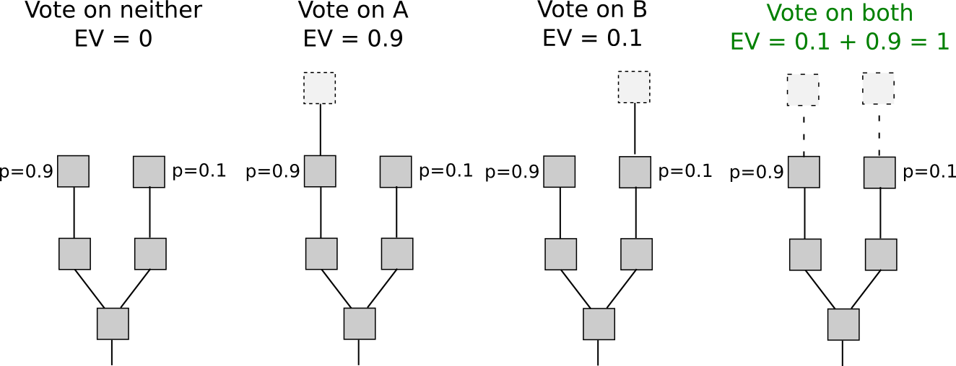
In proof of work, doing so would require splitting one's computing power in half, and so would not be lucrative:
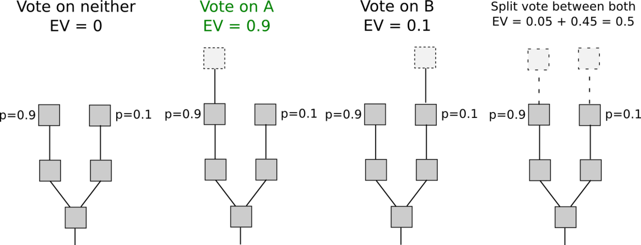
The result is that if all actors are narrowly economically rational, then even if there are no attackers, a blockchain may never reach consensus. If there is an attacker, then the attacker need only overpower altruistic nodes (who would exclusively stake on the original chain), and not rational nodes (who would stake on both the original chain and the attacker's chain), in contrast to proof of work, where the attacker must overpower both altruists and rational nodes (or at least credibly threaten to: see P + epsilon attacks). Some argue that stakeholders have an incentive to act correctly and only stake on the longest chain in order to "preserve the value of their investment", however this ignores that this incentive suffers from tragedy of the commons problems: each individual stakeholder might only have a 1% chance of being "pivotal" (ie. being in a situation where if they participate in an attack then it succeeds and if they do not participate it fails), and so the bribe needed to convince them personally to join an attack would be only 1% of the size of their deposit; hence, the required combined bribe would be only 0.5-1% of the total sum of all deposits. Additionally, this argument implies that any zero-chance-of-failure situation is not a stable equilibrium, as if the chance of failure is zero then everyone has a 0% chance of being pivotal.
This can be solved via two strategies. The first, described in broad terms under the name "Slasher"here and developed further by Iddo Bentov here, involves penalizing validators if they simultaneously create blocks on multiple chains, by means of including proof of misbehavior (ie. two conflicting signed block headers) into the blockchain as a later point in time at which point the malfeasant validator's deposit is deducted appropriately. This changes the incentive structure thus:
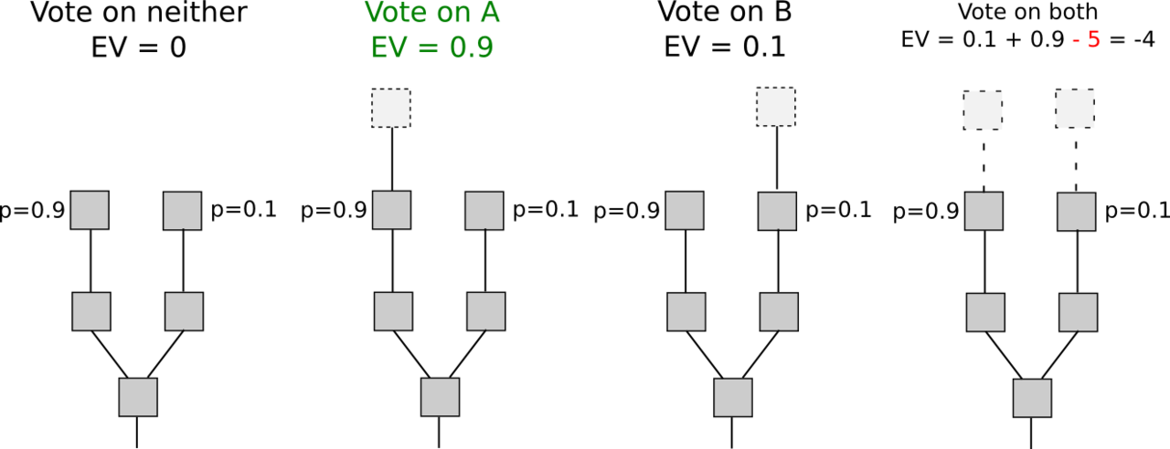
Note that for this algorithm to work, the validator set needs to be determined well ahead of time. Otherwise, if a validator has 1% of the stake, then if there are two branches A and B then 0.99% of the time the validator will be eligible to stake only on A and not on B, 0.99% of the time the validator will be eligible to stake on B and not on A, and only 0.01% of the time will the validator will be eligible to stake on both. Hence, the validator can with 99% efficiency probabilistically double-stake: stake on A if possible, stake on B if possible, and only if the choice between both is open stake on the longer chain. This can only be avoided if the validator selection is the same for every block on both branches, which requires the validators to be selected at a time before the fork takes place (in these algorithms it is assumed that forks will not last longer than a few hours; this is often achieved through a "revert limit" that simply forbids nodes from accepting long-range forks, for more on this see the section on weak subjectivity below). This has its own flaws, including opening up medium-range validator collusion risks (ie. situations where, for example, 25 out of 30 consecutive validators get together and agree ahead of time to implement a 51% attack on the previous 19 blocks), but if these risks are deemed acceptable then it works well.
The second strategy is to simply punish validators for creating blocks on the wrong chain. That is, if there are two competing chains, A and B, then if a validator creates a block on B, they get a reward of +R on B, but the block header can be included into A (in Casper this is called a "dunkle") and on A the validator suffers a penalty of -F (possibly F = R). This changes the economic calculation thus:
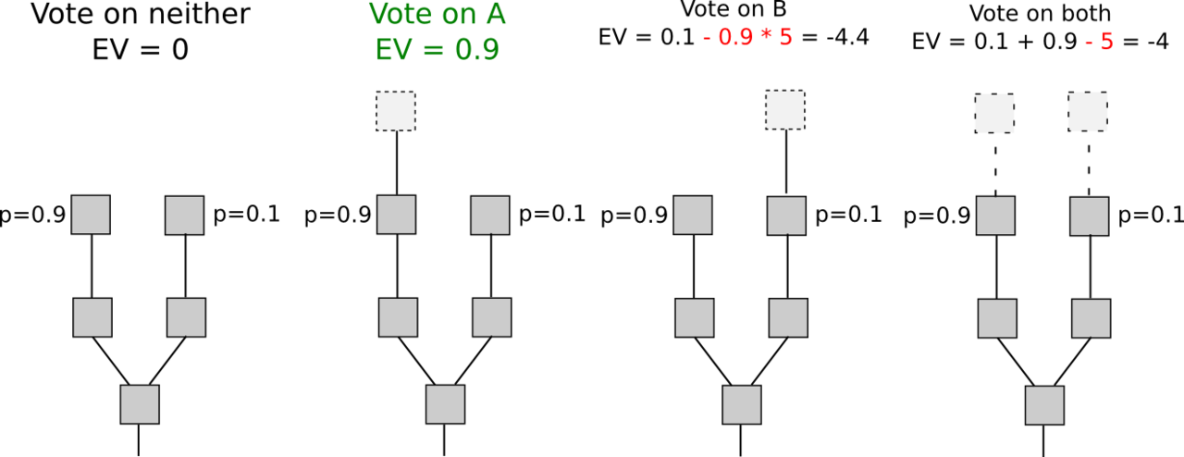
The intuition here is that we can replicate the economics of proof of work inside of proof of stake. In proof of work, there is also a penalty for creating a block on the wrong chain, but this penalty is implicit in the external environment: miners have to spend extra electricity and obtain or rent extra hardware. Here, we simply make the penalties explicit. This mechanism has the disadvantage that it imposes slightly more risk on validators (although the effect should be smoothed out over time), but has the advantage that it does not require validators to be known ahead of time.

What is "weak subjectivity"?
It is important to note that the mechanism of using deposits to ensure there is "something at stake" does lead to one change in the security model. Suppose that deposits are locked for 1 month, and can later be withdrawn. Suppose that an attempted 51% attack happens that reverts 10 days worth of transactions. The blocks created by the attackers can simply be imported into the main chain as proof-of-malfeasance (or "dunkles") and the validators can be punished. However, suppose that such an attack happens after 40 days. Then, even though the blocks can certainly be re-imported, by that time the malfeasant validators will be able to withdraw their deposits on the main chain, and so they cannot be punished. To solve this problem, a "revert limit", ie. a rule by which nodes simply refuse to revert further back than the deposit length, is required. This now means that nodes have two additional requirements:
- When they sync the chain for the first time, they must authenticate the latest state out of band. They can do this by checking with their friends, block explorers, etc. Note that if there node only finds one chain, then it knows that that one chain is correct; it is only in the case that two chains that diverge further than the revert limit exist that such social authentication is required.
- Nodes must log on at least once every revert limit. If they do not, another round of social authentication may be required.
Note that this social authentication is in fact extremely limited in scope; in order for it to actually become an attack vector, an attacker would have to create a very large portion of the community that the chain that they created is legitimate when it in fact is not, and even then the attacker would only convince newly connecting nodes. Newly connecting nodes may well simply receive a recent checkpoint as part of the software; an attacker that can corrupt the checkpoint in the software can arguably just as easily corrupt the software itself, and no amount of pure cryptoeconomic verification can solve that problem. Once a node is connected, as long as it logs in frequently enough it can remain connected to the blockchain under a purely cryptoeconomic security model with no additional social authentication required.
Additionally, the social authentication can if needed even be automated in several ways. One is to bake it into natural user workflow: a BIP 70-style payment request could include a recent block hash, and the user's client software would make sure that they are on the same chain as the vendor before approving a payment (or for that matter, any on-chain interaction). The other is to use Jeff Coleman's universal hash time. If UHT is used, then a successful attack chain would need to be generated secretly at the same time as the legitimate chain was being built, requiring a majority of validators to secretly collude for that long.

What is "economic finality"?
Economic finality is a mechanism for preventing medium-range blockchain forks, which works by having validators place claims on blocks of the form "I agree to lose Y in all histories where block B is not included in exchange for gaining X in all histories where block B is included". Once validators are sufficiently sure of a block, they will be willing to place very high values for Y, going all the way up to the size of their entire deposits. Once a block has reached a state where a very large portion of validators have bet their entire deposits for it, that block is considered "economically finalized". This ensures that even majority collusions cannot implement 51% attacks to revert transactions except at an extremely high cost to themselves.

Can one economically penalize censorship in proof of stake?
Unlike reverts, censorship is much more difficult to prove. The blockchain itself cannot directly tell the difference between "user A tried to send transaction X but it was unfairly censored", "user A tried to send transaction X but it never got in because the transaction fee was insufficient" and "user A never tried to send transaction X at all". However, there are a number of techniques that can be used to mitigate censorship issues.
The first is censorship resistance by halting problem. In the weaker version of this scheme, the protocol is designed to be Turing-complete in such a way that a validator cannot even tell whether or not a given transaction will lead to an undesired action without spending a large amount of processing power executing the transaction, and thus opening itself up to denial-of-service attacks. This is what prevented the DAO soft fork.
In the stronger version of the scheme, transactions can trigger guaranteed effects at some point in the near to mid-term future. Hence, a user could send multiple transactions which interact with each other and with predicted third-party information to lead to some future event, but the validators cannot possibly tell that this is going to happen until the transactions are already included (and economically finalized) and it is far too late to stop them; even if all future transactions are excluded, the event that validators wish to halt would still take place. Note that in this scheme, validators could still try to prevent all transactions, or perhaps all transactions that do not come packaged with some formal proof that they do not lead to anything undesired, but this would entail forbidding a very wide class of transactions to the point of essentially breaking the entire system, which would cause validators to lose value as the price of the cryptocurrency in which their deposits are denominated would drop.
The second, described by Adam Back here, is to require transactions to be timelock-encrypted. Hence, validators will include the transactions without knowing the contents, and only later could the contents automatically be revealed, by which point once again it would be far too late to un-include the transactions. If validators were sufficiently malicious, however, they could simply only agree to include transactions that come with a cryptographic proof (eg. ZK-SNARK) of what the decrypted version is; this would force users to download new client software, but an adversary could conveniently provide such client software for easy download, and in a game-theoretic model users would have the incentive to play along.
Perhaps the best that can be said in a proof-of-stake context is that users could also install a software update that includes a hard fork that deletes the malicious validators and this is not that much harder than installing a software update to make their transactions "censorship-friendly". Hence, all in all this scheme is also moderately effective, though it does come at the cost of slowing interaction with the blockchain down (note that the scheme must be mandatory to be effective; otherwise malicious validators could much more easily simply filter encrypted transactions without filtering the quicker unencrypted transactions).
A third alternative is to include censorship detection in the fork choice rule. The idea is simple. Nodes watch the network for transactions, and if they see a transaction that has a sufficiently high fee for a sufficient amount of time, then they assign a lower "score" to blockchains that do not include this transaction. If all nodes follow this strategy, then eventually a minority chain would automatically coalesce that includes the transactions, and all honest online nodes would follow it. The main weakness of such a scheme is that offline nodes would still follow the majority branch, and if the censorship is temporary and they log back on after the censorship ends then they would end up on a different branch from online nodes. Hence, this scheme should be viewed more as a tool to facilitate automated emergency coordination on a hard fork than something that would play an active role in day-to-day fork choice.

How does validator selection work, and what is stake grinding?
In any chain-based proof of stake algorithm, there is a need for some mechanism which randomly selects which validator out of the currently active validator set can make the next block. For example, if the currently active validator set consists of Alice with 40 ether, Bob with 30 ether, Charlie with 20 ether and David with 10 ether, then you want there to be a 40% chance that Alice will be the next block creator, 30% chance that Bob will be, etc (in practice, you want to randomly select not just one validator, but rather an infinite sequence of validators, so that if Alice doesn't show up there is someone who can replace her after some time, but this doesn't change the fundamental problem). In non-chain-based algorithms randomness is also often needed for different reasons.
"Stake grinding" is a class of attack where a validator performs some computation or takes some other step to try to bias the randomness in their own favor. For example:
- In Peercoin, a validator could "grind" through many combinations of parameters and find favorable parameters that would increase the probability of their coins generating a valid block.
- In one now-defunct implementation, the randomness for block N+1 was dependent on the signature of block N. This allowed a validator to repeatedly produce new signatures until they found one that allowed them to get the next block, thereby seizing control of the system forever.
- In NXT, the randomness for block N+1 is dependent on the validator that creates block N. This allows a validator to manipulate the randomness by simply skipping an opportunity to create a block. This carries an opportunity cost equal to the block reward, but sometimes the new random seed would give the validator an above-average number of blocks over the next few dozen blocks. See here for a more detailed analysis.
(1) and (2) are easy to solve; the general approach is to require validators to deposit their coins well in advance, and not to use information that can be easily manipulated as source data for the randomness. There are several main strategies for solving problems like (3). The first is to use schemes based on secret sharing or deterministic threshold signatures and have validators collaboratively generate the random value. These schemes are robust against all manipulation unless a majority of validators collude (in some cases though, depending on the implementation, between 33-50% of validators can interfere in the operation, leading to the protocol having a 67% liveness assumption).
The second is to use cryptoeconomic schemes where validators commit to information (ie. publishsha3(x)) well in advance, and then must publish x in the block; x is then added into the randomness pool. There are two theoretical attack vectors against this:
- Manipulate x at commitment time. This is impractical because the randomness result would take many actors' values into account, and if even one of them is honest then the output will be a uniform distribution. A uniform distribution XORed together with arbitrarily many arbitrarily biased distributions still gives a uniform distribution.
- Selectively avoid publishing blocks. However, this attack costs one block reward of opportunity cost, and because the scheme prevents anyone from seeing any future validators except for the next, it almost never provides more than one block reward worth of revenue. The only exception is the case where, if a validator skips, the next validator in line AND the first child of that validator will both be the same validator; if these situations are a grave concern then we can punish skipping further via an explicit skipping penalty.
The third is to use Iddo Bentov's "majority beacon", which generates a random number by taking the bit-majority of the previous N random numbers generated through some other beacon (ie. the first bit of the result is 1 if the majority of the first bits in the source numbers is 1 and otherwise it's 0, the second bit of the result is 1 if the majority of the second bits in the source numbers is 1 and otherwise it's 0, etc). This gives a cost-of-exploitation of ~C * sqrt(N) where C is the cost of exploitation of the underlying beacons. Hence, all in all, many known solutions to stake grinding exist; the problem is more like differential cryptanalysis than the halting problem - an annoyance that proof of stake designers eventually understood and now know how to overcome, not a fundamental and inescapable flaw.

Doesn't MC => MR mean that all consensus algorithms with a given security level are equally efficient (or in other words, equally wasteful)?
This is an argument that many have raised, perhaps best explained by Paul Sztorc in this article. Essentially, if you create a way for people to earn $100, then people will be willing to spend anywhere up to $99.9 (including the cost of their own labor) in order to get it; marginal cost approaches marginal revenue. Hence, the theory goes, any algorithm with a given block reward will be equally "wasteful" in terms of the quantity of socially unproductive activity that is carried out in order to try to get the reward.
There are three flaws with this:
- It's not enough to simply say that marginal cost approaches marginal revenue; one must also posit a plausible mechanism by which someone can actually expend that cost. For example, if tomorrow I announce that every day from then on I will give $100 to a randomly selected one of a given list of ten people (using my laptop's /dev/urandom as randomness), then there is simply no way for anyone to send $99 to try to get at that randomness. Either they are not in the list of ten, in which case they have no chance no matter what they do, or they are in the list of ten, in which case they don't have any reasonable way to manipulate my randomness so they're stuck with getting the expected-value $10 per day.
- MC => MR does NOT imply total cost approaches total revenue. For example, suppose that there is an algorithm which pseudorandomly selects 1000 validators out of some very large set (each validator getting a reward of $1), you have 10% of the stake so on average you get 100, and at a cost of $1 you can force the randomness to reset (and you can repeat this an unlimited number of times). Due to the central limit theorem, the standard deviation of your reward is $10, and based on other known results in math the expected maximum of N random samples is slightly under M + S * sqrt(2 * log(N)) where M is the mean and S is the standard deviation. Hence the reward for making additional trials (ie. increasing N) drops off sharply, eg. with 0 re-trials your expected reward is $100, with one re-trial it's $105.5, with two it's $108.5, with three it's $110.3, with four it's $111.6, with five it's $112.6 and with six it's $113.5. Hence, after five retrials it stops being worth it. As a result, an economically motivated attacker with ten percent of stake will inefficiently spend $5 to get an additional revenue of $13, though the total revenue is $113. If the exploitable mechanisms only expose small opportunities, the economic loss will be small; it is decidedly NOT the case that a single drop of exploitability brings the entire flood of PoW-level economic waste rushing back in. This point will also be very relevant in our below discussion on capital lockup costs.
- Proof of stake can be secured with much lower total rewards than proof of work.

What about capital lockup costs?
Locking up X ether in a deposit is not free; it entails a sacrifice of optionality for the ether holder. Right now, if I have 1000 ether, I can do whatever I want with it; if I lock it up in a deposit, then it's stuck there for months, and I do not have, for example, the insurance utility of the money being there to pay for sudden unexpected expenses. I also lose some freedom to change my token allocations away from ether within that timeframe; I could simulate selling ether by shorting an amount equivalent to the deposit on an exchange, but this itself carries costs including exchange fees and paying interest. Some might argue: isn't this capital lockup inefficiency really just a highly indirect way of achieving the exact same level of economic inefficiency as exists in proof of work? The answer is no, for both reasons (2) and (3) above.
Let us start with (3) first. Consider a model where proof of stake deposits are infinite-term, ASICs last forever, ASIC technology is fixed (ie. no Moore's law) and electricity costs are zero. Let's say the equilibrium interest rate is 5% per annum. In a proof of work blockchain, I can take $1000, convert it into a miner, and the miner will pay me $50 in rewards per year forever. In a proof of stake blockchain, I would buy $1000 of coins, deposit them (ie. losing them forever), and get $50 in rewards per year forever. So far, the situation looks completely symmetrical (technically, even here, in the proof of stake case my destruction of coins isn't fully socially destructive as it makes others' coins worth more, but we can leave that aside for the moment). The cost of a "Maginot-line" 51% attack (ie. buying up more hardware than the rest of the network) increases by $1000 in both cases.
Now, let's perform the following changes to our model in turn:
- Moore's law exists, ASICs depreciate by 50% every 2.772 years (that's a continuously-compounded 25% per annum; picked to make the numbers simpler). If I want to retain the same "pay once, get money forever" behavior, I can do so: I would put $1000 into a fund, where $167 would go into an ASIC and the remaining $833 would go into investments at 5% interest; the $41.67 dividends per year would be just enough to keep renewing the ASIC hardware (assuming technological development is fully continuous, once again to make the math simpler). Rewards would go down to $8.33 per year; hence, 83.3% of miners will drop out until the system comes back into equilibrium with me earning $50 per year, and so the Maginot-line cost of an attack on PoW given the same rewards drops by a factor of 6.
- Electricity plus maintenance makes up 1/3 of mining costs. We estimate the 1/3 from recent mining statistics: one of Bitfury's new data centers consumes 0.06 joules per gigahash, or 60 J/TH or 0.000017 kWh/TH, and if we assume the entire Bitcoin network has similar efficiencies we get 27.9 kWh per second given 1.67 million TH/s total Bitcoin hashpower. Electricity in China costs $0.11 per kWh, so that's about $3 per second, or $260,000 per day. Bitcoin block rewards plus fees are $600 per BTC * 13 BTC per block * 144 blocks per day = $1.12m per day. Thus electricity itself would make up 23% of costs, and we can back-of-the-envelope estimate maintenance at 10% to give a clean 1/3 ongoing costs, 2/3 fixed costs split. This means that out of your $1000 fund, only $111 would go into the ASIC, $55 would go into paying ongoing costs, and $833 would go into hardware investments; hence the Maginot-line cost of attack is 9x lower than in our original setting.
- Deposits are temporary, not permanent. Sure, if I voluntarily keep staking forever, then this changes nothing. However, I regain some of the optionality that I had before; I could quit within a medium timeframe (say, 4 months) at any time. This means that I would be willing to put more than $1000 of ether in for the $50 per year gain; perhaps in equilibrium it would be something like $3000. Hence, the cost of the Maginot line attack on PoS increases by a factor of three, and so on net PoS gives 27x more security than PoW for the same cost.
The above included a large amount of simplified modeling, however it serves to show how multiple factors stack up heavily in favor of PoS in such a way that PoS gets more bang for its buck in terms of security. The meta-argument for why this perhaps suspiciously multifactorial argument leans so heavily in favor of PoS is simple: in PoW, we are working directly with the laws of physics. In PoS, we are able to design the protocol in such a way that it has the precise properties that we want - in short, we can optimize the laws of physics in our favor. The "hidden trapdoor" that gives us (3) is the change in the security model, specifically the introduction of weak subjectivity.
Now, we can talk about the marginal/total distinction. In the case of capital lockup costs, this is very important. For example, consider a case where you have $100,000 of ether. You probably intend to hold a large portion of it for a long time; hence, locking up even $50,000 of the ether should be nearly free. Locking up $80,000 would be slightly more inconvenient, but $20,000 of breathing room still gives you a large space to maneuver. Locking up $90,000 is more problematic, $99,000 is very problematic, and locking up all $100,000 is absurd, as it means you would not even have a single bit of ether left to pay basic transaction fees. Hence, your marginal costs increase quickly. We can show the difference between this state of affairs and the state of affairs in proof of work as follows:
Hence, the total cost of proof of stake is potentially much lower than the marginal cost of depositing 1 more ETH into the system multiplied by the amount of ether currently deposited.
Note that this component of the argument unfortunately does not fully translate into reduction of the "safe level of issuance". It does help us because it shows that we can get substantial proof of stake participation even if we keep issuance very low; however, it also means that a large portion of the gains will simply be borne by validators as economic surplus.

Will exchanges in proof of stake pose a similar centralization risk to pools in proof of work?
From a centralization perspective, in both Bitcoin and Ethereum it's the case that roughly three pools are needed to coordinate on a 51% attack (4 in Bitcoin, 3 in Ethereum at the time of this writing). In PoS, if we assume 30% participation including all exchanges, then three exchangeswould be enough to make a 51% attack; if participation goes up to 40% then the required number goes up to eight. However, exchanges will not be able to participate with all of their ether; the reason is that they need to accomodate withdrawals.
Additionally, pooling in PoS is discouraged because it has a much higher trust requirement - a proof of stake pool can pretend to be hacked, destroy its participants' deposits and claim a reward for it. On the other hand, the ability to earn interest on one's coins without oneself running a node, even if trust is required, is something that many may find attractive; all in all, the centralization balance is an empirical question for which the answer is unclear until the system is actually running for a substantial period of time. With sharding, we expect pooling incentives to reduce further, as (i) there is even less concern about variance, and (ii) in a sharded model, transaction verification load is proportional to the amount of capital that one puts in, and so there are no direct infrastructure savings from pooling.
A final point is that centralization is less harmful in proof of stake than in proof of work, as there are much cheaper ways to recover from 51% attacks; one does not need to switch to a new mining algorithm.

