# HW06 – Chapter 7 and 8

You need to create an **HTML5** web page and a **CSS** cascading style sheet that displays the following web page. File names are: (1) hw06.html, (2) hw06.css

hw06.html should be saved in the “hw” folder in the root directory of your web server.

Hw06.css should be saved in the “css” folder in “hw” folder.

Here is the instruction of the assignment.

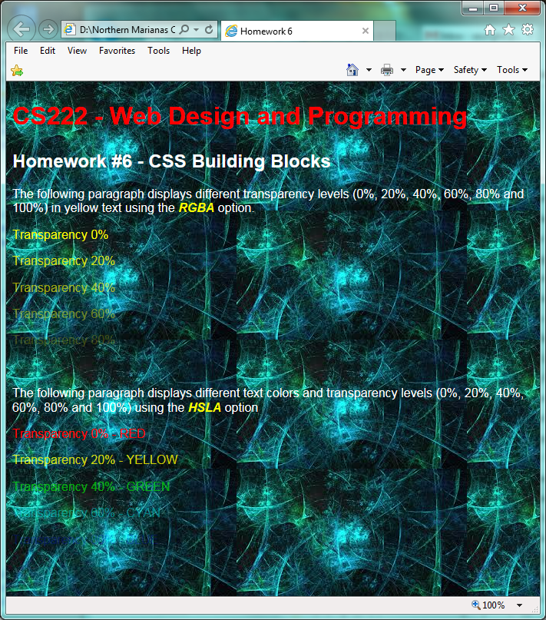

6

5

3

4

3

2

1

10

9

8

Create a CSS file to apply the following settings.

The “head” element in hw06.html file should contain the link element to the css file:

<link rel=”stylesheet” href=”css/hw06.css” />

1. The heading element is h1, but the h1 size is increased to 200%.
2. Apply h2 and white color.
3. The color of “RGBA” and “HSLA” texts should be **yellow**, and others are white  
   Use the “**code**” element for the RGBA and HSLA texts in the hw06.html file, and change the **code** style declaration in the hw06.css file.
4. Use the “**rgba**” style rule to display each text with different transparency level.  
   Each line should have its own id so that you can apply the style to each id.  
   The first line is for 0% transparency level. The second line is for 20% transparency level, and so on.  
   Note that the last line does not display anything because the line is 100% transparent.
5. Use the “**hsla**” style rule to display each text with different transparency level.  
   Each line should have its own id so that you can apply the style to each id.  
   The first line is for 0% transparency level. The second line is for 20% transparency level, and so on.  
   Note that the last line does not display anything because the line is 100% transparent.
6. Include the body style in the CSS file so that the background image “background-02.jpg” is **repeated**.   
   The background image should be stored in the “img” folder.