2707

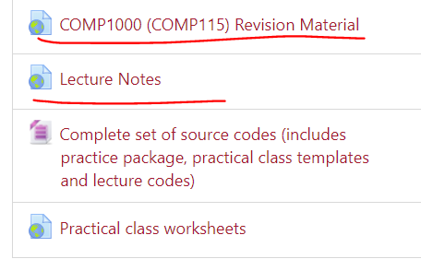

Read COMP1000 revision material. (array is important)

\*\* study revision material and Codecademy!

In the lecture notes  
we are going to study from 14~31

Software to be installed – java SE / eclipase IDE

Need to know before

-variables, conditions, loops

-operate on arrays

-define the functions

Read practical class worksheets as well.

Basic things to know how to do

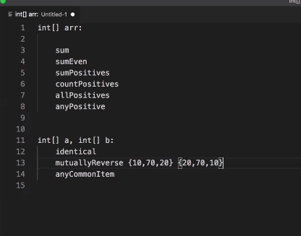

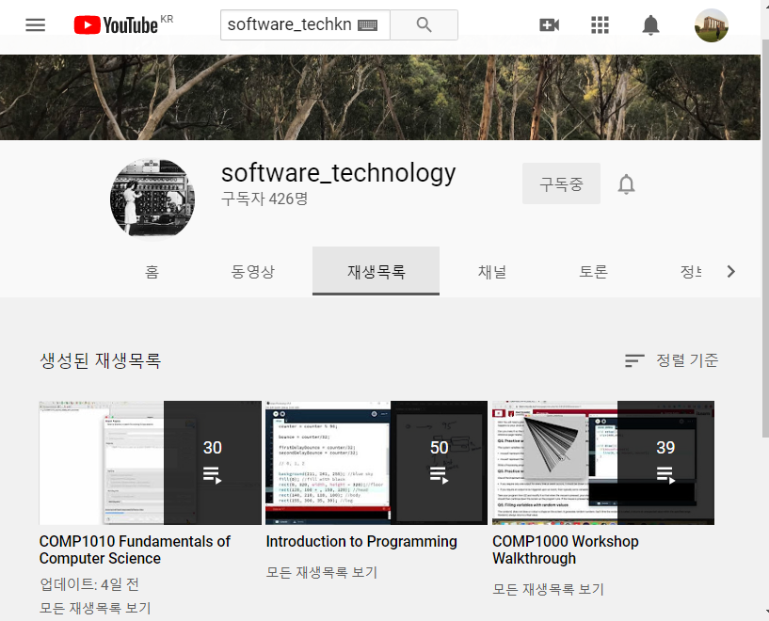

You can see how to install and do the things.

Java SE: https://www.oracle.com/java/technologies/javase-downloads.htmlEclipse IDE: https://www.eclipse.org/downloads/https://www.youtube.com/playlist?list=PL25sMKw559Gg9xlmLVLkmpS5XZJ-pvCd-

-IDE for the java developer

I should download the 2020 new version of the Eclipse

When you download the program then you should download the source codes

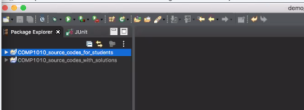

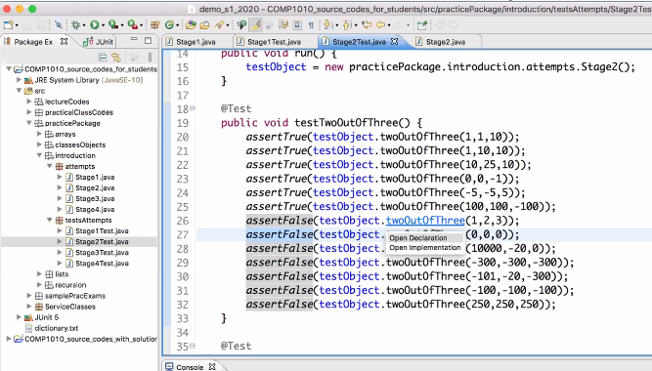

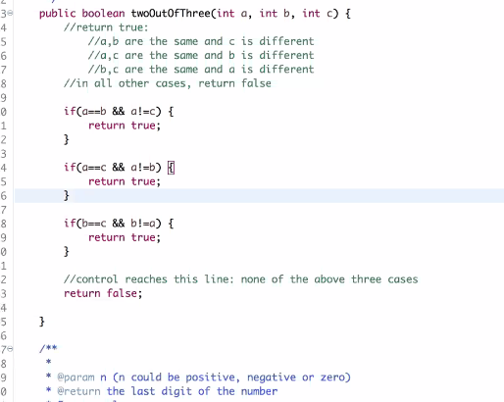

Ctrl+ click the function -> I will bring you to the exact functions

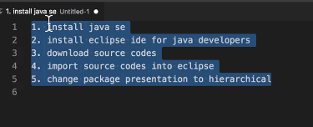

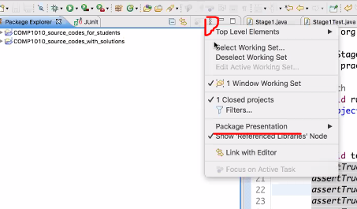

Run these – tutor will make the group for practice discussion

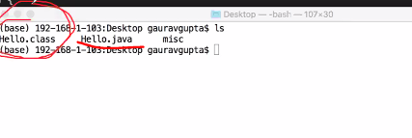

After the javac Hello.java

There will be class file

And do the java Hello ( to use the class file)

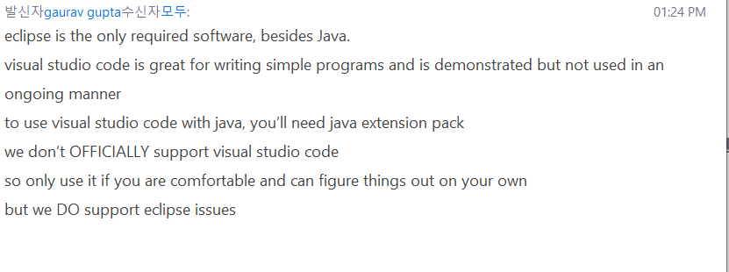

How to make new java file

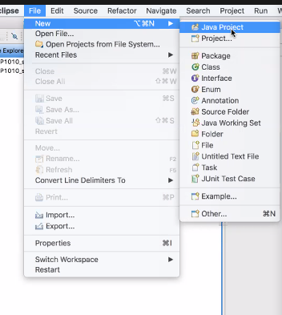

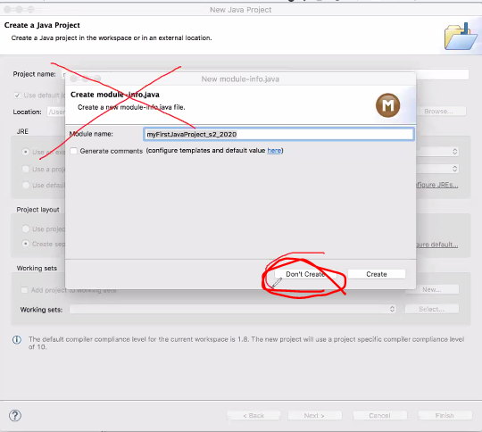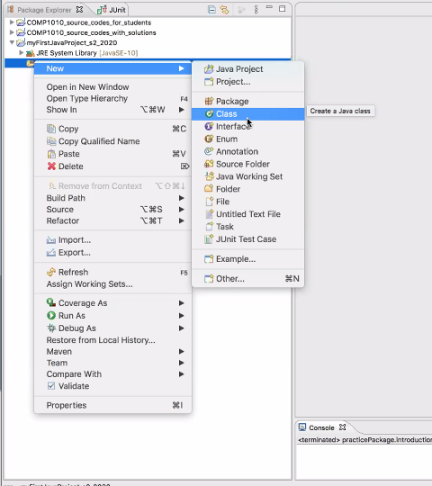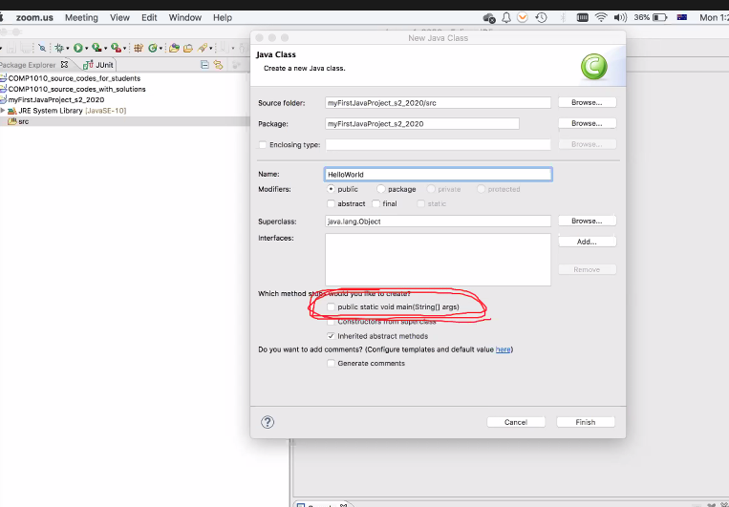

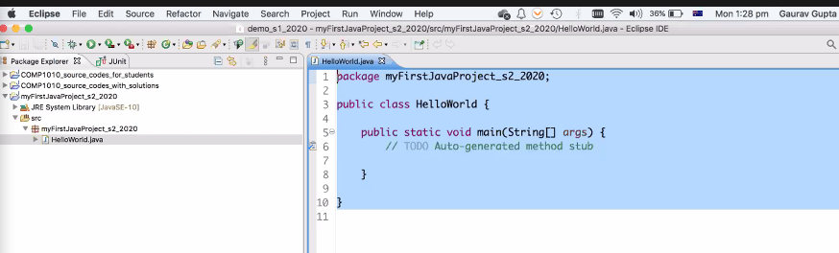

Unlike visual studio you should create the project

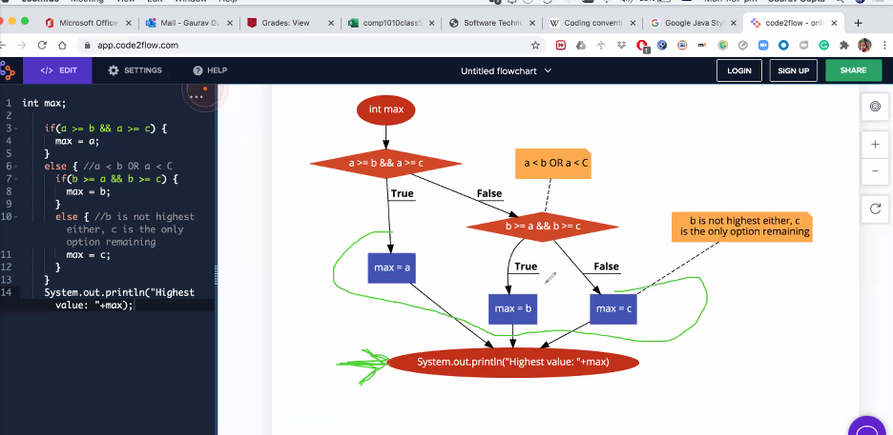

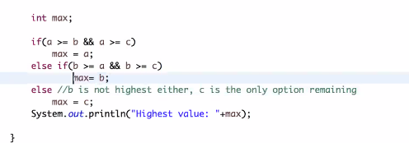

Main is function too

And you can create more function below

