3007_pratical_intro

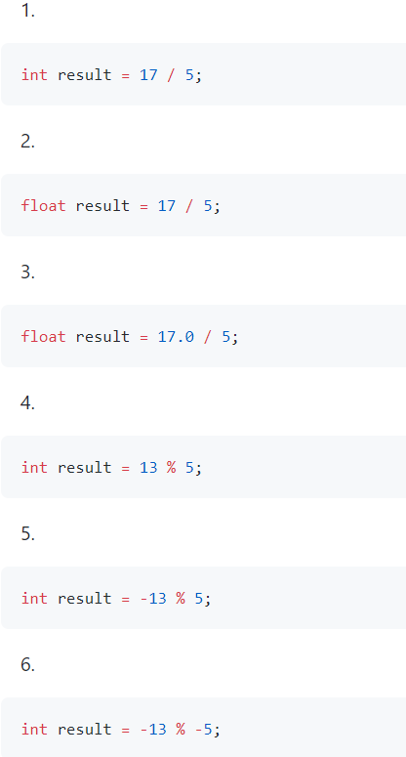

3

3.0

3.4

3

-3

-3

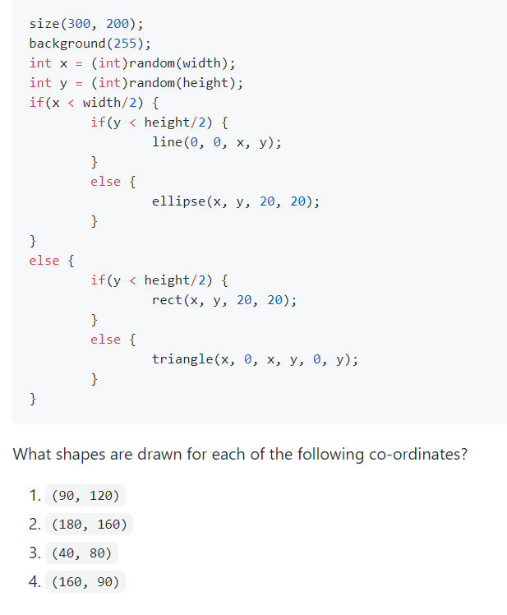

Ellipse

Triangle

Line

Rect

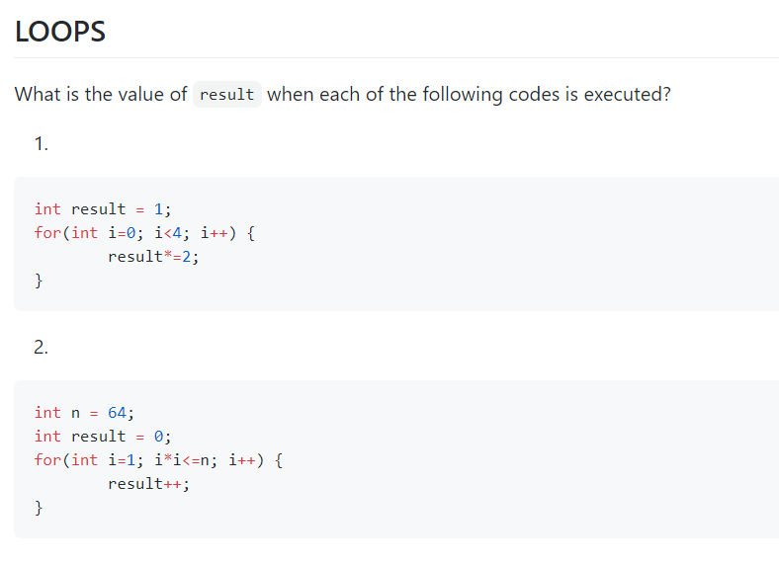

16

8

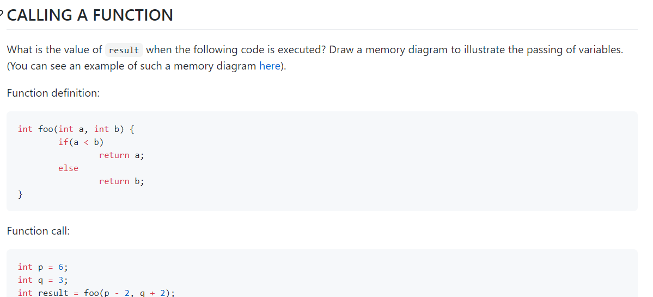

4

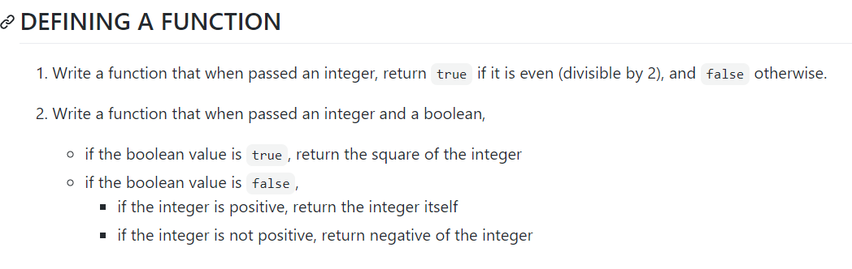

Public Boolean divisible(int x){

If(x%2==0){

Return true;  
}

Else{

Return false;

}

}

->>>>>

We can change this code to this!!(so simple)

Return a%2==0;

Public int name(int num, Boolean flag){  
if(flag == true){

Return num*num;

}

Else{

If(num>=0){  
return num;

Else{

Return –num;

}

}

}

You can change this into->>>

Int foo(int num, Boolean flag){

Int(flag){

Return num*num;

}

Else{

Return Math.abs(num);

}

-using abs function (built in function)

Shallow = reference copy

Deep=instance

Int x=8;

Int y=8;

X=2

* Primitive data is instance copy

So it doesn’t effect the value of int y;

But the reference copy is different.

int data={3,7,8,91};

int result1=0;

for(int i=0; i<data.length;i++){

result1+=data[i];

}

//enhanced for loop

int result2=0;

//for(type name:array)

for(int item:data){

result1 +=item;

}

<https://repl.it/@NoahKwon/3007#Main.java>