1108(L)

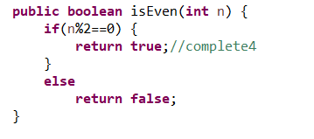

This can be just

Return n%2==0;

And if you want to do the correct indentation you can press ctrl+i

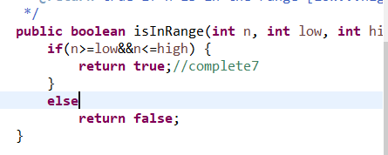

This one as well

I can just return

Return (n>=low && n<=high);

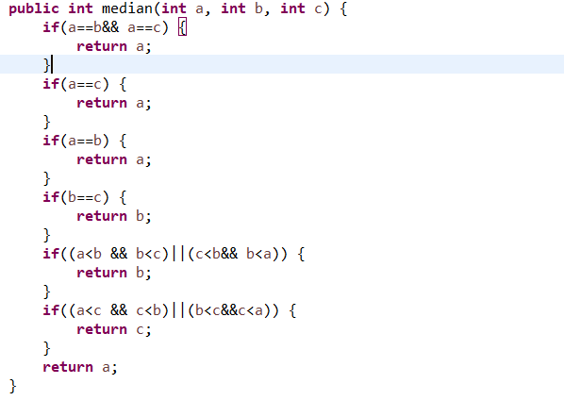

Make it like this and sort it after

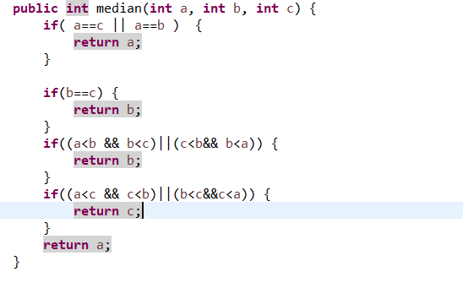

Like this

But it is okay to stick to the first one because first one is very clear to know the meaning of the code

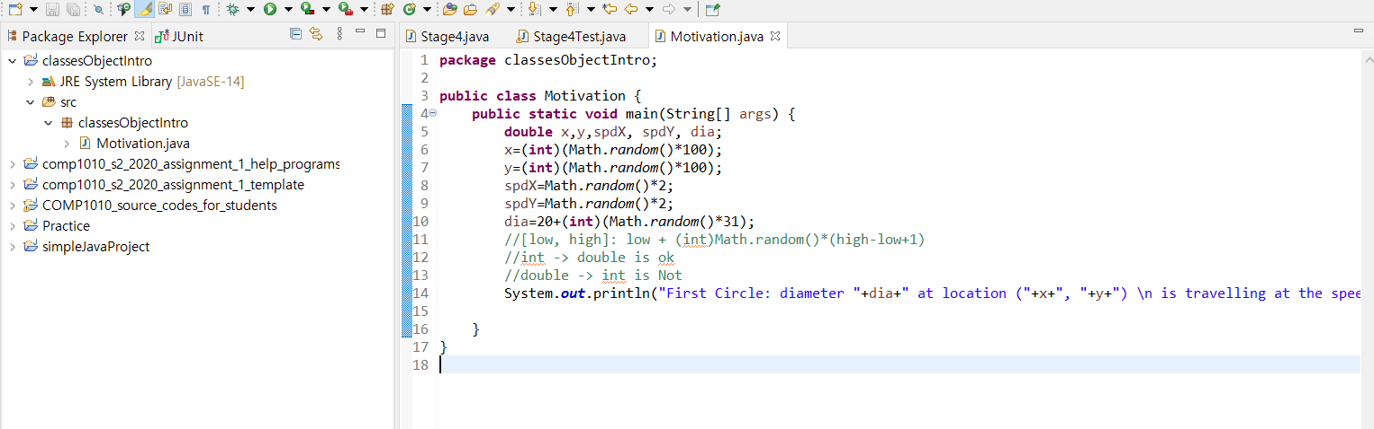

I made this and if I want to make a second circle then I should make another 5 variables .

It is very tedious so we will make a box that contains 5 variable and can reuse when we make second objects.

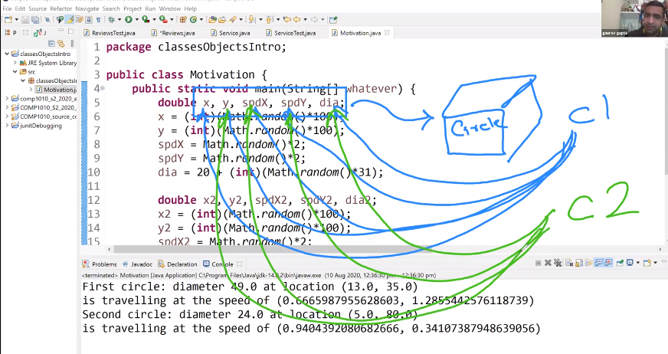

Like this

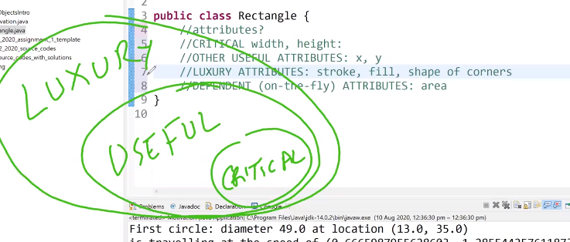

We are focus on critical variables

They will have instance variables.

Critical -🡪 dependent(which is calculated by critical)

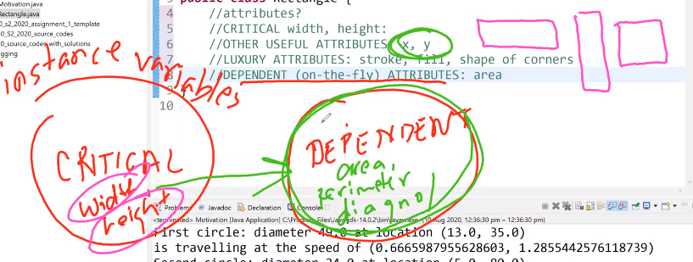

So

//CRITICAL width, height:stored as instance variables

//DEPENDENT ATTRIBUTES implemented as functions or instance methods

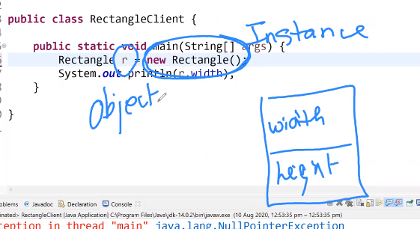

R holds the address of Rectangle instance

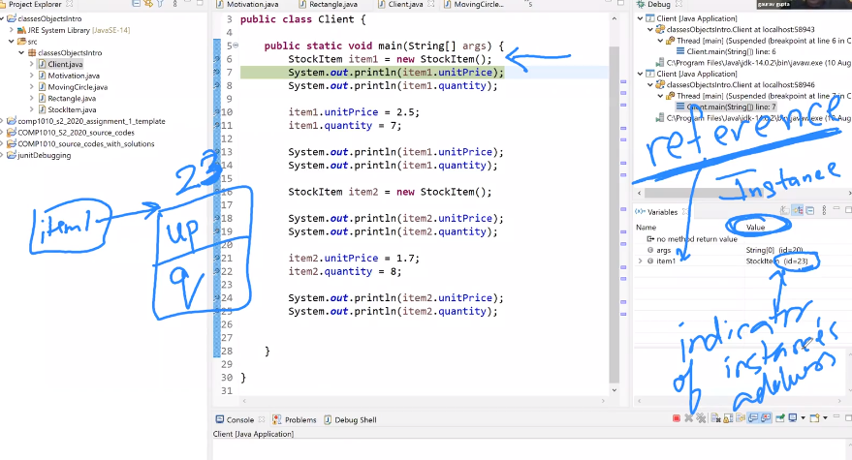

Id is the indicator of instance’s address

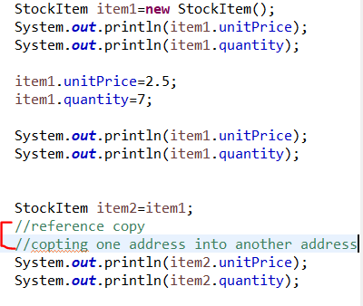

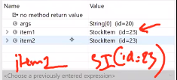

There are only 1 instance in this(two reference, one instance)

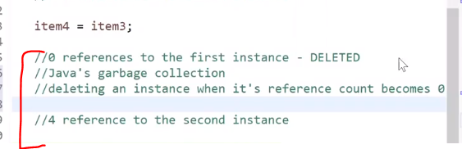

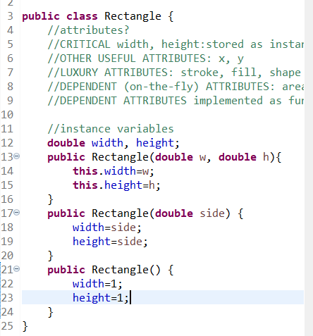

You can make different types of constructer

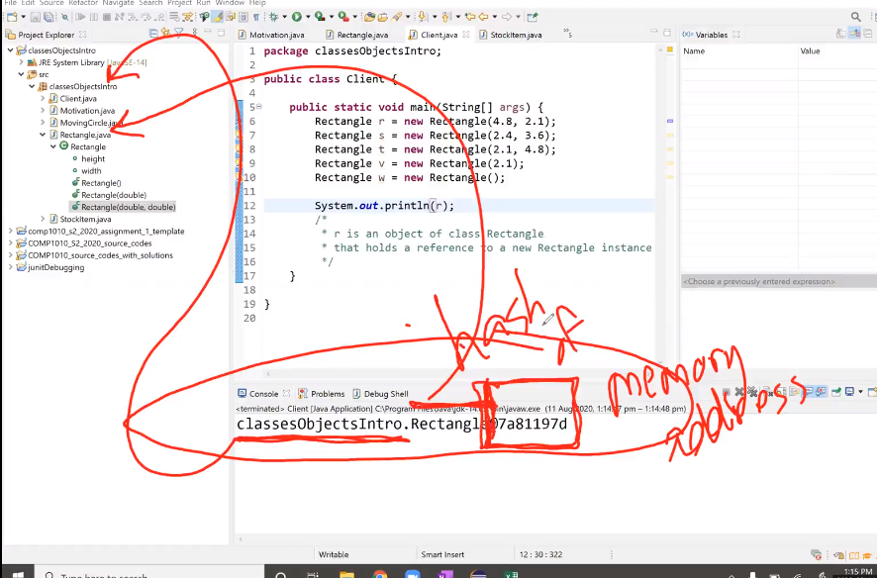

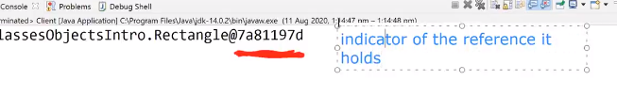

If you have

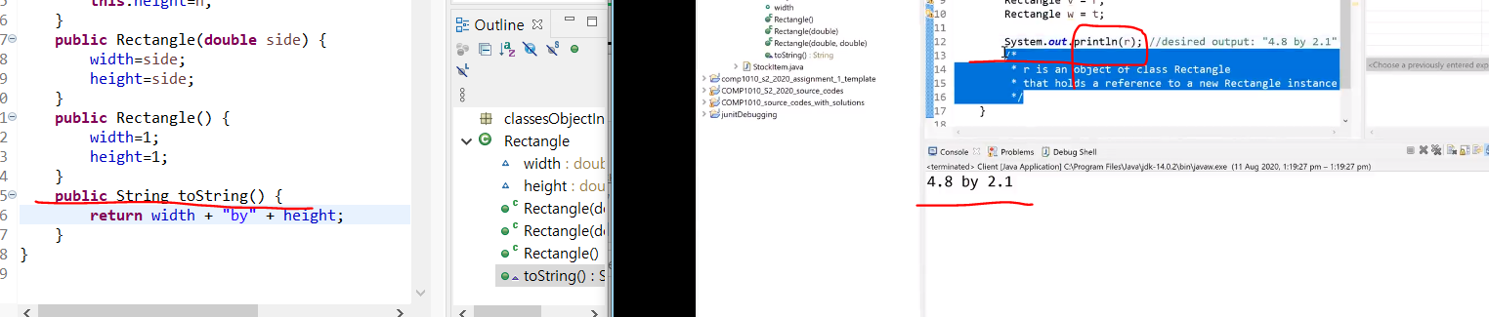

Public string tostring method, when you print object then the string that you want will be show out.

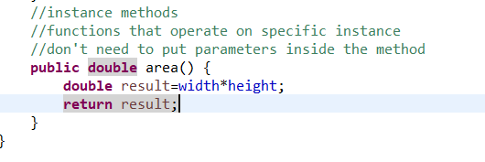

Don’t have input

And don’t have static

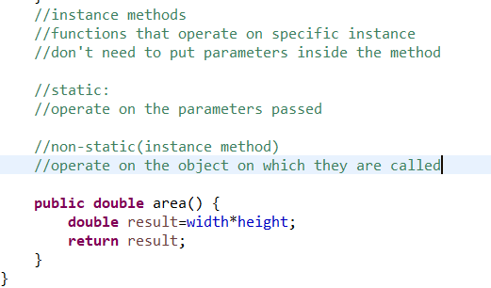 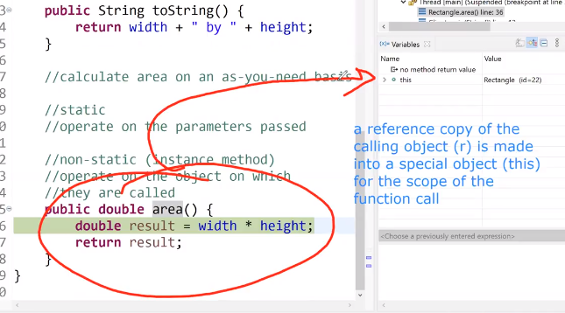

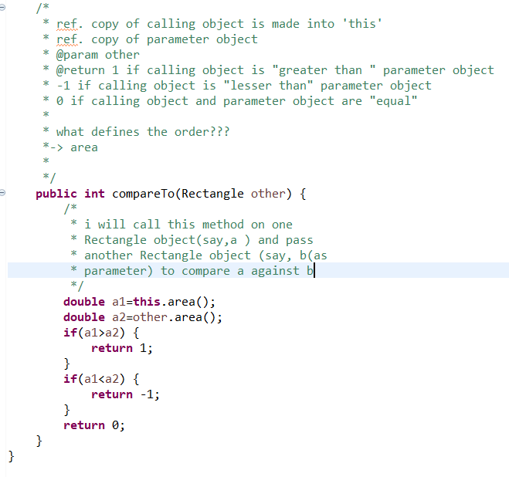

CompareTo method

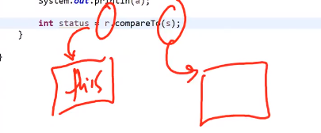

 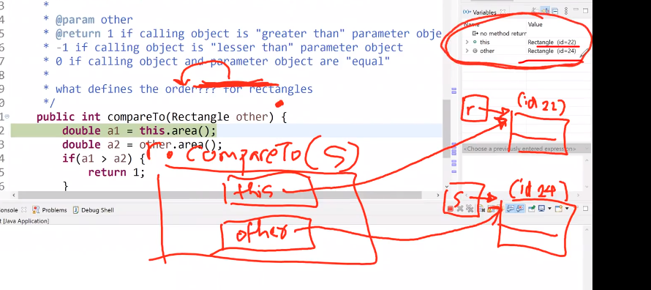when we called compareTo

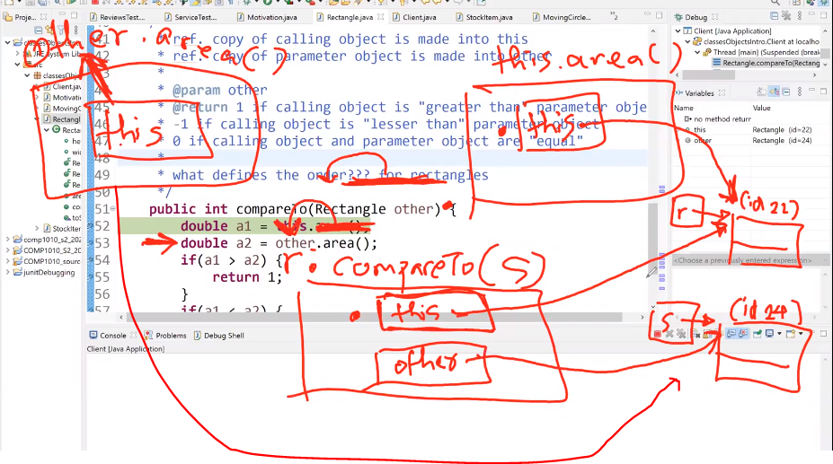

When we called this.area() and other.area()

Reference copy!!

Function will hold the reference of instance that use that method

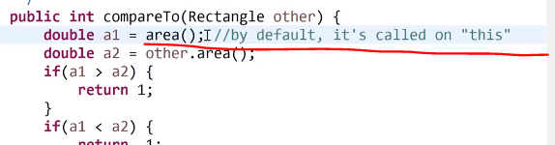

This=calling object of method