1308_p

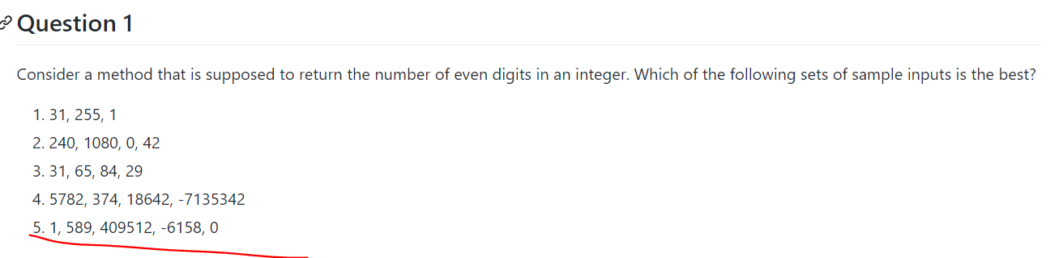

This one is the best testing sample

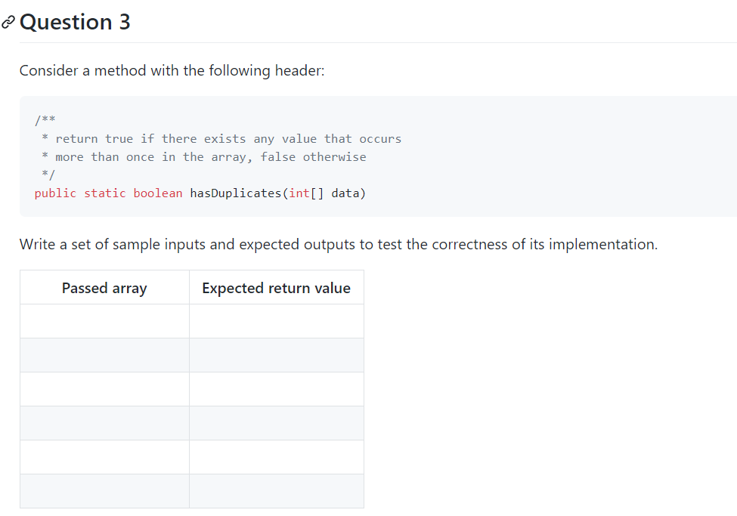

{1,1,2} -> standard True

{23,8,4} -> standard false

{-1,0,1}->absolute value(f) {4}->single value(f)

Null->null(f)

{}->empty(f)