1708_L

Hold references of point

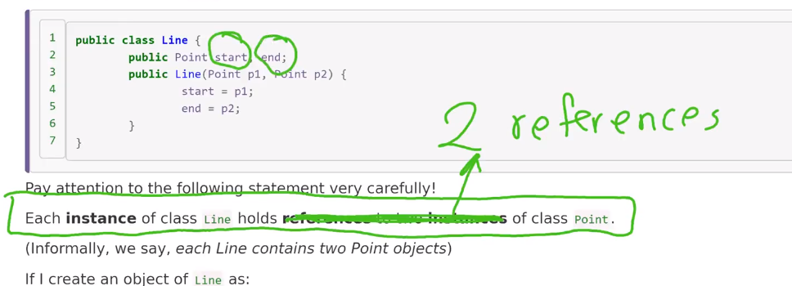

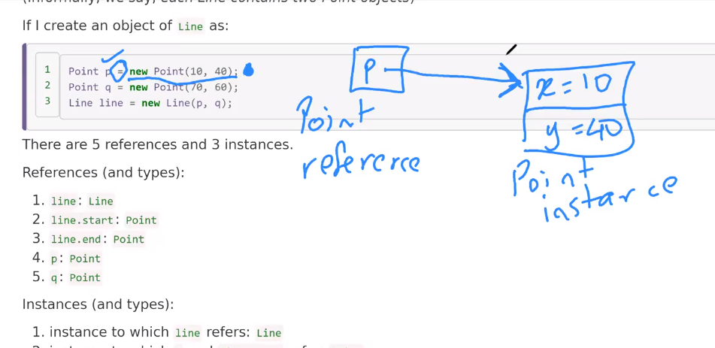

P is an reference to Point object which hold 10 , 40 for x and y

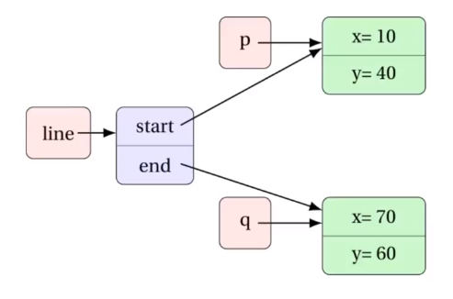

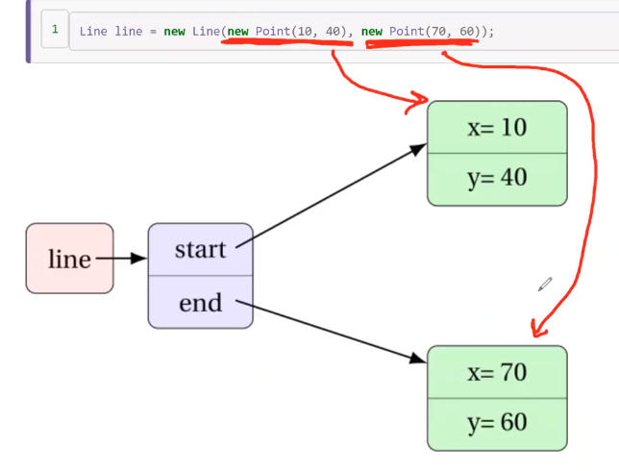

Sending two references as p1,p2

P and line.start have the same reference.

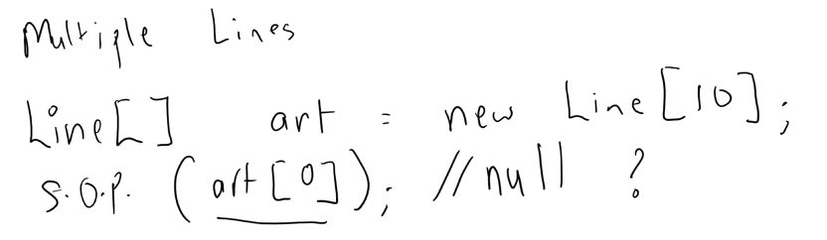

We didn’t instantiated yet

So we will get the null value.

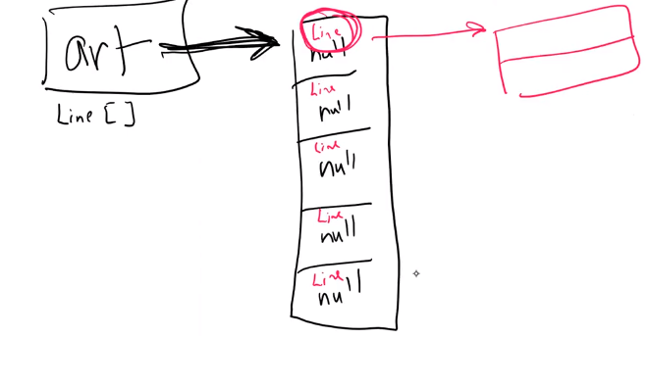

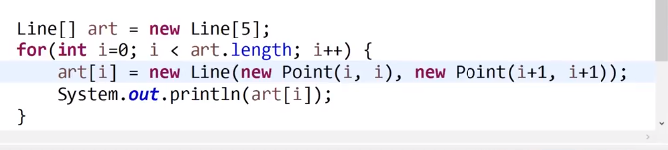

Public String toString(){}

When you want to get

Width = 2.0, 2.1, 2.2, … 16.0

Height = 5.6, 5.8, 6.0, 6.2 … 10.0

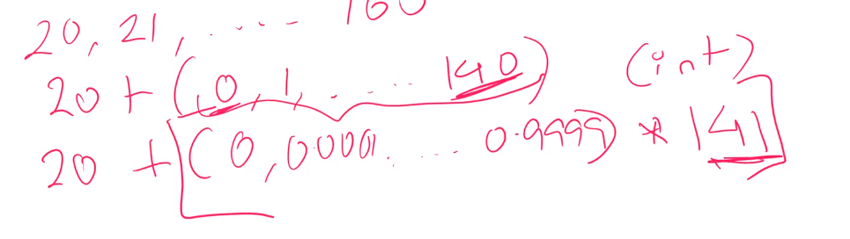

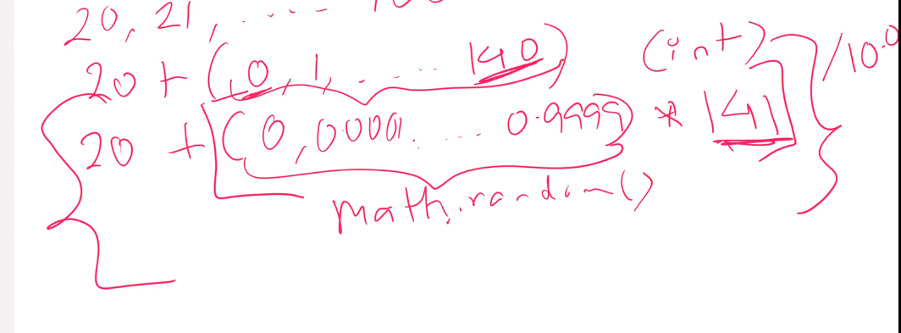

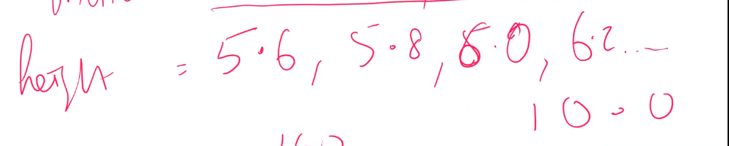



toString method

public String toString(){

return ~~;}

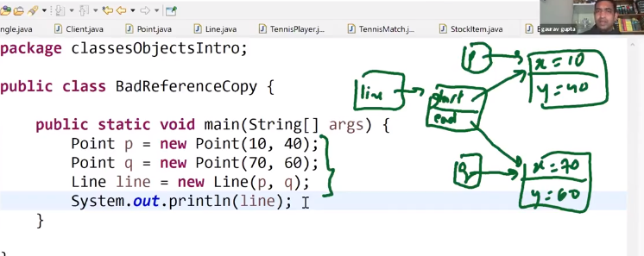

Line is changed too

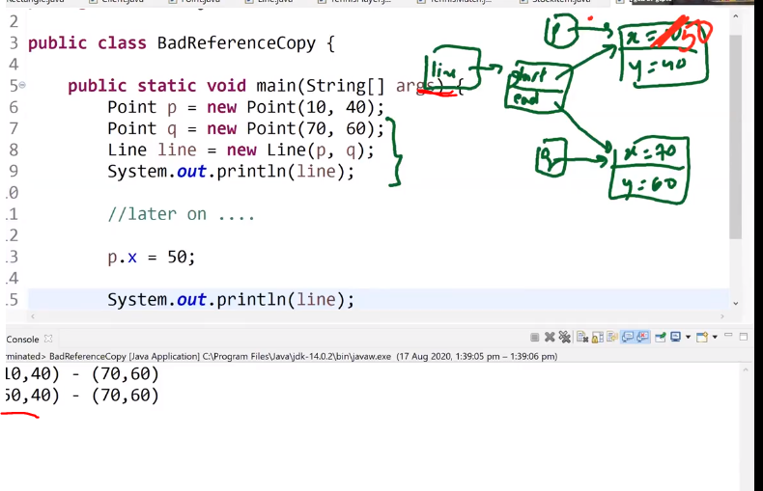

Because they are connected with the reference copy( shallow copy)

Line.start.x=50 -> this become 50 as well

이게 reference copy라서 그냥 계속 바뀔 때마다 바뀌게 되는데

이것이 안 좋을 때도 있다. 그러면 이것을 고치고 싶다면 밑에처럼 한다.

To prevent this

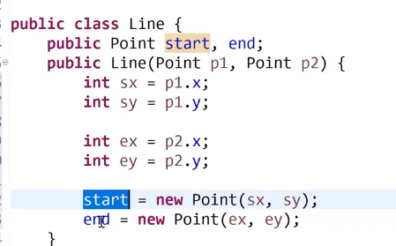

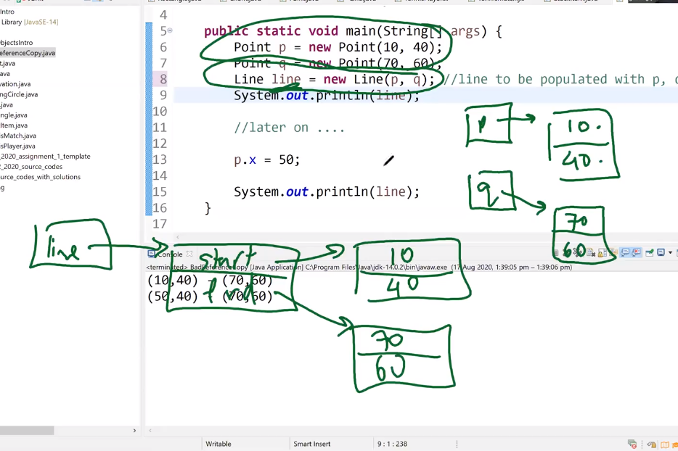

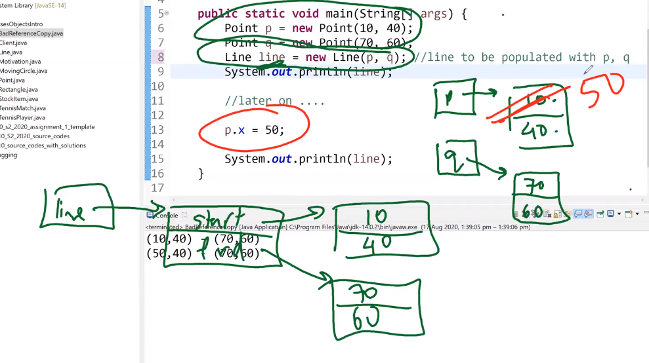

In this case when we change the p.x to 50 line’s value don’t be changed because we only use p value to instantiate the line – so it is not a reference copy

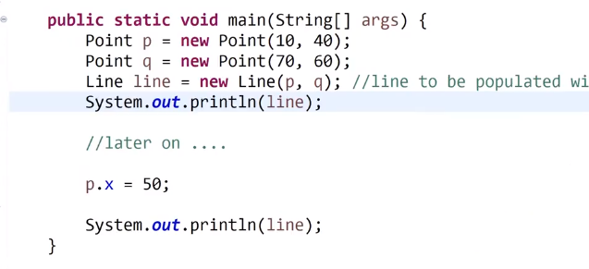

We can simply say

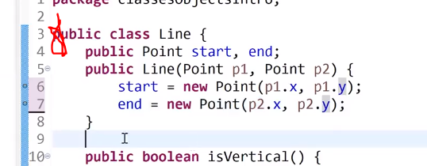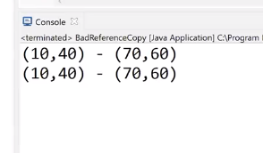

Are we can make copy constructor

It used to make an instance copy of the parameter object

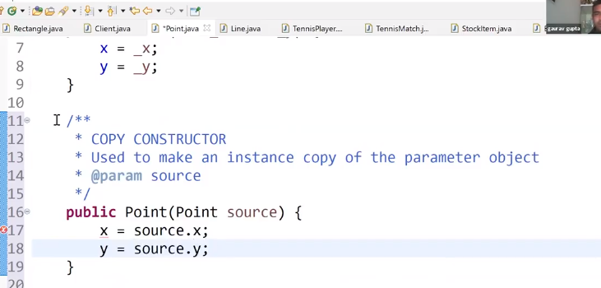

In this case you can just simply pass the object

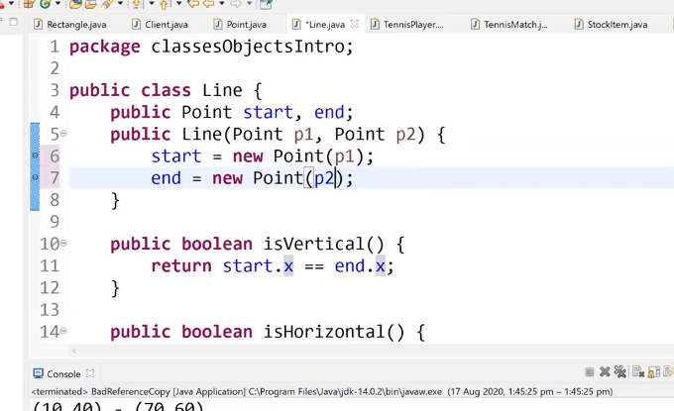

**Copy constructor – when you don’t want to share the references -> don’t make it linked**

Practice this

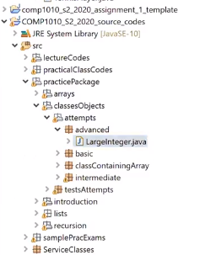

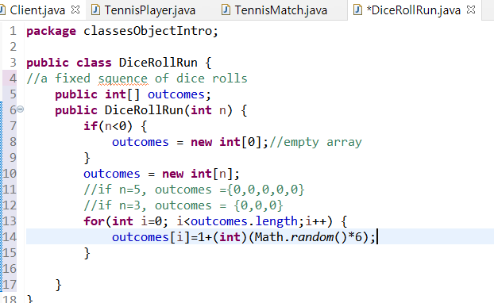

How to make dice

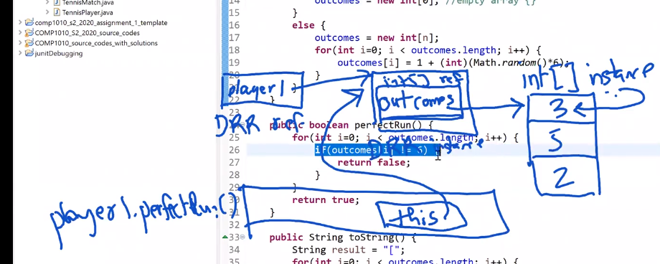

In the while loops

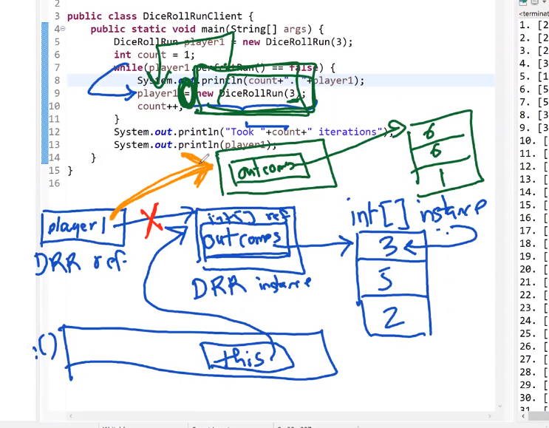

Player1 reference the other outcomes .

And the old references called orphan references and it will be erased completely.

If you want to return array

First : determine the size of array that you want to return

Second: create and populate the required array