Howard University
College of Engineering and Architecture
Department of Electrical Engineering & Computer Science

Large Scale Programming
Fall 2024

Midterm Exam – Part I
October 17, 2024

Part I: 50 pts. (essay questions)

Instructions:
- Submit completed exam to your github repository under package org.howard.edu.lsp.midterm

Verify that the commit(s) completed successfully

- OPEN BOOK, OPEN NOTES. THERE IS NO COLLABORATION ON THIS EXAM
- Site any and ALL references for anything obtained off the internet.

Question 1. (10 pts.)

You are reviewing the following class in a Fitness Tracking System. The class is intended to manage various aspects of a user’s fitness activities.

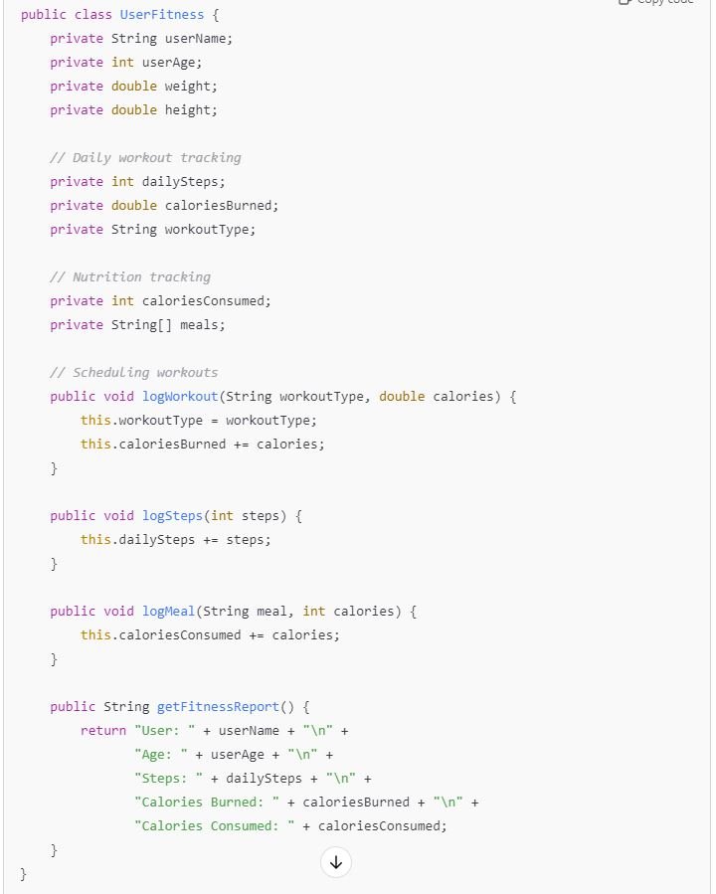

Tasks:
- Analyze the UserFitness class. Explain why this class has low cohesion. (5 pts.)

- Describe, in general, how you would split the UserFitness class into more cohesive classes. Your answer should not be a complete design. (5 pts.)

Question 2. (5 pts.)
Given the following, answer the below questions.

A university manages its students using a program that has a class Student with subclasses FirstYear, SecondYear, and ThirdYear for year-specific state and behaviors. The program has a List that contains all Students.

Should Student be a class, an abstract class or an interface? Explain your answer

- At the end of each year, the third-year students graduate and must be removed. This is done by passing the list to the following method:

void removeThirdYears(List<Students> students) {
for (Student student : students) {
try {
ThirdYear = (ThirdYear) student;
students.remove(thirdyear);
}
}
}

Why is the above method flawed? Hint: Another Arthur Riel heuristic (5 pts.)

Question 3. (5 pts.)
Given the following, answer the below questions.

public class BankAccount {
public String accountHolderName;
public String accountNumber;
public double balance;
public double interestRate;

public BankAccount(
String accountHolderName,
String accountNumber,
double initialDeposit,
double interestRate) {
this.accountHolderName = accountHolderName;
this.accountNumber = accountNumber;
this.balance = initialDeposit;
this.interestRate = interestRate;
}

// Exposed implementation for adding interest
public void addInterest() {
double interest = balance * (interestRate / 100);
balance += interest;
}

// Exposed implementation for deposits
public void deposit(double amount) {
balance += amount;
}

// Exposed implementation for withdrawals
public void withdraw(double amount) {
balance -= amount;
}
}

- Is BankAccount well-encapsulated? Why or why not? If so, describe what changes you would make to the class. Otherwise, state nothing. (5 pts.)

Question 4. (10 pts.)
Given the following, answer the below questions.

Given:
A car manufacturer uses Java software to track current vehicles being built. The UML diagram below shows an excerpt of the current software structure. You should assume the presence of other appropriate fields and methods

Car
getTrimLevel()
Engine
accelerate()
getFuelLevel()
Base
Sports
Luxury
Electric
Petrol

Each car can be built to one of three trim levels: Base, Luxury or Sport. They can also be configured with an electric or petrol engine. At various points in the manufacturing process the customer can choose to change the trim level.

Task:
- Explain in detail why the current structure does not support this. (5 pts.)

- Describe how to refactor the structure to allow trim-level change for a car to dynamically change. Hint: How would you modify Car to use composition to solve the problem? (5 pts.)

Question 5. (5 pts.)
Suppose you are about to code a particular class and find that you have written another class with nearly the functionality that you now are developing. This means that the two classes in large parts contain the same code, but in smaller parts have different code. Explain in detail why this may be a problem and how to solve it. Give your answer in terms of Arthur Riel’s design heuristics.

Question 6. (5 pts.)
Suppose we need to store instances of the classes Car and BankAccount in a database. To obtain low coupling it may seem as if the functionality to save an instance should be in precisely those classes, since they have the information that shall be saved. Why is it unwise to place the database calls there?

Question 7. (5 pts.)
Given a set of requirements, what conditions must be met to make it appropriate to create a new class hierarchy using inheritance? Neither superclass nor subclass exist before, the question is about designing a new class hierarchy.

Question 8. (2.5 pts.)
Describe the difference between inheritance and composition why would you choose one over the other.

Question 9. (2.5 pts.)
Explain the meaning of cohesion and describe whether low or high cohesion is better.

Exam Short Answers

Question 1:

- Analyze the UserFitness class. Explain why this class has low cohesion.

Since cohesion is how closely related the elements of a class are. A class has low cohesion if its methods and responsibilities are not highly related. The UserFitness class handles too many unrelated aspects (like tracking, reporting, and calculating fitness), it is trying to do too much and should be divided into smaller classes.

- Describe, in general, how you would split the UserFitness class into more cohesive classes. Your answer should not be a complete design.

You could break the UserFitness class into smaller classes based on specific responsibilities. We could create a Fitness Tracker that is responsible for tracking user activities, a fitness_report that generates reports of fitness activities, and/or a goal_manager that handles fitness goals and achievements.

Question 2:

- Should Student be a class, abstract class, or interface?

Students should be in an abstract class. It allows the common behavior and properties (name, student ID, major) to be defined, while each subclass (FirstYear, SecondYear) can implement year-specific behaviors.

- Why is the method removeThirdYears flawed?

The method uses a loop that modifies the list while iterating over it, which causes a ConcurrentModificationException. A better approach is to use an iterator or filter the list to remove third-year students after the iteration.

Question 3:

Is BankAccount well-encapsulated? Why or why not? If so, describe what changes you would make to the class. Otherwise, state nothing?

No, the class exposes its fields (like accountHolderName, accountNumber, and balance) as public, which violates the principle of encapsulation. In the real world doing this would be extremely risky because it increases the ability of individuals to steal personal banking information and ruin the lives of many people. These fields should be private, and access should be controlled through getter and setter methods. For instance:

private String accountHolderName;
private String accountNumber;
private double balance;

Question 4:

- Explain in detail why the current structure does not support this.

The trim levels (Base, Luxury, Sport) are hardcoded as part of the class hierarchy, making it difficult to dynamically change a car's trim level during the manufacturing process.

- Describe how to refactor the structure to allow trim-level change for a car to dynamically change. Hint: How would you modify Car to use composition to solve the problem?

You could use composition instead of inheritance. For example, the Car class could have a TrimLevel object as a field, allowing the trim level to be changed dynamically anytime it is needed, like:

class Car {
private TrimLevel trimLevel;
public void setTrimLevel(TrimLevel trim) {
this.trimLevel = trim;
}
}

Now you can change the trimLevel.

Question 5:

Suppose you are about to code a particular class and find that you have written another class with nearly the functionality that you now are developing. This means that the two classes in large parts contain the same code, but in smaller parts have different code. Explain in detail why this may be a problem and how to solve it. Give your answer in terms of Arthur Riel’s design heuristics.?

According to Arthur Riel’s heuristics, duplicated code reduces maintainability. The solution is to refactor the common code into a shared superclass or extract shared functionality into a separate utility class to avoid redundancy and function reuse.

Question 6:

Suppose we need to store instances of the classes Car and BankAccount in a database. To obtain low coupling it may seem as if the functionality to save an instance should be in precisely those classes, since they have the information that shall be saved. Why is it unwise to place the database calls there?

Placing database logic in these classes would lead to high coupling between the business logic and data storage concerns. I think we would be better off using a separate data access layer, like a repository, to handle database operations, maintaining low coupling and high cohesion.

Question 7:

Given a set of requirements, what conditions must be met to make it appropriate to create a new class hierarchy using inheritance? Neither superclass nor subclass exist before, the question is about designing a new class hierarchy.

Conditions to create a new class hierarchy using inheritance:
- There is a clear "is-a" relationship between the entities.
- Shared functionality can be moved to the superclass to avoid duplication.
- The subclass must override or extend the behavior of the superclass.
- You should expect to add more subclasses in the future.

Question 8:

Describe the difference between inheritance and composition why would you choose one over the other.

Inheritance creates a "is-a" relationship and shares behavior from a parent class while composition creates a "has-a" relationship where one class contains instances of another class. You choose composition over inheritance when you want more flexibility and loose coupling.

Question 9:

Explain the meaning of cohesion and describe whether low or high cohesion is better.

Cohesion is closely the responsibilities of a class are related. High cohesion is better because it ensures that a class is focused on a single task, making it easier to maintain and understand.
Refrences in addition to Slides/ Lectures
• Mdy, M. "Cohesion and Coupling in JavaScript." Dev.to, 6 July 2020, https://dev.to/m__mdy__m/cohesion-and-coupling-in-javascript-2efg.
• Stack Overflow. "Interface vs Abstract Class (general OO)." Stack Overflow, https://stackoverflow.com/questions/761194/interface-vs-abstract-class-general-oo.
• Riel, Arthur. "Riel’s Object-Oriented Programming Heuristics." Victoria University of Wellington, https://homepages.ecs.vuw.ac.nz/~elvis/db/misc/rules.html.
• "Topic 9.5: Class Hierarchies." Runestone Academy, https://runestone.academy/ns/books/published/csawesome/Unit9-Inheritance/topic-9-5-hierarchies.html.
• "Coupling and Cohesion in Software Engineering." GeeksforGeeks, https://www.geeksforgeeks.org/software-engineering-coupling-and-cohesion/.

