DSE predictive modeling Chapter 3

Noah Foilb

3/27/2022

# Libraries and daat

library(ISLR)

## Warning: package 'ISLR' was built under R version 4.0.4

library(MASS)  
head(Auto)

## mpg cylinders displacement horsepower weight acceleration year origin  
## 1 18 8 307 130 3504 12.0 70 1  
## 2 15 8 350 165 3693 11.5 70 1  
## 3 18 8 318 150 3436 11.0 70 1  
## 4 16 8 304 150 3433 12.0 70 1  
## 5 17 8 302 140 3449 10.5 70 1  
## 6 15 8 429 198 4341 10.0 70 1  
## name  
## 1 chevrolet chevelle malibu  
## 2 buick skylark 320  
## 3 plymouth satellite  
## 4 amc rebel sst  
## 5 ford torino  
## 6 ford galaxie 500

summary(Auto)

## mpg cylinders displacement horsepower weight   
## Min. : 9.00 Min. :3.000 Min. : 68.0 Min. : 46.0 Min. :1613   
## 1st Qu.:17.00 1st Qu.:4.000 1st Qu.:105.0 1st Qu.: 75.0 1st Qu.:2225   
## Median :22.75 Median :4.000 Median :151.0 Median : 93.5 Median :2804   
## Mean :23.45 Mean :5.472 Mean :194.4 Mean :104.5 Mean :2978   
## 3rd Qu.:29.00 3rd Qu.:8.000 3rd Qu.:275.8 3rd Qu.:126.0 3rd Qu.:3615   
## Max. :46.60 Max. :8.000 Max. :455.0 Max. :230.0 Max. :5140   
##   
## acceleration year origin name   
## Min. : 8.00 Min. :70.00 Min. :1.000 amc matador : 5   
## 1st Qu.:13.78 1st Qu.:73.00 1st Qu.:1.000 ford pinto : 5   
## Median :15.50 Median :76.00 Median :1.000 toyota corolla : 5   
## Mean :15.54 Mean :75.98 Mean :1.577 amc gremlin : 4   
## 3rd Qu.:17.02 3rd Qu.:79.00 3rd Qu.:2.000 amc hornet : 4   
## Max. :24.80 Max. :82.00 Max. :3.000 chevrolet chevette: 4   
## (Other) :365

?Auto

## starting httpd help server ... done

pairs(Auto)

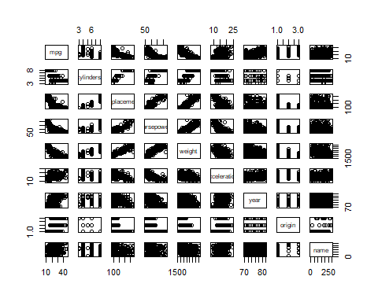

cor(subset(Auto, select = -name))

## mpg cylinders displacement horsepower weight  
## mpg 1.0000000 -0.7776175 -0.8051269 -0.7784268 -0.8322442  
## cylinders -0.7776175 1.0000000 0.9508233 0.8429834 0.8975273  
## displacement -0.8051269 0.9508233 1.0000000 0.8972570 0.9329944  
## horsepower -0.7784268 0.8429834 0.8972570 1.0000000 0.8645377  
## weight -0.8322442 0.8975273 0.9329944 0.8645377 1.0000000  
## acceleration 0.4233285 -0.5046834 -0.5438005 -0.6891955 -0.4168392  
## year 0.5805410 -0.3456474 -0.3698552 -0.4163615 -0.3091199  
## origin 0.5652088 -0.5689316 -0.6145351 -0.4551715 -0.5850054  
## acceleration year origin  
## mpg 0.4233285 0.5805410 0.5652088  
## cylinders -0.5046834 -0.3456474 -0.5689316  
## displacement -0.5438005 -0.3698552 -0.6145351  
## horsepower -0.6891955 -0.4163615 -0.4551715  
## weight -0.4168392 -0.3091199 -0.5850054  
## acceleration 1.0000000 0.2903161 0.2127458  
## year 0.2903161 1.0000000 0.1815277  
## origin 0.2127458 0.1815277 1.0000000

m1 <- lm(mpg ~., data = subset(Auto, select = -name))  
summary(m1)

##   
## Call:  
## lm(formula = mpg ~ ., data = subset(Auto, select = -name))  
##   
## Residuals:  
## Min 1Q Median 3Q Max   
## -9.5903 -2.1565 -0.1169 1.8690 13.0604   
##   
## Coefficients:  
## Estimate Std. Error t value Pr(>|t|)   
## (Intercept) -17.218435 4.644294 -3.707 0.00024 ***  
## cylinders -0.493376 0.323282 -1.526 0.12780   
## displacement 0.019896 0.007515 2.647 0.00844 **   
## horsepower -0.016951 0.013787 -1.230 0.21963   
## weight -0.006474 0.000652 -9.929 < 2e-16 ***  
## acceleration 0.080576 0.098845 0.815 0.41548   
## year 0.750773 0.050973 14.729 < 2e-16 ***  
## origin 1.426141 0.278136 5.127 4.67e-07 ***  
## ---  
## Signif. codes: 0 '***' 0.001 '**' 0.01 '*' 0.05 '.' 0.1 ' ' 1  
##   
## Residual standard error: 3.328 on 384 degrees of freedom  
## Multiple R-squared: 0.8215, Adjusted R-squared: 0.8182   
## F-statistic: 252.4 on 7 and 384 DF, p-value: < 2.2e-16

#i YES! while not all predictors are statistically significant in this model, the R^2 is high! There is some sort of relationship between them in order for a model to explain that much variance.  
  
#ii From this model, displacement, weight, year, and origin. This is only an analysis from the combined model. This doesn't mean that they cannot be statistically insignificant when predicting mpg in a different model.   
  
#iii Since year ranges from 70 - 84 as it is the model year, we would take the value of the year and multiply it by .75.While first impressions of this coefficient would make year seem more important that isn't true. For example look at weight. While weight's coefficient is much less than year, the range of weights values is significantly higher (1613 - 5140). In order to compensate, it needs to change the weight value.

par(mfrow = c(2, 2))  
plot(m1)

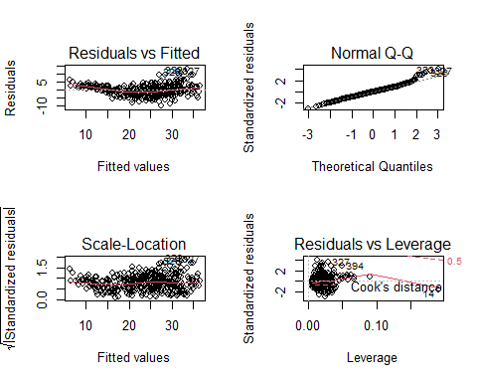

# the Q-Q plot varies away from normal by the end.LEverage shows some outliers.

m2 <- lm(mpg ~ cylinders * displacement + displacement * weight, data = Auto)  
summary(m2)

##   
## Call:  
## lm(formula = mpg ~ cylinders * displacement + displacement *   
## weight, data = Auto)  
##   
## Residuals:  
## Min 1Q Median 3Q Max   
## -13.2934 -2.5184 -0.3476 1.8399 17.7723   
##   
## Coefficients:  
## Estimate Std. Error t value Pr(>|t|)   
## (Intercept) 5.262e+01 2.237e+00 23.519 < 2e-16 ***  
## cylinders 7.606e-01 7.669e-01 0.992 0.322   
## displacement -7.351e-02 1.669e-02 -4.403 1.38e-05 ***  
## weight -9.888e-03 1.329e-03 -7.438 6.69e-13 ***  
## cylinders:displacement -2.986e-03 3.426e-03 -0.872 0.384   
## displacement:weight 2.128e-05 5.002e-06 4.254 2.64e-05 ***  
## ---  
## Signif. codes: 0 '***' 0.001 '**' 0.01 '*' 0.05 '.' 0.1 ' ' 1  
##   
## Residual standard error: 4.103 on 386 degrees of freedom  
## Multiple R-squared: 0.7272, Adjusted R-squared: 0.7237   
## F-statistic: 205.8 on 5 and 386 DF, p-value: < 2.2e-16

# The interaction between displacement and weight is statistically ssignificant. In both * and :

# After playing around and looking at the scatterplots, it seems mostly linear and I feel like it wouldnt change or make a better model.

# 10

head(Carseats)

## Sales CompPrice Income Advertising Population Price ShelveLoc Age Education  
## 1 9.50 138 73 11 276 120 Bad 42 17  
## 2 11.22 111 48 16 260 83 Good 65 10  
## 3 10.06 113 35 10 269 80 Medium 59 12  
## 4 7.40 117 100 4 466 97 Medium 55 14  
## 5 4.15 141 64 3 340 128 Bad 38 13  
## 6 10.81 124 113 13 501 72 Bad 78 16  
## Urban US  
## 1 Yes Yes  
## 2 Yes Yes  
## 3 Yes Yes  
## 4 Yes Yes  
## 5 Yes No  
## 6 No Yes

summary(Carseats)

## Sales CompPrice Income Advertising   
## Min. : 0.000 Min. : 77 Min. : 21.00 Min. : 0.000   
## 1st Qu.: 5.390 1st Qu.:115 1st Qu.: 42.75 1st Qu.: 0.000   
## Median : 7.490 Median :125 Median : 69.00 Median : 5.000   
## Mean : 7.496 Mean :125 Mean : 68.66 Mean : 6.635   
## 3rd Qu.: 9.320 3rd Qu.:135 3rd Qu.: 91.00 3rd Qu.:12.000   
## Max. :16.270 Max. :175 Max. :120.00 Max. :29.000   
## Population Price ShelveLoc Age Education   
## Min. : 10.0 Min. : 24.0 Bad : 96 Min. :25.00 Min. :10.0   
## 1st Qu.:139.0 1st Qu.:100.0 Good : 85 1st Qu.:39.75 1st Qu.:12.0   
## Median :272.0 Median :117.0 Medium:219 Median :54.50 Median :14.0   
## Mean :264.8 Mean :115.8 Mean :53.32 Mean :13.9   
## 3rd Qu.:398.5 3rd Qu.:131.0 3rd Qu.:66.00 3rd Qu.:16.0   
## Max. :509.0 Max. :191.0 Max. :80.00 Max. :18.0   
## Urban US   
## No :118 No :142   
## Yes:282 Yes:258   
##   
##   
##   
##

m3 <- lm(Sales ~ Price + Urban + US, data = Carseats)  
summary(m3)

##   
## Call:  
## lm(formula = Sales ~ Price + Urban + US, data = Carseats)  
##   
## Residuals:  
## Min 1Q Median 3Q Max   
## -6.9206 -1.6220 -0.0564 1.5786 7.0581   
##   
## Coefficients:  
## Estimate Std. Error t value Pr(>|t|)   
## (Intercept) 13.043469 0.651012 20.036 < 2e-16 ***  
## Price -0.054459 0.005242 -10.389 < 2e-16 ***  
## UrbanYes -0.021916 0.271650 -0.081 0.936   
## USYes 1.200573 0.259042 4.635 4.86e-06 ***  
## ---  
## Signif. codes: 0 '***' 0.001 '**' 0.01 '*' 0.05 '.' 0.1 ' ' 1  
##   
## Residual standard error: 2.472 on 396 degrees of freedom  
## Multiple R-squared: 0.2393, Adjusted R-squared: 0.2335   
## F-statistic: 41.52 on 3 and 396 DF, p-value: < 2.2e-16

? Carseats

# FOr each value of price (which is the amoung a company charges for car sears at each site) the amounf of sales (in thousands) decreases by 0.054  
# UrbanYes is if it is urban, then the sales decrease by -.021916. This isnt statisically significant  
# For USYES, if US is yes, then the sales increase by at least 1.2 thousand sales.

# Sales = Price*-.054459 - UrbanYes*-0.021916 + USYes*1.200573

# We should get rid of Urban Yes

m4 = lm(Sales ~ Price+US, data= Carseats)  
summary(m4)

##   
## Call:  
## lm(formula = Sales ~ Price + US, data = Carseats)  
##   
## Residuals:  
## Min 1Q Median 3Q Max   
## -6.9269 -1.6286 -0.0574 1.5766 7.0515   
##   
## Coefficients:  
## Estimate Std. Error t value Pr(>|t|)   
## (Intercept) 13.03079 0.63098 20.652 < 2e-16 ***  
## Price -0.05448 0.00523 -10.416 < 2e-16 ***  
## USYes 1.19964 0.25846 4.641 4.71e-06 ***  
## ---  
## Signif. codes: 0 '***' 0.001 '**' 0.01 '*' 0.05 '.' 0.1 ' ' 1  
##   
## Residual standard error: 2.469 on 397 degrees of freedom  
## Multiple R-squared: 0.2393, Adjusted R-squared: 0.2354   
## F-statistic: 62.43 on 2 and 397 DF, p-value: < 2.2e-16

# While the models are statiscially significant, when looking at the 0.2354 R^2. This model only explains 23.54% of the variance, which does not fit the model well.

confint(m3)

## 2.5 % 97.5 %  
## (Intercept) 11.76359670 14.32334118  
## Price -0.06476419 -0.04415351  
## UrbanYes -0.55597316 0.51214085  
## USYes 0.69130419 1.70984121

confint(m4)

## 2.5 % 97.5 %  
## (Intercept) 11.79032020 14.27126531  
## Price -0.06475984 -0.04419543  
## USYes 0.69151957 1.70776632

# AH, UrbanYes is also statistically insignificant because the confit interval crosses the 0.

par(mfrow=c(2,2))  
plot(m4)

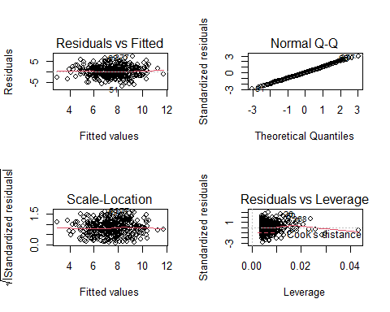

# There is no evidence higher leverage