Client Website Phase Two
Noah Ford, Vanay Rowell, Alyssa Carlomusto, Marco Crea, Hannah Hollick
Part One – Information Architecture and Page Descriptions

Information Architecture
Our website will be split across 4 individual pages that client can access and interact with.
- Landing Page / Upload Page
  - Allow the user to upload their exit ticket data to be processed into insights
- Data Overview Dashboard
  - Display an information dashboard of the information provided
  - Should include things like average difficulty, total responses, etc.
- Student Response Analysis
  - Display processed insights about student responses
  - E.g. What they understood or what they struggled with
- Trends Over Time
  - Given multiple data sources, display a graph of student understanding over time

Page Hierarchy

Page Wireframes
Landing Page / Upload Page
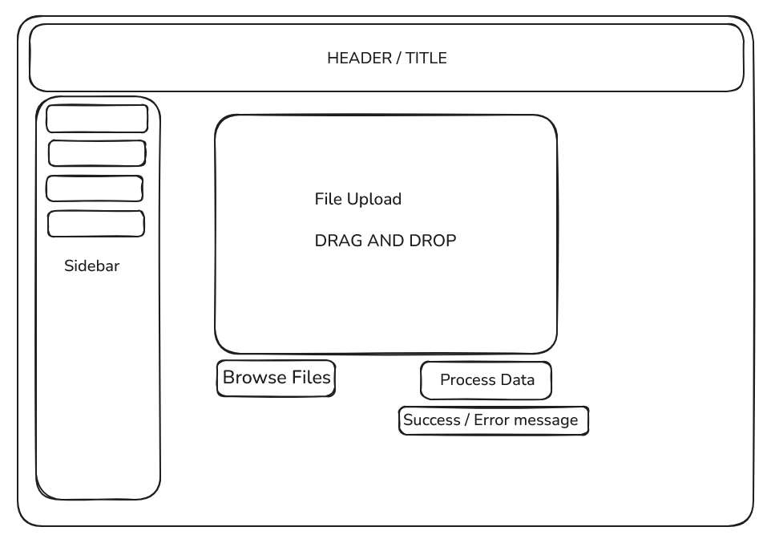
Data Overview Dashboard
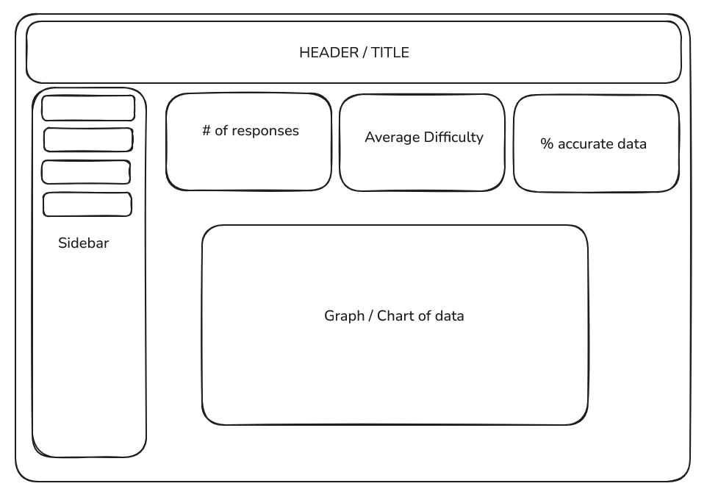
Student Response Analysis
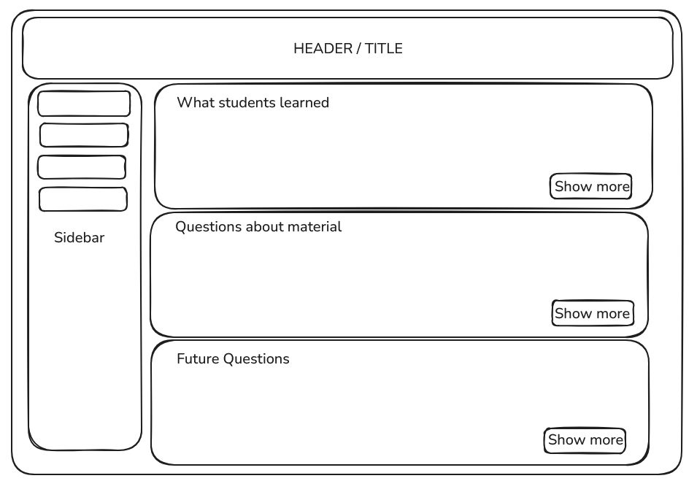
Trends Over Time
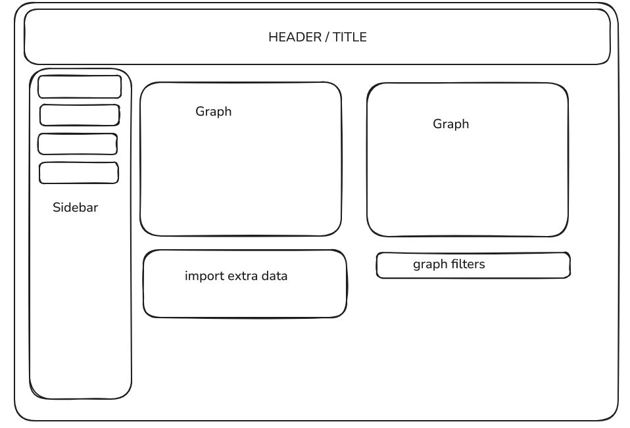
Part Two – Color Palette, Design elements, and Persona Concerns and Solutions

Color Palette and Logo’s

Logo

Icon

Illustrated Header


Page Example
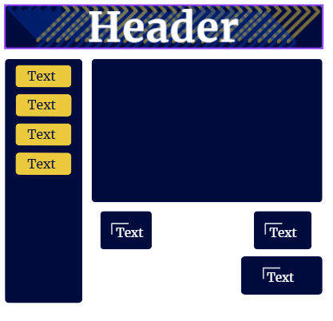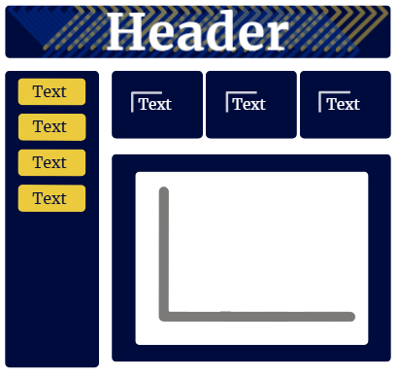

Persona Concerns and Solutions

Concern: Is far-sighted, so text needs to be legible to read.
Solution: Text will be in a large font to be legible for those with poor vision. In the worst case the user may also zoom in the website.

Concern: Requires keyboard navigation to be functional.
Solution: All menus should be accessible through keyboard and tab interactions.

Concern: Seamless user experience, intuitive design.
Solution: Pages will be structured in a logical manner such that they are easily accessible.

Concern: Has Tritanomaly, which makes it hard to see the difference between blue and green. So, he needs a strong color contrast.
Solution: We use distinct contrasting ETSU colors that are visible to those who are colorblind.

Concern: Color contrast and mobile accessibility for usability in a bright field environment.
Solution: A dark mode to use a darker color scheme for greater contrast.

Website Design Goal
Page 1:
The Landing Page serves as the main entry point for the client and is designed to allow easy data submission. This page will include a clean header and a sidebar for navigation, along with a central drag-and-drop upload area where users can upload exit ticket data files. Users will also have the option to browse files manually and click the “Process Data” button to begin analysis. Feedback messages, such as success or error notifications, will appear to guide the user. Overall, this page prioritizes simplicity and efficiency, so the client can quickly upload data without confusion.
Page 2:
The Data Overview Dashboard provides the client with a summary of the uploaded data. This page will display key metrics such as total responses, average difficulty, and other general statistics in a visually organized format, likely using charts, graphs, or data cards. The goal of this page is to give the client a quick and clear understanding of overall student performance without requiring in-depth analysis, making it useful for fast insights and decision-making.
Page 3:
The Student Response Analysis page focuses on insights into how students performed. It will break down responses to show what concepts students understood well and where they struggled. This page may include categorized results, visual breakdowns, or highlighted patterns in student answers. Its purpose is to help the client identify specific learning gaps or strengths so they can adjust instruction or evaluate student understanding more effectively.
Page 4:
The Trends Over Time page is designed to show how student performance changes across multiple sets of data. This page will allow the client to track progress, identify patterns, and observe improvements or declines in understanding over time. This feature is especially useful when multiple datasets are uploaded, as it provides a long-term view of student learning and helps the client make data-driven decisions.

