Project 2 – Data Structures & Algorithms – Noah Ford
Part A – Pre-Benchmark Expectations

Insertion Sort
Insertion Sort sorts data by comparing it previous values and inserting elements into the correct position. It seems to have its best use cases for smaller sets of data, or data that is already close to completion. Insertion sort extremely inefficient for data that is sorted in reverse order however, as it requires the sort to fully iterate through every element in its entirety to properly place it.
- Sorted Data: O(n) Ω
- Random Data: O(n²) θ
- Reverse Data: O(n²)
Merge Sort
Merge Sort sorts data by splitting it in half and recursively sorting all the partitions before merging them back together. Merge sort guarantees a time complexity of O(n log n) performance regardless of how the data is organized.
- Sorted Data: O(n log n) Ω
- Random Data: O(n log n) θ
- Reverse Data: O(n log n)
Quick Sort
Quick Sort sorts data by designating a “pivot” point where data is partitioned before being sorted recursively. It works best for data that is suitable random, where data that has some sorted-ness will create bad pivots and take more time.
- Sorted Data: O(n²) θ
- Random Data: O(n log n) Ω
- Reverse Data: O(n²)
Radix Sort (Integer & String)
Radix sort is only concerned with the number of integers/characters, not how they are ordered, as it organizes data by either least or most significant digit/character. This makes the sort extremely consistent as the actual order of the data has no bearing on the time complexity.
- Sorted Data: O(nk) – where k is length of the integer/string
- Random Data: O(nk) Ω
- Reverse Data: O(nk)
Part B – Post-Benchmark Outcomes

Insertion Sort
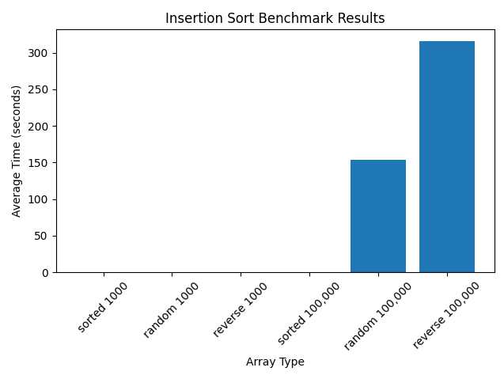
(Time for random 1000 and random 100000 taken over 100 samples and averaged)
Insertion sort suffers greatly from its worst case of O(n²) and struggles with large datasets even beyond 10,000. It suffers it’s worst outcome when attempting to sort reverse-order data, where it must iterate fully for every step which creates a O(n²) time complexity attempting to solve.
Insertion sort works well with smaller sets of data where O(n²) doesn’t have a significant impact just because the data is so few. It also excels at sorting data that is “near sorted” where fixing out of order elements is low cost, and of course it has an O(n) complexity when attempting to sort an already sorted list.
Insertion overall is quite poor however when attempting to sort large data, and data is random. Other options such as the other sorts being benchmarked will almost always be faster than insertion sort for large data.
Merge Sort
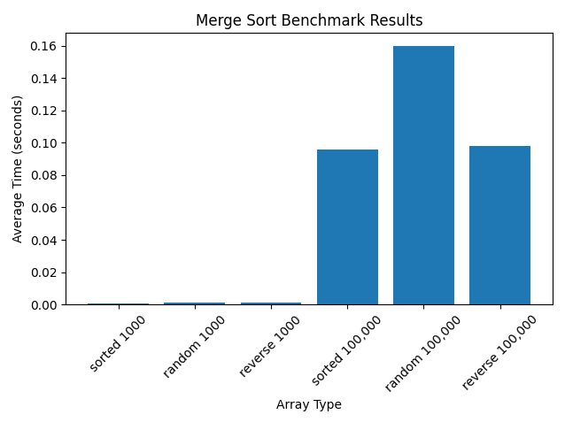
(Time for random 1000 and random 100000 taken over 100 samples and averaged)
Merge sort is an extremely consistent algorithm that almost always expresses a time complexity of O(n log n), making it very reliable for large data.
Merge sort is not effected by any existing sorted-ness of the data, so for random data is very efficient, however for reverse order or already sorted data, it still requires an O(n log n) complexity to sort.
Merge sort being consistently O(n log n) means there isn’t a specific “best” or “worst” case for usage, however merge sort is slower than some other algorithms when checking for sorted-ness or sorting a reverse order list, but it does exceed in sorting randomized data.

Quick Sort
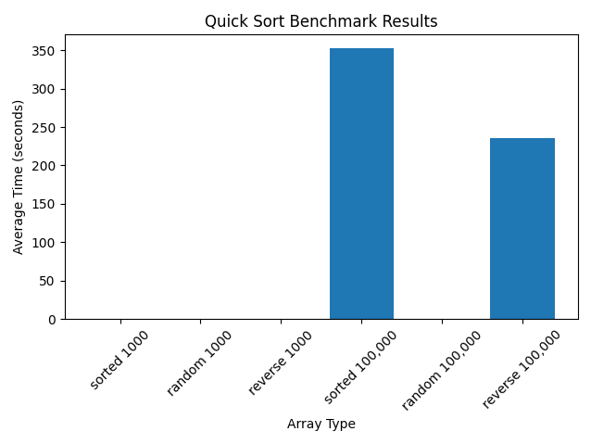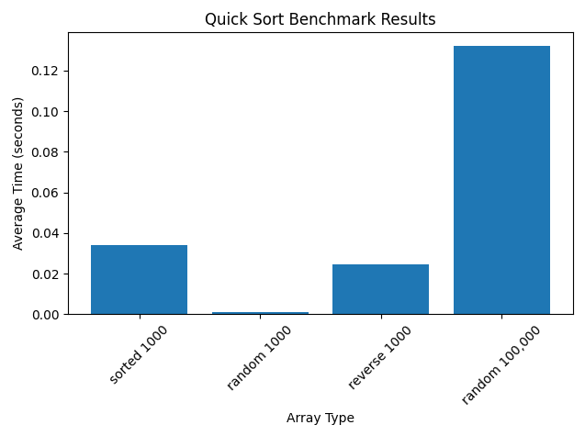
(Time for random 1000 and random 100000 taken over 100 samples and averaged)
Quick Sort is a mixed bag of O(n log n) and O(n²), where quick sort is abysmal when approaching already sorted, or reverse order lists, but is efficient when sorting random order lists.
Quick Sort has it’s best-case time complexity of O(n log n) when sorting random order lists and can handle large data efficiently similar to Merge Sort.
It faulters with sorted and reverse order data, as the algorithm provides bad pivots and creates its worst-case time complexity of O(n²) where the algorithm becomes extremely inefficient, especially with large data, unlike Merge Sort where it is extremely consistent among sorted, reverse, and random data.
Radix Sort (Integer) 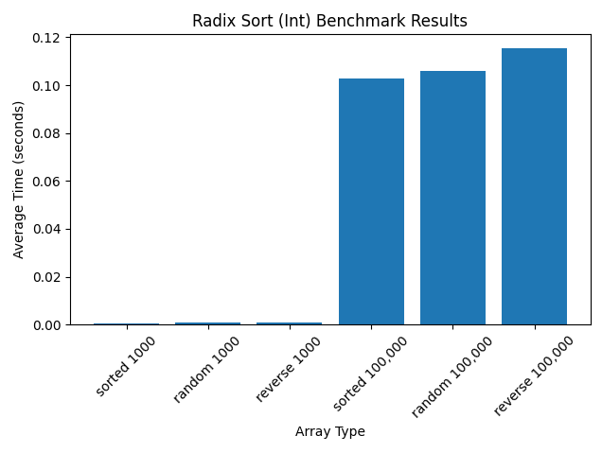
(Time for random 1000 and random 100000 taken over 100 samples and averaged)
Radix Sort for integers, similar to Merge Sort, operates very consistently with a time complexity of O(n * k), where k is the length of the given integer/string. Being so consistent, Radix sort is indifferent to whether a list is sorted, reverse, or random.
Radix Sort of course is faster with less data, but also with data that is shorter in length. Sorting 1000 pieces of data that are 2 digits long would be just the same as sorting 2 pieces of data that are 1000 digits long.
This means that Radix Sort’s worst use case is for large collections of long data, where O(n * k) adds up to be longer than it would take for other algorithms to complete the same task, e.g. Merge Sort.

Radix Sort (String)
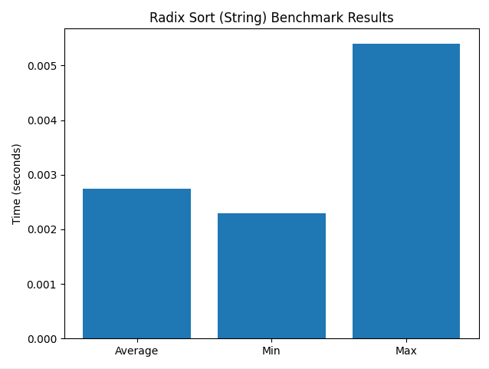
(Time for 1000 random words taken over 100 samples and averaged)
Radix Sort for strings operates similar to how it does for integers, where words are ordered by Most Significant Characters. Just like for integers, sorting strings has a time complexity of O(n * k) where k is the length of a given string.
This means that sorting short lists of long strings is similar in time to sorting long lists of short strings. This gives us a worst-case use of attempting to sort a long list of long strings, and a best case of a short list of short strings.

