CSCI 3110-001 – Advanced Topics in Web Development
Term Project Proposal
Team MVCDeez: Noah Ford, Olivia Smith, Brock Morell
Our project will be to make a web-based IT support system where users can submit and track technical support tickets. IT staff can view, categorize, prioritize, update, comment on, and resolve tickets. Administrators are able to manage users, roles, and assign permissions.
Preliminary UML
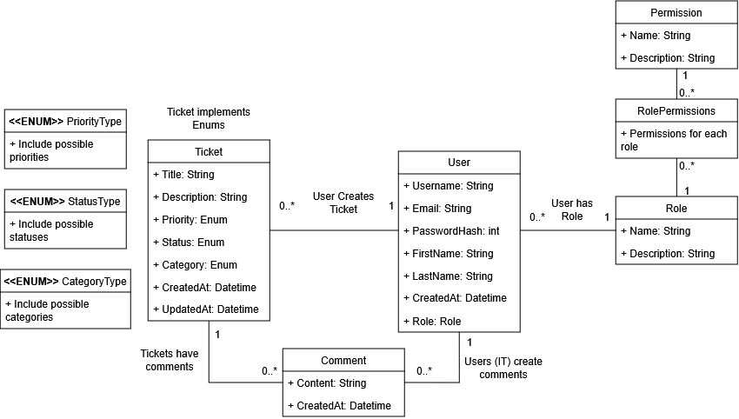
User Stories
- As a User, I want the ability to submit tickets so that I can receive IT support from the IT Staff.
- As an IT Staff member, I want the ability to view and modify ticket priority so that I can accurately assess which tickets need to be investigated first.
- As an Administrator, I want the ability to access anyone's account and modify roles so that I can properly assign roles to all users.
Technology List
Frontend: HTML, CSS, JavaScript | ORM: Entity Framework Core
Backend: C# with ASP.NET Core MVC | Version Control: Git + Github
Database: SQLite Relational Database | Auth: ASP.NET Core Identity
AI Disclosure
For this proposal, we only used AI for helping to decide our Technology list and examples on UML design. Going forward plans to use AI (ChatGPT, Gemini, etc.) ONLY for the purpose of learning and demonstration for concepts we are unfamiliar with.

