Noah Parker

Chapter 15 Study Sheet

In Java, a collection is a framework that provides an architecture for storing and manipulating a collection of objects.

Java Collections are capable of doing any data operations such as searching, sorting, insertion, manipulation, and deletion.

A single unit of objects in Java is referred to as a collection. Many interfaces are available in the Java Collection framework. (Set, List, Queue, Deque) and classes (ArrayList, Vector, LinkedList, PriorityQueue, HashSet, LinkedHashSet, TreeSet).

What is Collection in Java? A Collection represents a single unit of objects, i.e., a group.

|  |
| --- |
| What is a framework in Java  It provides readymade architecture.  It represents a set of classes and interfaces.  It is optional. |

|  |
| --- |
| What is Collection framework  The Collection framework represents a unified architecture for storing and manipulating a group of objects. It has:   1. Interfaces and its implementations, i.e., classes 2. Algorithm |

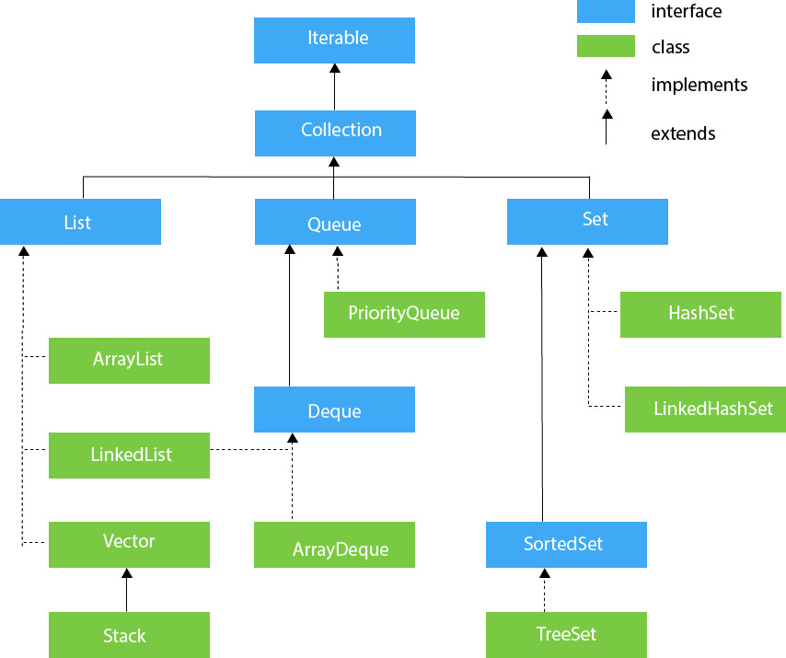This picture shows the hierarchy of the collection framework.

Linked List is a part of the Collection framework present in java. This class is an implementation of the LinkedList data structure which is a linear data structure where the elements are not stored in contiguous locations and every element is a separate object with a data part and address part.

Java Map HierarchyJava Map:A map contains values on the basis of key, i.e. key and value pair. Each key and value pair are known as an entry. A Map contains unique keys. A Map is useful if you have to search, update or delete elements on the basis of a key.

The picture above shows the hierarchy of a java map.

Stacks and queues are linear data structures that follow a particular order to add or remove entities. In this article, you will be introduced to stacks and queues. We will highlight their uses, functionalities, and show you how to implement these data structures in Java.

* A Stack is a first-in, last-out data structure that pops elements in the opposite order than they were pushed. By default, a Stack uses an Array for its internal storage, although this can easily be changed.
* A Queue is a first-in, first-out data structure that pops elements in the same order than they were pushed. By default, a Queue uses an SList for its internal storage, although this can easily be changed.
* A PriorityQueue is a form of queue that keeps its elements in a quasi-sorted state and pops them based on their sorted order rather than in the order that they were pushed. A PriorityQueue uses an Array for its underlying storage.