**Sinusoidal Analysis of BTC Stock & Future Prediction**

Noah G. Wood

College of Computer Science, Baker College

CS1110: Intro To Programming

Dr. Pamela Harris

May 8th, 2022

**Author Note**

Legal Notice: This content is for informational purposes only, it should not be construed as legal, tax, investment, financial, or other advice. **I am not responsible for any losses that may be incurred by using this software for trading or any algorithms therein.**

**Abstract**

Sinusoidal regression appears to provide a more accurate prediction of stock prices in the near term than linear regression and is better able to handle large (bull and bear) spikes than linear regression. Shorter periods of prediction such as weeks and months yield results more likely to be accurate than longer periods of time such as years with quarterly predictions appearing to be the longest useful period for stock prediction using this method. The method of creating the software is

**Sinusoidal Analysis of BTC Stock & Future Prediction**

As part of my “Intro To Programming” course at Baker College, I was tasked with analyzing stock prices. After some preliminary research, I found that many stock analysis implementations are based on Linear Regression (Norris, 2022; West, 2021), however I have also observed that stock prices tend to be sinusoidal in nature with peaks and valleys plotted along a linear slope rather than strictly linear. I decided that it would be interesting to try to develop a prediction based on sinusoidal regression, and so I set about developing Stockalizer, a stock analysis software based on sinusoidal regression.

This software is written in Python. The charts are created with matplotlib, the linear regression functionality is provided by sklearn, and numpy is used for creating and handling n-sized lists, and the built-in library math is used for sin functionality. The bulk of the sinusoidal regression algorithm is based on Angelica Lo Duca’s regression algorithm published on Toward’s Data Science (Duca, 2022), with the major difference being the application of the sine function to each point rather than the aggregate as well as not fitting the past regression to the curve which allows us to see the pure regression prediction for both past and future values.

Additional information was also provided by the software to further help stock analysis such as maximal and minimal differences in any day, largest increase and largest decrease in any N period of time, and a Point() class with a variety of properties was also created to allow for further modification and analysis of the data. Maximal and Miminal linear regression is also plotted so that we can see how the sinusoidal prediction algorithm compares to linear prediction

I decided to test the software on price data for BTC, the ticker name for Bitcoin. The reason I picked this is because it’s known to be highly volatile and difficult for many algorithms to predict price increases and decreases. Applying the sinusoidal algorithm to this data using days, weeks, months, quarters, and years for the period allowed me to generate their respective plots. Daily plotting took a noticeably long time and is very heavy on memory, it’s recommended to use weekly or longer periods for this reason. The daily plot shows just how accurate the sinusoidal prediction is over a short period of time in comparison to the linear regression prediction. The daily sinusoidal matches almost precisely the real daily amounts, although in the Graphical user interface, chart
current configuration, we are only predicting 1 period, so it’s only predicting a single day which might be useful for day trading but is unlikely to be useful for long-term stock picking. It’s also noted that the linear regression algorithm was unable to predict a minimum value for the stock price, and so only the max prediction is shown.

This plot shows us weekly predictions, as you can see, the sinusoidal regression algorithm was able to better predict the prices than simple linear regression was for this time period. It was also noticeably faster to run the prediction than on the daily. Some optimizations of the source may improve this, although the bulk of the delay was in plotting such a large amount of data to the screen. A future improvement might be to not plot data from prior years, as this data is generally superfluous for stock trading and only useful to test the accuracy of the sinusoidal regression algorithm.

The next thing I plotted was the weekly period of the same data, and as we can see in the following plot, the real value is well below the minimally predicted price point using the linear regression algorithm, and it is very likely that next week’s price will also be well below this price point as well. If we zoom in on the last week, we can see how closely the predicted values match the real values. You will notice that there tends to be a gap between the predicted and real values, however the price still clearly follows the prediction making this useful, in a “Heisenberg’s Principle” sort of way

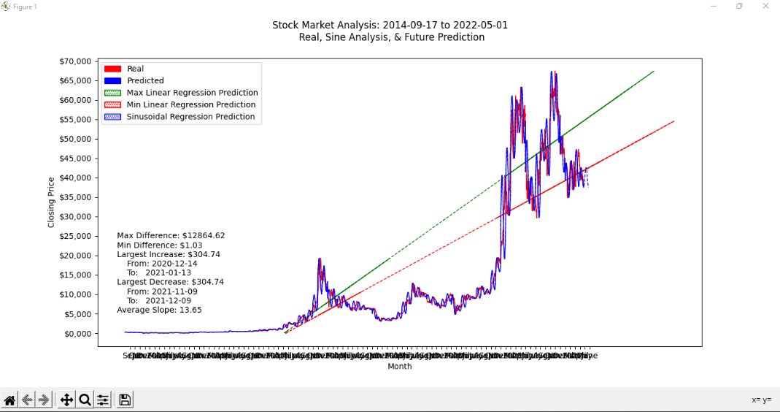 The next plot to look at is the monthly plot, which shows us much the same as the prior weekly regression, although the predicted values are starting to differ a bit more than the real values. Still, in spite of this variance, it’s a much closer match than either max and min linear regression predictions were able to show.

If we look at quarterly predictions, we begin to see even more noise in our sinusoidal predictions. In Q3 of 2016 we predicted a spike, unfortunately we over-predicted how large that spike would be, the spike in Q4 was a much more accurate prediction than prior, and again in 2021 we predicted a spike in Q1 that was a little bit lower than what it really was. Overall, sinusoidal prediction seems to be better able to handle these large spikes than linear prediction is.

If we look at yearly predictions, the spikes that we over-estimated in Q4 have continued growing larger and earlier than they should be, and we’re starting to see a noisier prediction which is to be expected. We really start to hit the limits of usefulness with yearly prediction as the sinusoidal wave now takes up over half of the min/max linear predictions, and the over and under-estimated peaks start to become larger.

Overall, sinusoidal regression provides a much more accurate method of predicting stock prices in the near to mid-term than linear regression. This is particularly true when dealing with the price of something such as bitcoin which has a history of being unstable and rapidly cycling between a bearish and bullish market. These results line up with what we would expect however, as while stocks and other markets tend to have linear growth, that linear growth occurs over a long period of time. Near term traders have also relied on oscillating indicators for some time now, with the closest to this method of analysis being stochastic oscillators which produce similar results to the sinusoidal regression algorithm. At this time, I have not analyzed the predictive capabilities of either in comparison to one another to say with certainty which is better, but the sine regression method will almost certainly be more useful to beginners who do not know how to use complex trading algorithms. Rather than attempt to identify bullish indicators, one would simply be able to see the predicted stock price over the next few weeks and make an informed decision on whether to buy or sell that stock. This provides an extremely simplified trading strategy for people interested in near-term stock trading while also providing another technical indicator to aid professional investors. The inclusion of the max/min linear regression is also likely to be useful for investors in determining potential losses, like Bollinger bands.

Further improvements to this software might include providing clear buy/sell signals based on the regression data, adding in additional technical indicators, integrating with other stock market data providers, etc. Closing price was the only value that regression was performed on, however opening, average, and other values might provide even more useful information. One idea is to create a sinusoidal max/min regression prediction to provide an even more accurate short-term profit and loss prediction than the linear regression provides. In moving towards usability, replacing matplotlib with a full GUI, and integrating with trading platforms would make this software an even more valuable asset for part-time traders.

**References**

Duca, A. L. (2022, April 20). *How to predict a variable sinusoid in Python*. Medium. Retrieved May 8, 2022, from https://towardsdatascience.com/how-to-predict-a-variable-sinusoid-in-python-4a21404dc061

Norris, E. (2022, January 6). *The linear regression of time and price*. Investopedia. Retrieved May 5, 2022, from https://www.investopedia.com/articles/trading/09/linear-regression-time-price.asp

West, Z. (2021, December 3). *Predicting stock prices with linear regression in python*. αlphαrithms. Retrieved May 10, 2022, from https://www.alpharithms.com/predicting-stock-prices-with-linear-regression-214618/

Wood, N. (2022, May 5th). *Stockalizer source code* [Source code]. <https://github.com/NoahGWood/Stockalizer>

BTC-USD. (2014-2022, September 14th-May 5th). *Bitcoin Historical Price* [Stock data]. Retrieved May 5th, 2022, from https://finance.yahoo.com/quote/BTC-USD/profile?p=BTC-USD