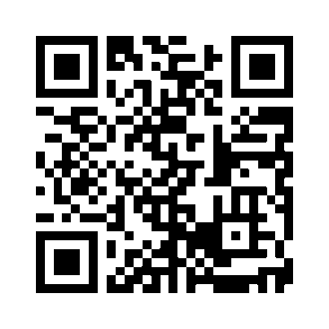
Education
Bachelor of Science, Marine Biology
Discover more: Scan this to engage with my interactive, AI driven resume and explore my background in a new way.

Florida Institute of Technology, Melbourne, Fl | 2017- 2021
- Dean’s List. 2019 – 2021
Master of Science, Environmental Science and Policy
Northeastern University, Boston, Ma | 2022-2024

Experience
Teaching Assistant, Three Seas Program
Northeastern University, Boston, MA | June 2022 – May 2024
- Supervised instructional and training dives under AAUS scientific diving standards
- Mentored 20+ students in dive safety, protocols, and underwater task execution.
- Developed quizzes to assess diving theory comprehension.
- Managed diving equipment and supervised hands-on training.
Marine Ecology Research Technician, Kimbro Lab
Northeastern University, Boston, MA | August 2022 – May 2023
- Provided SCUBA field support for marine ecology research projects.
- Conducted underwater research assistance and task-based dives
- Led meta-analysis on Artificial Reef Units using R and ArcGIS.
- Synthesized scientific literature and created spatial visualizations.

SCUBA and Field Skills
- SCUBA Skills: Scientific Diving (AAUS), cold water and low visibility diving, dive planning and risk assessment, equipment maintenance, underwater data collection, ecological fieldwork and sampling

Technical and Analytical Skills: Python, R, ArcGIS, Tableau, Agent Development Kit (ADK), Machine Learning, Gemini, Ollama, Kaggle, LangChain

Project & Leadership Skills: Project Management, Team Leadership, Scientific Communication

Certifications
- AAUS Scientific Diver, American Academy of Underwater Sciences, 2019
- 95+ logged dives (cold water, low visibility, instructional diving)
- Master SCUBA diver, PADI, 2014
- NITROX Scuba diver, PADI, 2018
- Protected Species Observer, AIS, 2021
- Florida Boat Operating License, NASBLA, 2019

Volunteer Work
Grafton Massachusetts Conservation Commissioner
June 2025– Present
- Reviewed 25+ development proposals and ensured compliance with Massachusetts Wetlands Protection Act and local environmental regulations
- Collaborated with 50+ community members, developers, and municipal staff on land use and conservation projects
- Assessed ecological impacts and prioritized conservation initiatives

