Face removal tool
Noah Hallows
Manual

Installation:

For the final release there will be an executable however as this is a beta the user will have to install the dependencies and run the .py file. While it is recommend to install the dependencies inside a python virtual environment it is often possible to install them site wide. To install the required python packages run pip install -r requirements.txt from the directory containing the coded solution.

Basic usage:

Running:
To run the program open a terminal inside the directory containing the coded solution and activate the python virtual environment if it was used. Then type python3 main_qt.py to run.

Selecting image containing face to search for:
This image contains the face the application will search for in the other images. This image should contain a single clear and well lit face. For best results select an image where the target is in the foreground. This has to be a .jpg or .png image.
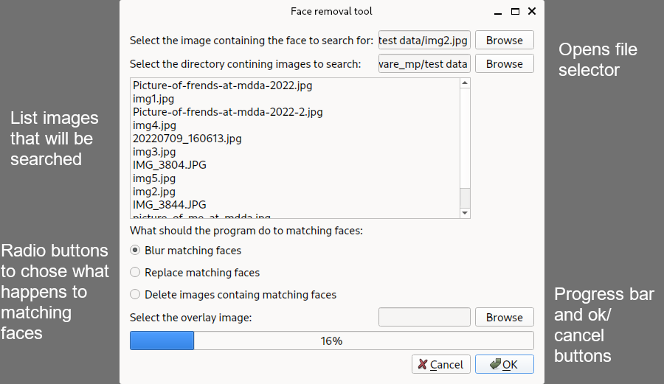
Selecting directory containing images to search:
This is the directory containing the images the application will search through. Any images in sub-directories will also be searched. It will only run on .png or .jpg images

Choosing action for application to take on matching images:
There are three options for what the application should do once it finds a marching face in one of the images. The first option blurs the face but leaves the rest of the image intact. The second option replaces the matching face with an overlay, obscuring the face but leaving the rest of the image intact. The third option simply deletes the image.

Overlay image:
The overlay image is an image that gets placed over the matching face in the original image. For example

Troubleshooting:

Error running:
Attempt to reinstall the dependencies to a new virtual environment and fix any errors. The Dlib dependency requires additional packages to be installed on some Linux machines such as Fedora based computers. Ensure that the latest version of python is installed.

Error detecting faces:
Ensure that the image containing the face the program is searching contains only one well lit face. Also check that the file types are .jpg or .png.

