Noah Henry

5/16/2022

Professor Beck

Intro to Programming

Order Organizer Quick User Guide:

Order Organizer is a simple Python program designed to give catering and food service workers an easy way to input relevant personal and order information given by a customer and create an organized list of the orders. It achieves this by prompting the user to add information about a customer’s order piece by piece one customer at a time. The program is designed to display customer information for both one customer and multiple customers depending on the needs of the user. The program prompts suggested formats for things like pick-up date, pick-up time, and the customer’s phone number but has intentionally left these inputs adaptable to fit the needs of individual users. It is recommended that you use these suggested formats to make the table more legible, but it is not a requirement.

How to guide:

The program will first prompt the user with a message box asking if they’d like to input a customer’s information:

Selecting “OK” will allow the user to begin entering information about a customer, selecting “Cancel” will close the program.

If the user selects “OK” the program will then prompt the user for further inputs one at a time. These inputs will be the customer’s first and last names, phone number, the pick-up date and time of their order, and what items the customer has placed an order for. Chart
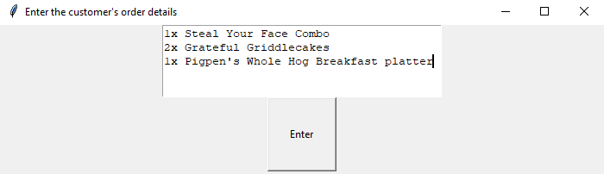

Once the user has finished inputting all the required customer details the program will print out a list of the order details in the same format, they were entered in like so:

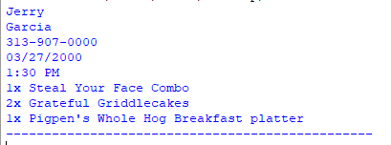

The program will then automatically prompt the user again on weather they would like to exit the program or enter another customer’s information:

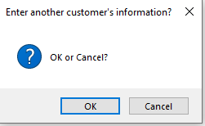

Once again selecting “OK” will allow the user to input customer information and selecting “Cancel” will exit.