PlantBot: A Mobile-Friendly Remote Plant Monitoring and Watering System
Phase III Combined Research and Implementation Report
Dr. Iqbal
COSC 6355 - Mobile Computing
Noah Nieberle
April 27, 2026
A lightweight mobile-friendly demo for remote plant observation, safe watering control, and Cloudflare-ready public deployment.

1. Title of the Problem
PlantBot: A mobile-friendly remote plant monitoring and watering system with Raspberry Pi-style control, browser camera preview, and payment-triggered watering credits.

2. Abstract
This report presents PlantBot, a small remote plant-watering demo built to test the full path from a browser button to a device-side control service. Instead of starting with hardware, I built the first version as two Flask containers in Docker Compose: one acts as the web server and one acts as a Raspberry Pi-style controller. The main page shows a live camera view, pump status, a soil dashboard link, and one Water Plant button. On the controller side, the service simulates pump activation, automatic shutoff, cooldown protection, soil hydration changes, and event logging. I also added an optional PayPal credit flow so a completed payment can be turned into one queued watering action, with Cloudflare expected to provide the public HTTPS endpoint in a real deployment. The system stays intentionally small: there is no database, no user-account system, and no scheduling engine. Even with those limits, the prototype still demonstrates the mobile-computing ideas that matter here: remote observation, remote actuation, safe device control, and fast user feedback. For that reason, PlantBot works both as a classroom prototype and as a starting point for a later Raspberry Pi hardware build.

3. Keywords
Mobile computing, remote plant watering, Raspberry Pi simulation, Flask, Docker Compose

4. Introduction
Remote control of physical devices is a good fit for mobile computing because the whole point of the phone or browser client is to let the user act from somewhere else. A plant-watering system is a simple example, but it still has the hard parts of the larger problem: the user needs to see something, send a command, and trust that the system will not behave unsafely after the button is pressed. If any of those pieces are missing, the experience feels incomplete.
Most of the work I reviewed on smart irrigation uses Raspberry Pi or similar controllers together with soil sensors, relays, cloud dashboards, and automated watering rules [1]-[4]. Those systems are useful, especially for agriculture and long-running monitoring, but they are harder to demo quickly because they depend on physical hardware being stable from the start. At the web layer there are also practical constraints: browser camera access usually wants a secure context [6], and public webhooks are much easier to handle when a reverse proxy such as Cloudflare sits in front of the app [9].
Because of that, I built PlantBot as a staged prototype. The current version runs as two Flask containers: a web server on port 5000 and a Raspberry Pi simulator on port 5001. The browser shows either the laptop camera through getUserMedia or a proxied camera feed, and the main action is a single Water Plant button. When that button is pressed, the web server sends a request to the simulator, the simulator decides whether watering is allowed, and if allowed it turns the simulated pump on for a fixed time and then turns it off automatically. Later in the project, I added an optional PayPal watering-credit flow for public demos.
The work here is less about inventing a new irrigation algorithm and more about building a clean end-to-end control path that can actually be shown and tested. The useful pieces are the two-service split, the decision to keep webcam handling in the browser, the safety rules around cooldown and shutoff, the soil dashboard for visible state changes, and a deployment path that can move from localhost to a Cloudflare-protected public demo without changing the basic API structure.
The report starts with the motivation and system characteristics, then reviews related work and compares PlantBot with other common approaches. After that, it walks through the design, implementation details, and evaluation results. The last sections cover strengths, weaknesses, impact, future work, and the implementation deliverables required for the project.

5. Motivation
The main motivation for PlantBot was practical: I wanted a version of a remote watering system that I could actually run, explain, and debug on a normal laptop before committing to full hardware. A complete build with a Raspberry Pi, relay, pump, valve, moisture sensor, and public networking is absolutely possible, but it adds several failure points at once. For a class project, that makes it harder to show what part of the system is working and what part is failing.
A simple use case makes the idea clear. If someone is away from home and wants to check a desk plant, the experience should be short and obvious: open the page, look at the plant, press one button, and see whether watering happened. Another use case is a demo or livestream where viewers can trigger one watering event through a payment flow. In that case the interface still needs guardrails, because multiple users pressing at once should not stack ten water cycles back-to-back.
Those use cases pushed the design in a specific direction. I kept the interface small, put the safety decisions on the device side, and made the system show its state in plain language instead of hiding it. I also wanted something I could move between local testing, same-Wi-Fi testing, and a public Cloudflare setup without rewriting the app. That is why PlantBot looks more like a clean prototype than a feature-heavy smart-home product.

6. Characteristics of the Problem/System

6.1 Functional Characteristics
- The user must be able to observe the plant while interacting with the system.
- A watering action must be one click from the main interface.
- The control service must confirm success or failure with JSON responses and visible status text.
- The device-side service must own the final pump state and must automatically turn the pump off after a fixed duration.
- The system must surface current state such as pump on/off, cooldown, and soil hydration to support user trust.

6.2 Constraints and Safety Characteristics
- The project must remain easy to deploy on a normal laptop using Docker Compose and two application containers.
- Containers should not require direct access to the laptop camera, because browser camera access is more portable across platforms [6].
- Repeated requests must not stack indefinitely; a cooldown or lock is required on the device side and is helpful on the web side.
- A public-facing version should assume HTTPS, reverse-proxy protection, and webhook filtering through Cloudflare rather than exposing the device service directly.
- The prototype should avoid a database so that the control logic stays easy to understand and modify.

6.3 Mobile Computing Characteristics
Although PlantBot is presented as a web demo, its interaction style is mobile-oriented. The interface is responsive, the actuation path is short, and the camera permission model matches the secure-context requirements of modern browsers [6]. The API boundary between the frontend and backend also makes it straightforward to replace the browser UI with a native mobile application in the future.

7. Related Works
The papers and systems I looked at mostly fit into three practical groups. The first group is sensor-first irrigation research, where the focus is automatic watering based on soil moisture, weather, or crop conditions [1], [2]. These projects are useful because they try to save water and reduce manual labor. They usually include a controller board, one or more sensors, a relay, and some kind of cloud or local monitoring dashboard. The limitation for my project is that the hardware stack is already the main story, so it is harder to isolate the communication path and user experience.
The second group is Raspberry Pi or ARM-based remote monitoring systems that expose irrigation data and controls through web pages or mobile clients [3], [4]. These are closer to PlantBot because they care about visibility as well as actuation. In many of them, however, the codebase quickly grows to include sensor drivers, logging, dashboards, automation rules, and remote hosting concerns all at once. That is a reasonable direction for a production system, but it is heavier than what I needed for a controlled classroom demonstration.
The third group is commercial smart-device ecosystems. These products usually provide polished apps, device pairing, notifications, and cloud management. Their advantage is convenience for end users. Their downside for a project like this is that the internal control flow is mostly hidden, the API surface is limited or proprietary, and it is difficult to explain exactly where safety checks happen or how a payment-triggered event would be inserted into the pipeline.
PlantBot takes ideas from the first two groups but keeps the scope narrower. I kept the Raspberry Pi service model, a dashboard, and the idea of visible device state, but I replaced the real hardware layer with a simulator so the request flow could be tested first. I also treated live viewing as part of the system instead of an optional extra. That mattered because the user experience is much better when the person can see the plant while pressing the button rather than watering blindly.
The biggest difference is really the goal. Many existing systems are built to automate irrigation for long periods. PlantBot is built to show, clearly and safely, how a mobile-friendly client can talk to a device-side controller, how the controller can enforce its own rules, and how that same structure could later be connected to real hardware, Cloudflare, and verified payment events.

8. A Comparison Table with Other Approaches
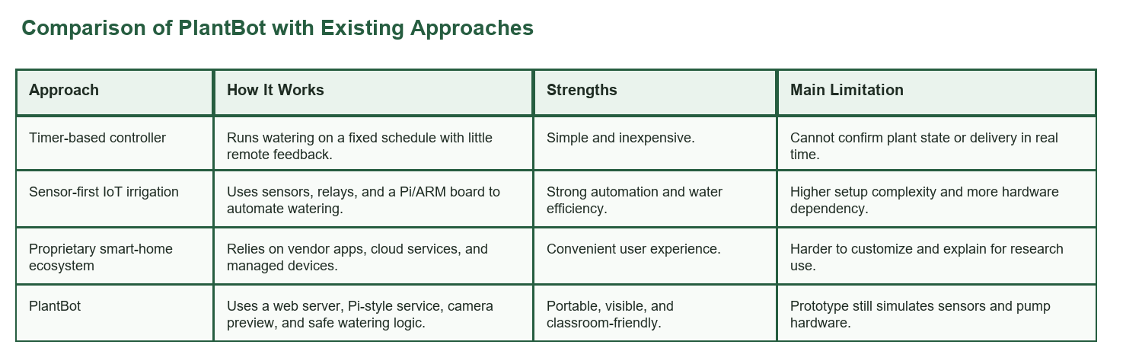
Figure 1. Comparison table for PlantBot and representative alternatives.
Compared with existing approaches, PlantBot mainly improves portability, demonstration clarity, and human-observable actuation. Its tradeoff is that it is intentionally less autonomous than fully sensor-driven irrigation systems and less mature than production smart-home ecosystems.

9. Overview of the Proposed Solution
PlantBot runs as two containers in Docker Compose [7]. The `web-server` container serves the frontend, answers the browser API calls, and forwards watering commands. The `raspberry-pi-simulator` container acts like the device side: it owns the pump state, cooldown timer, soil simulation, watering counters, and dashboard data. Keeping those responsibilities separate made the request flow easier to debug during testing because I could see whether a problem was in the UI, the middle layer, or the device logic.
The observation layer has two modes. In browser mode, the page asks for camera access with getUserMedia and shows the laptop webcam directly in the browser [6]. I chose that path because direct webcam access from Docker is inconsistent across laptops and would have made the demo harder to run. In camera-proxy mode, the web server can instead connect to an RTSP source and re-serve frames as MJPEG. In both cases the browser stays simple, while the device-side service remains the only place that can actually accept or reject a watering request.
For public use, the plan is to place the web server behind Cloudflare and let PayPal call back into a verified webhook endpoint after payment [8], [9]. Instead of mapping money directly to immediate pump activation, the system stores a watering credit and lets a background worker redeem it only when the simulator is ready. That small change is important because it keeps payment handling and safety handling from becoming the same thing.

10. Details of the Solution

10.1 Architecture and Service Boundaries
I used Flask for both services because the project only needed a few HTML routes and a few JSON endpoints, and Flask makes that easy to trace in code [5]. The web-server side owns the template, frontend JavaScript, camera mode selection, PayPal-related logic, and the calls into the device API. The Raspberry Pi simulator owns the state that actually matters for safety: whether the pump is on, when it last ran, whether cooldown is still active, and how the soil model changes over time. Docker Compose wires the two services together on a local network so the web server can call the simulator by container name [7].

10.2 Frontend and Camera Layer
The main page was kept intentionally plain. It shows a live camera area, one Water Plant button, a message area, pump state, cooldown timing, and payment status. In browser mode, the frontend asks for camera permission through `navigator.mediaDevices.getUserMedia`, which is the most portable way to use the laptop camera in this setup [6]. That choice also explains why HTTPS becomes important outside localhost: modern browsers are stricter about camera access in insecure contexts. To keep the implementation simple, the page polls the backend every 1.5 seconds instead of using WebSockets.

10.3 Web-Server Backend
On the backend, the web server exposes `GET /` for the page, `GET /api/status` for pump and soil state, `POST /api/water` for the main button, `GET /api/payment_status` for the payment card, and `POST /api/paypal/webhook` for verified PayPal events. I also added a small `PaymentCreditWorker` loop that periodically checks whether a queued watering credit can be redeemed. The important rule is that this service never makes the final safety decision. It can request watering, but the simulator is still allowed to say no.

10.4 Raspberry Pi Simulator
The simulator exposes just two core endpoints: `POST /water` and `GET /status`. Internally it keeps the pump state in memory, protects state changes with a lock, and starts a fixed-duration watering cycle when the request is accepted. I also added a lightweight soil model that increases hydration while watering and slowly dries out afterward. That model is not meant to be scientifically precise; it exists so the dashboard can show visible changes in hydration, condition, and watering counts during the demo.

10.5 Safety, Cooldown, and Auto-Shutoff
The safety logic is simple on purpose. First, watering always has a fixed duration, so the pump turns itself off after the configured number of seconds even if the client disappears. Second, a cooldown blocks rapid repeat activations. This mattered in testing because it is easy to click twice or to trigger overlapping requests from different clients. Third, the payment-credit worker only consumes a credit after the simulator has actually accepted the watering request. Taken together, these checks keep the demo from behaving unpredictably.

10.6 Payment and Cloudflare Security Model
The PayPal path was added after the base watering demo was already working. When enabled, the frontend creates an order through the web server, captures it after user approval, and then waits for a verified `PAYMENT.CAPTURE.COMPLETED` webhook from PayPal [8]. The webhook signature is checked before any credit is added. For public deployment, Cloudflare is expected to provide the HTTPS hostname and reverse-proxy layer [9]. The current code also trusts forwarded headers from a configurable proxy count so the app can behave correctly when it sits behind Cloudflare.

10.7 Data and Class Structure
The core data entities are simple. Pump state includes whether the pump is on, when it was last activated, and how much time remains. Soil state includes hydration, target range, temperature, pH, and derived condition. Payment state includes queued credits, processed captures, and last fulfillment status. The class layout mirrors this simplicity: the web package focuses on routing, camera proxying, and payment orchestration, while the device package focuses on pump control, soil simulation, and dashboard reporting.

10.8 Deployment and Portability
One of the better outcomes of the project is that the same code works in a few different demo styles. Locally, both services come up with `docker compose up --build`, the browser uses `localhost`, and the webcam stays outside the containers [7]. On a shared Wi-Fi network, the same web UI can still talk to the device-side service by host/IP. For a public demo, the web server can sit behind Cloudflare while the device-side service stays private. That progression from laptop to public demo happened without changing the basic routes, which is exactly what I wanted from the architecture.

11. Evaluate the Solution
The solution was evaluated as a working implementation and simulation rather than a formal proof. The goal of evaluation was to confirm that the communication path, safety rules, camera behavior, and dashboard updates all function as designed.
- Container startup: docker compose up --build -d launched both services and exposed ports 5000 and 5001.
- Frontend reachability: GET / and GET /api/status returned HTTP 200 and valid JSON state.
- Manual watering: POST /api/water returned pump_on=true and began a 5-second watering cycle.
- Cooldown enforcement: an immediate second activation was rejected until the cooldown expired.
- Payment-state endpoint: GET /api/payment_status returned a valid idle state when PayPal was disabled.
- Cloudflare-facing headers: API responses included no-store cache headers and browser security headers.
I also checked the UI directly through the running demo and the saved prototype screenshots. The main page showed the camera area, watering controls, payment card, and live status cards in the expected places. The Raspberry Pi dashboard showed hydration, temperature, pH, recent events, and watering counters updating after a watering cycle. In short, the prototype behaved like a usable demo and not just like a set of isolated API endpoints.
The evaluation is still limited. It focuses on a local demo, not on weeks of real plant care. It does not measure physical pump current, actual sensor drift, packet loss to a remote Raspberry Pi, or abuse cases in a real public payment flow. Even so, for the scope of this project, the implementation is enough to show that the communication model and the safety rules work the way they were intended to work.

12. Strength and Weakness of the Solution

Strengths
- Very small architecture that is easy to explain and easy to deploy.
- Strong separation between user interface logic and device-side safety decisions.
- Live camera viewing makes watering observable instead of blind.
- Cooldown and auto-shutoff create a safer actuation model than naive button-triggered control.
- Cloudflare and PayPal integration paths make the prototype extensible to public demos.

Weaknesses
- The current prototype relies on simulated pump and soil state rather than full hardware verification.
- Payment credit state is kept in memory, so it would need persistence for production use.
- Browser camera mode depends on user permission and secure deployment behavior.
- The current model does not yet include real sensor-based decision making.

13. Broad Impact of the Research Result
The broader value of PlantBot is mostly educational and practical. It gives students a small example of how mobile clients, web services, and device-side control can fit together without needing a large lab setup. Because the code uses common tools such as Python, Flask, Docker, browser APIs, and a Raspberry Pi-style service split, the barrier to entry is fairly low. The project also shows a responsible pattern for connecting public web traffic to a physical action: verify the request, keep the safety logic near the device, and do not expose the device directly if a safer proxy path is available. Those lessons can carry over to other device-control systems such as home automation, assistive technology, or environmental monitoring.

14. Discussion
The project ended up being strongest where it stayed simple. The web UI, the simulator, and the dashboard are all easy to explain, and that makes debugging easier too. The tradeoff is that some parts are still clearly prototype pieces, especially the in-memory state and the simulated soil model. I think that is acceptable for this phase of the project, because the point was to prove the request flow and safety behavior first. From here, the best path is to swap in real hardware and persistence carefully instead of adding unrelated features.

15. Future Works
- Replace the Raspberry Pi simulator with real GPIO, relay, and pump hardware.
- Attach real soil moisture and reservoir-level sensors for closed-loop watering decisions.
- Move payment credits and event logs into persistent storage.
- Add a native mobile client that reuses the same API contract.
- Expand Cloudflare rules and monitoring for public demonstration traffic.

16. References
[1] P. Nandhini, V. Kalpana, and J. Sikkandhar Batcha, "IoT Based Smart Agriculture Monitoring and Irrigation System Using Raspberry Pi Kit," International Journal of Engineering Development and Research, vol. 6, no. 2, pp. 820-824, 2018.
[2] R. Anitha, D. Suresh, P. Gnaneswar, and M. M. Puneeth, "IoT Based Automatic Soil Moisture Monitoring System using Raspberry PI," International Journal of Innovative Technology and Exploring Engineering, vol. 9, no. 2, pp. 4375-4379, Dec. 2019, doi: 10.35940/ijitee.B9002.129219.
[3] H. Tu, X. Liu, Y. Li, and C. Ma, "Design and Implementation of Soil Moisture Monitoring and Irrigation System based on ARM and IoT," Procedia Computer Science, vol. 208, pp. 486-493, 2022, doi: 10.1016/j.procs.2022.10.067.
[4] K. Shashidhar, G. Phanisahithi, M. Aniketh, B. Rahul, and N. Manoj Kumar, "Smart Irrigation Using Raspberry Pi," International Journal of Data Science and IoT Management System, vol. 4, no. 4, pp. 366-370, 2025, doi: 10.64751/ijdim.2025.v4.n4.pp366-370.
[5] Pallets, "Flask Documentation (3.1.x)," Flask, 2026. [Online]. Available: https://flask.palletsprojects.com/en/stable/.
[6] Mozilla, "MediaDevices: getUserMedia() method," MDN Web Docs, 2026. [Online]. Available: https://developer.mozilla.org/en-US/docs/Web/API/MediaDevices/getUserMedia.
[7] Docker, "docker compose," Docker Docs, 2026. [Online]. Available: https://docs.docker.com/reference/cli/docker/compose/.
[8] PayPal, "Webhooks API and webhook signature verification," PayPal Developer, 2026. [Online]. Available: https://developer.paypal.com/docs/api/webhooks/v1/.
[9] Cloudflare, "Cloudflare Tunnel," Cloudflare Docs, 2026. [Online]. Available: https://developers.cloudflare.com/tunnel/.

Part II. Implementation Project Deliverables

A. Title of the Project
PlantBot: Remote Plant Monitoring, Watering Control, and Payment-Triggered Watering Credits

B. Detailed Functional Requirements
- FR-1: The system shall serve a main web page from the web-server container.
- FR-2: The main page shall display a live camera preview using browser getUserMedia or a proxied network feed.
- FR-3: The main page shall display a Water Plant button and current pump status.
- FR-4: The frontend shall send watering requests to the web-server backend over HTTP.
- FR-5: The web server shall forward approved watering commands to the Raspberry Pi simulator.
- FR-6: The Raspberry Pi simulator shall turn the pump on for a fixed duration and then turn it off automatically.
- FR-7: The simulator shall enforce cooldown protection and reject overlapping activations.
- FR-8: The simulator shall expose status and dashboard APIs that report soil and watering metrics.
- FR-9: When payment is enabled, the web server shall create, capture, and verify PayPal-triggered watering credits.
- FR-10: The system shall provide JSON responses for status, watering, payment, and dashboard endpoints.

C. Detailed Non-Functional Requirements
- Performance: Status polling should feel near-real-time; the UI currently refreshes every 1.5 seconds.
- Reliability: Pump auto-shutoff must happen even if the client stops polling.
- Security: Public deployment should use Cloudflare-backed HTTPS and verified PayPal webhooks.
- Usability: The interface should keep the primary action visible and understandable from a mobile browser.
- Maintainability: Services should remain small, use environment variables, and avoid hardcoded secrets.
- Portability: The prototype should run on a normal laptop with Docker Desktop and Python-based containers.

D. Use Case Diagram
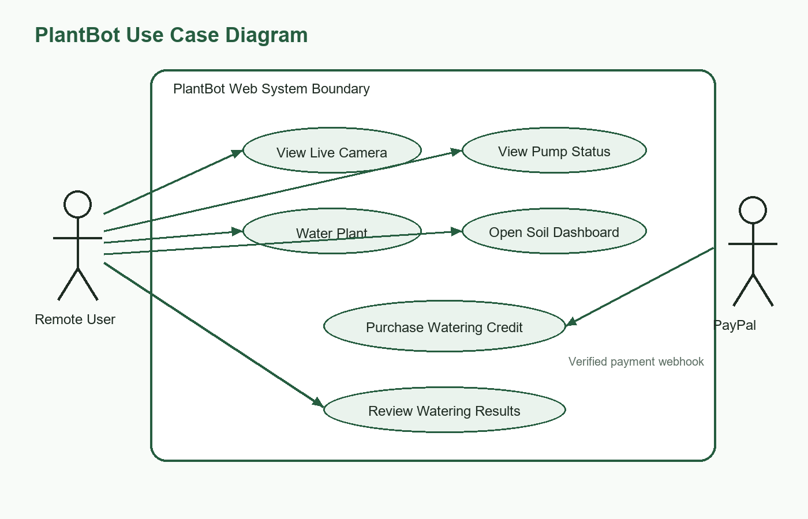
Figure 2. Use case diagram included in the implementation section.

E. Interaction Diagrams
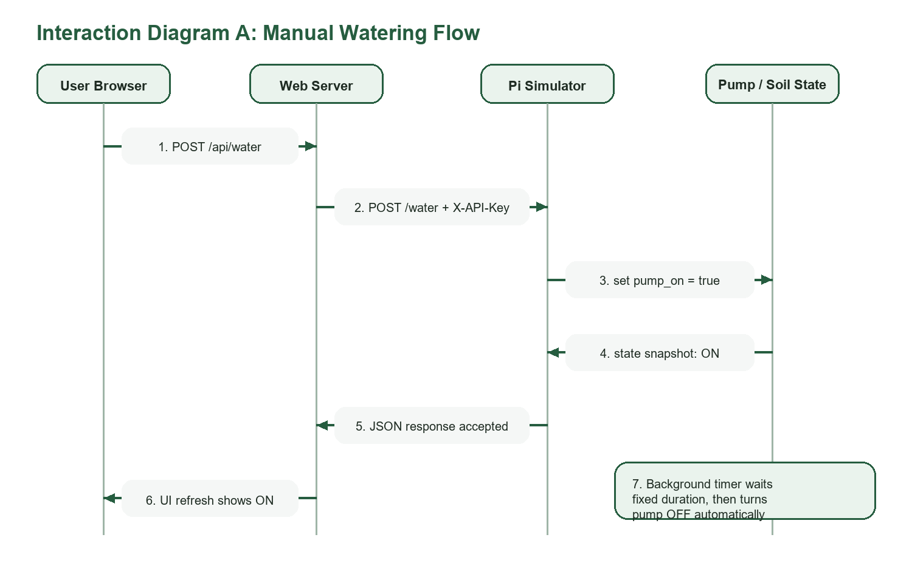
Figure 3. Watering interaction diagram.
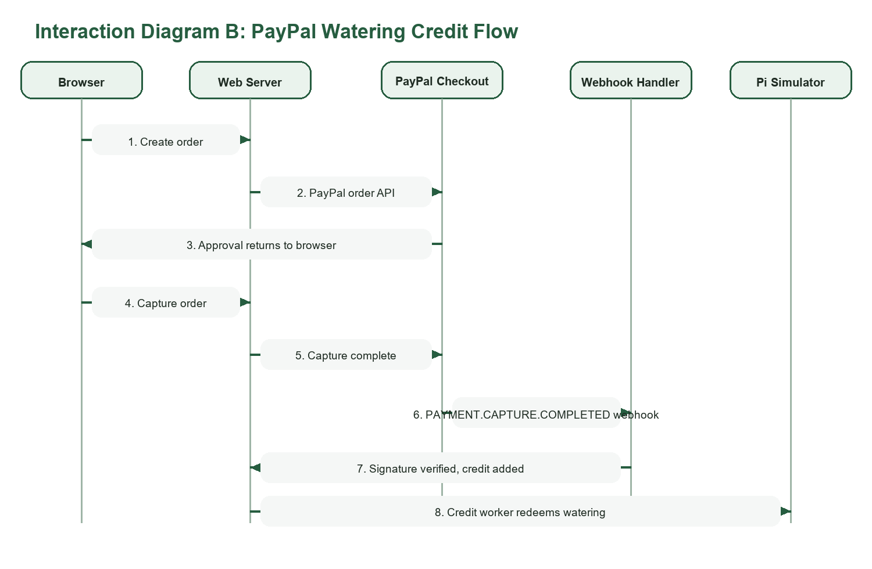
Figure 4. Payment-credit interaction diagram.

F. Detailed Class Diagram (Including Packages)
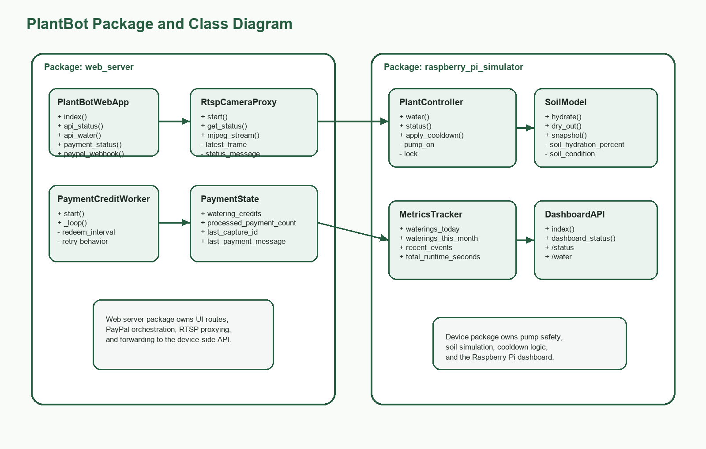
Figure 5. Package-aware class diagram for PlantBot.

G. Test Plan
- TC-1: Start both containers with Docker Compose. Expected result: both services bind to localhost. Actual result: passed.
- TC-2: Open the main UI. Expected result: browser renders the control page. Actual result: passed.
- TC-3: Allow camera access in browser mode. Expected result: camera preview appears. Actual result: passed.
- TC-4: Click Water Plant once. Expected result: pump state turns ON then OFF after the fixed duration. Actual result: passed.
- TC-5: Click again immediately. Expected result: cooldown prevents stacked activation. Actual result: passed.
- TC-6: Open the Raspberry Pi dashboard. Expected result: soil and watering metrics update after watering. Actual result: passed.
- TC-7: Call /api/payment_status. Expected result: valid JSON state is returned even when PayPal is disabled. Actual result: passed.

H. User Guide
1. Start the prototype with docker compose up --build from the docker_plant_demo project folder.
2. Open http://localhost:5000 in a browser.
3. If using laptop-camera mode, allow the browser to access the camera.
4. Watch the live preview and the current pump status cards.
5. Press Water Plant to trigger a watering cycle.
6. Observe the pump state change to ON and then back to OFF after the fixed duration.
7. Open http://localhost:5001 to inspect the Raspberry Pi dashboard and soil metrics.
8. If PayPal is configured, use the checkout button to purchase a watering credit and wait for webhook confirmation.

I. Tools, Programming Language, and Environment
- Python 3.11: keeps both services easy to read, modify, and deploy.
- Flask: provides a lightweight framework for HTML routes and JSON APIs [5].
- requests: handles service-to-service HTTP communication cleanly.
- Docker Compose: starts the full two-service system with one command and preserves portability [7].
- HTML/CSS/JavaScript: supports a simple browser-based UI without a heavy frontend stack.
- PayPal plus Cloudflare: supports public payment-triggered watering with HTTPS and proxy protection [8], [9].

J. Installation Guide and Prototype Screenshots
1. Install Docker Desktop and confirm the Linux engine is running.
2. Open the project folder C:\Users\noahn\Repo\docker_plant_demo.
3. Review the .env file and set camera mode, simulator key, and optional PayPal values.
4. Run docker compose up --build.
5. Visit http://localhost:5000 for the main UI and http://localhost:5001 for the dashboard.
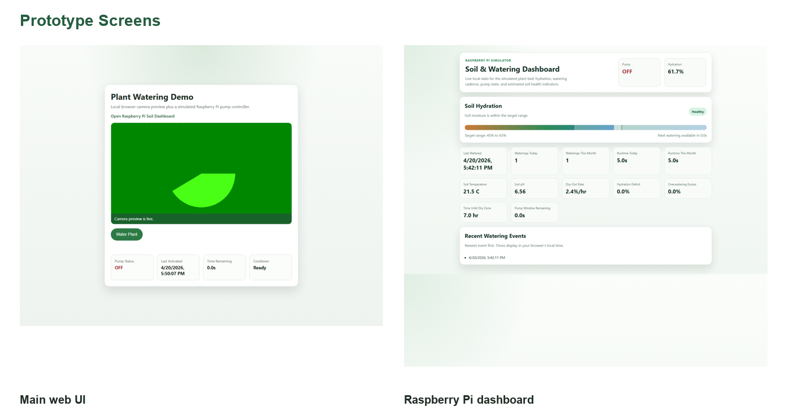
Figure 6. Prototype screenshots of the main web interface and Raspberry Pi dashboard.

K. Prototype Summary and Submission Checklist
- Prototype completed as a working two-container Docker application.
- Research report and implementation material combined in this document for easier submission.
- Codebase available in the local PlantBot demo project folder.
- Presentation slides and demonstration video can be prepared directly from the included screenshots and diagrams.

