**CMPE 460 Laboratory Exercise 8 Lab**

**Heartrate Monitor**

Noah Lutz and Alejandro Vasquez-Lopez

Performed 11/1/19

Submitted 11/15/19

Lab Section 02

Instructor: Louis Beato

TA: Nicholas Amatruda

Michael Baumgarten

John DeBrino

Lecture Section 01

Professor: Louis Beato

By submitting this report, you attest that you neither have given nor have received any assistance (including writing, collecting data, plotting figures, tables or graphs, or using previous student reports as a reference), and you further acknowledge that giving or receiving such assistance will result in a failing grade for this course.

|  |  |
| --- | --- |
| Your Signature: |  |

**Contents**

**Abstract………………………………………………..…………………………….……3**

**Design Methodology.………………………………………………….…………….……3**

**Results and Analysis………………………………………………….…………….……6**

**Conclusion…………………………………………………………….…………….……9**

**Appendix ………………………………………….………………….…………………10**

**Abstract**

The purpose of this exercise was to design and implement a heartrate monitor. The heart rate monitors signal would pass through stages known as the acquisition, conditioning and processing stage. The methodology for retrieving the heart rate of a person is via the Photoplethysmogram (PPG) where the blood volume is measured on the finger tip to detect a heartbeat. In order to acquire the change in blood volume, the OPB745 opt-isolator circuit was used in conjunction with a high-pass filter followed by a low-pass filter. Once the circuit was implemented, the schematic constructed in PSPICE was then ported over to Eagle to construct the PCB. The lab proved to be successful as the results obtained correlated to the simulation performed in PSPICE. Furthermore, the PCB designed in Eagle was successfully processed by OSH Park and ready for production and ordering.

**Design Methodology**

There consists more than one method to implement the heart rate monitor, in the case of this lab, our design followed the use of the Photoplethysmogram (PPG) which monitors the changes in blood volume. Essentially, monitoring directly into the dermis and subcutaneous tissue of the skin which will then detect the perfusion of blood to provide an accurate heart rate. For this exercise, the OPB745 was placed directly on the index fingers fingertip to achieve a heart rate reading. This does not mean that its only limited to the fingertips however. The human body has many areas in which the OPB745 can provide an accurate reading such as the carotid or wrist. It is important to note that darker skin tones provide less accurate to no results as the skin tone is too dark for the OPB745 to detect any blood.

This lab exercise consisted of constructing the proper filters for each stage of the heart rate monitor. Essentially, the sensors input would be brought directly into the pre-amplifier. After, the signal would go through signal conditioning. The signal conditioning consists of passing it through a high-pass filter and a low-pass filter afterwards. The reasoning behind the high-pass filter and low-pass filter design is to filter out as much noise as possible and any inaccurate signals while also amplifying the signal to an appropriate range of 0 to 3.3V. Figure 1 displays the circuit.

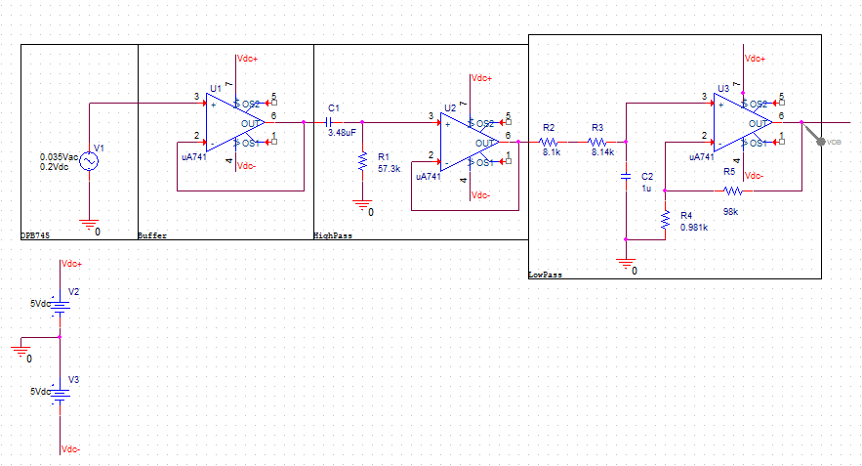

Figure 1: *Heart Rate Monitor Schematic*

As mentioned previously, the filters are required to amplify the signal due to the OPB745 not being designed to be a sensor for heart rate detection. With the use of the low-pass and high-pass filters, the signal is able to be amplified by 100V/V gain which allows the signal to be within the 0 to 3.3V range. A voltage source of 5V was applied for all op-amps within the circuit. The op-amps used in this exercise were the TLC277CP. To add surge protection for the microcontroller, two Schottky diodes have been placed at the output of the circuit. Schottky diodes take the excess current and safely send that excess towards ground. With that in place, the output signal of the circuit was sent to ADC0-DP0 port of the K64 microcontroller in order to be used for A/D conversion. The PuTTy terminal is used to verify the output values.

Talk about the ADC Conversions

Once properly converted, the terminal would output the correct heartbeat per minute. Figure 2 below illustrates an ideal PPG of a heartbeat.

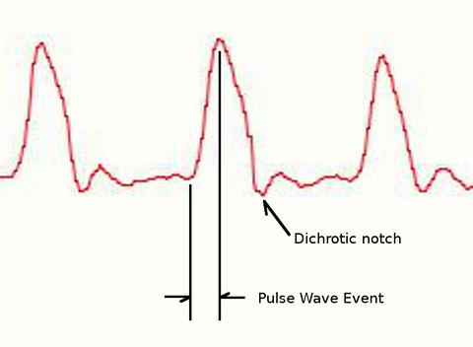

Figure 2: *Ideal PPG Heartbeat*

A heart rate is calculated via the number of peaks in the signal within a set of time. Figure 3 for example, demonstrates 3 peaks.

Talk about FTM timer and calc

The following portion of the exercise consisted of printing a circuit board via the use of OSH Park and Eagle. Essentially, the circuit implemented in PSPICE was transcribed into Eagle and then the design file was exported. The following transcribed schematic is seen here in Figure 3.

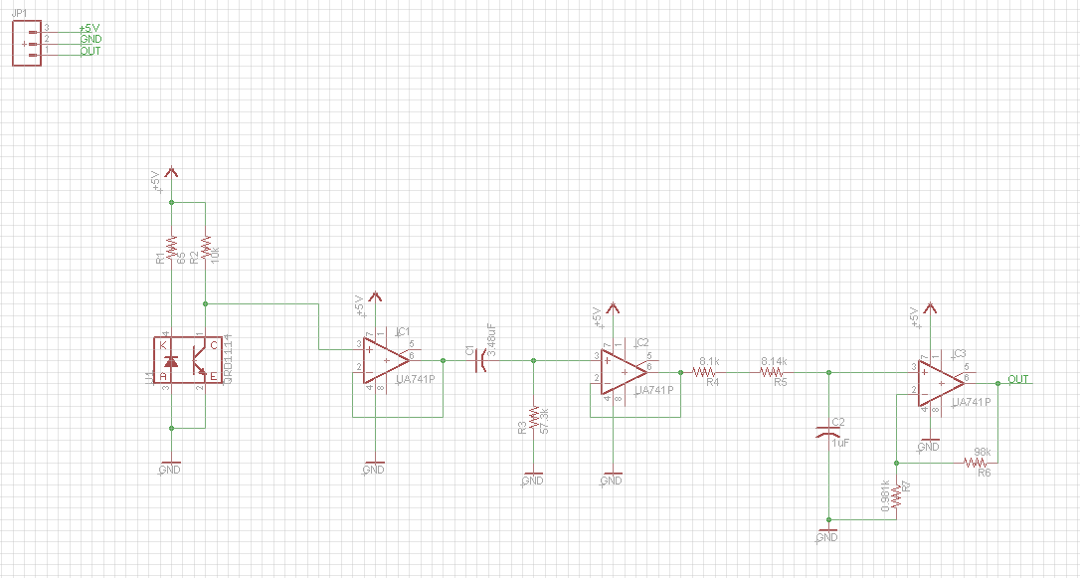

Figure 3: *Heart Rate Monitor Eagle Schematic*

Once the circuit was implemented, the .brd file was sent to OSH Park for PCB fabrication. OSH Park then displays the fabricated board and provides a preview of the layout once ordered.

**Results and Analysis**

Once the heart rate monitor was fully implemented within PSPICE, the circuit was simulated to verify correct operation. Figure 2 depicts the bandpass filter of both the low-pass and high-pass filter stages within the PSPICE schematic.

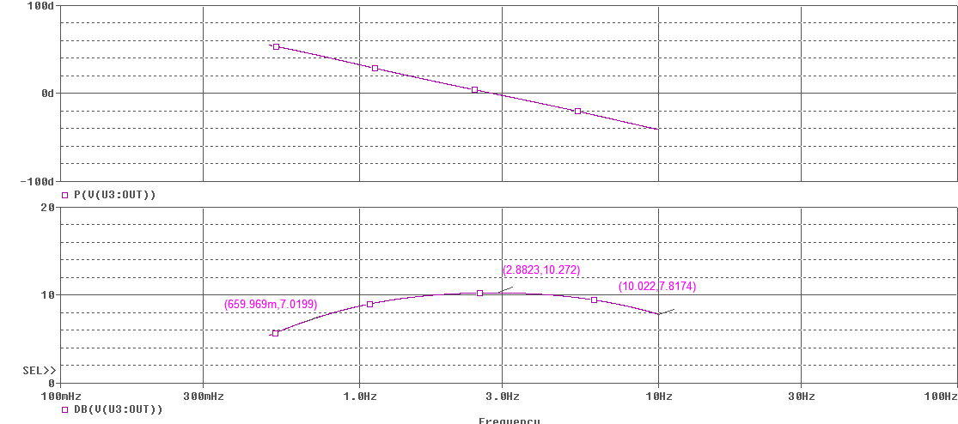

Figure 4: *PSPICE Bandpass Magnitude and Phase Simulation*

In Figure 4, under inspection, the cutoff frequency of the bandpass filter was 0.65 Hz and the center frequency of the band-pass filter was 2.8 Hz. Since the heart rate of 60 bpm correlates to 1 Hz signal, these values were chosen in order for the low-pass and high-pass to achieve the previously mentioned bandpass frequencies to closely match that specification.

Once the simulation was complete, the circuit was then translated to a breadboard and validated via oscilloscope. Figure 5 shows the ouput of the heart rate monitor

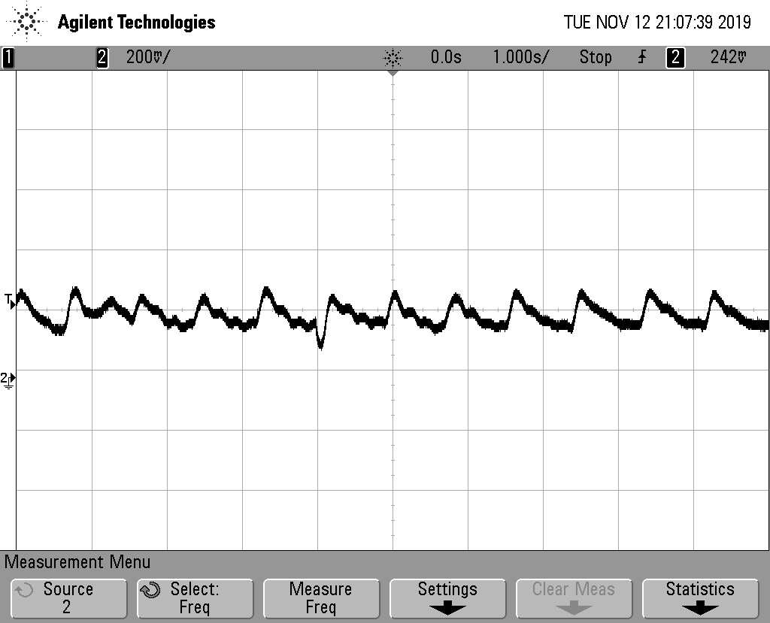

Figure 5: *Oscilloscope Output of Heart Rate Monitor*

In Figure 5, the user can see each peak and trough of the signal. Each peak depicts a pulse in a persons heart beat and here we can see a continous beat assuring that the user testing this is alive!

Insert image and discuss

Figure 6: *Terminal Output of Heart Rate Monitor*

Once the circut was designed in PSPICE and breadboarded, the same design was then ported over to Eagle for PCB design which is depicted in Figure 7.

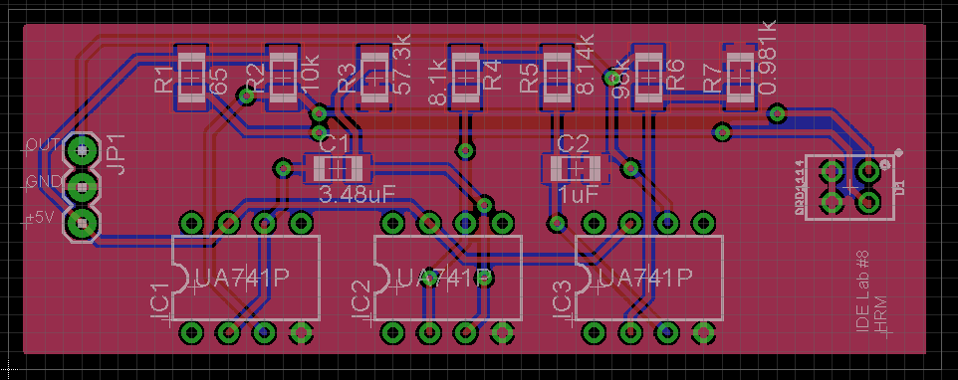

Figure 7: *PCB Layout of the Heart Rate Monitor*

Once the board was verified by OSH Park for any errors, an order can be placed which can be seen in Figure 8.

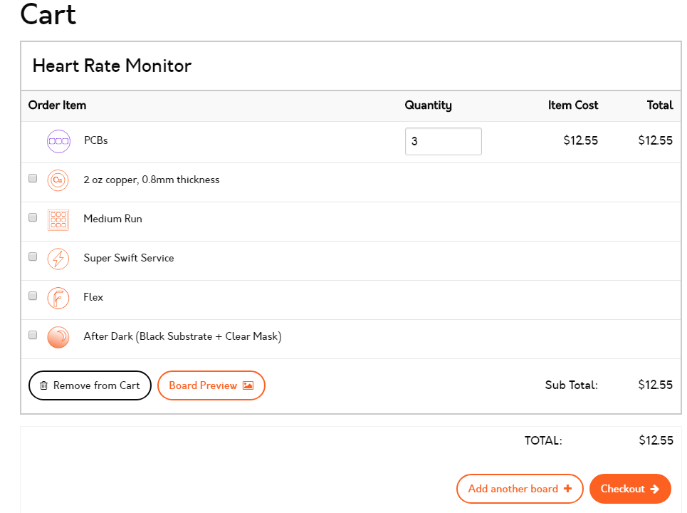

Figure 8: *OSH Park Checkout*

**Conclusions**

In this exercise, the object is to construct a heart rate monitor was constructed using the OPB745 opto-isolator and TLC277CP op-amp. Using PSPICE, the circuit was designed and simulated on PSPICE. Once that was completed, the circuit was transferred to Eagle for PCB design which allows for concise design rather than the breadboarded version designed earlier. The signal inputted by the OPB745 was conditioned to meet the requirements to properly display and achieve an acceptable signal. With that signal properly conditioned by the low-pass and high-pass filter, the signal was then converted via A/D conversion via the K64F microcontroller. This took the frequency values and converted them to beats per minute (bpm) and displayed via UART on the PuTTy terminal. The heart rate monitor reported a proper value reassuring the user that the implementation was correct. This exercise proved to be successful and an excellent example to see the process of PCB design and fabrication.

**Appendix**

* Figure 1: *Heart Rate Monitor Schematic*
* Figure 2: *Ideal PPG Heartbeat*
* Figure 3: *Heart Rate Monitor Eagle Schematic*
* Figure 4: *PSPICE Bandpass Magnitude and Phase Simulation*
* Figure 5: *Oscilloscope Output of Heart Rate Monitor*
* Figure 6: *Terminal Output of Heart Rate Monitor*
* Figure 7: *PCB Layout of the Heart Rate Monitor*
* Figure 8: *OSH Park Checkout*