**1050 Programming Logic**

Lab 3 (20 points total)

Name: __Noah Morrison__

***Instructions:***

1. Create a project/solution called Lab3 in your GitHub repository. Add all of the following code to your Lab3 project in Program.cs.
2. In a comment inside of Program.cs, compare and contrast the if single-selection statement and the while repetition statement. How are these two statements similar? How are they different?
3. Declare two int variables: 1) speedLimit and 2) speed. Assign values speedLimit=35 and speed=42. Write an if statement that displays “SLOW NOW” if speed is greater than speedLimit.
4. if-else statement - Write a program that declares and assigns a value to a Boolean variable called isTrue. Use a condition to output “It is True!” or “It is False!” based on the assigned value. Paste your code and screenshots of your program running with both true and false values.

bool condition = true;

if (condition)

{

Console.WriteLine("It is true.");

}

else

{

Console.WriteLine("It is false.");

}

Console.ReadKey();

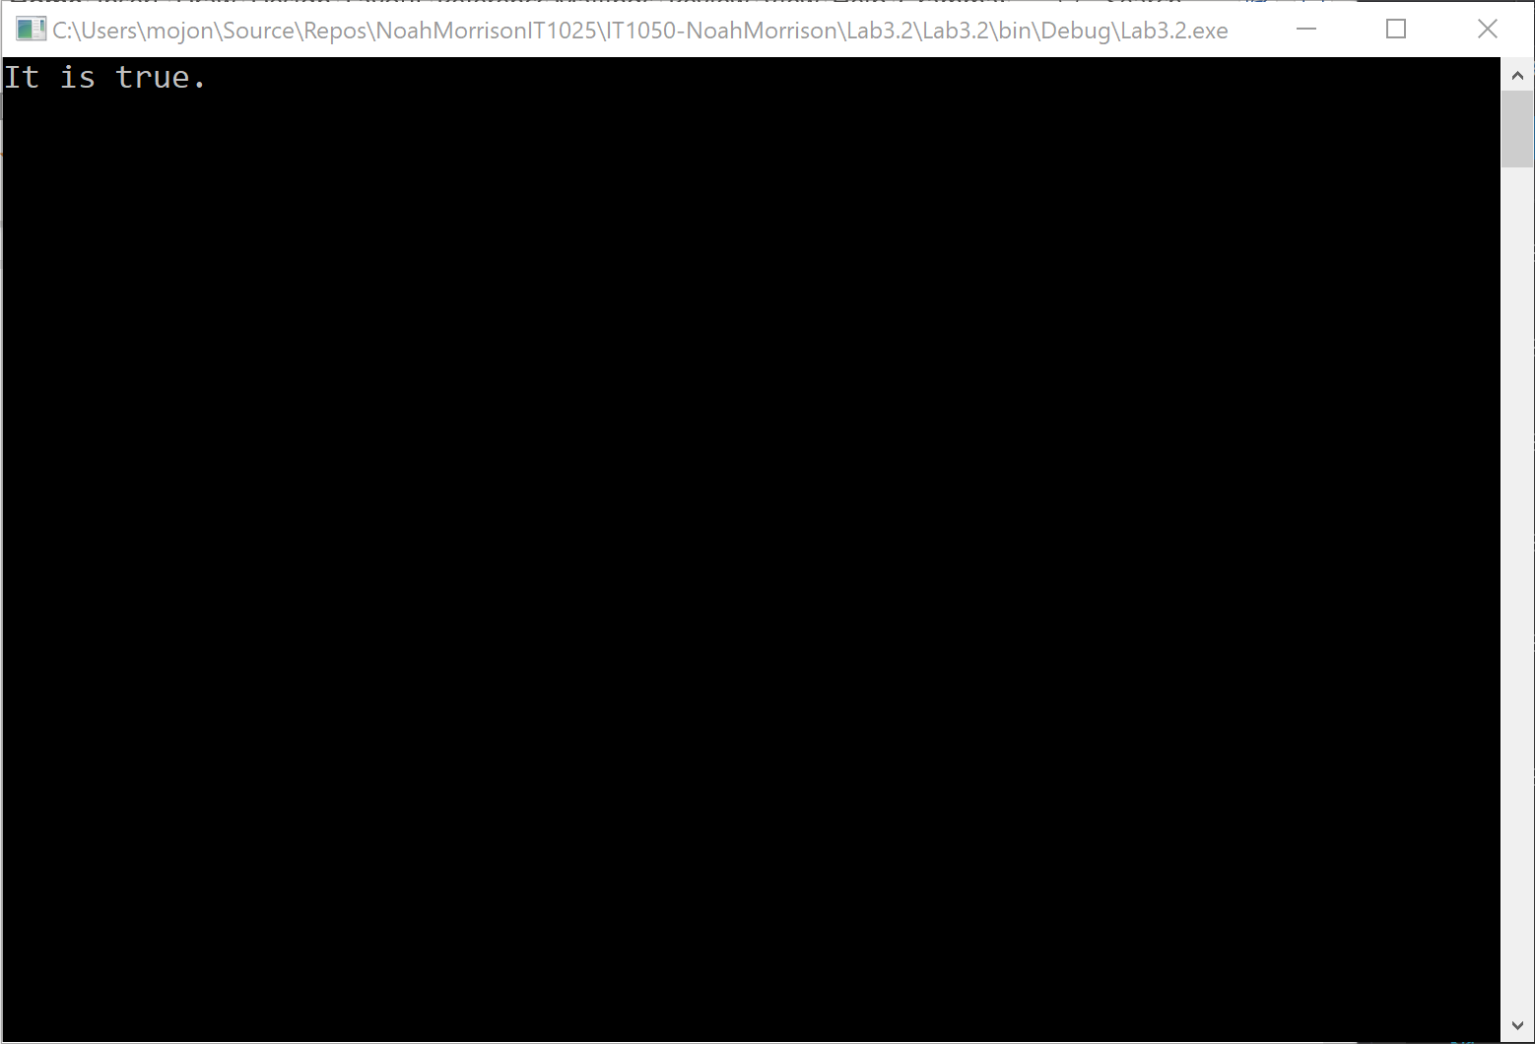

bool condition = false;

if (condition)

{

Console.WriteLine("It is true.");

}

else

{

Console.WriteLine("It is false.");

}

Console.ReadKey();

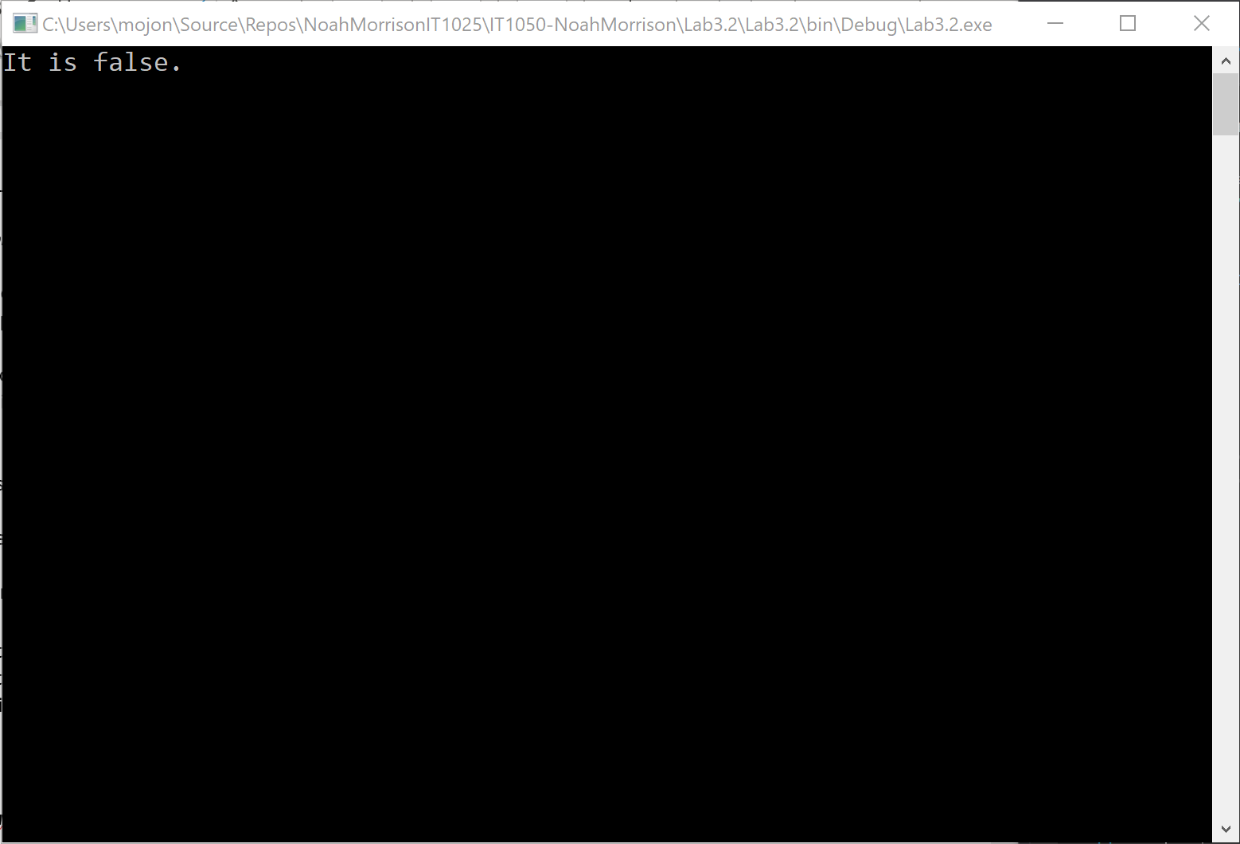

1. if statement - Write a program that converts a Fahrenheit temperature to Celsius. The user should be able to input the temperature at the Command prompt and it should output the temperature. In addition, you should output “It is cold” if the Fahrenheit value is less that 40 or it should output “It is hot” if the temperature is over 90.

***Code to read a value: double fahrenheit = Convert.ToDouble(Console.ReadLine()); Code to convert: celsius = (fahrenheit - 32d) * 5d / 9d;***

1. Write a while loop that outputs values 1 to 10. Increment by 1.
2. Write a while loop that outputs values 60 to 20. Decrement by 5.
3. Write a while that outputs values 10-20. Increment by 2

***Deliverables:***

Commit and push your project to your GitHub repository. Before submitting the link in Blackboard, it would be a good idea to log into github.com and make sure all of the changes were successfully pushed (uploaded). Submit the URL to your GitHub repository in the comments section of the Blackboard assignment. Please do not attach any files to the Blackboard submission.