Noah Niedzwiecki

ELEC 5200

PROJECT 3

March 3, 2019

The goal of this project is to build our ISA hardware with description language models. For the rest of the project the system will be described using VHDL syntax and semantics. An index is on the following page to help navigate the code. A data path reference can be located on the last page.

The following hardware is used:

* Two Sign Extension Units
* Dedicated Address Addition ALU
* Main ALU
* Register File
* Instruction Memory and Data Memory
* ALU / Data Memory Mux
* Program Counter
* Main Control Unit
* Address Mux

In the previous project report, each of the 16 instructions was explained in detail. Now, we will look at the datapath for each of these pieces of hardware during the instruction executions.

Changes that were done since last assignment:

* Calls are now called branches
* File tables have been combined into one unit
* ALU output is not demuxed, simply connected to memory and ALU/DataMemory Mux

**Index:**

**Control Code 3 – 7**

**Control Test Bench 7 – 22**

**ALU Code 23- 27**

**PC ADDER 28 – 31**

**Register File 32 – 36**

**Data Memory 36 -37**

**Program Counter 38**

**ALU/ DataMemory Mux 39**

**Sign Extension1 40**

**Sign Extension2 41**

Control Code:

library IEEE;

use IEEE.STD_LOGIC_1164.ALL;

use IEEE.numeric_std.ALL;

use ieee.std_logic_unsigned.all;

entity CONTROL is

port(

instruction : in STD_LOGIC_VECTOR(15 downto 0);

branchBit : in STD_LOGIC;

regMuxCtrl : out STD_LOGIC;

regTableA : out STD_LOGIC_VECTOR(3 downto 0);

regTableB : out STD_LOGIC_VECTOR(3 downto 0);

regTableD : out STD_LOGIC_VECTOR(3 downto 0);

ALUout : out STD_LOGIC_VECTOR(3 downto 0);

regTable : out STD_LOGIC_VECTOR(2 downto 0);

signCtrl: out STD_LOGIC;

dataMem : out STD_LOGIC_VECTOR(1 downto 0);

addCtrl: out STD_LOGIC_VECTOR(1 downto 0));

end CONTROL;

architecture Behavioral of CONTROL is

signal regTableAsig : STD_LOGIC_VECTOR(3 downto 0) := "0000";

signal regTableBsig : STD_LOGIC_VECTOR(3 downto 0) := "0000";

signal regTableDsig : STD_LOGIC_VECTOR(3 downto 0) := "0000";

signal ALUOutsig : STD_LOGIC_VECTOR(3 downto 0) := "0000";

signal regTablesig : STD_LOGIC_VECTOR(2 downto 0) := "000";

signal signCtrlsig: STD_LOGIC := '0';

signal regMuxCtrlsig: STD_LOGIC := '0';

signal dataMemsig: STD_LOGIC_VECTOR(1 downto 0) := "00";

signal addCtrlsig: STD_LOGIC_VECTOR(1 downto 0) := "00";

begin

process(instruction) begin

if(instruction(15 downto 12) = "0000") then --halt

addCtrlsig <= "11";

elsif(instruction(15 downto 12) = "0001")then --jump

signCtrlsig <= '1';

addCtrlsig <= "01"; --sign extended

elsif(instruction(15 downto 12) = "0010")then --add

regTablesig <= "000";

regTableDsig <= instruction(11 downto 8);

regTableAsig <= instruction(7 downto 4);

regTableBsig <= instruction(3 downto 0);

ALUOutsig <= "0010";

dataMemsig <= "11"; -- do nothing

addCtrlsig <= "00"; --PC + 1

regMuxCtrlsig <= '0'; --ALU TO REG

elsif(instruction(15 downto 12) = "0011")then --sub

regTablesig <= "000";

regTableDsig <= instruction(11 downto 8);

regTableAsig <= instruction(7 downto 4);

regTableBsig <= instruction(3 downto 0);

ALUOutsig <= "0011";

dataMemsig <= "11"; --do nothing

addCtrlsig <= "00"; --PC + 1

regMuxCtrlsig <= '0'; --ALU TO REG

elsif(instruction(15 downto 12) = "0100")then --load

regTablesig <= "000"; --read so regtable looks at input

regTableDsig <= instruction(11 downto 8); --load address

ALUOutsig <= "0000"; --do nothing

dataMemsig <= "10"; --write pcIn address

addCtrlsig <= "00"; --PC + 1

regMuxCtrlsig <= '1'; --MEM TO REG

elsif(instruction(15 downto 12) = "0101")then --load C

regTablesig <= "001"; --read sign extend 2

regTableDsig <= instruction(11 downto 8); --load address

ALUOutsig <= "0000"; --do nothing

dataMemsig <= "11"; --do nothing

addCtrlsig <= "00"; --PC + 1

elsif(instruction(15 downto 12) = "0110")then --MOV

regTablesig <= "000"; --rtype

regTableDsig <= instruction(11 downto 8); --destination

regTableAsig <= instruction(7 downto 4); --value being moved

ALUOutsig <= "0110"; --pass values from reg to reg mux

dataMemsig <= "11"; --default

addCtrlsig <= "00"; --PC + 1

regMuxCtrlsig <= '0'; --ALU TO REG

elsif(instruction(15 downto 12) = "0111")then --STORE

regTablesig <= "000"; --rtype

regTableAsig <= instruction(7 downto 4); --value being stored

ALUOutsig <= "0110"; --pass values from reg to reg mux

dataMemsig <= "01"; --write to mem

addCtrlsig <= "00"; --PC + 1

regMuxCtrlsig <= '0'; --ALU TO REG

elsif(instruction(15 downto 12) = "1000")then --JUMP AND LINK

regTablesig <= "010"; --save PC

regTableAsig <= instruction(7 downto 4); --value being stored

ALUOutsig <= "0000"; --pass values from reg to reg mux

dataMemsig <= "11"; --do nothing

signCtrlsig <= '0'; --put 8 bit offset to add

addCtrlsig <= "01"; --sign extended

--regMuxCtrlsig <= '0'; --ALU TO REG

elsif(instruction(15 downto 12) = "1001")then --RETURN

regTablesig <= "000"; --do nothing

dataMemsig <= "11"; --do nothing

addCtrlsig <= "10"; -- add puts the register into PC

ALUOutsig <= "0000"; --do nothing

dataMemsig <= "11"; --do nothing

regMuxCtrlsig <= '0'; --ALU TO REG

elsif(instruction(15 downto 12) = "1010")then --BRANCH IF EQUAL

regTablesig <= "000"; --do nothing

dataMemsig <= "11"; --do nothing

ALUOutsig <= "1010"; --branch if equal

dataMemsig <= "11"; --do nothing

regMuxCtrlsig <= '0'; --ALU TO REG

signCtrlsig <= '0'; --put 8 bit offset to add

if(branchBit = '1')then

addCtrlsig <= "01"; -- add puts the sign extend into PC

else

addCtrlsig <= "00"; -- PC + 1

end if;

elsif(instruction(15 downto 12) = "1011")then --BRANCH IF NOT EQUAL

regTablesig <= "000"; --do nothing

dataMemsig <= "11"; --do nothing

signCtrlsig <= '0'; --put 8 bit offset to add

ALUOutsig <= "1011"; --branch if equal

dataMemsig <= "11"; --do nothing

regMuxCtrlsig <= '0'; --ALU TO REG

if(branchBit = '1')then

addCtrlsig <= "01"; -- add puts the sign extend into PC

else

addCtrlsig <= "00"; -- PC + 1

end if;

elsif(instruction(15 downto 12) = "1100")then --OR

regTablesig <= "000";

regTableDsig <= instruction(11 downto 8);

regTableAsig <= instruction(7 downto 4);

regTableBsig <= instruction(3 downto 0);

ALUOutsig <= "1100";

dataMemsig <= "11"; -- do nothing

addCtrlsig <= "00"; --PC + 1

regMuxCtrlsig <= '0'; --ALU TO REG

elsif(instruction(15 downto 12) = "1101")then --AND

regTablesig <= "000";

regTableDsig <= instruction(11 downto 8);

regTableAsig <= instruction(7 downto 4);

regTableBsig <= instruction(3 downto 0);

ALUOutsig <= "1101";

dataMemsig <= "11"; -- do nothing

addCtrlsig <= "00"; --PC + 1

regMuxCtrlsig <= '0'; --ALU TO REG

elsif(instruction(15 downto 12) = "1110")then --BRANCH IF LESS THAN

regTablesig <= "000"; --do nothing

dataMemsig <= "11"; --do nothing

signCtrlsig <= '0'; --put 8 bit offset to add

ALUOutsig <= "1110"; --branch if equal

dataMemsig <= "11"; --do nothing

if(branchBit = '1')then

addCtrlsig <= "01"; -- add puts the sign extend into PC

else

addCtrlsig <= "00"; -- PC + 1

end if;

elsif(instruction(15 downto 12) = "1111")then --BRANCH IF LESS THAN

regTablesig <= "000"; --do nothing

dataMemsig <= "11"; --do nothing

signCtrlsig <= '0'; --put 8 bit offset to add

ALUOutsig <= "1111"; --branch if equal

dataMemsig <= "11"; --do nothing

if(branchBit = '1')then

addCtrlsig <= "01"; -- add puts the sign extend into PC

else

addCtrlsig <= "00"; -- PC + 1

end if;

end if;

end process;

regTableA <= regTableAsig;

regTableB <= regTableBsig;

regTableD <= regTableDsig;

ALUout <= ALUOutsig;

regTable <= regTablesig;

signCtrl <= signCtrlsig;

dataMem <= dataMemsig;

addCtrl <= addCtrlsig;

regMuxCtrl <= regMuxCtrlsig;

end Behavioral;

Control Testing

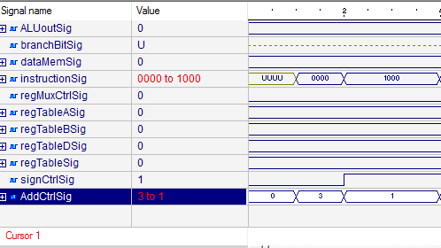

**Control Halt and Jump Execution**

At first, AddCtrlSig, the Adder Module signal is supplied “11” to halt all PC incrimination

Then, the Jump instruction arrives and the AddCtrlSig is changed to 1 to force the Address Mux to output an 8 bit offset from the instruction

AddCtrlSig controls the Add module which feeds the PC.

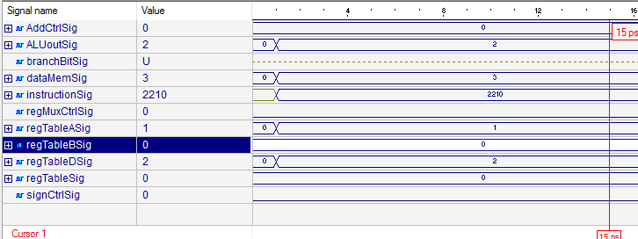

**Control Add and Subtract**

At one picosecond, the instruction signal arrives and the following are required to react:

The registerTableA address needs to be set to “0000”

registerTableB needs to be set to “0001”

registerTableD needs to be set to “0010”

the Add module needs to increment PC by 1 so addCtrlsig = “00”

ALUOutsig needs to be “0010” for Add

AddCtrlSig is set to 0 to increment PC by 1

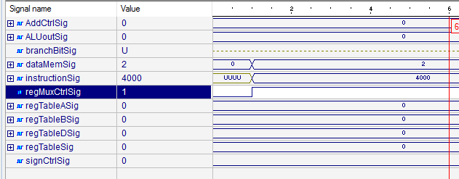

**Control Load**

The instruction with opcode “0100” arrives in the instruction signal

The register table regTableSig needs to be set to write, “000”

The Data Memory is set to “10” so that it is read

The regMuxCtrl which directs where the read data is going is set to ‘1’ for registers

AddCtrlSig is set to 0 to increment PC by 1

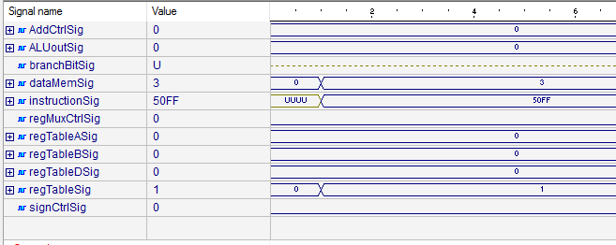

**Control LoadC**

LoadC takes a 8 bit constant and stores it in a specific address

In this case, the address is “0000”; the data to be written is “FF”

The data memory is set to “11” as a default read since it is not being used

The Register File is set to “000” which is a default read and or write if data changes on the input

AddCtrlSig is set to 0 to increment PC by 1

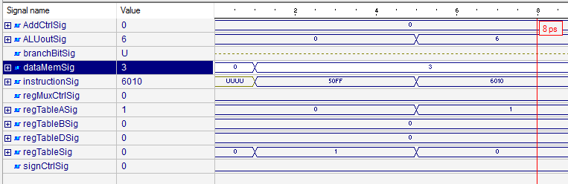

**Control LoadC and Move**

This includes the first part of the LoadC instruction seen above

When the instruction signal changes it can be seen that the register table signal returns to 0 to do the writing to the ALU

Since the ALU is involved, it must be set to 6 to allow the input data to flow through to the ALU/Data Memory Mux

AddCtrlSig is set to 0 to increment PC by 1

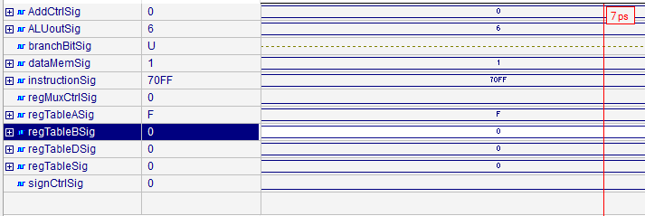

**Control Store**

The store instruction takes a register and writes it into the data memory.

For this to happen, the ALU must be set to 6 to allow data to flow through from the registers

The data memory must be set to 1to write data

AddCtrlSig is set to 0 to increment PC by 1

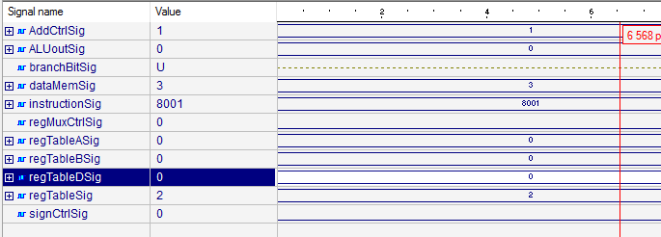

**Control Jump and Link**

For Jump and Link, the PC is incremented by an 8 bit offset value specified by the last 8 bits of the instruction

The Sign Extension signal, signCtrlSig, is set to 0 to direct the 8 bits to the Add unit

The add unit is also supplied a signal called AddCtrlSig which at ‘1’ adds the PC with the sign extended value

Register 15 is also written with the PC which is controlled by the regTableSig signal

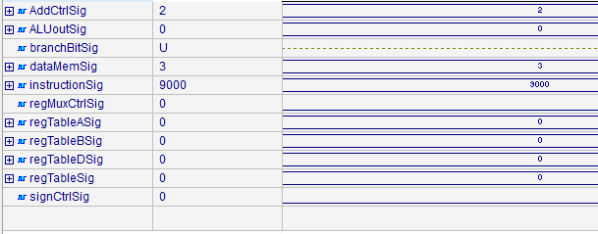

**Control Return**

Control return takes the PC value that was written during jump and link and returns it back to the PC register.

The register file can be set to a default read state and the add module needs to be set to 2 so it takes the value from the register

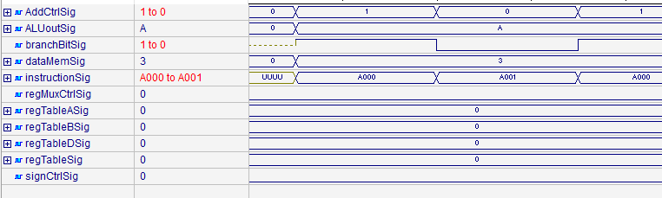

**Control Branch Equal/Not Equal**

Branching does not save the address in the PC, however the adder circuit needs to take the 8 bit offset specified in the instruction.

To extend 8 bits, the signCtrlSig is set to 0

The registers need to be read so the register file is set to a default state

If the ALU determines that they are equal, then the Add circuitry needs to take the supplied offset.

If the branch bit stays 0 then the add circuit increments the PC by one, which can be seen in the fluctuation in the AddCtrlSig as the branchBitSig is changed

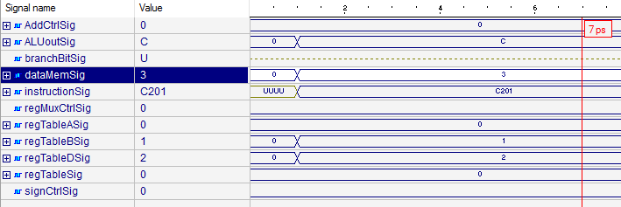

**Control OR**

Given two registers, regTableAsig, and regTableBsig, the ALU executes a bitwise OR operation on the two and stores the result in regTableDsig.

The Data Memory needs to be defaulted and the ALU/ Data Memory Mux needs to be set to 0 to allow writing to the registers

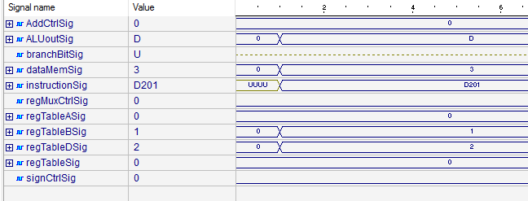

**Control AND**

Given two registers, regTableAsig, and regTableBsig, the ALU executes a bitwise AND operation on the two and stores the result in regTableDsig.

The Data Memory needs to be defaulted and the ALU/ Data Memory Mux needs to be set to 0 to allow writing to the registers

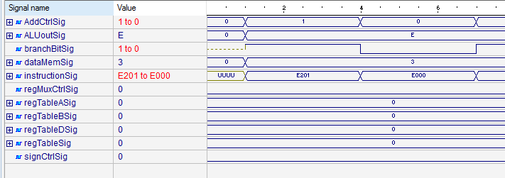

**Control Branch if Greater/ Lesser**

This is similar to the branch if equal not equal, but the ALU subtracts the two operators and determines if the first is greater or lesser than the second

As the branchBitSig signal changes the ADD circuitry reacts appropriately as defined in the other branch calls

Control Test Bench

library IEEE;

use IEEE.STD_LOGIC_1164.ALL;

entity controlBench is

-- Port ( );

end controlBench;

architecture Behavioral of controlBench is

signal instructionSig : STD_LOGIC_VECTOR(15 downto 0);

signal branchBitSig : STD_LOGIC;

signal regMuxCtrlSig : STD_LOGIC;

signal regTableASig : STD_LOGIC_VECTOR(3 downto 0);

signal regTableBSig : STD_LOGIC_VECTOR(3 downto 0);

signal regTableDSig : STD_LOGIC_VECTOR(3 downto 0);

signal ALUoutSig: STD_LOGIC_VECTOR(3 downto 0);

signal regTableSig : STD_LOGIC_VECTOR(2 downto 0);

signal signCtrlSig: STD_LOGIC;

signal dataMemSig: STD_LOGIC_VECTOR(1 downto 0);

signal AddCtrlSig: STD_LOGIC_VECTOR(1 downto 0);

component CONTROL is

port(

instruction : in STD_LOGIC_VECTOR(15 downto 0);

branchBit : in STD_LOGIC;

regMuxCtrl : out STD_LOGIC;

regTableA : out STD_LOGIC_VECTOR(3 downto 0);

regTableB : out STD_LOGIC_VECTOR(3 downto 0);

regTableD : out STD_LOGIC_VECTOR(3 downto 0);

ALUout : out STD_LOGIC_VECTOR(3 downto 0);

regTable : out STD_LOGIC_VECTOR(2 downto 0);

signCtrl: out STD_LOGIC;

dataMem : out STD_LOGIC_VECTOR(1 downto 0);

addCtrl: out STD_LOGIC_VECTOR(1 downto 0));

end component;

begin

M1: CONTROL port map(instruction => instructionSig, branchBit => branchBitSig, regMuxCtrl => regMuxCtrlSig, regTableA => regTableAsig,

regTableB => regTableBsig, regTableD => regTableDsig, ALUout => ALUoutSig, regTable => regTableSig, signCtrl => signCtrlSig, dataMem => dataMemSig,

addCtrl => addCtrlSig);

process begin

----------------------------------------------------------------------HALT

wait for 1ps;

instructionSig <= "0000000000000000";

assert AddCtrlSig = "11"

report "CNTRL HALT IS BAD"

severity ERROR;

---------------------------------------------------------------------JUMP

wait for 1 ps;

instructionSig <= "0001000000000000";

assert AddCtrlSig = "01"

report "ADDER CONTROL IS BAD"

severity ERROR;

wait for 1 ps;

assert signCtrlSig = '1' -- 12bit extension

report "EXTEND CONTROL IS BAD"

severity ERROR;

------------------------------------------------------------------------

--ADD reg0 to reg1 store in reg 2 / SUB WITH ALU CHANGE

wait for 1 ps;

instructionSig <= "0010001000010000";

wait for 1 ps;

assert regTableASig = "0000" -- A = 0

report "INCORRECT FIRST OP"

severity ERROR;

wait for 1 ps;

assert regTableBSig = "0001" --B = 1

report "INCORRECT SECOND OP"

severity ERROR;

wait for 1 ps;

assert regTableDSig = "0010" --D = 0010

report "INCORRECT DEST OP"

severity ERROR;

wait for 1 ps;

assert addCtrlsig = "00" -- PC + 1

report "INCORRECT DEST OP"

severity ERROR;

wait for 1 ps;

assert ALUOutsig = "0010"; -- ALU to ADD

report "INCORRECT ALU ADD OP"

severity ERROR;

wait for 1 ps;

assert regMuxCtrlSig = '0'; -- REG MUX to REG

report "INCORRECT REG MUX LOCAL OP"

severity ERROR;

wait for 1 ps;

---------------------------------------------------------------LOAD

wait for 1 ps;

instructionSig <= "0100000000000000"; --load reg 0 with add 00000000

wait for 1 ps;

assert regTablesig = "000"; -- REG set to write

report "REG TABLE SET WRONG"

severity ERROR;

wait for 1 ps;

assert regTableDSig = "0000" -- REGister to write

report "REG TABLE SET WRONG"

severity ERROR;

wait for 1 ps;

assert dataMemsig = "10" -- data mem to read

report "DATA REG SET WRONG"

severity ERROR;

wait for 1 ps;

assert regMuxCtrlsig = '1'

report " REG MUX SET WRONG"

severity ERROR;

wait for 1 ps;

------------------------------------------------------------LOAD C

wait for 1 ps;

instructionSig <= "0101000011111111"; --load reg 0 with 11111111

wait for 1 ps;

assert regTablesig = "000"; -- REG set to read/write

report "REG TABLE SET WRONG"

severity ERROR;

wait for 1 ps;

assert regTableDSig = "0000" -- REGister to write

report "REG TABLE SET WRONG"

severity ERROR;

wait for 1 ps;

assert dataMemsig = "11" -- data mem to do nothing

report "DATA REG SET WRONG"

severity ERROR;

wait for 1 ps;

------------------------------------------------------------MOV reg 1 to reg 0

instructionSig <= "0110000000010000"; --load reg 0 with 11111111

wait for 1 ps;

assert regMuxCtrlsig = '0' --ALU TO REG

report "REG MUX SET WRONG"

severity ERROR;

wait for 1 ps;

assert regTablesig = "000"; -- REG set to read/write

report "REG TABLE SET WRONG"

severity ERROR;

wait for 1 ps;

assert ALUOutsig = "0110"

report "ALU SET WRONG"

severity ERROR;

-------------------------------------------------------STORE reg 0 to 11111111

instructionSig <= "0111000011111111";

wait for 1 ps;

assert regMuxCtrlsig = '0' --ALU TO REG

report "REG MUX SET WRONG"

severity ERROR;

wait for 1 ps;

assert regTablesig = "000" -- REG set to read/write

report "REG TABLE SET WRONG"

severity ERROR;

wait for 1 ps;

assert ALUOutsig = "0110"

report "ALU SET WRONG"

severity ERROR;

assert dataMemsig = "01";

report "DATA MEM SET WRONG"

severity ERROR;

--------------------------------------------------------JUMP AND LINK

instructionSig <= "1000000000000001";

assert signCtrlsig = '0' --8 bits to PC

report "SIGN EXTEN SET WRONG"

severity ERROR;

wait for 1 ps;

assert addCtrlsig = "01"

report "ADD UNIT SET WRONG"

severity ERROR;

wait for 1 ps;

assert regTablesig = "010"

report "REGFILE SET WRONG"

severity ERROR;

wait for 1 ps;

----------------------------------------------------------RETURN

instructionSig <= "1001000000000000";

wait for 1 ps;

assert addCtrlsig = "10"

report "ADD UNIT SET WRONG"

severity ERROR;

wait for 1 ps;

assert regTablesig = "010"

report "REGFILE SET WRONG"

severity ERROR;

wait for 1 ps;

----------------------------------------------------------BRANCH EQUAL NOT EQUAL

wait for 1 ps;

instructionSig <= "1010000000000000";

branchBitSig <= '1';

wait for 1 ps;

assert ALUOutsig <= "1010"

report "ALU SET INCORRECTLY"

severity ERROR;

assert signCtrlsig = '0' --8 bits to PC

report "SIGN EXTEN SET WRONG"

severity ERROR;

wait for 1 ps;

assert addCtrlsig = "01"

report "BRANCH BIT RESPONSE WRONG"

severity ERROR;

wait for 1 ps;

instructionSig <= "1010000000000001";

branchBitSig <= '0';

wait for 1 ps;

assert addCtrlsig = "00"

report "BRANCH BIT RESPONSE WRONG"

severity ERROR;

wait for 1 ps;

--------------------------------------------------OR 1 and 0 into 2

wait for 1 ps;

instructionSig <= "1100001000000001";

wait for 1 ps;

assert regTableASig = "0000" -- A = 0

report "INCORRECT FIRST OP"

severity ERROR;

wait for 1 ps;

assert regTableBSig = "0001" --B = 1

report "INCORRECT SECOND OP"

severity ERROR;

wait for 1 ps;

assert regTableDSig = "0010" --D = 0010

report "INCORRECT DEST OP"

severity ERROR;

wait for 1 ps;

assert addCtrlsig = "00" -- PC + 1

report "INCORRECT ADD OP"

severity ERROR;

wait for 1 ps;

assert ALUOutsig = "1100"; -- ALU to OR

report "INCORRECT ALU OR OP"

severity ERROR;

wait for 1 ps;

assert regMuxCtrlSig = '0'; -- REG MUX to REG

report "INCORRECT REG MUX LOCAL OP"

severity ERROR;

wait for 1 ps;

------------------------------------------------AND

wait for 1 ps;

instructionSig <= "1101001000000001";

wait for 1 ps;

assert regTableASig = "0000" -- A = 0

report "INCORRECT FIRST OP"

severity ERROR;

wait for 1 ps;

assert regTableBSig = "0001" --B = 1

report "INCORRECT SECOND OP"

severity ERROR;

wait for 1 ps;

assert regTableDSig = "0010" --D = 0010

report "INCORRECT DEST OP"

severity ERROR;

wait for 1 ps;

assert addCtrlsig = "00" -- PC + 1

report "INCORRECT ADD OP"

severity ERROR;

wait for 1 ps;

assert ALUOutsig = "1101"; -- ALU to OR

report "INCORRECT ALU OR OP"

severity ERROR;

wait for 1 ps;

assert regMuxCtrlSig = '0'; -- REG MUX to REG

report "INCORRECT REG MUX LOCAL OP"

severity ERROR;

wait for 1 ps;

-------------------------------------------------BRANCH GREATER LESS THAN

wait for 1 ps;

instructionSig <= "1110001000000001";

branchBitSig <= '1';

wait for 1 ps;

assert ALUOutsig <= "1110"

report "ALU SET INCORRECTLY"

severity ERROR;

assert signCtrlsig = '0' --8 bits to PC

report "SIGN EXTEN SET WRONG"

severity ERROR;

wait for 1 ps;

assert addCtrlsig = "01"

report "BRANCH BIT RESPONSE WRONG"

severity ERROR;

wait for 1 ps;

instructionSig <= "1110000000000000";

branchBitSig <= '0';

wait for 1 ps;

assert addCtrlsig = "00"

report "BRANCH BIT RESPONSE WRONG"

severity ERROR;

wait for 1 ps;

end process;

end Behavioral;

**ALU Code**

library IEEE;

use IEEE.STD_LOGIC_1164.ALL;

use IEEE.numeric_std.ALL;

use ieee.std_logic_unsigned.all;

entity ALU is

port(

bit16InA : in STD_LOGIC_VECTOR(15 downto 0);

bit16InB : in STD_LOGIC_VECTOR(15 downto 0);

bit16Out : out STD_LOGIC_VECTOR(15 downto 0); -- this goes to either datamem or regtable

branchBit : out STD_LOGIC;

signCtrl : in STD_LOGIC_VECTOR(3 downto 0));

end ALU;

architecture Behavioral of ALU is

signal bit16Outsig : STD_LOGIC_VECTOR(15 downto 0) := "0000000000000000";

signal branchBitsig : STD_LOGIC := '0';

begin

process(signCtrl) begin

if(signCtrl = "0010") then --add

bit16Outsig <= bit16InA + bit16InB;

elsif(signCtrl = "0011") then --sub

bit16Outsig <= bit16InA - bit16InB;

elsif(signCtrl = "0110") then --mov/store passes B out to dataMem or registers

bit16Outsig <= bit16InA;

elsif(signCtrl = "1010") then

if(bit16inA - bit16inB = "0000000000000000") then --branch if equal

branchBitsig <= '1';

else

branchBitsig <= '0';

end if;

elsif(signCtrl = "1011") then

if(bit16inA - bit16inB = 0) then --branch if not equal

branchBitsig <= '0';

else

branchBitsig <= '1';

end if;

elsif(signCtrl = "1100") then

bit16Outsig <= bit16InA or bit16InB; --or

elsif(signCtrl = "1101") then

bit16Outsig <= bit16InA and bit16InB; -- and

elsif(signCtrl = "1110") then

if(bit16inB - bit16inA > 0) then

branchBitsig <= '1'; --Branch if less than

else

branchBitsig <= '0';

end if;

elsif(signCtrl = "1111") then

if(bit16inA - bit16inB > 0) then

branchBitsig <= '1'; --Branch if greater than

else

branchBitsig <= '0';

end if;

else

bit16Outsig <= "0000000000000000";

end if;

end process;

bit16Out <= bit16Outsig;

branchBit <= branchBitsig;

end Behavioral;

**ALU Testing**

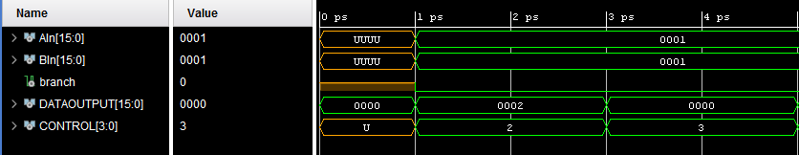

**ALU Add/Sub**

When the Control signal is 2, the values seen on Ain and Bin are added together

It can be seen that both Ain and Bin contain 1 so the sum is 2

After the add, the control is changed to a 3 for a subtraction to take place and the result is 0

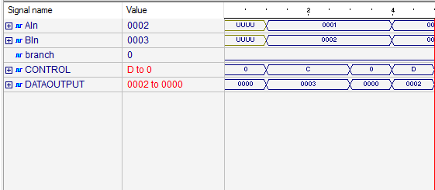

**ALU AND/OR**

When the CONTROL signal is C the inputs Ain and Bin are OR’d together, resulting in a 3

When the CONTROL is set to D the DATAOUTPUT is the resulting AND operation which would result in 2 with Ain being 1 and Bin being 2

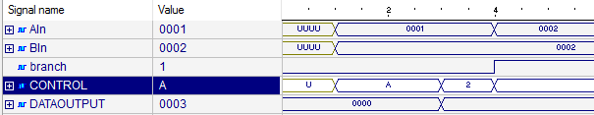

**ALU Branch Equal/Not Equal**

When Ain and Bin are not matching when CONTROL is A, meaning Branch Equal, the resulting branch bit output is 0.

When CONTROL is changed to B(cut off the screen), the resulting branch bit is 1

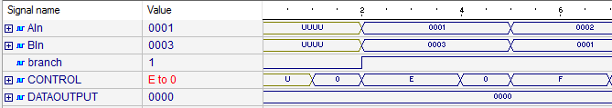

**ALU Branch Less Than / Greater**

This acts the exact same as equal not equal, however if A is greater than B when Control is set to E, the branch bit is set high. When branch less than is set, if the inputs are swapped the branch bit will remain high due to A being less than B

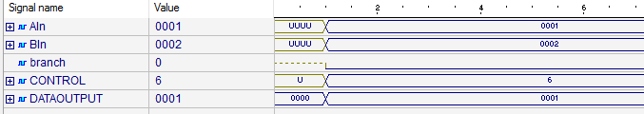

**ALU Store/Move**

When Storing or moving the input at AIN is set to the output.

Control must be equal to 6 for this to happen

**ALU Test Bench**

library IEEE;

use IEEE.STD_LOGIC_1164.ALL;

entity aluBench is

-- Port ( );

end aluBench;

architecture Behavioral of aluBench is

signal AIn: std_logic_vector(15 downto 0);

signal BIn: std_logic_vector(15 downto 0);

signal branch: std_logic;

signal DATAOUTPUT: std_logic_vector(15 downto 0);

signal CONTROL: std_logic_vector(3 downto 0);

component ALU is

port(

bit16InA : in STD_LOGIC_VECTOR(15 downto 0);

bit16InB : in STD_LOGIC_VECTOR(15 downto 0);

bit16Out : out STD_LOGIC_VECTOR(15 downto 0); -- this goes to either datamem or regtable

branchBit : out STD_LOGIC;

signCtrl : in STD_LOGIC_VECTOR(3 downto 0));

end component;

begin

M1: ALU port map(bit16InA => AIn, bit16InB => Bin, bit16Out => DATAOUTPUT, branchBit => branch, signCtrl => CONTROL);

process begin

----test add

wait for 1ps;

AIn <= "0000000000000001";

BIn <= "0000000000000001";

branch <= '0';

CONTROL <= "0010";

wait for 1 ps;

assert DATAOUTPUT = "0000000000000010"

report "ALU ADD IS BAD"

severity ERROR;

----test sub

wait for 1 ps;

AIn <= "0000000000000001";

BIn <= "0000000000000001";

branch <= '0';

CONTROL <= "0011";

wait for 1 ps;

assert DATAOUTPUT = "0000000000000000"

report "ALU SUB IS BAD"

severity ERROR;

--alu mov store

wait for 1 ps;

AIn <= "0000000000000001";

BIn <= "0000000000000010";

branch <= '0';

CONTROL <= "0110";

wait for 1 ps;

assert DATAOUTPUT = "0000000000000001";

report "ALU MOVE IS BAD"

severity ERROR;

----alu equal than

wait for 1 ps;

AIn <= "0000000000000001";

BIn <= "0000000000000010";

CONTROL <= "1010";

wait for 1 ps;

assert branch = '0'

report "ALU BRANCH EQUAL IS BAD"

severity ERROR;

wait for 1 ps;

CONTROL <= "0010";

wait for 1 ps;

CONTROL <= "1010";

AIn <= "0000000000000010";

BIn <= "0000000000000010";

wait for 1 ps;

assert branch = '1'

report "ALU BRANCH EQUAL IS BAD"

severity ERROR;

--OR

CONTROL <= "0000";

wait for 1 ps;

CONTROL <= "1100";

AIn <= "0000000000000001";

BIn <= "0000000000000010";

wait for 1 ps;

assert DATAOUTPUT = "0000000000000011";

report "ALU OR IS BAD"

severity ERROR;

--AND

wait for 1 ps;

CONTROL <= "0000";

wait for 1 ps;

CONTROL <= "1101";

AIn <= "0000000000000010";

BIn <= "0000000000000011";

wait for 1 ps;

assert DATAOUTPUT = "0000000000000010";

report "ALU AND IS BAD"

severity ERROR;

--branch less that

wait for 1 ps;

CONTROL <= "0000";

wait for 1 ps;

CONTROL <= "1110";

AIn <= "0000000000000001";

BIn <= "0000000000000011";

wait for 1 ps;

assert BRANCH = '1'

report "ALU BRANCH LESS IS BAD"

severity ERROR;

--branch greater

wait for 1 ps;

CONTROL <= "0000";

wait for 1 ps;

CONTROL <= "1111";

AIn <= "0000000000000010";

BIn <= "0000000000000001";

wait for 1 ps;

assert BRANCH = '1'

report "ALU BRANCH GREATER IS BAD"

severity ERROR;

end process;

end Behavioral;

**PC ADD Unit**

library IEEE;

use IEEE.STD_LOGIC_1164.ALL;

use IEEE.numeric_std.ALL;

use ieee.std_logic_unsigned.all;

entity ADD is

port(

bit16In : in STD_LOGIC_VECTOR(15 downto 0);

PCin : in STD_LOGIC_VECTOR(15 downto 0);

REGin : in STD_LOGIC_VECTOR(15 downto 0);

bit16Out : out STD_LOGIC_VECTOR(15 downto 0);

signCtrl : in STD_LOGIC_VECTOR(1 downto 0));

end ADD;

architecture Behavioral of ADD is

signal bit16OutSig : STD_LOGIC_VECTOR(15 downto 0) := "0000000000000000";

begin

CTRL: process(signCtrl)

begin

if(signCtrl = "00") then

bit16OutSig <= PCin + "0000000000000001";--PC = PC+1

elsif(signCtrl = "01") then

bit16OutSig <= PCin + bit16In;--from signextend1

elsif(signCtrl = "10") then

bit16OutSig <= REGin;--Branch value

else

bit16OutSig <= "0000000000000000"; --HALT

end if;

end process;

bit16Out <= bit16OutSig;

end Behavioral;

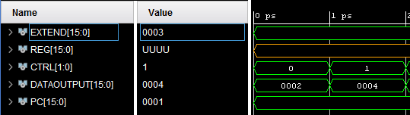

**PC + 1**

When the Control signal, CTRL, is set to 1, the PC is incremented by 1.

With it starting off as 1, it is immediately incremented to 2 at 0ps

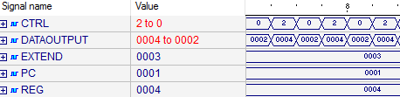

**PC + Extended Address**

When the Control is set to 2, he offset address is added to the PC, hence 3+ 1 = 4

**ADD Test Bench**

library IEEE;

use IEEE.STD_LOGIC_1164.ALL;

entity addBench is

-- Port ( );

end addBench;

architecture Behavioral of addBench is

signal EXTEND: std_logic_vector(15 downto 0);

signal REG: std_logic_vector(15 downto 0);

signal CTRL: std_logic_vector(1 downto 0);

signal DATAOUTPUT: std_logic_vector(15 downto 0);

signal PC: std_logic_vector(15 downto 0);

component ADD is

port(

bit16In : in STD_LOGIC_VECTOR(15 downto 0);

PCin : in STD_LOGIC_VECTOR(15 downto 0);

REGin : in STD_LOGIC_VECTOR(15 downto 0);

bit16Out : out STD_LOGIC_VECTOR(15 downto 0);

signCtrl : in STD_LOGIC_VECTOR(1 downto 0));

end component;

begin

M1: ADD port map(bit16In => EXTEND, PCin => PC, REGin => REG, bit16Out => DATAOUTPUT, signCtrl => CTRL);

process begin

--test control to increment PC + 1

wait for 1 ps;

--EXTEND <= "0000000000000011";

CTRL <= "00";

wait for 1 ps;

PC <= "0000000000000001";

wait for 1 ps;

assert DATAOUTPUT = "0000000000000010"

report "PC WAS NOT INCREMENTED"

severity ERROR;

--test to see if extended gets added

CTRL <= "00";

EXTEND <= "0000000000000011";

PC <= "0000000000000001";

REG <= "0000000000000100";

wait for 2 ps;

CTRL <= "01";

wait for 2 ps;

assert DATAOUTPUT = "0000000000000100"

report "PC WAS NOT INCREMENTED"

severity ERROR;

----test to see if register write works

CTRL <= "00";

EXTEND <= "0000000000000011";

PC <= "0000000000000001";

REG <= "0000000000000100";

wait for 2 ps;

CTRL <= "10";

wait for 2 ps;

assert DATAOUTPUT = "0000000000000100"

report "PC WAS NOT INCREMENTED"

severity ERROR;

end process;

end Behavioral;

**Register File Code**

library IEEE;

use IEEE.STD_LOGIC_1164.ALL;

use IEEE.numeric_std.ALL;

use ieee.std_logic_unsigned.all;

--this is for reg table

entity REGTABLE is

port(

addressA: in STD_LOGIC_VECTOR(3 downto 0) := (others => '0');--from contrl

addressB: in STD_LOGIC_VECTOR(3 downto 0) := (others => '0');--from contrl

addressD: in STD_LOGIC_VECTOR(3 downto 0) := (others => '0');--from contrl

PC: in STD_LOGIC_VECTOR(15 downto 0) := (others => '0'); --from CP

regMuxIn: in STD_LOGIC_VECTOR(15 downto 0) := (others => '0');--from REGister MUX

addOUT : out STD_LOGIC_VECTOR(15 downto 0);--to ADD

signExtend2: in STD_LOGIC_VECTOR(15 downto 0) := (others => '0'); -- for loadC

signCTRL: in STD_LOGIC_VECTOR(2 downto 0):= (others => '0'); --from control

bit16OutB: out STD_LOGIC_VECTOR(15 downto 0);

bit16OutA: out STD_LOGIC_VECTOR(15 downto 0));

end REGTABLE;

architecture Behavioral of REGTABLE is

signal bit16OutSigA : STD_LOGIC_VECTOR(15 downto 0) := "0000000000000000";

signal bit16OutSigB : STD_LOGIC_VECTOR(15 downto 0) := "0000000000000000";

subtype word is std_logic_vector(15 downto 0);

type memory is array((2**4)-1 downto 0) of word;

signal RAM: memory;

begin

process(signCTRL)

begin

if(signCTRL = "000")then

bit16OutSigA <= RAM(conv_integer(addressA)); --basic read at addresses R TYPE

bit16OutSigB <= RAM(conv_integer(addressB));

elsif(signCTRL = "001")then

RAM(conv_integer(addressA)) <= signExtend2; --write immediate to mem LOADC

elsif(signCTRL = "010")then

bit16OutSigA <= RAM(conv_integer(addressA));

bit16OutSigB <= RAM(conv_integer(addressB));

RAM(conv_integer("1111")) <= PC; --write PC value to reg for Jump and LINK

else

bit16OutSigA <= RAM(conv_integer(addressA)); --basic read at addresses

bit16OutSigB <= RAM(conv_integer(addressB)); --basic read at addresses

end if;

end process;

process(regMuxIn) begin

if(signCTRL = "000") then

RAM(conv_integer(addressD)) <= regMuxIn;

end if;

end process;

addOUT <= RAM(conv_integer("1111"));

bit16OutA <= bit16OutSigA;

bit16OutB <= bit16OutSigB;

end Behavioral;

I could not successfully simulate the register file by the due date. I will have it ready and operational by the next project.

**Register File Test Bench**

library IEEE;

use IEEE.STD_LOGIC_1164.ALL;

use IEEE.numeric_std.ALL;

use ieee.std_logic_unsigned.all;

entity regBench is

-- Port ( );

end regBench;

architecture Behavioral of regBench is

component REGTABLE is

port(

addressA: in STD_LOGIC_VECTOR(3 downto 0);--from contrl

addressB: in STD_LOGIC_VECTOR(3 downto 0);--from contrl

addressD: in STD_LOGIC_VECTOR(3 downto 0);--from contrl

PC: in STD_LOGIC_VECTOR(15 downto 0); --from PC

regMuxIn: in STD_LOGIC_VECTOR(15 downto 0);--from REGister MUX

addOUT : out STD_LOGIC_VECTOR(15 downto 0);--to ADD

signExtend2: in STD_LOGIC_VECTOR(15 downto 0); -- for loadC

signCTRL: in STD_LOGIC_VECTOR(2 downto 0); --from control

bit16OutB: out STD_LOGIC_VECTOR(15 downto 0);

bit16OutA: out STD_LOGIC_VECTOR(15 downto 0));

end component;

signal adA : STD_LOGIC_VECTOR(3 downto 0) := "0000";

signal adB : STD_LOGIC_VECTOR(3 downto 0):= "0000";

signal adD : STD_LOGIC_VECTOR(3 downto 0):= "0000";

signal PCsig: STD_LOGIC_VECTOR(15 downto 0) := "1111111111111111";

signal regMuxSig : STD_LOGIC_VECTOR(15 downto 0) := "1111111111111111";

signal signExSig: STD_LOGIC_VECTOR(15 downto 0):= "0000000000001111";

signal Ctrl : STD_LOGIC_VECTOR(2 downto 0):= "111";

signal outA : STD_LOGIC_VECTOR(15 downto 0) := "1111111111111111";

signal outB : STD_LOGIC_VECTOR(15 downto 0) := "1111111111111111";

signal addOutSig: STD_LOGIC_VECTOR(15 downto 0) := "1111111111111111";

begin

M1: REGTABLE port map(addressA => adA, addressB => adB, addressD => adD,PC => PCsig, regMuxIn => regMuxSig, signExtend2 => signExSig, signCtrl => Ctrl, addOut => addOutSig,bit16OutA => outA, bit16OutB => outB);

process begin

Ctrl <= "111"; -- read

adA <= "0000";

adB <= "0000";

adD <= "0000";

signExSig <= "0000000000001111";

regMuxSig <="0000000000000000";

PCsig <= "1111111111111111";

wait for 5 ps;

Ctrl <= "001"; -- load imm

wait for 5 ps;

Ctrl <="111"; --read

wait for 1 ps;

assert outA = "0000000000001111"

report "REG FILE NOT SET"

severity ERROR;

wait for 5 ps;

Ctrl <= "010"; --write pc

wait for 1 ps;

assert addOutSig = "1111111111111111"

report "REG FILE NOT SET"

severity ERROR;

end process;

end Behavioral;

**Data Memory Code**

library IEEE;

use IEEE.STD_LOGIC_1164.ALL;

use IEEE.numeric_std.ALL;

use ieee.std_logic_unsigned.all;

--this is for instruction mem

entity MEM is

port(

address: in STD_LOGIC_VECTOR(15 downto 0);

bit8out: out STD_LOGIC_VECTOR(7 downto 0);

bit12out: out STD_LOGIC_VECTOR(11 downto 0);

bit16out: out STD_LOGIC_VECTOR(15 downto 0));

end MEM;

architecture Behavioral of MEM is

signal bit16OutSig : STD_LOGIC_VECTOR(15 downto 0) := "0000000000000000";

signal bit12OutSig : STD_LOGIC_VECTOR(15 downto 0) := "000000000000";

signal bit8OutSig : STD_LOGIC_VECTOR(15 downto 0) := "00000000";

subtype word is std_logic_vector(15 downto 0);

type memory is array((2**16)-1 downto 0) of word;

signal INSTMEM: memory;

begin

ADDR: process(address)

begin

bit8OutSig <= INSTMEM(conv_integer(address));

bit12OutSig <= INSTMEM(conv_integer(address));

bit16OutSig <= INSTMEM(conv_integer(address));

end process;

bit8Out <= bit8OutSig;

bit12Out <= bit12OutSig;

bit16Out <= bit16OutSig;

end Behavioral;

**Program Counter Register**

library IEEE;

use IEEE.STD_LOGIC_1164.ALL;

use IEEE.numeric_std.ALL;

use ieee.std_logic_unsigned.all;

entity PC is

generic ( N : integer := 16);

port(

CLK : in STD_LOGIC;

PCIN : in STD_LOGIC_VECTOR(15 downto 0);

PCOUT : out STD_LOGIC_VECTOR(15 downto 0));

end PC;

architecture Behavioral of PC is

signal PCOUTsig : STD_LOGIC_VECTOR(15 downto 0) := "0000000000000000";

begin

CLOCK : process(CLK)

begin

if rising_edge(CLK) then

PCOUTsig <= PCIN;

end if;

end process;

PCOUT <= PCOUTsig;

end Behavioral;

**ALU/ DATA MEMORY Mux**

library IEEE;

use IEEE.STD_LOGIC_1164.ALL;

use IEEE.numeric_std.ALL;

use ieee.std_logic_unsigned.all;

entity REGMUX is

port(

signCtrl : in STD_LOGIC;

bit16Out : out STD_LOGIC_VECTOR(15 downto 0);

aluIn : in STD_LOGIC_VECTOR(15 downto 0);

memIn : in STD_LOGIC_VECTOR(15 downto 0));

end REGMUX;

architecture Behavioral of REGMUX is

signal bi16Outsig : STD_LOGIC_VECTOR(15 downto 0) := "0000000000000000";

begin

process(signCtrl)begin

if(signCtrl = '0')then

bi16Outsig <= aluIn;

else

bi16Outsig <= memIn;

end if;

end process;

bit16Out <= bi16Outsig;

end Behavioral;

**Sign Extension 1**

library IEEE;

use IEEE.STD_LOGIC_1164.ALL;

use IEEE.numeric_std.ALL;

use ieee.std_logic_unsigned.all;

entity SIGN1 is

port(

in8bit : in STD_LOGIC_VECTOR(7 downto 0);

in12bit: in STD_LOGIC_VECTOR(11 downto 0);

bit16Out: out STD_LOGIC_VECTOR(15 downto 0);

signCtrl: in STD_LOGIC);

end SIGN1;

architecture Behavioral of SIGN1 is

signal bit16OutSig : STD_LOGIC_VECTOR(15 downto 0) := "0000000000000000";

begin

CTRL: process(signCtrl)

begin

if(signCtrl = '0') then

bit16OutSig <= in8bit;

elsif(signCtrl = '1') then

bit16OutSig <= in12bit;

end if;

end process;

bit16Out <= bit16OutSig;

end Behavioral;

**Sign Extension 2**

library IEEE;

use IEEE.STD_LOGIC_1164.ALL;

use IEEE.numeric_std.ALL;

use ieee.std_logic_unsigned.all;

entity SIGN2 is

port(

in8bit : in STD_LOGIC_VECTOR(7 downto 0);

bit16Out: out STD_LOGIC_VECTOR(15 downto 0));

end SIGN2;

architecture Behavioral of SIGN2 is

signal bit16OutSig : STD_LOGIC_VECTOR(15 downto 0) := "0000000000000000";

begin

process(in8bit)

begin

bit16OutSig <= in8bit;

end process;

bit16Out <= bit16OutSig;

end Behavioral;

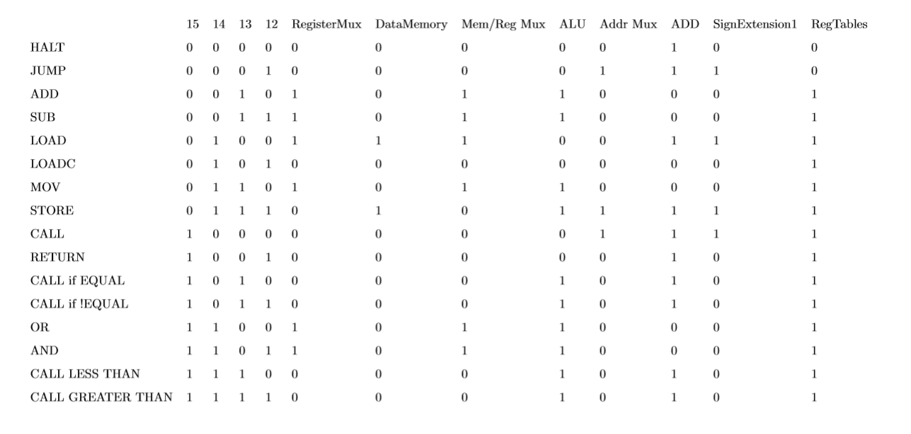

Control Unit Data Path Reference