Eddings Noah Final

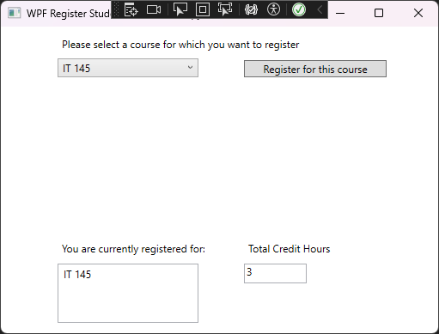

Each course carries 3 credit hours

No registration for more than once for the same course

No registration for more than 9 credit hours

Source code Main Window:

using System;

using System.Collections.Generic;

using System.Linq;

using System.Text;

using System.Threading.Tasks;

using System.Windows;

using System.Windows.Controls;

using System.Windows.Data;

using System.Windows.Documents;

using System.Windows.Input;

using System.Windows.Media;

using System.Windows.Media.Imaging;

using System.Windows.Navigation;

using System.Windows.Shapes;

namespace WPFRegisterStudent

{

public partial class MainWindow : Window

{

private Course choice;

private List<Course> registeredCourses;

private int totalCreditHours;

public MainWindow()

{

InitializeComponent();

registeredCourses = new List<Course>();

totalCreditHours = 0;

}

private void Window_Loaded(object sender, RoutedEventArgs e)

{

Course course1 = new Course("IT 145");

Course course2 = new Course("IT 200");

Course course3 = new Course("IT 201");

Course course4 = new Course("IT 270");

Course course5 = new Course("IT 315");

Course course6 = new Course("IT 328");

Course course7 = new Course("IT 330");

this.comboBox.Items.Add(course1);

this.comboBox.Items.Add(course2);

this.comboBox.Items.Add(course3);

this.comboBox.Items.Add(course4);

this.comboBox.Items.Add(course5);

this.comboBox.Items.Add(course6);

this.comboBox.Items.Add(course7);

this.textBox.Text = "Total Credit Hours: 0";

}

private void button_Click(object sender, RoutedEventArgs e)

{

choice = (Course)this.comboBox.SelectedItem;

if (choice == null)

{

MessageBox.Show("Please select a course to register.", "Error", MessageBoxButton.OK, MessageBoxImage.Error);

return;

}

if (choice.IsRegisteredAlready())

{

MessageBox.Show("You are already registered for this course.", "Error", MessageBoxButton.OK, MessageBoxImage.Error);

return;

}

if (totalCreditHours + 3 > 9)

{

MessageBox.Show("You cannot register for more than 9 credit hours.", "Error", MessageBoxButton.OK, MessageBoxImage.Error);

return;

}

RegisterCourse(choice);

}

private void RegisterCourse(Course course)

{

course.SetToRegistered();

registeredCourses.Add(course);

totalCreditHours += 3;

MessageBox.Show($"You have successfully registered for {course.getName()}.", "Registration Successful", MessageBoxButton.OK, MessageBoxImage.Information);

this.textBox.Text = $"{totalCreditHours}";

this.listBox.ItemsSource = null;

this.listBox.ItemsSource = registeredCourses;

}

}