IT teknolog
Opgave 28



Forfatter
Noah Christian Rosenkjær – ncro58767@edu.ucl.dk

Indholdsfortegnelse

1 Publikum 1
2 Udstyrsliste 1
3 Opgaver 2

Publikum

Det er til forfatterene.

Udstyrsliste

VMware Workstation pro 17
4 linux maskiner

Opgaver

- Tegn et netværks diagram.
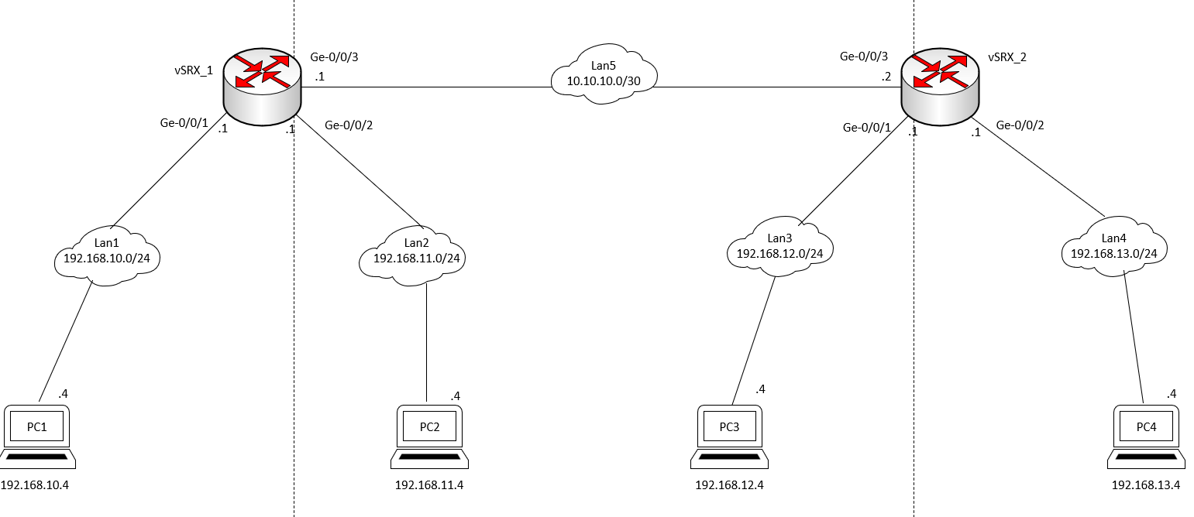

- Byg netværket i lab i henhold til netværksdiagrammet.

PC’s opsætning:

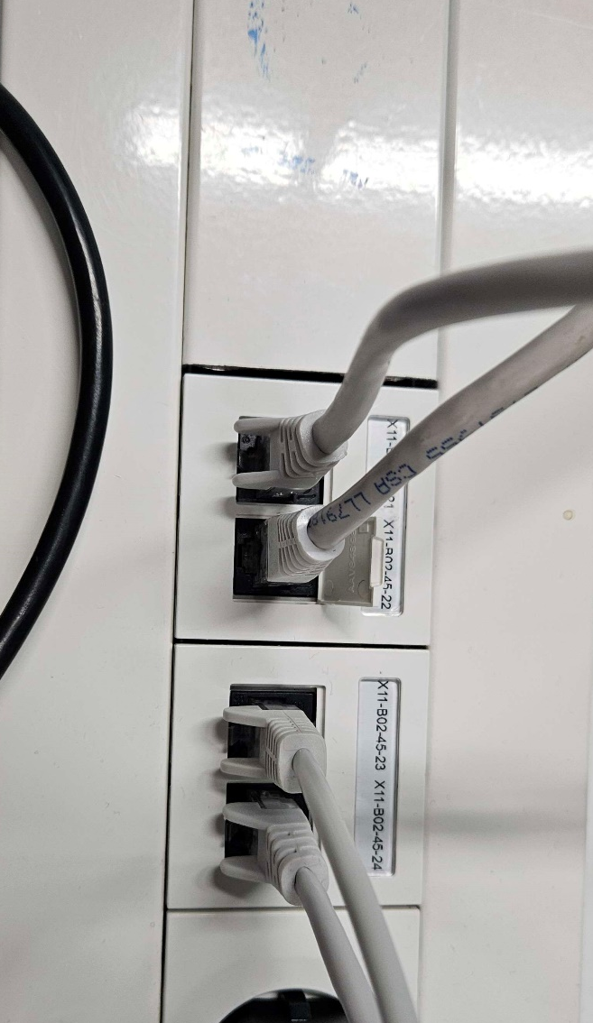

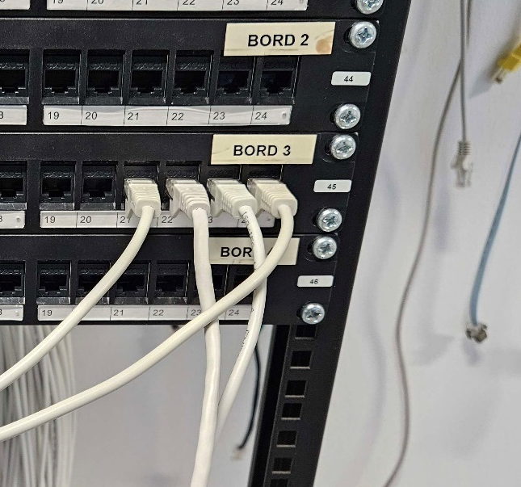

Routers opsætning:

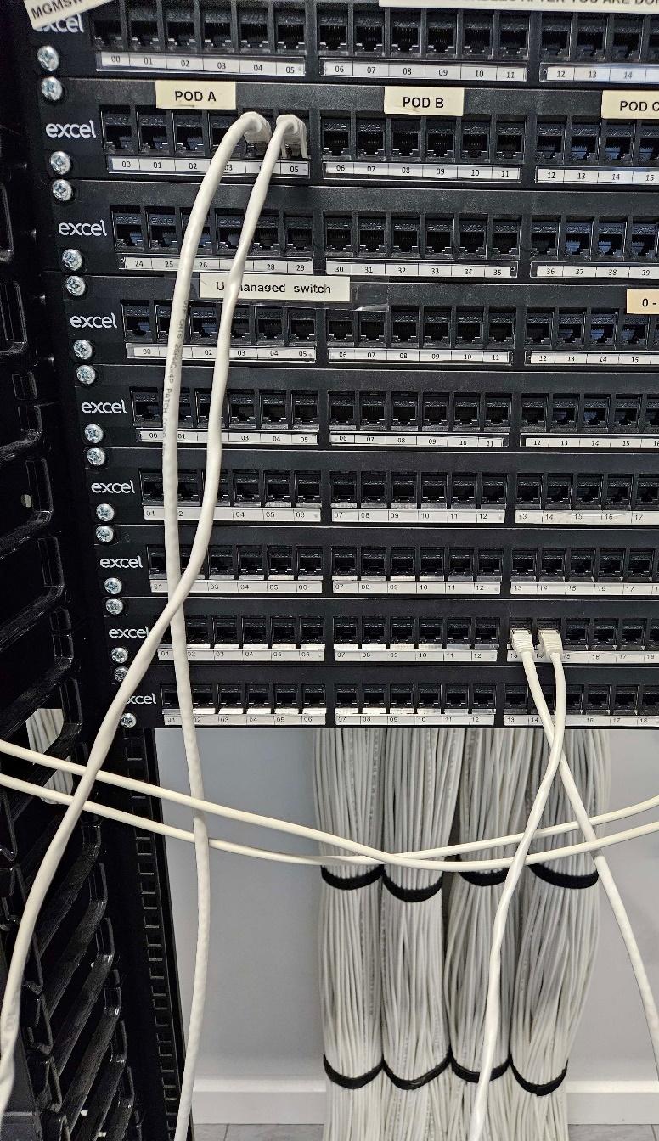

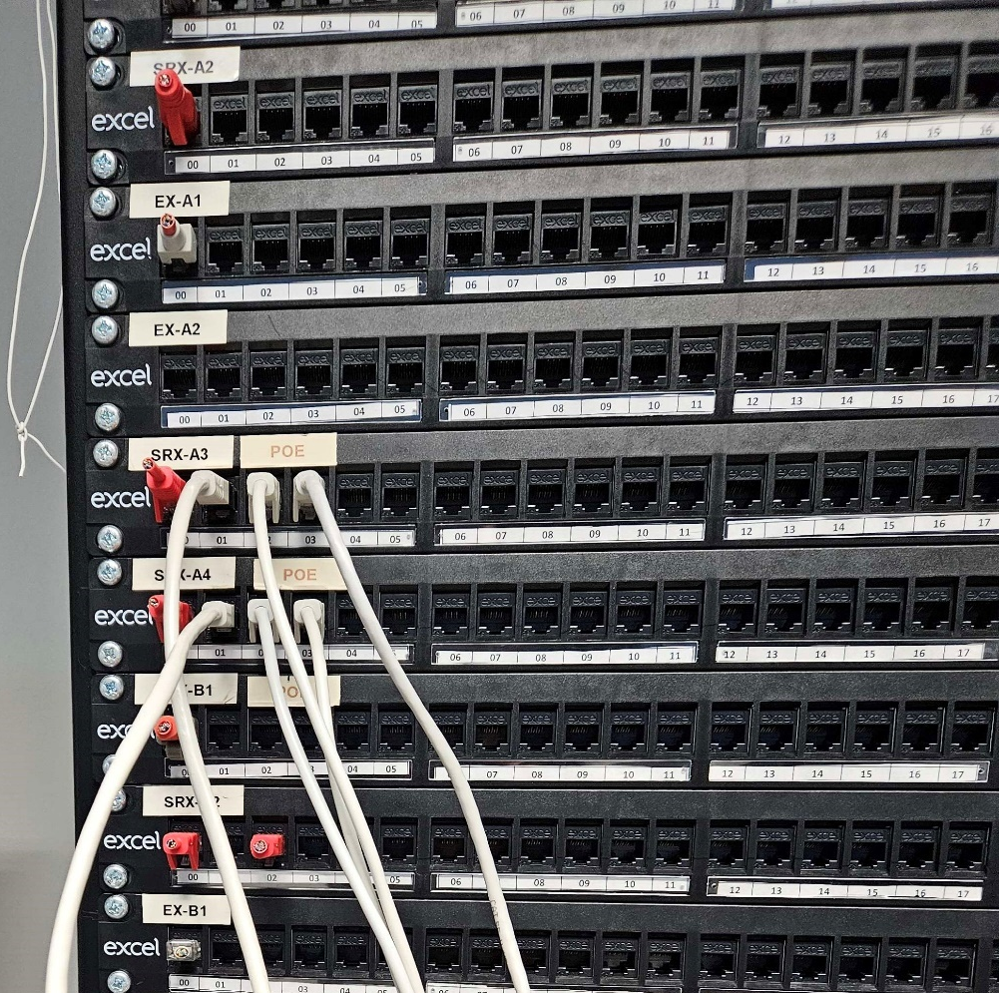

- Konfigurere router og PC’s.

vSRX_1:
[edit]
root@vSRX_1# load override terminal

/* Assignment 11. Two routers five subnets. */
/* By Per Dahlstroem */
version 12.1X47-D15.4;
system {
host-name vSRX_1;
/* User: root Password: Rootpass */
root-authentication {
encrypted-password "$1$4TkbZDtp$6E8C6Bg7K6gnHR31XnJjl0";
}
}
interfaces {
ge-0/0/1 {
unit 0 {
family inet {
/* Lan1 */
address 192.168.10.1/24;
}
}
}
ge-0/0/2 {
unit 0 {
family inet {
/* Lan2 */
address 192.168.11.1/24;
}
}
}
ge-0/0/3 {
unit 0 {
family inet {
/* Lan5 */
address 10.10.10.1/30;
}
}
}
}
routing-options {
static {
/* Route to Lan3 */
route 192.168.12.0/24 next-hop 10.10.10.2;
/* Route to Lan4 */
route 192.168.13.0/24 next-hop 10.10.10.2;
}
}
security {
policies {
from-zone myTrust_1 to-zone myTrust_1 {
policy default-permit {
match {
source-address any;
destination-address any;
application any;
}
then {
permit;
}
}
}
}
zones {
security-zone myTrust_1 {
interfaces {
ge-0/0/1.0 {
host-inbound-traffic {
system-services {
ping;
}
}
}
ge-0/0/2.0 {
host-inbound-traffic {
system-services {
ping;
}
}
}
ge-0/0/3.0 {
host-inbound-traffic {
system-services {
ping;
}
}
}
}
}
}
}

vSRX_2:
[edit]
root@vSRX_1# load override terminal
/* Assignment 11. Two routers five subnets. */
/* By Per Dahlstroem */
version 12.1X47-D15.4;
system {
host-name vSRX_1;
/* User: root Password: Rootpass */
root-authentication {
encrypted-password "$1$4TkbZDtp$6E8C6Bg7K6gnHR31XnJjl0";
}
}
interfaces {
ge-0/0/1 {
unit 0 {
family inet {
/* Lan3 */
address 192.168.12.1/24;
}
}
}
ge-0/0/2 {
unit 0 {
family inet {
/* Lan4 */
address 192.168.13.1/24;
}
}
}
ge-0/0/3 {
unit 0 {
family inet {
/* Lan5 */
address 10.10.10.2/30;
}
}
}
}
routing-options {
static {
/* Route to Lan3 */
route 192.168.10.0/24 next-hop 10.10.10.1;
/* Route to Lan4 */
route 192.168.11.0/24 next-hop 10.10.10.1;
}
}
security {
policies {
from-zone myTrust_1 to-zone myTrust_1 {
policy default-permit {
match {
source-address any;
destination-address any;
application any;
}
then {
permit;
}
}
}
}
zones {
security-zone myTrust_1 {
interfaces {
ge-0/0/1.0 {
host-inbound-traffic {
system-services {
ping;
}
}
}
ge-0/0/2.0 {
host-inbound-traffic {
system-services {
ping;
}
}
}
ge-0/0/3.0 {
host-inbound-traffic {
system-services {
ping;
}
}
}
}
}
}
}

PC1:
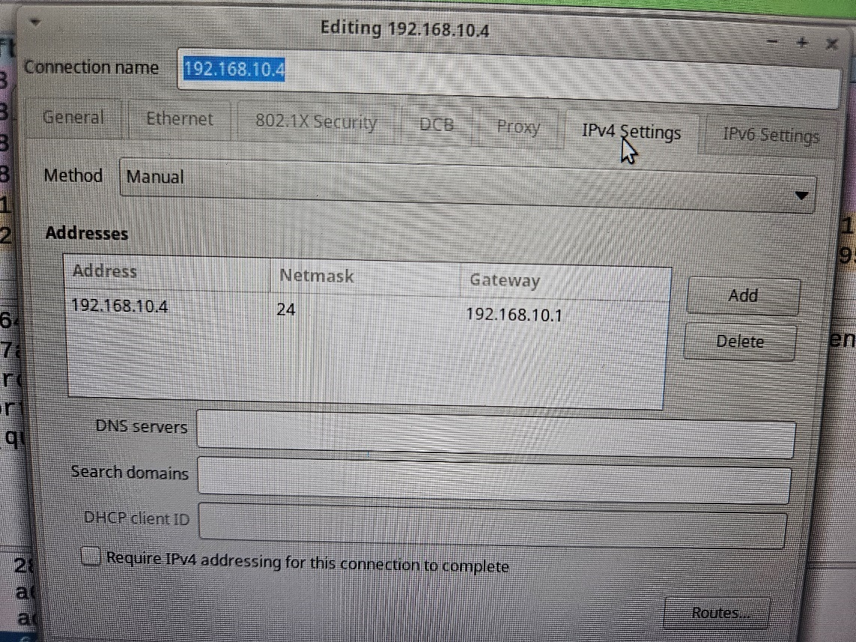

PC2:
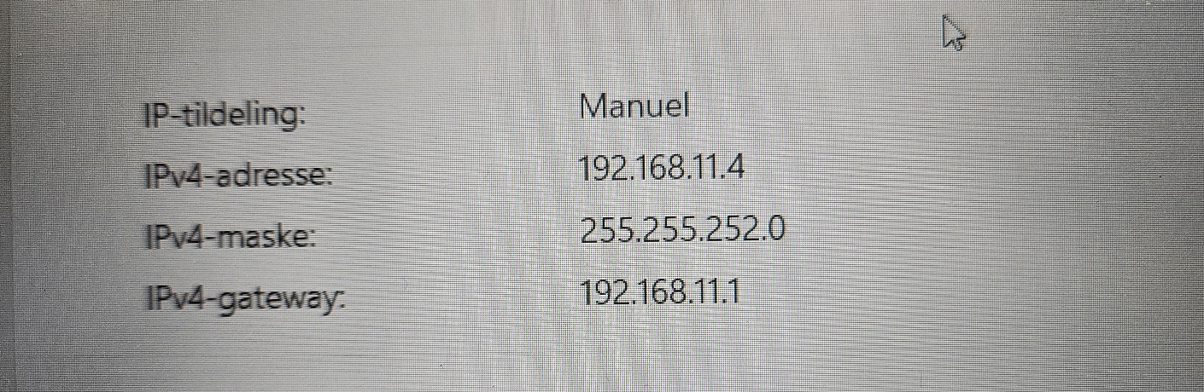
PC3:
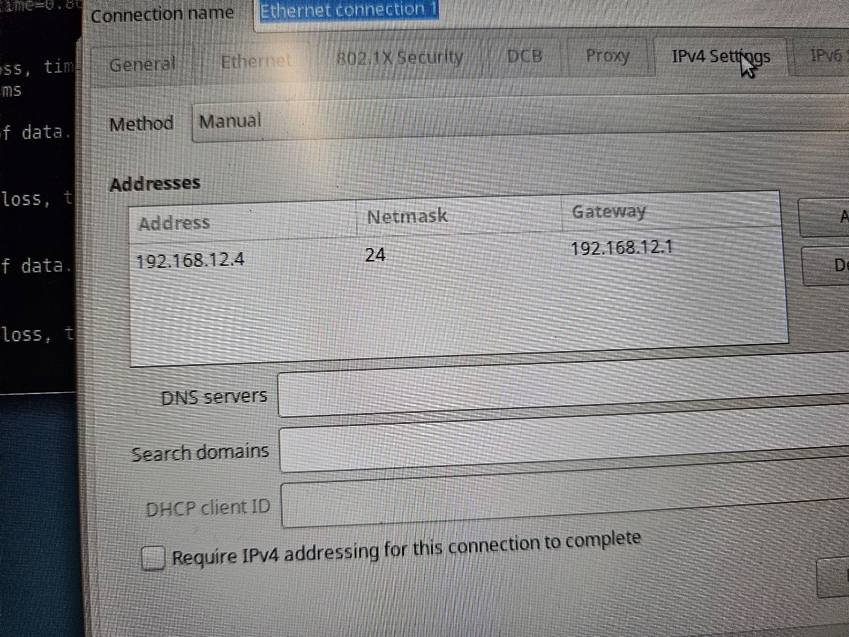

PC4:
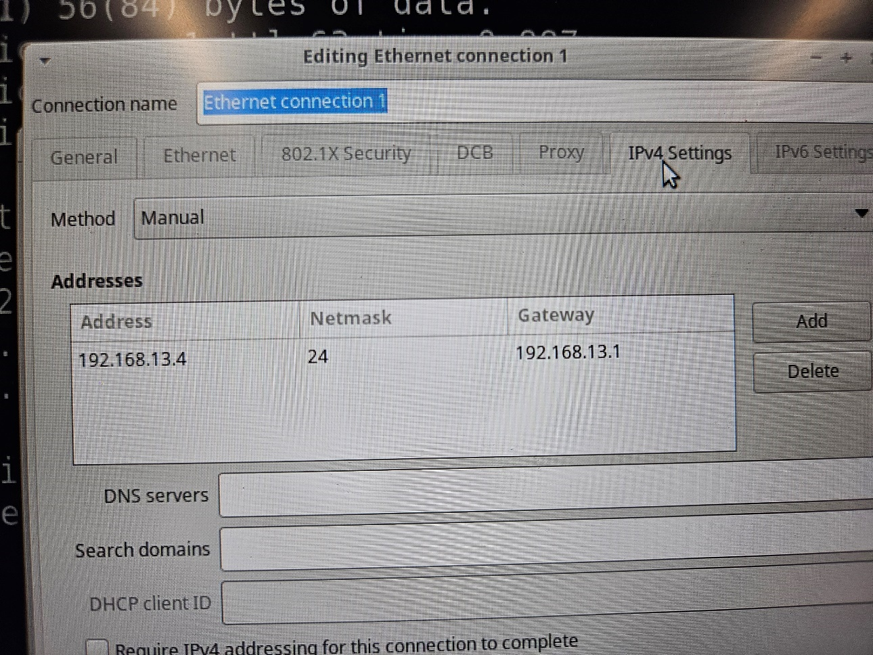

- List routingtabellen på SRX_1 og SRX_2. Kommenter de viste ruter.

SRX_1 rutningstabel:
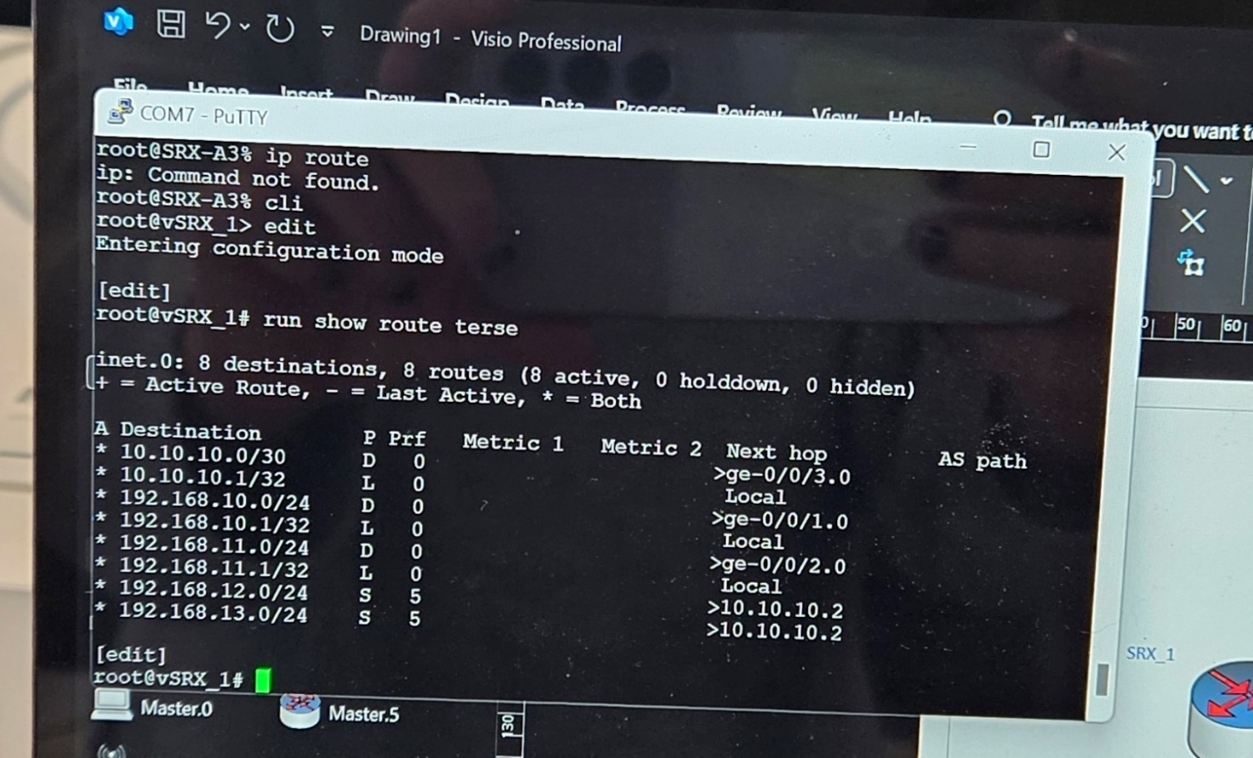
SRX_2 rutningstabel:
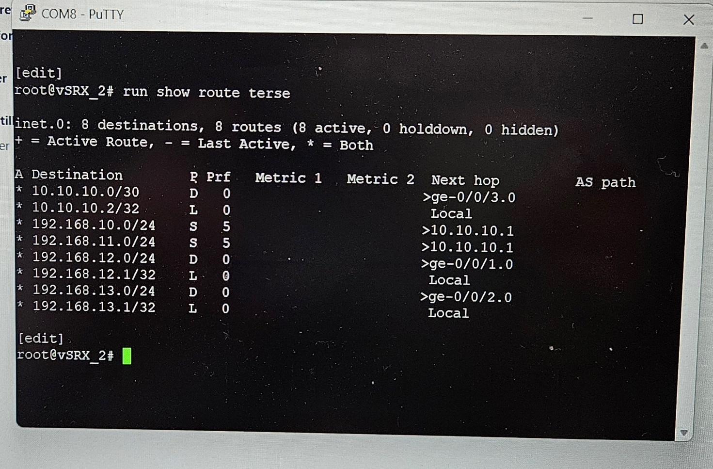
På rutnings tabellerne bruger routerne til at finde ud af hvor pings skal sendes hen. De viste router er til PC1, PC2, PC3 og PC4.

- Lav pc-ping for at teste, at SRX'ernes routing mellem de fem subnets fungerer.
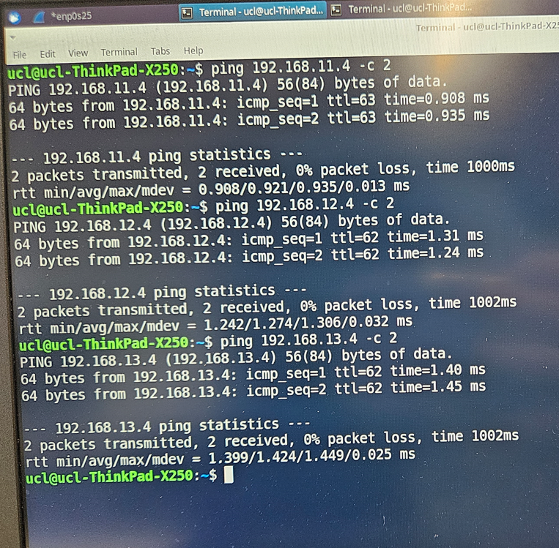

- Wireshark PC4 og PC1 interfaces.
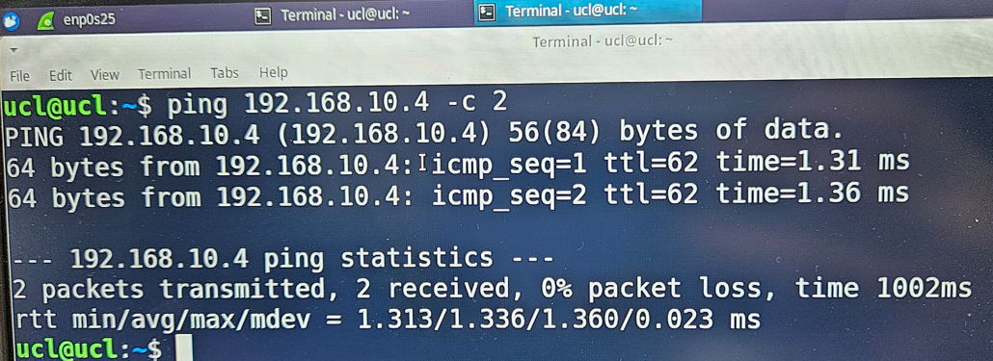
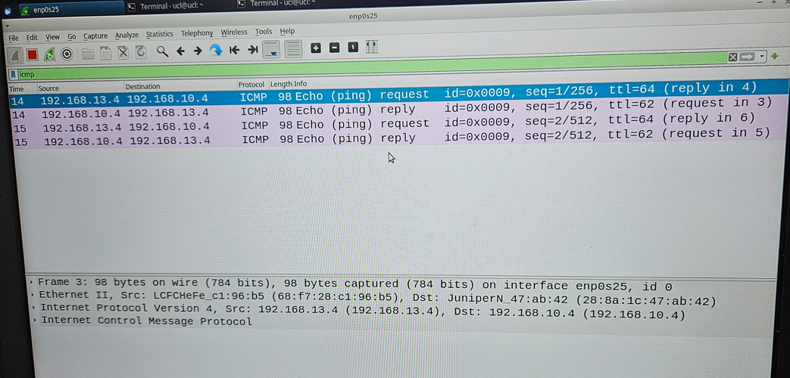

- Kør traceroute på PC1 til PC4.




