IT-Teknolog
Opgave 4



Forfatter
Noah Christian Rosenkjær
ncro58767@edu.ucl.dk

D. 29-09-2023

Indholdsfortegnelse

1 Introduktion 3
2 Publikum 3
3 Udstyrsliste 3
4 Teknisk documentation 4
4.1 Please draw the network diagram. 4
4.2 Please intercconnect all devices according to the network diagram. 5
4.3 Configure the two PCs according to the network diagram. 6
4.4 Configure the switch S1 according to the network diagram. Please configure Spanning Tree Protocoll STP to be off to not have STP traffic blurring captures: 7
4.5 Run wireshark on PC1 and on PC2 and confirm that IPs on the internet are reachable. Ping e.g. dr.fk and/or 8.8.8.8. Use this Wireshark display filter to only see "ping" traffic: 7
4.6 List the MAC or SAT table in the switch. Please explain the addresses in the table. 7
4.7 Verify with wireshark that: 1. the switch is forwarding broadcast frames to all connected devices and 2. the switch is not forwarding non broadcast frames to all connected devices. 8
4.8 List PC1 and PC2 ARP tables to verify if any switch S1 MAC addresses have been entered. Comment on wether switch mac addresses are in the ARP tables or not. Can the switch be regarded as "invisible" to traffic between PC1 and PC2? 9
4.9 Configure a Linux Switch number two S2 and interconnect the two switches S1 and S2 as shown in the diagram. 9
4.9.1 Draw the network diagram. 10
4.9.2 Please try to predict what the MAC table will be in S1. I.e. how will S1 know that multiple PCs are on its port ens38? 10
4.9.3 Please verify the MAC table in S1 and S2. 10
5 Konklusion 11

Introduktion

Denne dokumentation går ud på at bygge en switch ud fra en linux maskine.

Publikum

It-teknolog studerende på 1. semester.

Udstyrsliste
VMware Workstation pro
Linux

Teknisk documentation

Please draw the network diagram.
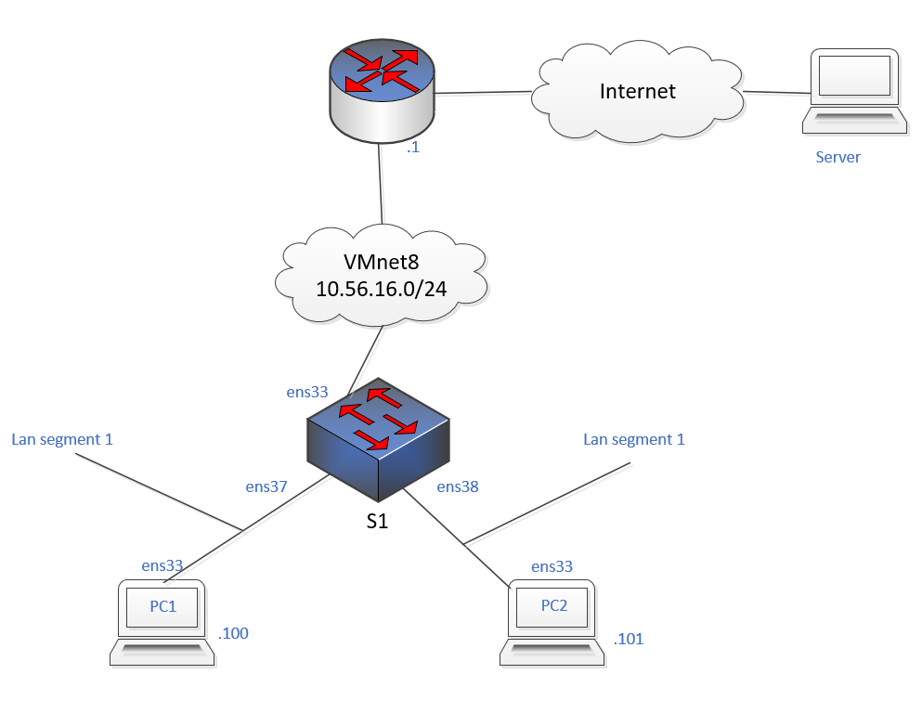

Please intercconnect all devices according to the network diagram.
S1 switch’en:
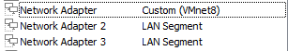
Her er Network Adapter 2 sat til LAN segment 1, og Network Adapter 3 er sat til LAN segment 2.

PC1:

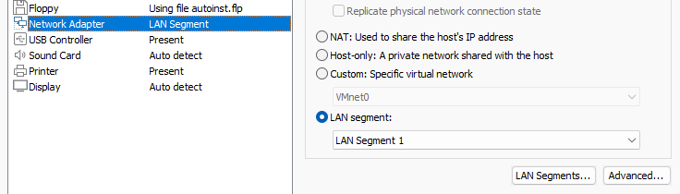
Er sat til LAN segment 1.

PC2:
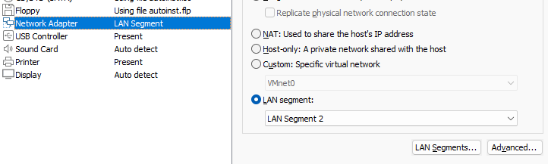
Er sat til LAN segment 2.

Configure the two PCs according to the network diagram.
PC1:

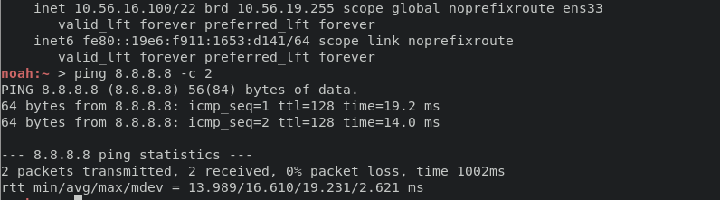
Som det kan ses har PC1 .100 IP addresen.

PC2:

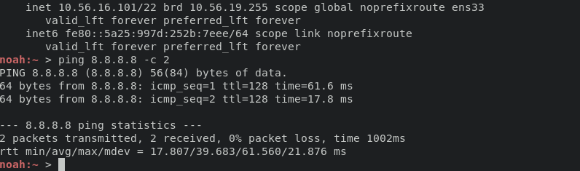
Og PC2 har .101 IP addresen.

Configure the switch S1 according to the network diagram. Please configure Spanning Tree Protocoll STP to be off to not have STP traffic blurring captures:
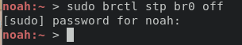

Run wireshark on PC1 and on PC2 and confirm that IPs on the internet are reachable. Ping e.g. dr.fk and/or 8.8.8.8. Use this Wireshark display filter to only see "ping" traffic:
PC1:
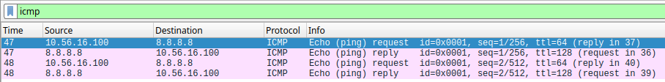

PC2:
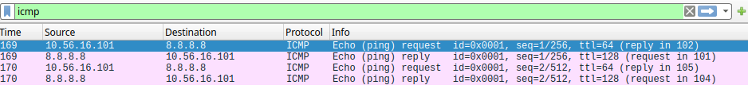

List the MAC or SAT table in the switch. Please explain the addresses in the table.
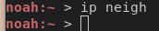
Når ip neigh bliver brugt på S1 kommer der intet frem, den har heller ikke internet adgang, men både PC1 og PC2 har internet adgange igennem S1. Så ved ikke helt hvad der sker.

Verify with wireshark that: 1. the switch is forwarding broadcast frames to all connected devices and 2. the switch is not forwarding non broadcast frames to all connected devices.
- Som det kan ses på billedet under prøver .100 at pinge .101, men .100’s arp table havde kun .1 i sig så .100 spørger om hvem der har .101, og det hele går gennem S1.
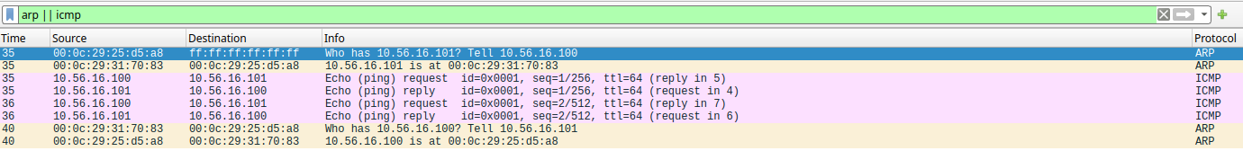
- Som det kan ses her så bliver alle broadcasts vidregivet, og .92 som er koblet direkte til vmnet8 kan også se dem. Ved ikke hvorfor eller hvad der skal gøres for at S1 ikke sender dem vidre.
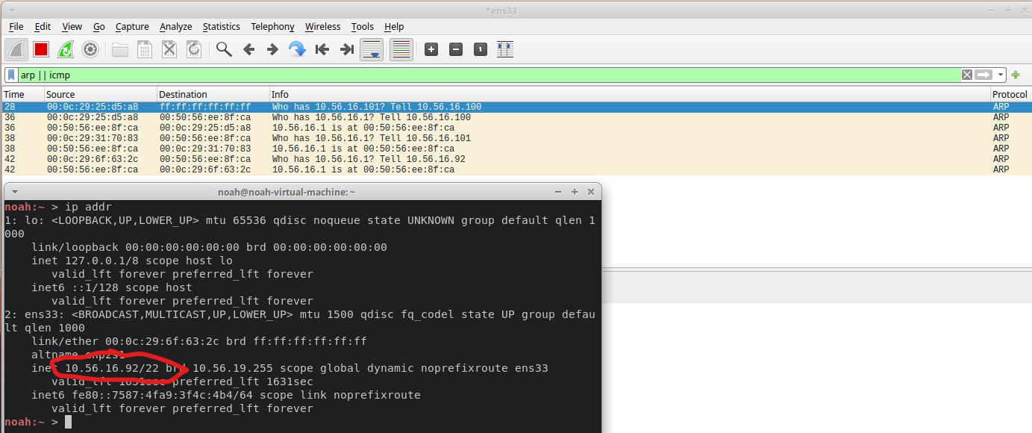

List PC1 and PC2 ARP tables to verify if any switch S1 MAC addresses have been entered. Comment on wether switch mac addresses are in the ARP tables or not. Can the switch be regarded as "invisible" to traffic between PC1 and PC2?
PC1:
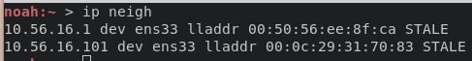

PC2:
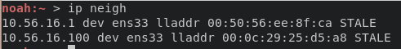

Som det kan ses af begge ARP tabellerne bliver S1 ikke skrevet ind, da den kun vidresender packets. Så ja den kan vel godt blive set som usynelig.

Configure a Linux Switch number two S2 and interconnect the two switches S1 and S2 as shown in the diagram.
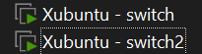

Draw the network diagram.
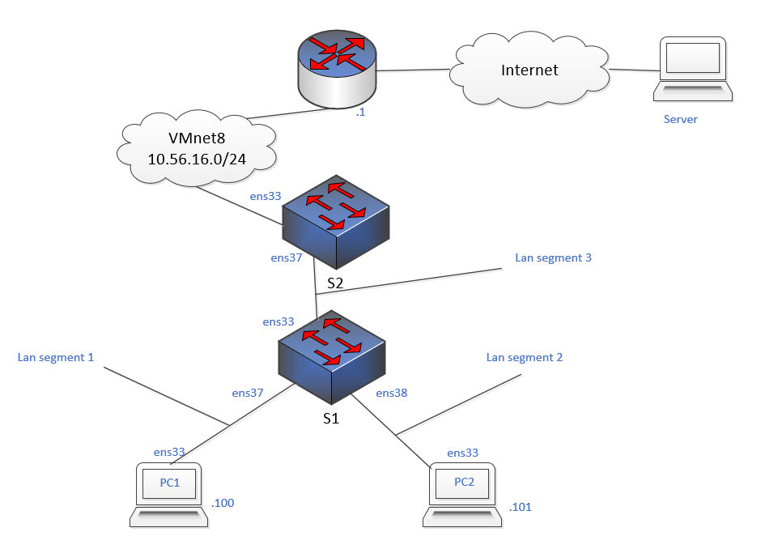

Please try to predict what the MAC table will be in S1. I.e. how will S1 know that multiple PCs are on its port ens38?
Jeg tror ikke det ændre noget.

Please verify the MAC table in S1 and S2.
S1:
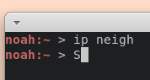

S2:
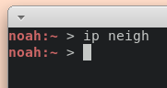

Som udgangs punkt er både S1 og S2’s ARP tables tomme.

Konklusion
Det kan ses af opgaven at der blev lært hvordan men laver en switch ud af en normal linux maskine, samt hvordan man bruger lan-segmenter.

