General schematic to go from 120V AC to 5V DC. As this schematic stands, having the 100 ohm resistor will have a current of 0.87A in that junction. We will need to adjust this based on the resistance of the raspberry Pi (I think it needs 500mA input) We also may switch this around because it’s hard to find diodes that can handle 120V:

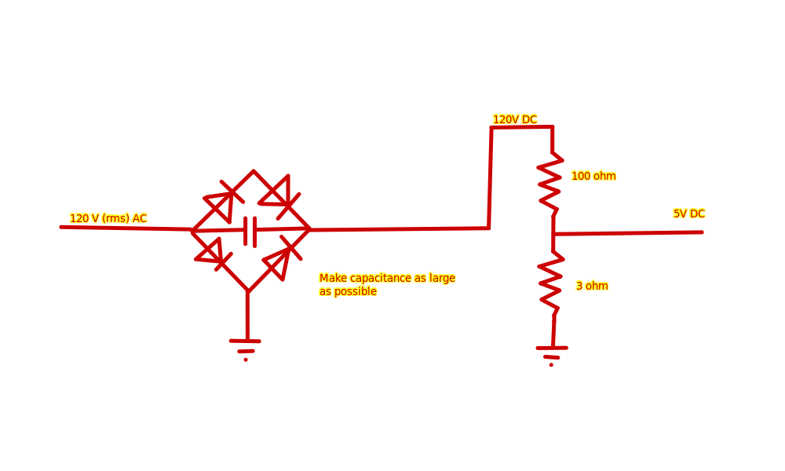

Components required for this circuit

1. 4 diodes
2. 1 capacitor (the largest capacitance possible while still fitting in the space allotted)
3. 2 resistors. The one resistor approximately 33.3 times larger than the other
4. Raspberry pi
5. RGB LED