Homework 4
CS332 Dr. Unan
Noah Sellers
BlazerID: Sellersn

Approach
Main
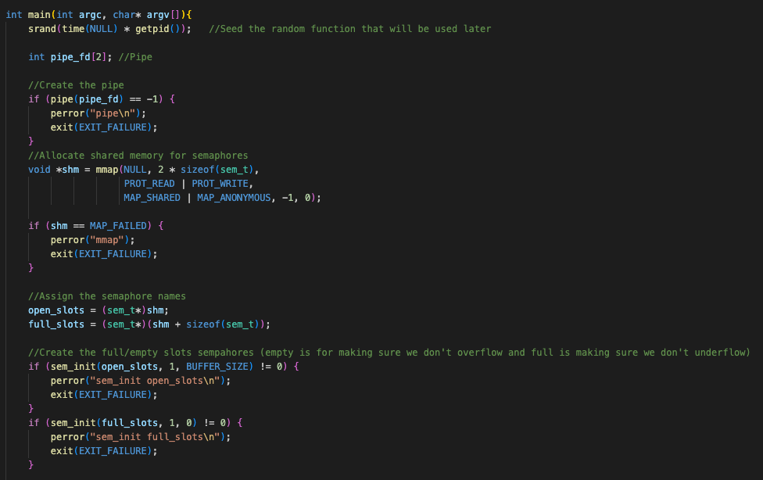
In my program, we’ll start by initializing the global and shared variables. Create a pipe that each thread will read/write to and from. Create semaphores for that pipe that will indicate the number of empty slots in the pipe and the number of full slots in the pipe. Next we’ll call fork() and create a child process.

Parent Process
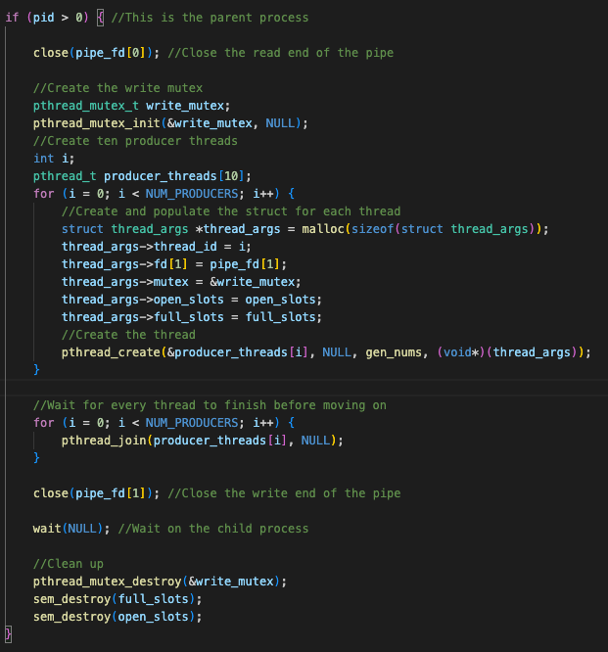
In the parent process, we’ll close the read end of the pipe since the parent doesn’t need to use it. We’ll also need to create a mutex that we can lock/unlock to prevent race conditions with the threads that we’re about to create. Each thread can lock the mutex to ensure that no other thread can write to the pipe at the same time. We’ll create an array to store the threads and create 10 threads, creating and passing a struct with the necessary information. Each thread will execute the gen_nums method.

Gen_nums
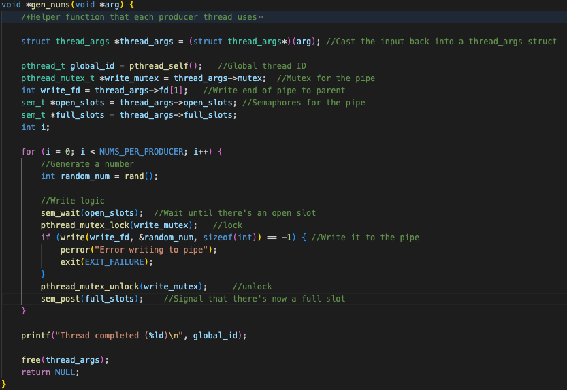
The gen_nums method reads the information from the struct that it was passed and initializes its variables. Then, for each number that we need to generate (I used a macro for this number so it can be changed easily) we’ll generate the number with the rand() function that was seeded earlier in main. We need to make sure there is an open slot in the pipe, grab the mutex, and write to the pipe. Once we’re done writing to the pipe we’ll unlock the mutex and use sem_post to signal to the next available consumer thread (I’ll cover those in a moment) that that there is now a full slot. After all the numbers are generated and written to the pipe, the thread is complete and we can print the message and free the memory that held the copy of the thread_args struct.

Child Process
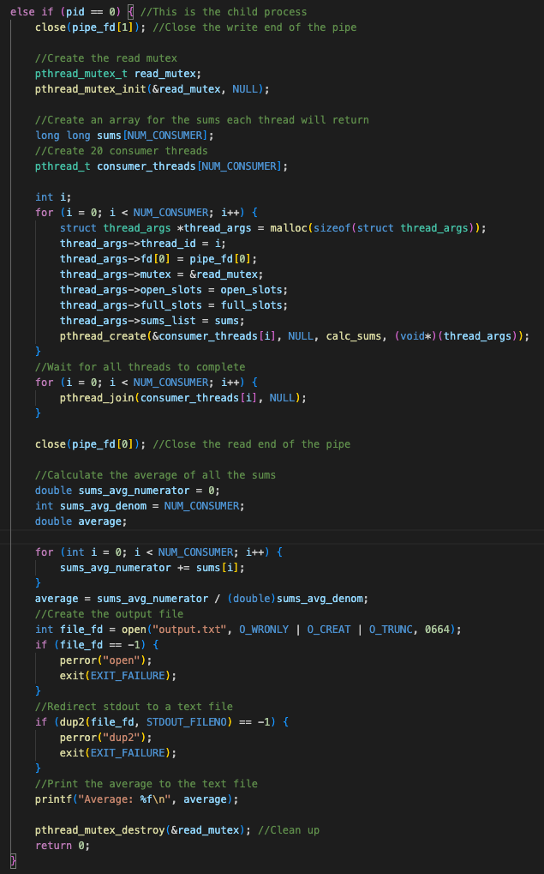
In the child process, we’ll close the write end of the pipe since it’s not necessary. Each child thread will calculate a sum, so we’ll need to create an array to store those sums. Now we can create the threads in the exact way as the parent process, with the only difference being that the thread will execute the calc_sums method.

Calc_sums
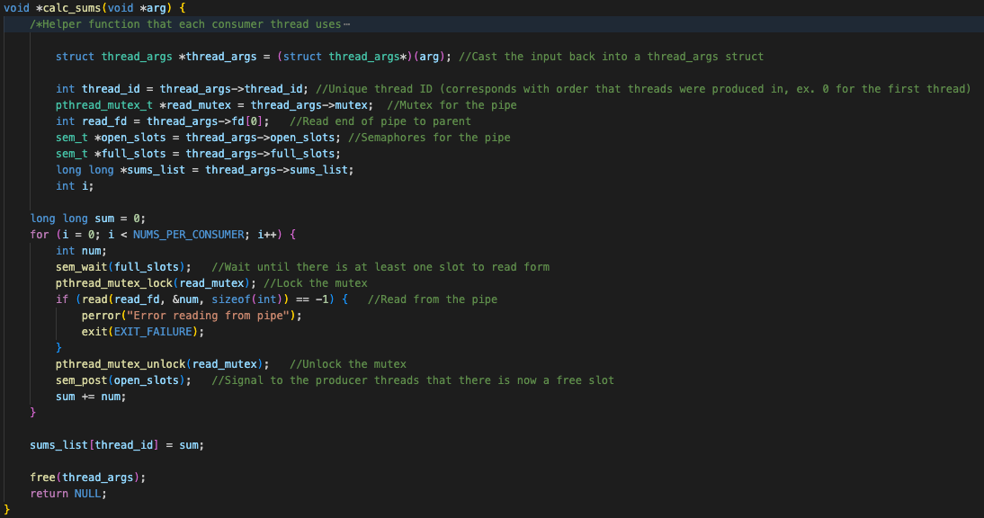
The calc sum method initializes its variables from the struct that we passed to it. We’ll create a sum variable to keep track of the total sum of all numbers. Next, we’ll grab 250 numbers (NUMS_PER_CONSUMER) from the pipe with the for loop. Each iteration will wait for there to be at least one full slot, lock the mutex so the other threads in the child process don’t try to read at the same time, read one number from the pipe, then unlock the mutex and signal to the next producer thread that there is a free slot. At the end of the iteration, add the number to the total sum. After the loop, free the copy of the thread_args struct.

Child Process
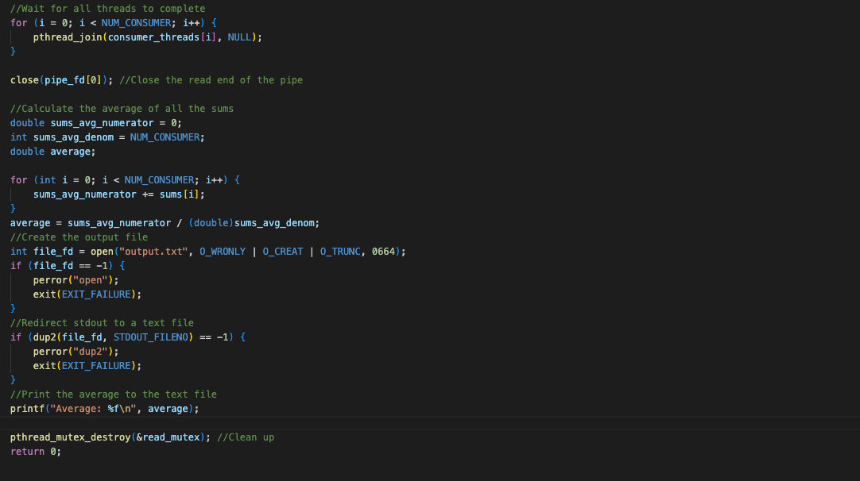
After all the threads in the child process complete (we make sure of this is the pthread_join()) we can close the read end of the pipe because we’re done reading from it. To calculate the average we just add together each sum and divide that by the total number of sums in the array (equal to the number of threads.) We’ll then redirect stdout to the text file with dup2 and print the average. Finally, we need to destroy the read protection mutex because it is local to the child process only.

Parent Process
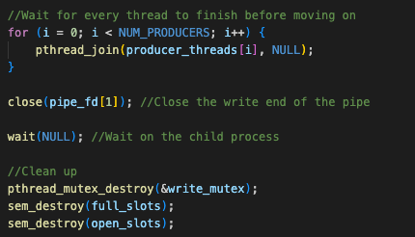
Back to the parent process. Once all the producer threads are done and the child process completes, we have successfully finished execution of the program. We’ll simply destroy our mutex that was local to the parent process and destroy the global semaphores.

