**Desktop Flight Monitoring Tool**

This little board sits on a desk and keeps you appraised of any status changes for your favorite flights.

Demo: Flair Air (FLE) flight 227 departing Toronto Airport (YYZ)

Alerts are set using FlightAware.com for specific airports, flights, or airports

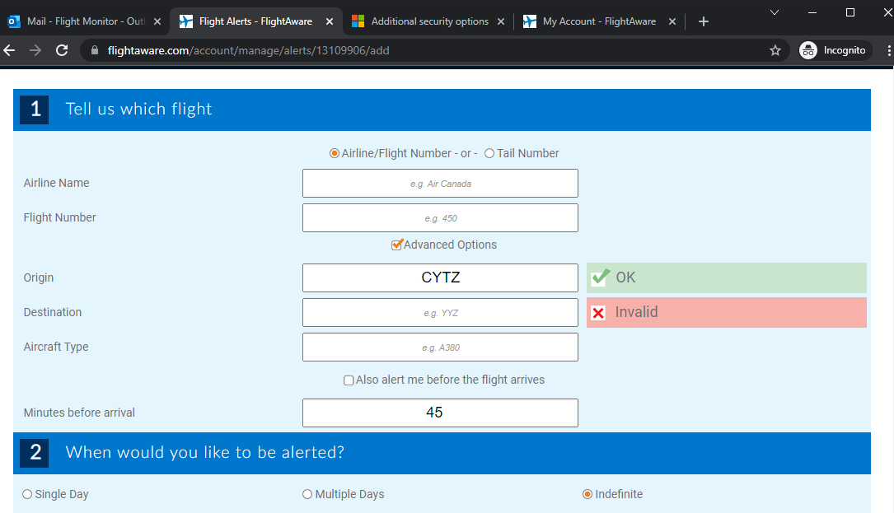

How it works

Email sent, moved to subfolder via Rule

Alert Pushed to board