* 1. Select one UDP packet from your trace. From this packet, determine how many fields there are in the UDP header. (You shouldn’t look in the textbook! Answer these questions directly from what you observe in the packet trace.) Name these fields.
     1. There are four fields, source port, destination port, length, and checksum
  2. By consulting the displayed information in Wireshark’s packet content field for this packet, determine the length (in bytes) of each of the UDP header fields.
     1. Each of the headers is two bytes long for a total of eight bytes
  3. The value in the Length field is the length of what? (You can consult the text for this answer). Verify your claim with your captured UDP packet.
     1. The length is 58
     2. 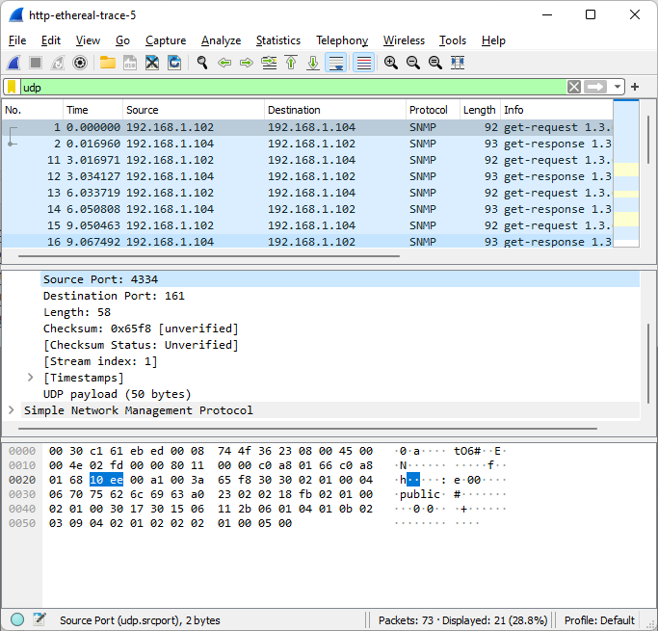
  4. What is the maximum number of bytes that can be included in a UDP payload? (Hint: the answer to this question can be determined by your answer to 2. above)
     1. So to solve this we subtract the largest source port number (2^16 -1) from the eight bytes being used in the header field which comes out to 65535-8=65527 bytes.
  5. What is the largest possible source port number? (Hint: see the hint in 4.)
     1. The largest possible source port number is 2^16 -1(-1 for port 0) which is also the number 65535
  6. What is the protocol number for UDP? Give your answer in both hexadecimal and decimal notation. To answer this question, you’ll need to look into the Protocol field of the IP datagram containing this UDP segment (see Figure 4.13 in the text, and the discussion of IP header fields).
     1. The protocol number for UDP is 17 or 11 in hexadecimal
  7. Examine a pair of UDP packets in which your host sends the first UDP packet and the second UDP packet is a reply to this first UDP packet. (Hint: for a second packet to be sent in response to a first packet, the sender of the first packet should be the destination of the second packet). Describe the relationship between the port numbers in the two packets.
     1. The source port of the first packet is the same as destination port of the second packet and the destination port of the first packet is the same as the source port of the second packet.

**Trace 1**

C :\Users\kv str\Downloads\http-ethereal-trace-5 73 total packets, 21 shown No. Time Source Destination Protocol Length Info 1 0.000000 192.168.1.102 192.168.1.104 SNMP 92 get-request 1.3.6.1.4.1.11.2.3.9.4.2.1.2.2.2.1.0 Frame 1: 92 bytes on wire (736 bits), 92 bytes captured (736 bits) Ethernet II, Src: Dell_4f:36:23 (00:08:74:4f:36:23), Dst: HewlettP_61:eb:ed (00:30:c1:61:eb:ed) Destination: HewlettP_61:eb:ed (00:30:c1:61:eb:ed) Source: Dell_4f:36:23 (00:08:74:4f:36:23) Type: IPv4 (0x0800) Internet Protocol Version 4, Src: 192.168.1.102, Dst: 192.168.1.104 User Datagram Protocol, Src Port: 4334, Dst Port: 161 Source Port: 4334 Destination Port: 161 Length: 58 Checksum: 0x65f8 [unverified] [Checksum Status: Unverified] [Stream index: 1] [Timestamps] UDP payload (50 bytes) Simple Network Management Protocol No. Time Source Destination Protocol Length Info 2 0.016960 192.168.1.104 192.168.1.102 SNMP 93 get-response 1.3.6.1.4.1.11.2.3.9.4.2.1.2.2.2.1.0 Frame 2: 93 bytes on wire (744 bits), 93 bytes captured (744 bits) Ethernet II, Src: HewlettP_61:eb:ed (00:30:c1:61:eb:ed), Dst: Dell_4f:36:23 (00:08:74:4f:36:23) Destination: Dell_4f:36:23 (00:08:74:4f:36:23) Source: HewlettP_61:eb:ed (00:30:c1:61:eb:ed) Type: IPv4 (0x0800) Internet Protocol Version 4, Src: 192.168.1.104, Dst: 192.168.1.102 User Datagram Protocol, Src Port: 161, Dst Port: 4334 Source Port: 161 Destination Port: 4334 Length: 59 Checksum: 0x53f2 [unverified] [Checksum Status: Unverified] [Stream index: 1] [Timestamps] UDP payload (51 bytes) Simple Network Management Protocol