1. Are DHCP messages sent over UDP or TCP?
   1. They are sent using UDP
2. Draw a timing datagram illustrating the sequence of the first four-packet Discover/Offer/Request/ACK DHCP exchange between the client and server. For each packet, indicated the source and destination port numbers. Are the port numbers the same as in the example given in this lab assignment?
   1. The Discover and Request packets have source port 67 and destination port 68, and the Offer and ACK packets have source port 68 and destination port 67 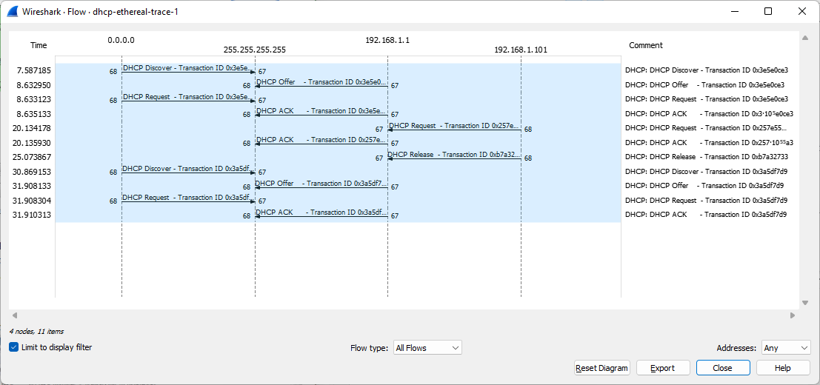
3. What is the link-layer (e.g., Ethernet) address of your host?
   1. 00:08:74:4f:36:23
4. What values in the DHCP discover message differentiate this message from the DHCP request message?
   1. The value that is different is under option 53 and is the DHCP value
5. What is the value of the Transaction-ID in each of the first four (Discover/Offer/Request/ACK) DHCP messages? What are the values of the Transaction-ID in the second set (Request/ACK) set of DHCP messages? What is the purpose of the Transaction-ID field?
   1. The transaction ID for all of the first four is the same, 0x3e5e0ce3. The transaction ID for the second set is 0x257e55a3. A transaction ID is used so that a host can tell between different requests made by the user.
6. A host uses DHCP to obtain an IP address, among other things. But a host’s IP address is not confirmed until the end of the four-message exchange! If the IP address is not set until the end of the four-message exchange, then what values are used in the IP datagrams in the four-message exchange? For each of the four DHCP messages (Discover/Offer/Request/ACK DHCP), indicate the source and destination IP addresses that are carried in the encapsulating IP datagram.
   1. Discover: Destination -0.0.0.0 Source -255.255.255.255
   2. Offer: Destination -192.168.1.1 Source -255.255.255.255
   3. Request: Destination -0.0.0.0 Source -255.255.255.255
   4. ACK: Destination -192.168.1.1 Source -255.255.255.255
7. What is the IP address of your DHCP server?
   1. My IP address is 192.168.1.1
8. What IP address is the DHCP server offering to your host in the DHCP Offer message? Indicate which DHCP message contains the offered DHCP address.
   1. The IP address that I am being offered is 192.168.1.101. Option 53 contains the offered DHCP address.
9. In the example screenshot in this assignment, there is no relay agent between the host and the DHCP server. What values in the trace indicate the absence of a relay agent? Is there a relay agent in your experiment? If so what is the IP address of the agent?
   1. If the relay agent IP address is 0.0.0.0 then there is an absence of a relay agent. The value of my relay agent IP address is also 0.0.0.0 so I do not have a relay agent
   2. Table

      Description automatically generated with medium confidence
10. Explain the purpose of the router and subnet mask lines in the DHCP offer message.
    1. The router line tells us where the client will be sending messages by default. The subnet mask line tells the client which subnet mask to use.
11. In the DHCP trace file noted in footnote 2, the DHCP server offers a specific IP address to the client (see also question 8. above). In the client’s response to the first server OFFER message, does the client accept this IP address? Where in the client’s RESPONSE is the client’s requested address?
    1. The client does accept the IP address and the requested IP address is in Option 50 in the clients response.
    2. Graphical user interface

       Description automatically generated with low confidence
12. Explain the purpose of the lease time. How long is the lease time in your experiment?
    1. Lease time is used to tell a client how long they can use an IP address before they get assigned a new one. Under Option 51 it says the Lease time is 1 day
    2. 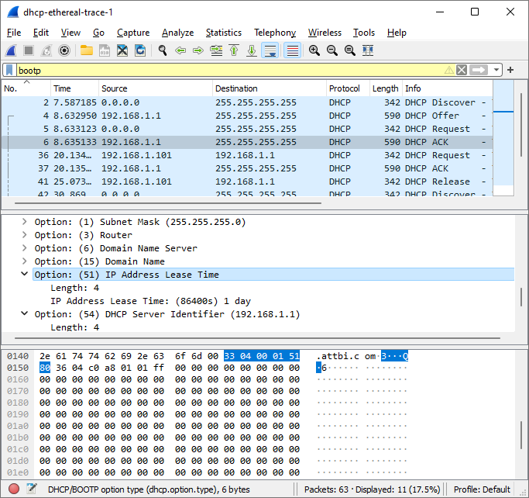
13. What is the purpose of the DHCP release message? Does the DHCP server issue an acknowledgment of receipt of the client’s DHCP request? What would happen if the client’s DHCP release message is lost?
    1. The purpose of the DHCP release message is to release the IP address back to the server. No, the server does not issue an ACK of the DHCP request. If the message is lost then the client will still release the IP address, but the server won’t reassign the address until the address expires.
14. Clear the bootp filter from your Wireshark window. Were any ARP packets sent or received during the DHCP packet-exchange period? If so, explain the purpose of those ARP packets.
    1. Yes, there were ARP packets exchanged. ARP packets are used to request to see if any machines are using a particular IP address.
    2. Table

       Description automatically generated with medium confidence