1. What is the 48-bit Ethernet address of your computer?
   1. The Ethernet address is 00:d0:59:a9:3d:68
   2. 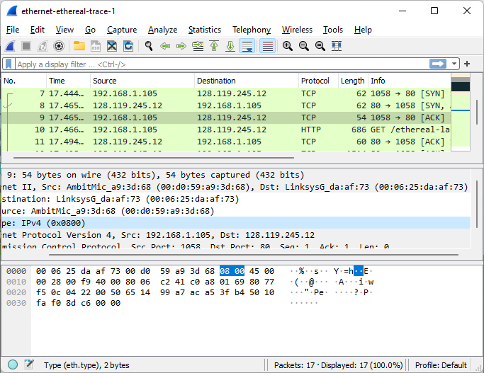
2. What is the 48-bit destination address in the Ethernet frame? Is this the Ethernet address of gaia.cs.umass.edu? (Hint: the answer is no). What device has this as its Ethernet address? [Note: this is an important question, and one that students sometimes get wrong. Re-read pages 468-469 in the text and make sure you understand the answer here.]
   1. The destination address is 00:06:25:da:af:73. It is not the ethernet address of gaia.cs.umass.edu, it is the address of the Linksys router.
3. Give the hexadecimal value for the two-byte Frame type field. What upper layer protocol does this correspond to?
   1. The hex value is 0x0800 for the Frame type field. This corresponds to the IP protocol.
4. How many bytes from the very start of the Ethernet frame does the ASCII “G” in “GET” appear in the Ethernet frame?
   1. The ASCII “G” appears 52 bytes from the start of the ethernet frame.
5. What is the value of the Ethernet source address? Is this the address of your computer, or of gaia.cs.umass.edu (Hint: the answer is no). What device has this as its Ethernet address?
   1. The ethernet source address is 00:06:25:da:af:73. It is not the ethernet address of gaia.cs.umass.edu, it is the address of the Linksys router.
   2. 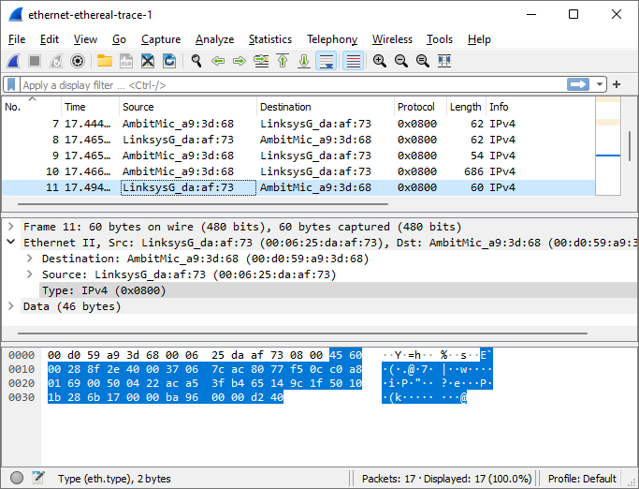
6. What is the destination address in the Ethernet frame? Is this the Ethernet address of your computer?
   1. The Ethernet destination address is 00:d0:59:a9:3d:68. This is the address of my computer.
7. Give the hexadecimal value for the two-byte Frame type field. What upper layer protocol does this correspond to?
   1. The hex value for the Frame type field is 0x0800.This corresponds to the IP protocol.
8. How many bytes from the very start of the Ethernet frame does the ASCII “O” in “OK” (i.e., the HTTP response code) appear in the Ethernet frame?
   1. There are 52 bytes that from the start to the appearance of the ASCII O.
9. Write down the contents of your computer’s ARP cache. What is the meaning of each column value?
   1. The Internet Address column contains the IP address. The Physical Address contains the MAC address. The type indicates a protocol type.
   2. 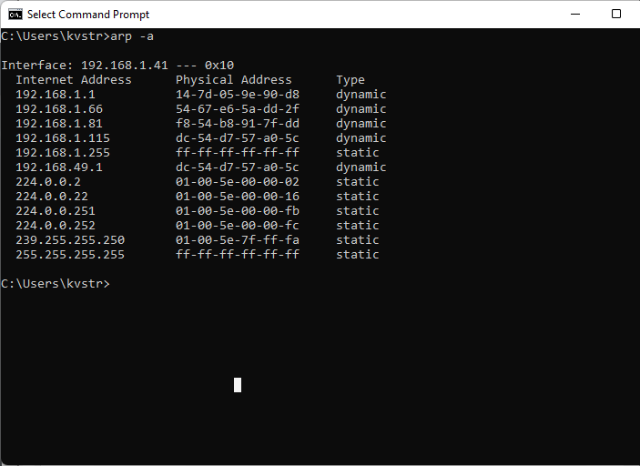
10. What are the hexadecimal values for the source and destination addresses in the Ethernet frame containing the ARP request message?
    1. The hexadecimal value for the source address is 00:d0:59:a9:3d:68, and the destination address is ff:ff:ff:ff:ff:ff
    2. 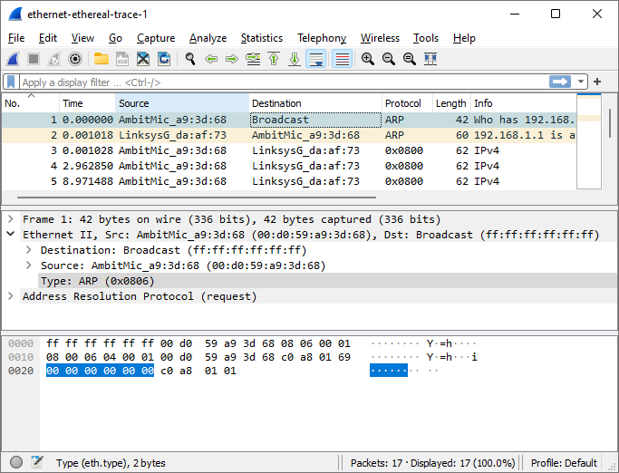
11. Give the hexadecimal value for the two-byte Ethernet Frame type field. What upper layer protocol does this correspond to?
    1. The hexadecimal value for the Frame is 0x0806. This corresponds to the IP protocol.
12. Download the ARP specification from ftp://ftp.rfc-editor.org/in-notes/std/std37.txt. A readable, detailed discussion of ARP is also at http://www.erg.abdn.ac.uk/users/gorry/course/inet-pages/arp.html.
    1. How many bytes from the very beginning of the Ethernet frame does the ARP opcode field begin?
       1. The ARP opcode field begins 20 bytes from the very beginning.
    2. What is the value of the opcode field within the ARP-payload part of the Ethernet frame in which an ARP request is made?
       1. The value of the opcode field is 0x0001.
    3. Does the ARP message contain the IP address of the sender?
       1. Yes, the ARP message contains the IP address of the sender
    4. Where in the ARP request does the “question” appear – the Ethernet address of the machine whose corresponding IP address is being queried?
       1. The question appears under the field Target MAC address and contains the corresponding IP address of the queried machine.
13. Now find the ARP reply that was sent in response to the ARP request.
    1. 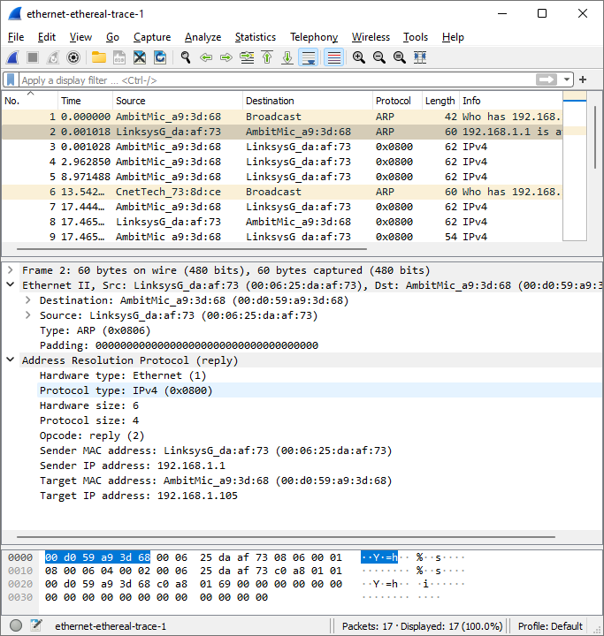
    2. How many bytes from the very beginning of the Ethernet frame does the ARP opcode field begin?
       1. The ARP opcode field begins 20 bytes from the very beginning.
    3. What is the value of the opcode field within the ARP-payload part of the Ethernet frame in which an ARP response is made?
       1. The hex value for the opcode field is 2.
    4. Where in the ARP message does the “answer” to the earlier ARP request appear – the IP address of the machine having the Ethernet address whose corresponding IP address is being queried?
       1. The answer to the earlier request is under the field Sender MAC Address.
14. What are the hexadecimal values for the source and destination addresses in the Ethernet frame containing the ARP reply message?
    1. The hex value for the source address 00:06:25:da:af:73 is and the destination address is 00:d0:59:a9:3d:68
15. Open the ethernet-ethereal-trace-1 trace file in http://gaia.cs.umass.edu/wireshark-labs/wireshark-traces.zip. The first and second ARP packets in this trace correspond to an ARP request sent by the computer running Wireshark, and the ARP reply sent to the computer running Wireshark by the computer with the ARP-requested Ethernet address. But there is yet another computer on this network, as indicated by packet 6 – another ARP request. Why is there no ARP reply (sent in response to the ARP request in packet 6) in the packet trace?
    1. There is no reply in this trace because we are not at the machine that sent the request. The request is a broadcast, but the ARP reply is sent back directly to the sender’s Ethernet address.