Noah Tolentino Nguyen

**Homework 1**

**New HTML tags used:**  
<em>  
Used for italicizing text.   
  
<aside>  
Used specifically in the "Best Practices" sidebar to denote side info  
  
**New CSS rules:**   
box-shadow  
Use to add drop-shadows to divs  
  
border-radius  
Used to add rounded corners to divs

**index.html Page Validation**

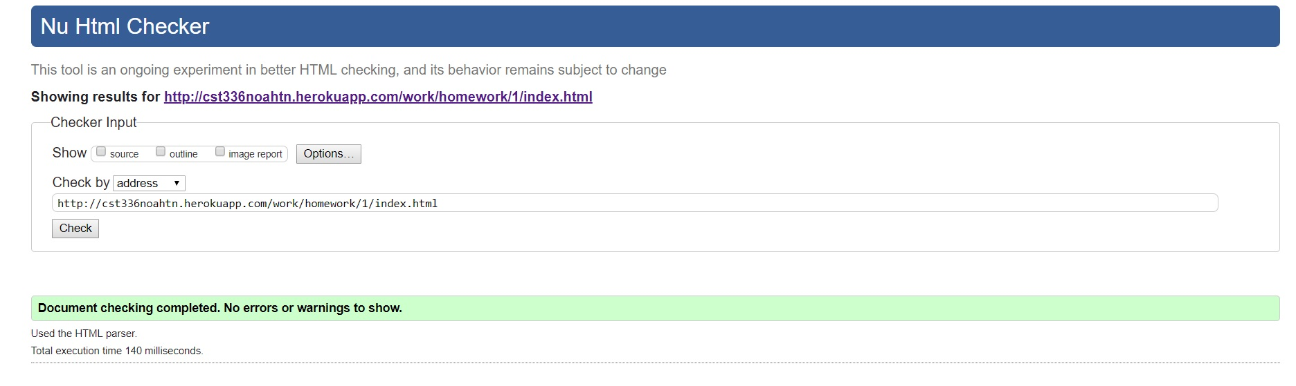

**adwareabout.html Page Validation**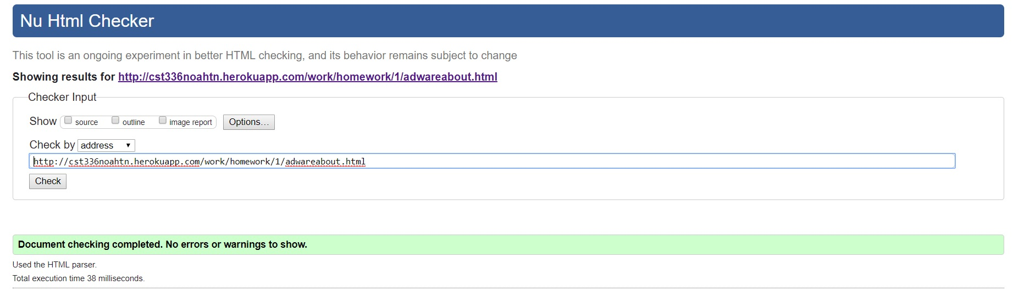

**ransomewareabout.html Page Validation**

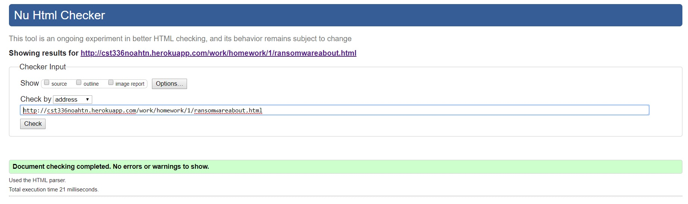

**trojans.html Page Validation**

