R Noah Padilla
CS 4363
1/27/2021
Lab 1 Report

Problem description
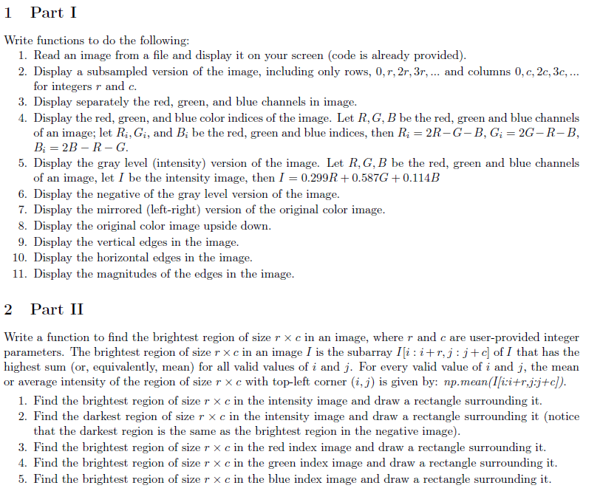

Algorithms implemented
The algorithms that I used were straight forward and followed from the instructions.
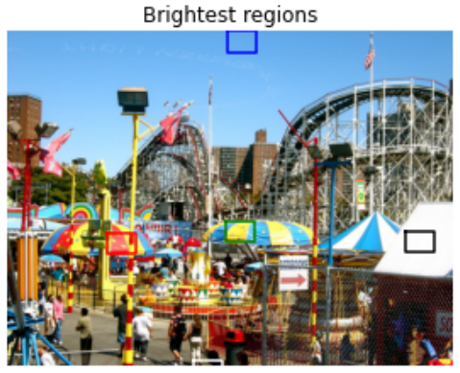
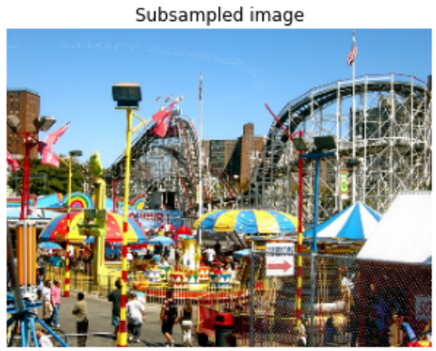
Experimental results
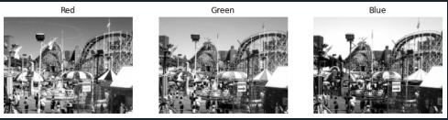
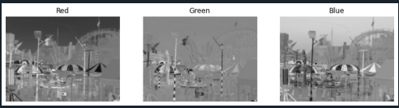
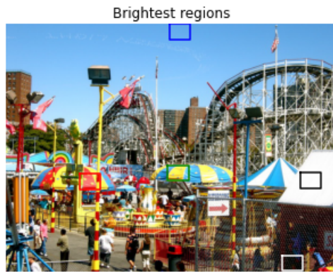
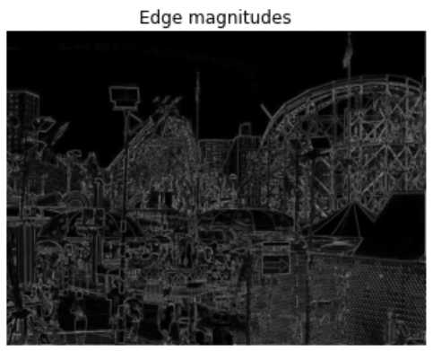
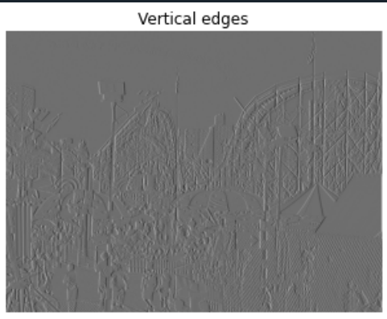
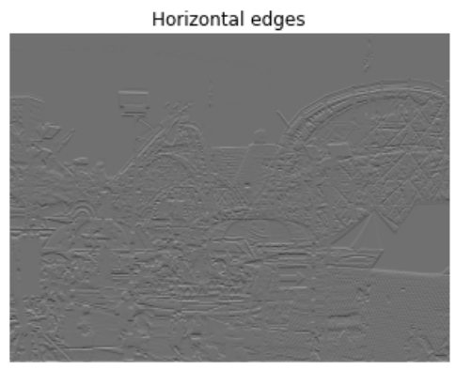
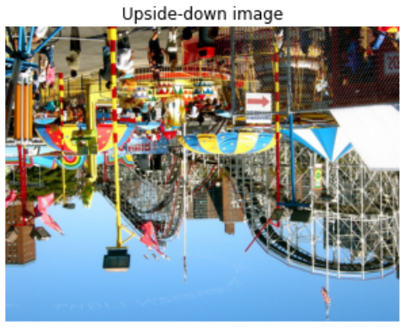
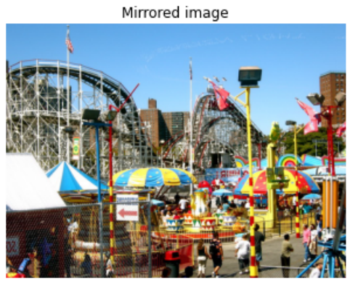
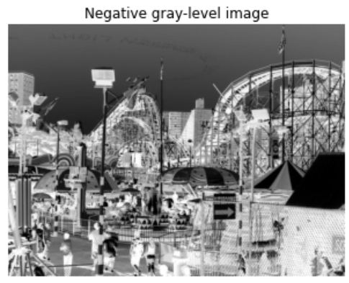
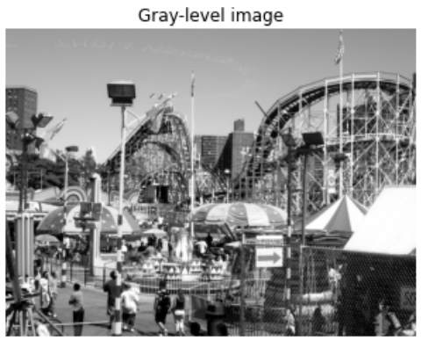

Discussion of results
The results I obtained after many hours of debugging were very similar to those of the example given in the instructions for this assignment. Although I completed all of the tasks given in part 1 and part 2, I could not find a way to optimize find the brightest region given a 2D image. I could not figure out how to rid the two for loops so I decided to try and get rid of 1 by replacing the inner for loop in the brightest region function by allowing steps when looking at the image. This idea could not be carried out because I bumped into other various issues but I attempted it.
Conclusions
In conclusion I learned how to modify an image and filter an image using slicing and how to find the brightest regions.

Appendix: Source code

