R Noah Padilla

11/5/2020

PCA AND KNN Results

**Introduction**

In this exercise our goal was to use principle components to change the data given in such a way that helps us use our data efficiently before being processed by our KNN model. The goal of this exercise was to calculate how many principle components were needed to obtain accuracies of 90%,95% and 97%

**Method**

The method I performed to do this was to start the number of principle component at 1 and increment by 1 and obtain an accuracy. This process was then repeated until I was able to store and obtain the PC (principle components) necessary to get those accuracies.

**Results**

|  |  |  |  |  |
| --- | --- | --- | --- | --- |
| **PC** | **KNN** | **Train Time** | **Test Time** | **Accuracy** |
| 8 | 3 | 0.071012 secs | 0.819000 secs | 0.9 |
| 12 | 3 | 0.100952 secs | 2.187750 secs | 0.95 |
| 16 | 3 | 0.129938 secs | 3.603628 secs | 0.97 |

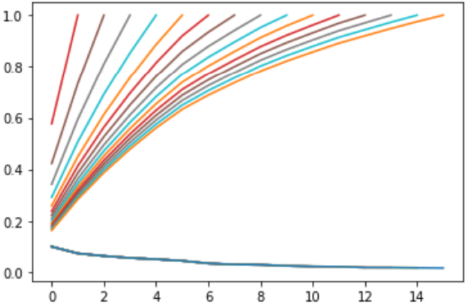

The plot above shows the PC by Accuracy where we can see that as the number of components rise so will the accuracy.

**Conclusion**

In conclusion we know that as the number of principle components rise, the better the accuracy will get.