Big History

World War II
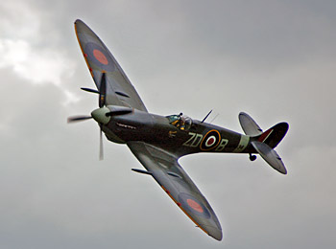

Caleb Weaver

Part One The Beginning

The Second World War was very bloody. Almost 300,000 USA service men were killed. 80 million people died in World War II.

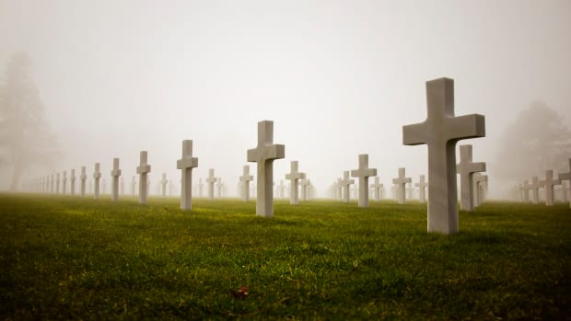

Part 2: Hitler’s Speech It’s so long I’ll only gonna write some of it.
Hitler says, “My German, men and women, changes of government have occurred. Frequent attended so far-reaching results as that eight years ago. At that time the Reich was desperate….”
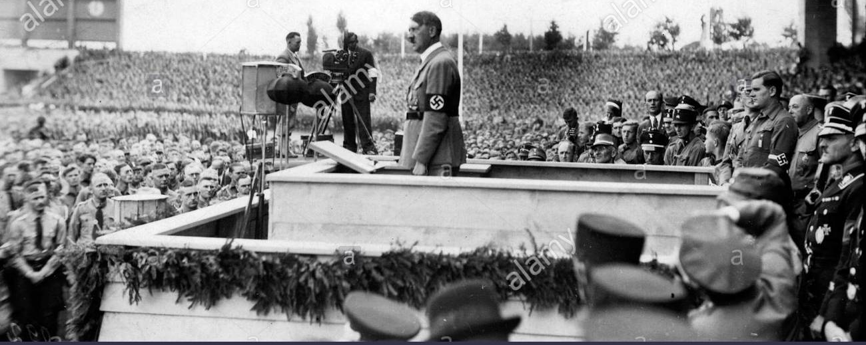

Chapter 3 Hitler’s Blunders
In 1941 Hitler invaded Russia. He thought Russia had only 200 regiments, but they identified more than 300. Hitler almost won, but the Red Army stopped him in the Suburbs of Moscow, just in view or the Kremlin. Now the Germans fought against the heavy Russian snow.
Hitlers other blunder was to declare war on the US. When the Japanese attacked Pearl Harbor the Americans used it as a lever to join the European War.

Part 4 D-Day
On June 6, 1944 more than 160,000 Allied troops landed along 50 miles of heavily fortified French coastline to fight the Germans on the beaches.
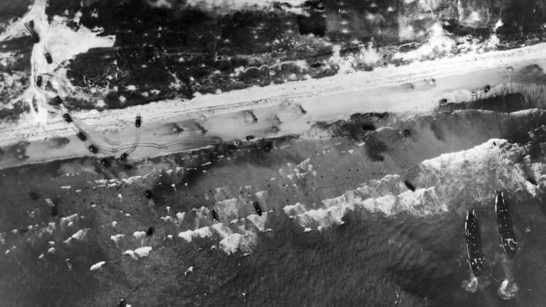

Part 5: The Long War is Over
The Nazis were pushed back into Germany. Hitler killed himself and gave command over to Grand Admiral Burnitz. Durnitz surrendered to the Allies that month.
The War was over! America won the War!

We WON!

