QAP 1 – Java

Noah Whiffen – SD12

Assessment Questions and Images

Image for Problem 1:

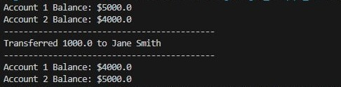

Image for Problem 2:



Image for Problem 3:

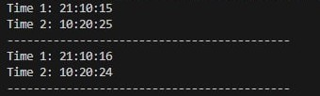

Assessment Questions:

1. The first problem took me about 2 hours, the other two took me an hour each roughly. The screenshots and assessment questions about 15 minutes.
2. I used ChatGPT and Google for bug fixing (it did not write the code for me.)
3. I didn’t have to ask anyone for help with these questions.
4. I didn’t have to ask any instructors for help with these questions.
5. The first question was the hardest, but not overly difficult. I had to figure out how to implement the logic. After that it was smooth sailing for all other questions. I had a lot of fun with this and I am confident I could solve a similar problem in the future!