Cornerstone Café

*Cherish the little moments together, one cup of coffee at a time.*



Design Plan

By Noah Woodburn

Date: October 11th, 2024

Course: Web Programming

Cornerstone Café

At Cornerstone Café, we believe that the foundation to having an amazing day starts with an exquisite cup of coffee! Our coffeehouse serves as a comforting gathering place where family, friends, and colleagues can experience high quality coffee and delicious, sweet treats. Whether you’re looking for a quiet corner to work, a spot to catch up with friends, or a place to warm up, Cornerstone Café is the perfect place for you!

The Website

We hope that as many people as possible can find out about the Cornerstone Café. The main way we will accomplish that is through our web page. Through our website, users will learn about our business, values, locations, menu and events that will be held at our coffeehouse.

The Target Audience

The Cornerstone Café welcomes everyone. Students, families, adults, teenagers, elders and coffee enthusiasts are all welcome and encouraged to visit our coffeehouse.

Planned Pages

Home

The home page will provide users with essential information about our café as well as images they can expect to see when walking into a Cornerstone Café.

Our Locations

The locations page will inform clients where current and new Cornerstone Cafés are located.

Menu

The menu page is where you will be able to see images of our beverages and baked goods. Our menu also caters to dietary preferences with vegan and gluten-free options ensuring there is something for everyone to enjoy in a warm, inviting atmosphere. The menu page will also include prices.

Contact Us

This page will provide our contact information for our coffeehouses. Customers can reference this page any time they want to get in contact with us. Whether they have questions, feedback, or just want to say hello, we want them to reach out to us. The team at Cornerstone Café is here to help and welcomes any feedback pertaining to our coffee and how we can improve the experience for all. (Phone numbers of each of our locations will be listed and email addresses linked).

Sustainability

This page will explain how we can provide great coffee while respecting the environment. It will describe the sustainable practices at the Cornerstone Café and our minimal environmental footprint. For example, this page will describe our eco-friendly packaging, our waste reduction measures, the energy efficiency of our coffeehouses, and the sustainable sourcing at Cornerstone Café.

The Cornerstone Logo



This logo is courtesy of Flaticon.

Our Colour Palette

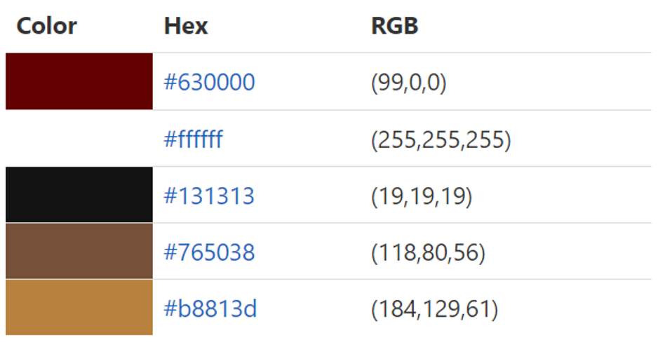

This colour palette was chosen because the colours evoke comfort and warmth which is what we want our customers to feel when they visit any Cornerstone Café location. In addition, a dark blue gradient was used as a background colour to evoke feelings of calmness and serenity.

Website banner



Desktop Layout

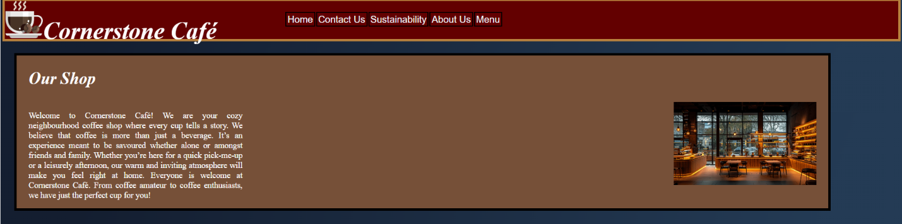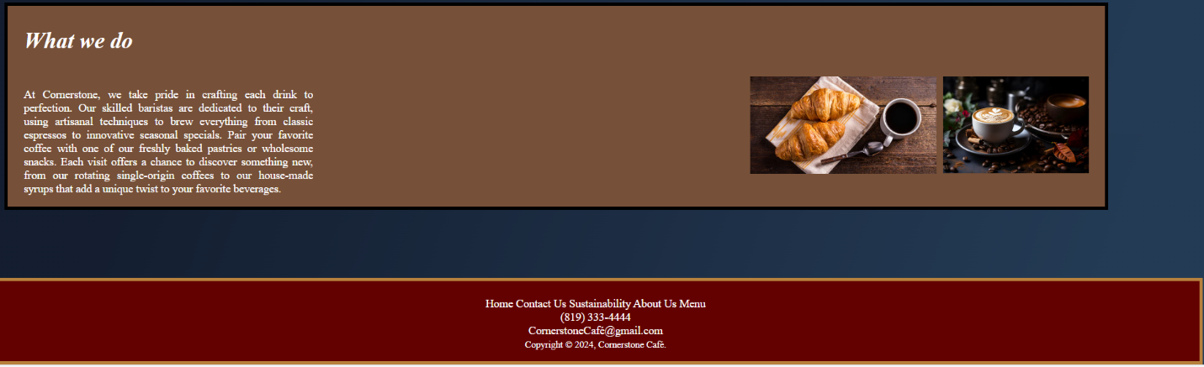

Mobile Layout

