Sam Young, Joseph Munsterteiger, Noah Hoberg

Step 1: Examining Gene Variation

1. Calculate Gene Fold Ratio Values.
2. The largest fold ratio is 800 found in 17 genes.
3. The smallest fold ratio is 1 found in 477 genes.

|  |  |
| --- | --- |
| Range | Count |
| value <= 2 | 644 |
| 2 < value <= 4 | 469 |
| 4 < value <= 8 | 1363 |
| 8 < value <= 16 | 1643 |
| 16 < value <= 32 | 1387 |
| 32 < value <= 64 | 840 |
| 64 < value <= 128 | 407 |
| 128 < value <= 256 | 183 |
| 256 < value <= 512 | 88 |
| 512 < value | 46 |

e. Used EDraw to create these graphs:

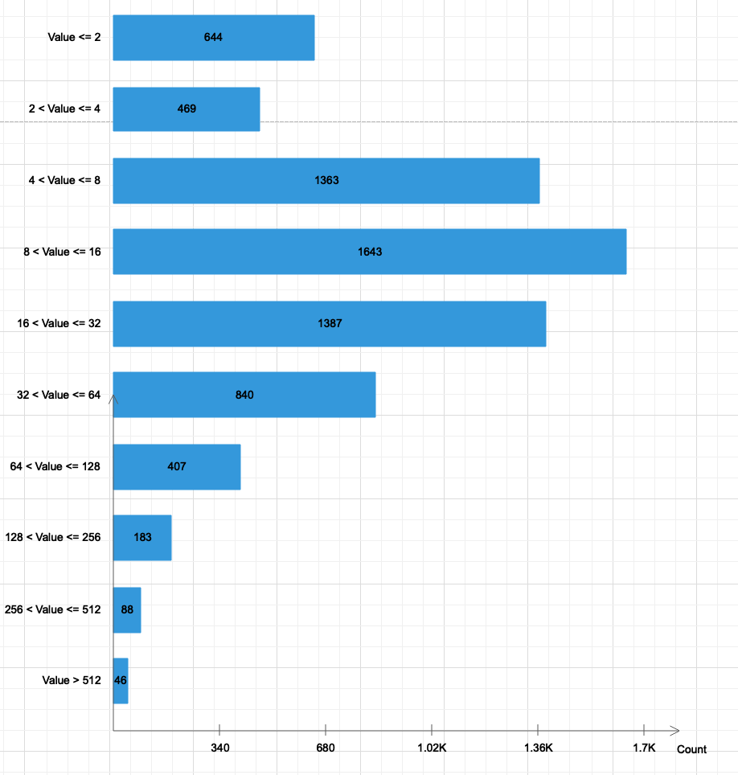

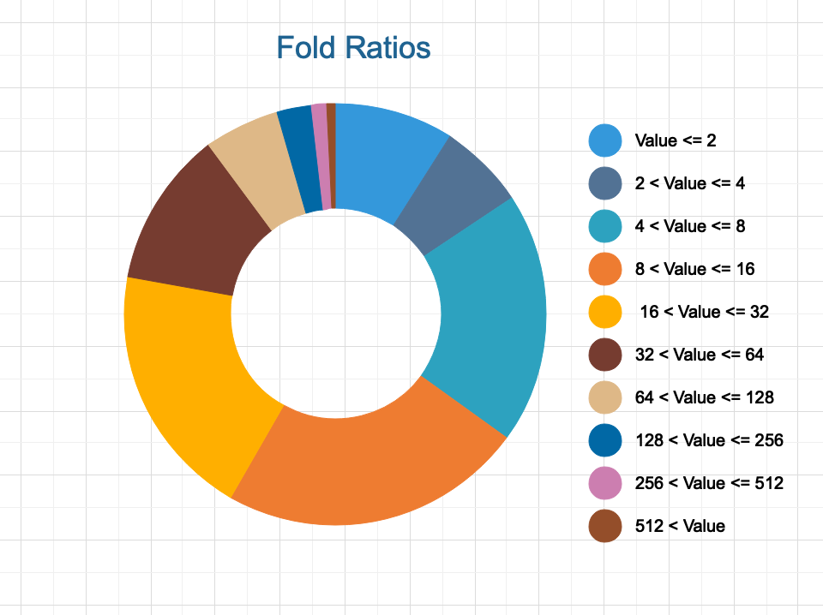

Step 2: Finding the most significant genes

1. Compute averages, standard deviations, T-value and S2N
2. Top 50 genes based on S2N:
   1. M55150_at 1.4676
   2. X95735_at 1.4445
   3. U50136_rna1_at 1.4217
   4. U22376_cds2_s_at 1.3339
   5. M81933_at 1.2040
   6. M16038_at 1.2032
   7. M84526_at 1.2014
   8. M23197_at 1.1960
   9. U82759_at 1.1926
   10. Y12670_at 1.1847
   11. D49950_at 1.1437
   12. M27891_at 1.1334
   13. X59417_at 1.1246
   14. X52142_at 1.1226
   15. M28170_at 1.1168
   16. X17042_at 1.1060
   17. U05259_rna1_at 1.1040
   18. Y00787_s_at 1.0820
   19. M96326_rna1_at 1.0772
   20. U12471_cds1_at 1.0697
   21. U46751_at 1.0641
   22. M80254_at 1.0444
   23. M92287_at 1.04305
   24. L13278_at 1.0420
   25. U09087_s_at 1.0363
   26. L08246_at 1.0348
   27. X74262_at 1.0278
   28. M62762_at 1.0234
   29. M31211_s_at 1.0229
   30. M28130_rna1_s_at 1.0013
   31. D26156_s_at 0.9891
   32. M63138_at 0.9836
   33. M31523_at 0.9712
   34. M57710_at 0.9677
   35. X15949_at 0.9601
   36. M69043_at 0.9589
   37. S50223_at 0.9567
   38. U32944_at 0.9549
   39. M81695_s_at 0.9531
   40. L47738_at 0.9513
   41. M83652_s_at 0.9475
   42. X85116_rna1_s_at 0.9464
   43. M11147_at 0.9458
   44. Z15115_at 0.9452
   45. M21551_rna1_at 0.9420
   46. M19045_f_at 0.9381
   47. X04085_rna1_at 0.9305
   48. L49229_f_at 0.9207
   49. X14008_rna1_f_at 0.9150
   50. M91432_at 0.9135
3. Top 50 genes based on T- Value:
   1. M55150_at 8.0919
   2. U22376_cds2_s_at 7.9043
   3. X59417_at 6.8031
   4. U50136_rna1_at 6.4359
   5. M31211_s_at 6.2942
   6. M28170_at 6.2540
   7. U82759_at 6.2430
   8. M92287_at 6.2174
   9. U09087_s_at 6.1824
   10. U05259_rna1_at 6.1751
   11. M81933_at 6.1650
   12. U12471_cds1_at 6.1462
   13. D26156_s_at 6.0971
   14. L13278_at 6.0213
   15. X74262_at 6.0163
   16. S50223_at 5.8586
   17. X52142_at 5.8331
   18. X95735_at 5.7276
   19. L47738_at 5.7150
   20. M31523_at 5.6775
   21. Z15115_at 5.6155
   22. M11147_at 5.5886
   23. D49950_at 5.5880
   24. X63469_at 5.5833
   25. D38073_at 5.5630
   26. U32944_at 5.4430
   27. U26266_s_at 5.4252
   28. J05243_at 5.4063
   29. L49229_f_at 5.3982
   30. X15949_at 5.3896
   31. X17042_at 5.3886
   32. M21551_rna1_at 5.3773
   33. M31303_rna1_at 5.3706
   34. Y08612_at 5.3666
   35. U20998_at 5.3612
   36. AF012024_s_at 5.3333
   37. X56411_rna1_at 5.3274
   38. Y12670_at 5.3250
   39. U29175_at 5.3227
   40. M91432_at 5.3009
   41. HG1612-HT1612_at 5.2769
   42. M13792_at 5.2223
   43. D63874_at 5.2069
   44. U72342_at 5.2067
   45. X97267_rna1_s_at 5.2030
   46. X76648_at 5.1952
   47. U35451_at 5.1444
   48. Z69881_at 5.1438
   49. D63880_at 5.1251
   50. M62762_at 5.1222
4. 31 Genes are common in both top 50 lists:
   1. D26156_s_at
   2. D49950_at
   3. L13278_at
   4. L47738_at
   5. L49229_f_at
   6. M11147_at
   7. M21551_rna1_at
   8. M28170_at
   9. M31211_s_at
   10. M31523_at
   11. M55150_at
   12. M62762_at
   13. M81933_at
   14. M91432_at
   15. M92287_at
   16. S50223_at
   17. U05259_rna1_at
   18. U9087_s_at
   19. U12471_cds1_at
   20. U22376_cds2_s_at
   21. U32944_at
   22. U50136_rna1_at
   23. U8279_at
   24. X15949_at
   25. X17042_at
   26. X52142_at
   27. X59417_at
   28. X74262_at
   29. X95735_at
   30. Y12670_at
   31. Z15115_at
5. 69 different genes are in either top 50 list or in both:
   1. AF012024_s_at
   2. D26156_s_at
   3. D38073_at
   4. D49950_at
   5. D63874_at
   6. D63880_at
   7. HG1612-HT1612_at
   8. J05243_at
   9. L08246_at
   10. L13278_at
   11. L47738_at
   12. L49229_f_at
   13. M11147_at
   14. M13792_at
   15. M16038_at
   16. M19045_f_at
   17. M21551_rna1_at
   18. M23197_at
   19. M27891_at
   20. M28130_rna1_s_at
   21. M28170_at
   22. M31211_s_at
   23. M31303_rna1_at
   24. M31523_at
   25. M55150_at
   26. M57710_at
   27. M62762_at
   28. M63138_at
   29. M69043_at
   30. M80254_at
   31. M81695_s_at
   32. M81933_at
   33. M83652_s_at
   34. M84526_at
   35. M91432_at
   36. M92287_at
   37. M96326_rna1_at
   38. S50223_at
   39. U05259_rna1_at
   40. U09087_s_at
   41. U12471_cds1_at
   42. U20998_at
   43. U22376_cds2_s_at
   44. U26266_s_at
   45. U29175_at
   46. U32944_at
   47. U35451_at
   48. U46751_at
   49. U50136_rna1_at
   50. U72342_at
   51. U82759_at
   52. X04085_rna1_at
   53. X14008_rna1_f_at
   54. X15949_at
   55. X17042_at
   56. X52142_at
   57. X56411_rna1_at
   58. X59417_at
   59. X63469_at
   60. X74262_at
   61. X76648_at
   62. X85116_rna1_s_at
   63. X95735_at
   64. X97267_rna1_s_at
   65. Y00787_s_at
   66. Y08612_at
   67. Y12670_at
   68. Z15115_at
   69. Z69881_at

**Step 3: Building the classifier**

1. See python program
2. See python program
3. See python program
4. **Confusion matrixes for every distance, k value and class label combination. Actual values are across the top and predicted values are vertical.**

**ALL matrix for k = 3 and Euclidean distance**

|  |  |  |
| --- | --- | --- |
|  | Positive | Negative |
| Positive | TP:16 | FP:6 |
| Negative | FN:5 | TN:7 |

**ALL matrix for k = 5 and Euclidean distance**

|  |  |  |
| --- | --- | --- |
|  | Positive | Negative |
| Positive | TP:16 | FP:6 |
| Negative | FN:5 | TN:7 |

**ALL matrix for k = 7 and Euclidean distance**

|  |  |  |
| --- | --- | --- |
|  | Positive | Negative |
| Positive | TP:17 | FP:6 |
| Negative | FN:4 | TN:7 |

**ALL matrix for k = 9 and Euclidean distance**

|  |  |  |
| --- | --- | --- |
|  | Positive | Negative |
| Positive | TP:17 | FP:6 |
| Negative | FN:4 | TN:7 |

**ALL matrix for k =11 and Euclidean distance**

|  |  |  |
| --- | --- | --- |
|  | Positive | Negative |
| Positive | TP:17 | FP:7 |
| Negative | FN:4 | TN 6 |

~~~~~~~~~~~~~~~~~~~~~~~~~~~~~~~~~~~~~~~~~~~~~~~~~~~~~~~~~~~~~~~~~~~~~~~

**ALL matrix for k = 3 and Manhattan distance**

|  |  |  |
| --- | --- | --- |
|  | Positive | Negative |
| Positive | TP:16 | FP:6 |
| Negative | FN:5 | TN:7 |

**ALL matrix for k = 5 and Manhattan distance**

|  |  |  |
| --- | --- | --- |
|  | Positive | Negative |
| Positive | TP:15 | FP:6 |
| Negative | FN:6 | TN:7 |

**ALL matrix for k = 7 and Manhattan distance**

|  |  |  |
| --- | --- | --- |
|  | Positive | Negative |
| Positive | TP:15 | FP:6 |
| Negative | FN:6 | TN:7 |

**ALL matrix for k = 9 and Manhattan distance**

|  |  |  |
| --- | --- | --- |
|  | Positive | Negative |
| Positive | TP:17 | FP:6 |
| Negative | FN:4 | TN:7 |

**ALL matrix for k = 11 and Manhattan distance**

|  |  |  |
| --- | --- | --- |
|  | Positive | Negative |
| Positive | TP:17 | FP:8 |
| Negative | FN:4 | TN:5 |

~~~~~~~~~~~~~~~~~~~~~~~~~~~~~~~~~~~~~~~~~~~~~~~~~~~~~~~~~~~~~~~~~~~~~~~

**ALL matrix for k = 3 and Chebyshev distance**

|  |  |  |
| --- | --- | --- |
|  | Positive | Negative |
| Positive | TP:14 | FP:6 |
| Negative | FN:7 | TN:7 |

**ALL matrix for k = 5 and Chebyshev distance**

|  |  |  |
| --- | --- | --- |
|  | Positive | Negative |
| Positive | TP:16 | FP:6 |
| Negative | FN:5 | TN:7 |

**ALL matrix for k = 7 and Chebyshev distance**

|  |  |  |
| --- | --- | --- |
|  | Positive | Negative |
| Positive | TP:16 | FP:6 |
| Negative | FN:5 | TN:7 |

**ALL matrix for k = 9 and Chebyshev distance**

|  |  |  |
| --- | --- | --- |
|  | Positive | Negative |
| Positive | TP:16 | FP:6 |
| Negative | FN:5 | TN:7 |

**ALL matrix for k = 11 and Chebyshev distance**

|  |  |  |
| --- | --- | --- |
|  | Positive | Negative |
| Positive | TP:16 | FP:7 |
| Negative | FN:5 | TN:6 |

~~~~~~~~~~~~~~~~~~~~~~~~~~~~~~~~~~~~~~~~~~~~~~~~~~~~~~~~~~~~~~~~~~~~~~~

**ALL matrix for k = 3 and Cosine similarity**

|  |  |  |
| --- | --- | --- |
|  | Positive | Negative |
| Positive | TP:9 | FP:8 |
| Negative | FN:12 | TN:5 |

**ALL matrix for k = 5 and Cosine similarity**

|  |  |  |
| --- | --- | --- |
|  | Positive | Negative |
| Positive | TP:8 | FP:8 |
| Negative | FN:13 | TN:5 |

**ALL matrix for k = 7 and Cosine similarity**

|  |  |  |
| --- | --- | --- |
|  | Positive | Negative |
| Positive | TP:9 | FP:8 |
| Negative | FN:12 | TN:5 |

**ALL matrix for k = 9 and Cosine similarity**

|  |  |  |
| --- | --- | --- |
|  | Positive | Negative |
| Positive | TP:9 | FP:8 |
| Negative | FN:12 | TN:5 |

**ALL matrix for k = 11 and Cosine similarity**

|  |  |  |
| --- | --- | --- |
|  | Positive | Negative |
| Positive | TP:8 | FP:8 |
| Negative | FN:13 | TN:5 |

~~~~~~~~~~~~~~~~~~~~~~~~~~~~~~~~~~~~~~~~~~~~~~~~~~~~~~~~~~~~~~~~~~~~~~~

**CLASS LABEL CHANGE**

~~~~~~~~~~~~~~~~~~~~~~~~~~~~~~~~~~~~~~~~~~~~~~~~~~~~~~~~~~~~~~~~~~~~~~~

**AML matrix for k = 3 and Euclidean distance**

|  |  |  |
| --- | --- | --- |
|  | Positive | Negative |
| Positive | TP: 7 | FP:5 |
| Negative | FN:6 | TN:16 |

**AML matrix for k = 5 and Euclidean distance**

|  |  |  |
| --- | --- | --- |
|  | Positive | Negative |
| Positive | TP:7 | FP:5 |
| Negative | FN:6 | TN:16 |

**AML matrix for k = 7 and Euclidean distance**

|  |  |  |
| --- | --- | --- |
|  | Positive | Negative |
| Positive | TP:7 | FP:4 |
| Negative | FN:6 | TN:17 |

**AML matrix for k = 9 and Euclidean distance**

|  |  |  |
| --- | --- | --- |
|  | Positive | Negative |
| Positive | TP:7 | FP:4 |
| Negative | FN:6 | TN:17 |

**AML matrix for k =11 and Euclidean distance**

|  |  |  |
| --- | --- | --- |
|  | Positive | Negative |
| Positive | TP:6 | FP:4 |
| Negative | FN:7 | TN:17 |

~~~~~~~~~~~~~~~~~~~~~~~~~~~~~~~~~~~~~~~~~~~~~~~~~~~~~~~~~~~~~~~~~~~~~~~

**AML matrix for k = 3 and Manhattan distance**

|  |  |  |
| --- | --- | --- |
|  | Positive | Negative |
| Positive | TP: 7 | FP: 5 |
| Negative | FN: 6 | TN: 16 |

**AML matrix for k = 5 and Manhattan distance**

|  |  |  |
| --- | --- | --- |
|  | Positive | Negative |
| Positive | TP: 7 | FP: 6 |
| Negative | FN: 6 | TN: 15 |

**AML matrix for k = 7 and Manhattan distance**

|  |  |  |
| --- | --- | --- |
|  | Positive | Negative |
| Positive | TP: 7 | FP: 6 |
| Negative | FN: 6 | TN: 15 |

**AML matrix for k = 9 and Manhattan distance**

|  |  |  |
| --- | --- | --- |
|  | Positive | Negative |
| Positive | TP: 7 | FP: 4 |
| Negative | FN: 6 | TN: 17 |

**AML matrix for k = 11 and Manhattan distance**

|  |  |  |
| --- | --- | --- |
|  | Positive | Negative |
| Positive | TP: 5 | FP: 4 |
| Negative | FN: 8 | TN: 17 |

~~~~~~~~~~~~~~~~~~~~~~~~~~~~~~~~~~~~~~~~~~~~~~~~~~~~~~~~~~~~~~~~~~~~~~~

**AML matrix for k = 3 and Chebyshev distance**

|  |  |  |
| --- | --- | --- |
|  | Positive | Negative |
| Positive | TP:7 | FP:7 |
| Negative | FN:6 | TN:14 |

**AML matrix for k = 5 and Chebyshev distance**

|  |  |  |
| --- | --- | --- |
|  | Positive | Negative |
| Positive | TP:7 | FP:5 |
| Negative | FN:6 | TN:16 |

**AML matrix for k = 7 and Chebyshev distance**

|  |  |  |
| --- | --- | --- |
|  | Positive | Negative |
| Positive | TP:7 | FP:5 |
| Negative | FN:6 | TN:17 |

**AML matrix for k = 9 and Chebyshev distance**

|  |  |  |
| --- | --- | --- |
|  | Positive | Negative |
| Positive | TP:7 | FP:5 |
| Negative | FN:6 | TN:16 |

**AML matrix for k = 11 and Chebyshev distance**

|  |  |  |
| --- | --- | --- |
|  | Positive | Negative |
| Positive | TP:7 | FP:5 |
| Negative | FN:6 | TN:16 |

~~~~~~~~~~~~~~~~~~~~~~~~~~~~~~~~~~~~~~~~~~~~~~~~~~~~~~~~~~~~~~~~~~~~~~~

**AML matrix for k = 3 and Cosine similarity**

|  |  |  |
| --- | --- | --- |
|  | Positive | Negative |
| Positive | TP: 5 | FP: 12 |
| Negative | FN: 8 | TN: 9 |

**AML matrix for k = 5 and Cosine similarity**

|  |  |  |
| --- | --- | --- |
|  | Positive | Negative |
| Positive | TP: 5 | FP: 13 |
| Negative | FN: 8 | TN: 8 |

**AML matrix for k = 7 and Cosine similarity**

|  |  |  |
| --- | --- | --- |
|  | Positive | Negative |
| Positive | TP: 5 | FP: 12 |
| Negative | FN: 8 | TN: 9 |

**AML matrix for k = 9 and Cosine similarity**

|  |  |  |
| --- | --- | --- |
|  | Positive | Negative |
| Positive | TP:5 | FP:12 |
| Negative | FN:8 | TN:9 |

**AML matrix for k = 11 and Cosine similarity**

|  |  |  |
| --- | --- | --- |
|  | Positive | Negative |
| Positive | TP:5 | FP:13 |
| Negative | FN:8 | TN:8 |

1. **Tables for precision, recall and F-1 measures for both class labels.**

**Precision measures for class label ALL**

|  |  |  |  |  |
| --- | --- | --- | --- | --- |
| **Precision** | ***Euclidean*** | ***Chebyshev*** | ***City block*** | ***Cosine Similarity*** |
| *k=3* | *.727272727273* | *.7* | *.727272727273* | *.592411764705* |
| *k=5* | *.727272727273* | *.727272727273* | *.714285714286* | *.5* |
| *k=7* | *.739130434783* | *.727272727273* | *.714285714286* | *.592411764706* |
| *k=9* | *.73913043873* | *.727272727273* | *.73913043873* | *.592411764706* |
| *K=11* | *.70833333333* | *.695652173913* | *.68* | *.5* |

**Recall measures for class label ALL**

|  |  |  |  |  |
| --- | --- | --- | --- | --- |
| **Recall** | ***Euclidean*** | ***Chebyshev*** | ***City block*** | ***Cosine Similarity*** |
| *k=3* | *.6956521* | *.66666666666* | *.695652173* | *.64285714* |
| *k=5* | *.695652173913* | *.6956521* | *.6818181818* | *.615384615* |
| *k=7* | *.708333333333* | *.6956521* | *.6818181818* | *.64285714* |
| *k=9* | *.708333* | *.695652* | *.708333* | *.64285* |
| *K=11* | *.73913* | *.7272727272* | *.7727272727* | *.6153846* |

**F-1 measures for class label ALL**

|  |  |  |  |  |
| --- | --- | --- | --- | --- |
| **ALL** | ***Euclidean*** | ***Chebyshev*** | ***City block*** | ***Cosine Similarity*** |
| *k=3* | *.711111111111* | *.682926829268* | *.711111111111* | *.58460516129* |
| *k=5* | *.711111111111* | *.711111111111* | *.697674118605* | *.551724137931* |
| *k=7* | *.723404255319* | *.711111111111* | *.697674118605* | *.58064516129* |
| *k=9* | .723404255319 | *.711111111111* | .723404255319 | *.58460516129* |
| *K=11* | .723404255319 | *.711111111111* | .723404255319 | *.551724137931* |

**Precision measures for class label AML**

|  |  |  |  |  |
| --- | --- | --- | --- | --- |
| **AML** | ***Euclidean*** | ***Chebyshev*** | ***City block*** | ***Cosine Similarity*** |
| *k=3* | *.583333333333* | *.5* | *.583333333333* | *.294117647059* |
| *k=5* | *.583333333333* | *.583333333333* | *.538461538462* | *.277777777778* |
| *k=7* | *.636363636364* | *.583333333333* | *.538461538462* | *.294117647059* |
| *k=9* | *.636363636364* | *.583333333333* | *.636363636364* | *. 294117647059* |
| *K=11* | *.6* | *.545454545455* | *.555555555556* | *. 277777777778* |

**Recall measures for class label AML**

|  |  |  |  |  |
| --- | --- | --- | --- | --- |
| **AML** | ***Euclidean*** | ***Chebyshev*** | ***City block*** | ***Cosine Similarity*** |
| *k=3* | *.30434782* | *.33333333333* | *.304347826087* | *.357142857143* |
| *k=5* | *.304347826* | *.30434782* | *.31818181818* | *.384615384615* |
| *k=7* | *.291666666* | *.30434782* | *.318181818* | *.357142857143* |
| *k=9* | *.291666666* | *.30434782* | *.291666666* | *.357142857143* |
| *K=11* | *.260869565217* | *.2727272727* | *.22727272* | *.384615384615* |

**F-1 measures for class label AML**

|  |  |  |  |  |
| --- | --- | --- | --- | --- |
| **AML** | ***Euclidean*** | ***Chebyshev*** | ***City block*** | ***Cosine Similarity*** |
| *k=3* | *.4* | *.4* | *.4* | *.322580645161* |
| *k=5* | *.4* | *.4* | *.4* | *.322580645161* |
| *k=7* | *.4* | *.4* | *.4* | *.322580645161* |
| *k=9* | *.4* | *.4* | *.4* | *.322580645161* |
| *K=11* | *.363636363636* | *.363636363636* | *.322580645161* | *.322580645161* |

1. Graphs using data from part e

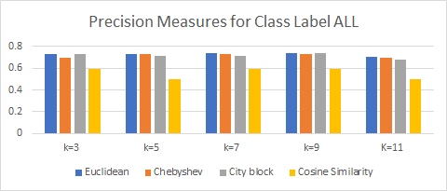

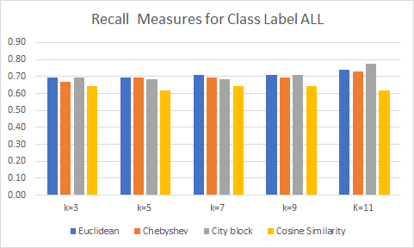

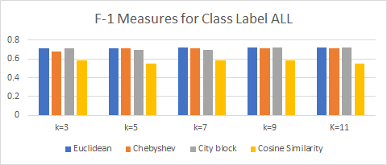

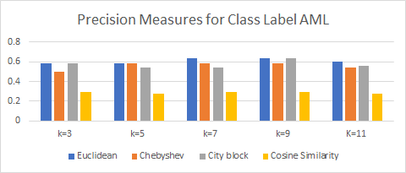

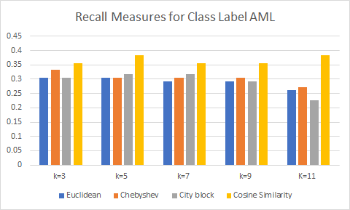

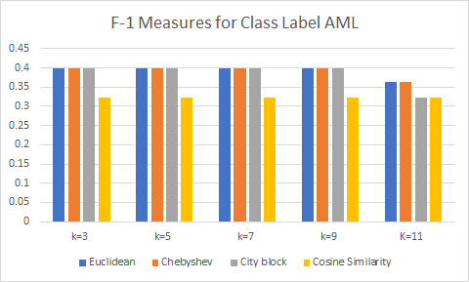

1. Repeat A-F but for all data instead of the preprocessed data. A-C is using the same program, so those parts can be seen in the python code.

**ALL matrix for k = 3 and Euclidean distance**

|  |  |  |
| --- | --- | --- |
|  | Positive | Negative |
| Positive | TP:15 | FP:6 |
| Negative | FN:6 | TN:7 |

**ALL matrix for k = 5 and Euclidean distance**

|  |  |  |
| --- | --- | --- |
|  | Positive | Negative |
| Positive | TP:15 | FP:7 |
| Negative | FN:6 | TN:6 |

**ALL matrix for k = 7 and Euclidean distance**

|  |  |  |
| --- | --- | --- |
|  | Positive | Negative |
| Positive | TP:16 | FP:7 |
| Negative | FN:5 | TN:6 |

**ALL matrix for k = 9 and Euclidean distance**

|  |  |  |
| --- | --- | --- |
|  | Positive | Negative |
| Positive | TP:17 | FP:10 |
| Negative | FN:4 | TN:3 |

**ALL matrix for k =11 and Euclidean distance**

|  |  |  |
| --- | --- | --- |
|  | Positive | Negative |
| Positive | TP:17 | FP:10 |
| Negative | FN:4 | TN 3 |

~~~~~~~~~~~~~~~~~~~~~~~~~~~~~~~~~~~~~~~~~~~~~~~~~~~~~~~~~~~~~~~~~~~~~~~

**ALL matrix for k = 3 and Manhattan distance**

|  |  |  |
| --- | --- | --- |
|  | Positive | Negative |
| Positive | TP:16 | FP:7 |
| Negative | FN:5 | TN:6 |

**ALL matrix for k = 5 and Manhattan distance**

|  |  |  |
| --- | --- | --- |
|  | Positive | Negative |
| Positive | TP:15 | FP:10 |
| Negative | FN:6 | TN:3 |

**ALL matrix for k = 7 and Manhattan distance**

|  |  |  |
| --- | --- | --- |
|  | Positive | Negative |
| Positive | TP:17 | FP:10 |
| Negative | FN:4 | TN:3 |

**ALL matrix for k = 9 and Manhattan distance**

|  |  |  |
| --- | --- | --- |
|  | Positive | Negative |
| Positive | TP:20 | FP:10 |
| Negative | FN:1 | TN:3 |

**ALL matrix for k = 11 and Manhattan distance**

|  |  |  |
| --- | --- | --- |
|  | Positive | Negative |
| Positive | TP:20 | FP:10 |
| Negative | FN:1 | TN:3 |

~~~~~~~~~~~~~~~~~~~~~~~~~~~~~~~~~~~~~~~~~~~~~~~~~~~~~~~~~~~~~~~~~~~~~~~

**ALL matrix for k = 3 and Chebyshev distance**

|  |  |  |
| --- | --- | --- |
|  | Positive | Negative |
| Positive | TP:16 | FP:7 |
| Negative | FN:5 | TN:6 |

**ALL matrix for k = 5 and Chebyshev distance**

|  |  |  |
| --- | --- | --- |
|  | Positive | Negative |
| Positive | TP:16 | FP:8 |
| Negative | FN:5 | TN:5 |

**ALL matrix for k = 7 and Chebyshev distance**

|  |  |  |
| --- | --- | --- |
|  | Positive | Negative |
| Positive | TP:14 | FP:7 |
| Negative | FN:7 | TN:6 |

**ALL matrix for k = 9 and Chebyshev distance**

|  |  |  |
| --- | --- | --- |
|  | Positive | Negative |
| Positive | TP:14 | FP:8 |
| Negative | FN:7 | TN:5 |

**ALL matrix for k = 11 and Chebyshev distance**

|  |  |  |
| --- | --- | --- |
|  | Positive | Negative |
| Positive | TP:15 | FP:10 |
| Negative | FN:6 | TN:3 |

~~~~~~~~~~~~~~~~~~~~~~~~~~~~~~~~~~~~~~~~~~~~~~~~~~~~~~~~~~~~~~~~~~~~~~~

**ALL matrix for k = 3 and Cosine similarity**

|  |  |  |
| --- | --- | --- |
|  | Positive | Negative |
| Positive | TP:18 | FP:10 |
| Negative | FN:3 | TN:3 |

**ALL matrix for k = 5 and Cosine similarity**

|  |  |  |
| --- | --- | --- |
|  | Positive | Negative |
| Positive | TP:18 | FP:11 |
| Negative | FN:3 | TN:2 |

**ALL matrix for k = 7 and Cosine similarity**

|  |  |  |
| --- | --- | --- |
|  | Positive | Negative |
| Positive | TP:16 | FP:11 |
| Negative | FN:5 | TN:2 |

**ALL matrix for k = 9 and Cosine similarity**

|  |  |  |
| --- | --- | --- |
|  | Positive | Negative |
| Positive | TP:15 | FP:12 |
| Negative | FN:6 | TN:1 |

**ALL matrix for k = 11 and Cosine similarity**

|  |  |  |
| --- | --- | --- |
|  | Positive | Negative |
| Positive | TP:19 | FP:11 |
| Negative | FN:2 | TN:2 |

~~~~~~~~~~~~~~~~~~~~~~~~~~~~~~~~~~~~~~~~~~~~~~~~~~~~~~~~~~~~~~~~~~~~~~~

**CLASS LABEL CHANGE**

~~~~~~~~~~~~~~~~~~~~~~~~~~~~~~~~~~~~~~~~~~~~~~~~~~~~~~~~~~~~~~~~~~~~~~~

**AML matrix for k = 3 and Euclidean distance**

|  |  |  |
| --- | --- | --- |
|  | Positive | Negative |
| Positive | TP: 7 | FP:6 |
| Negative | FN:6 | TN:15 |

**AML matrix for k = 5 and Euclidean distance**

|  |  |  |
| --- | --- | --- |
|  | Positive | Negative |
| Positive | TP:6 | FP:6 |
| Negative | FN:7 | TN:15 |

**AML matrix for k = 7 and Euclidean distance**

|  |  |  |
| --- | --- | --- |
|  | Positive | Negative |
| Positive | TP:6 | FP:5 |
| Negative | FN:7 | TN:16 |

**AML matrix for k = 9 and Euclidean distance**

|  |  |  |
| --- | --- | --- |
|  | Positive | Negative |
| Positive | TP:3 | FP:4 |
| Negative | FN:10 | TN:17 |

**AML matrix for k =11 and Euclidean distance**

|  |  |  |
| --- | --- | --- |
|  | Positive | Negative |
| Positive | TP:3 | FP:4 |
| Negative | FN:10 | TN:17 |

~~~~~~~~~~~~~~~~~~~~~~~~~~~~~~~~~~~~~~~~~~~~~~~~~~~~~~~~~~~~~~~~~~~~~~~

**AML matrix for k = 3 and Manhattan distance**

|  |  |  |
| --- | --- | --- |
|  | Positive | Negative |
| Positive | TP: 6 | FP: 5 |
| Negative | FN: 7 | TN: 16 |

**AML matrix for k = 5 and Manhattan distance**

|  |  |  |
| --- | --- | --- |
|  | Positive | Negative |
| Positive | TP: 3 | FP: 6 |
| Negative | FN: 10 | TN: 15 |

**AML matrix for k = 7 and Manhattan distance**

|  |  |  |
| --- | --- | --- |
|  | Positive | Negative |
| Positive | TP: 3 | FP: 4 |
| Negative | FN: 10 | TN: 17 |

**AML matrix for k = 9 and Manhattan distance**

|  |  |  |
| --- | --- | --- |
|  | Positive | Negative |
| Positive | TP: 3 | FP: 1 |
| Negative | FN: 10 | TN: 20 |

**AML matrix for k = 11 and Manhattan distance**

|  |  |  |
| --- | --- | --- |
|  | Positive | Negative |
| Positive | TP:3 | FP:1 |
| Negative | FN:10 | TN:20 |

~~~~~~~~~~~~~~~~~~~~~~~~~~~~~~~~~~~~~~~~~~~~~~~~~~~~~~~~~~~~~~~~~~~~~~~

**AML matrix for k = 3 and Chebyshev distance**

|  |  |  |
| --- | --- | --- |
|  | Positive | Negative |
| Positive | TP:6 | FP:5 |
| Negative | FN:7 | TN:16 |

**AML matrix for k = 5 and Chebyshev distance**

|  |  |  |
| --- | --- | --- |
|  | Positive | Negative |
| Positive | TP:5 | FP:5 |
| Negative | FN:8 | TN:18 |

**AML matrix for k = 7 and Chebyshev distance**

|  |  |  |
| --- | --- | --- |
|  | Positive | Negative |
| Positive | TP:6 | FP:7 |
| Negative | FN:7 | TN:14 |

**AML matrix for k = 9 and Chebyshev distance**

|  |  |  |
| --- | --- | --- |
|  | Positive | Negative |
| Positive | TP:5 | FP:7 |
| Negative | FN:8 | TN:14 |

**AML matrix for k = 11 and Chebyshev distance**

|  |  |  |
| --- | --- | --- |
|  | Positive | Negative |
| Positive | TP:3 | FP:6 |
| Negative | FN:10 | TN:15 |

~~~~~~~~~~~~~~~~~~~~~~~~~~~~~~~~~~~~~~~~~~~~~~~~~~~~~~~~~~~~~~~~~~~~~~~

**AML matrix for k = 3 and Cosine similarity**

|  |  |  |
| --- | --- | --- |
|  | Positive | Negative |
| Positive | TP: 3 | FP: 3 |
| Negative | FN: 10 | TN: 18 |

**AML matrix for k = 5 and Cosine similarity**

|  |  |  |
| --- | --- | --- |
|  | Positive | Negative |
| Positive | TP: 2 | FP: 3 |
| Negative | FN: 11 | TN: 18 |

**AML matrix for k = 7 and Cosine similarity**

|  |  |  |
| --- | --- | --- |
|  | Positive | Negative |
| Positive | TP: 2 | FP: 5 |
| Negative | FN: 11 | TN: 16 |

**AML matrix for k = 9 and Cosine similarity**

|  |  |  |
| --- | --- | --- |
|  | Positive | Negative |
| Positive | TP:1 | FP:6 |
| Negative | FN:12 | TN:15 |

**AML matrix for k = 11 and Cosine similarity**

|  |  |  |
| --- | --- | --- |
|  | Positive | Negative |
| Positive | TP:2 | FP:2 |
| Negative | FN:11 | TN:19 |

**Precision measures for class label ALL**

|  |  |  |  |  |
| --- | --- | --- | --- | --- |
| **Precision** | ***Euclidean*** | ***Chebyshev*** | ***City block*** | ***Cosine Similarity*** |
| *k=3* | *.714285714286* | *.695652173913* | *.695652173913* | *.642857142857* |
| *k=5* | *.681818181818* | *.6* | *.66666666667* | *.620689655172* |
| *k=7* | *.695652173913* | *.666666666667* | *.62962962963* | *.592592592593* |
| *k=9* | *.62962962963* | *.636363636364* | *.66666666667* | *.555555555556* |
| *K=11* | *.62962962963* | *.6* | *.66666666667* | *.633333333333* |

**Recall measures for class label ALL**

|  |  |  |  |  |
| --- | --- | --- | --- | --- |
| **Recall** | ***Euclidean*** | ***Chebyshev*** | ***City block*** | ***Cosine Similarity*** |
| *k=3* | *.68181818* | *.72727272* | *.72727272* | *.85714285* |
| *k=5* | *.714285714* | *.7619* | *.833333333* | *.9* |
| *k=7* | *.7272727272* | *.7* | *.85* | *.8888888* |
| *k=9* | *.85* | *.736842105* | *.869565217* | *.9375* |
| *K=11* | *.85* | *.8333333* | *.86956217391* | *.904761904* |

**F-1 measures for class label ALL**

|  |  |  |  |  |
| --- | --- | --- | --- | --- |
| **ALL** | ***Euclidean*** | ***Chebyshev*** | ***City block*** | ***Cosine Similarity*** |
| *k=3* | *.697674418605* | *.711111111111* | *.711111111111* | *.734693877551* |
| *k=5* | *.697674418605* | *.711111111111* | *.697674418605* | *.734693877551* |
| *k=7* | *.711111111111* | *.68292689268* | *.723404255139* | *.711111111111* |
| *k=9* | *.723404255139* | *.68292689268* | .754716981132 | *.697674418605* |
| *K=11* | *.723404255139* | *.697674418605* | .754716981132 | *.745098039216* |

**Precision measures for class label AML**

|  |  |  |  |  |
| --- | --- | --- | --- | --- |
| **AML** | ***Euclidean*** | ***Chebyshev*** | ***City block*** | ***Cosine Similarity*** |
| *k=3* | *.538461538462* | *.545454545455* | *.545454545455* | *.5* |
| *k=5* | *.5* | *.333333333333* | *.5* | *.4* |
| *k=7* | *.545454545455* | *.461538461538* | *.428571428571* | *.285714285714* |
| *k=9* | *.428571428571* | *.416666666667* | *.75* | *.142857142857* |
| *K=11* | *. 428571428571* | *.333333333333* | *.75* | *.5* |

**Recall measures for class label AML**

|  |  |  |  |  |
| --- | --- | --- | --- | --- |
| **AML** | ***Euclidean*** | ***Chebyshev*** | ***City block*** | ***Cosine Similarity*** |
| *k=3* | *.318181818* | *.27272727* | *.2727272727272* | *.14285714* |
| *k=5* | *.285714* | *.23809523* | *.1666666* | *.1* |
| *k=7* | *.272727272727* | *.3* | *.15* | *.1111111* |
| *k=9* | *.15* | *.26315789* | *.130434782609* | *.0625* |
| *K=11* | *.15* | *.1666666667* | *.130434782* | *.0952380952* |

**F-1 measures for class label AML**

|  |  |  |  |  |
| --- | --- | --- | --- | --- |
| **AML** | ***Euclidean*** | ***Chebyshev*** | ***City block*** | ***Cosine Similarity*** |
| *k=3* | *.4* | *.363636363636* | *.363636363636* | *.2222222222222* |
| *k=5* | *.363636363636* | *.322580645161* | *.222222222222* | *.16* |
| *k=7* | *.363636363636* | *.363636363636* | *.222222222222* | *.16* |
| *k=9* | *.222222222222* | *.322580645161* | *.222222222222* | *.0869565217391* |
| *K=11* | *.22222222222* | *.222222222222* | *.222222222222* | *.16* |

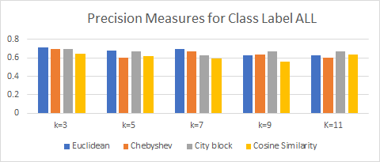

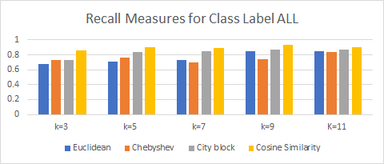

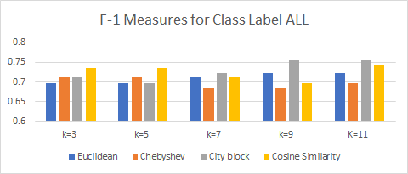

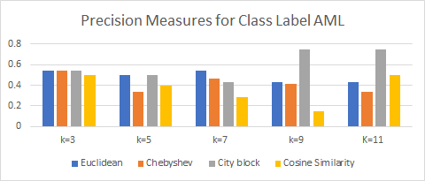

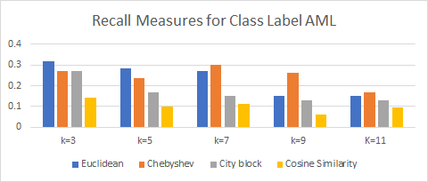

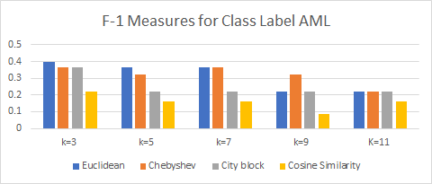

1. **Answer the following questions:**
   1. *For each dataset above, what distance/similarity measure and k value combination are best for predicting ALL class?*

For original data, the best distance and k value combination for predicting ALL is city block distance and either k = 9 or k = 11. Both of these share the highest F-1 value

For preprocessed data, the best combinations for predicting ALL is Euclidean at k = 7, Euclidean and city block at k = 9, and Euclidean and city block at k = 11. All of these share the highest F-1 value.

* 1. *For each dataset above, what distance/similarity measure and k value combination are best for predicting AML class?*

For original data, the best distance and k value combination for predicting AML is Euclidean at k=3.

For preprocessed data, the best distance and k value combination is any combination of k equaling 3, 5, 7 or 9 along with using Euclidean, Chebyshev or city block. Every combination of these shares the highest F-1 value.

* 1. *Overall, which dataset is better for our purposes: original or preprocessed?*

Original Preprocessed

Highest ALL .754 Highest ALL .723

Highest AML .4 Highest AML .4

Although the original dataset has the higher F-1 measure, the difference is negligible, and with large datasets the difference would not be worth the computational expenses.

Who Did What and Percentages

Due to the change in group we will be breaking apart what we did for part 3 and 4 as parts 1 and 2 had both been completed prior to our group formation.

**Work Day 1*:**

Joseph and Samuel met to figure out how to read and process the data that got formed into ARFF files. Joe and Sam thought of how to compute the distances between 2 files but got stuck and decided to schedule a meeting with Imad.

**Work Day 2*:**

All 3 group members met after the meeting with Imad. During the second work day, we were able to load the arff files in, but we still didn’t get the distances completely right because we didn’t fully understand how the file was being read in 3 huge rows, and we were having troubles with imports.

**Work Day 3*:**

Joseph and Samuel met to fix the previous distance formulas mistakes. The code became much less computationally expensive.

**Work Day 4*:**

All 3 group members met to use the distances to find the k nearest neighbors, to compute the weighted distances, and to make the predictions afterwards.

**Work Day 5*:**

All 3 group members met to construct tables for the confusion matrixes, precision, recall, and F-1 measures, along with graphs.

**Work Day 6*:**

All 3 group members met to construct even more tables and more graphs. Also, we made a readme, refactored our code to make it more legible, and finished our writeups as well as this document.

Noah Hoberg :30% Joseph Munsterteiger: 35% Samuel Young: 35%