Ref. 001 | Hazardous Substance Risk Assessment | Chemical Name  Ethanol
Substance(s) & Manufacturer/s | Ethanol (C2H6O, CAS 64-17-5)
Location/s | Lab 2.14
Persons at Risk | ☒ Employees ☐ Students ☐ Contractors ☐ Public
Task/s & Description | Test experiment
Quantity used | 50 mL

Classification (state the category of danger)
Hazard pictograms – select all that apply to the work activity.
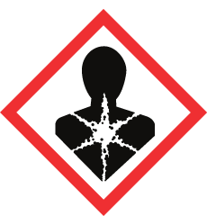 | 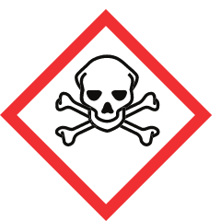 | 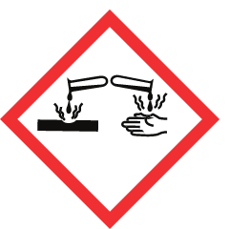 | 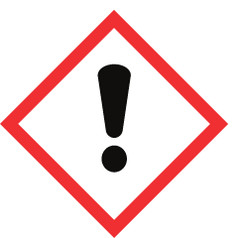 | 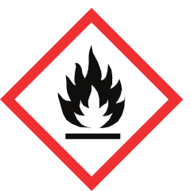 | 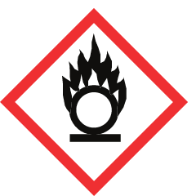 | 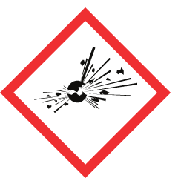 | 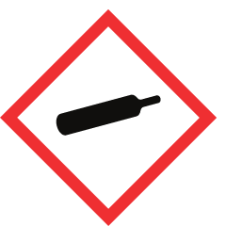 | 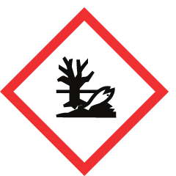
Serious Harm to Health | Toxic | Corrosive | Irritant | Flammable | Oxidiser | Explosive | Gas Under Pressure | Risk to Environment
 |  |  |  | X
Signal word | DANGER

Hazard Type
☐ Gas ☒ Vapour ☒ Mist ☐ Fume ☐ Dust ☒ Liquid ☐ Solid ☐ Other:

Hazard Statements
H225 – Highly Flammable liquid and vapor
Classification source: Regulation (EC) No 1272/2008 of the European Parliament and of the Council

Precautionary Statements
P210 – Keep away from heat, hot surface, sparks, open flames and other ignition sources. No smoking.
P233 – Keep container tightly closed.
P240 – Ground/bond container and receiving equipment.
P241 – Use explosion-proof [electrical/ventilating/lighting/.../] equipment.
P242 – Use only non-sparking tools.
P243 – Take precautionary measures against static discharge.
P280 – Wear protective gloves/protective clothing/eye protection/face protection/hearing protection/...
P303+P361+P353 – IF ON SKIN (or hair): Take off Immediately all contaminated clothing. Rinse SKIN with water [or shower].
P370+P378 – In case of fire: Use ... to extinguish.
P403+P235 – Store in a well-ventilated place. Keep cool.
P501 – Dispose of contents/container to ...

Main Route of Exposure
☒ Inhalation ☐ Skin ☐ Eyes ☐ Ingestion

Control Parameters: Exposure Limits and Monitoring
• ACGIH TLV: 15 min Short Term Exposure Limit (STEL): 1000 ppm. (Hazardous Substances Data Bank (HSDB))
• OEL: MAK (Maximale Arbeitsplatz Konzentration): 380 mg/m³ (ILO-WHO International Chemical Safety Cards (ICSCs))
• NIOSH REL: REL-TWA (Time Weighted Average): 1000 ppm (1900 mg/m³) (Occupational Safety and Health Administration (OSHA))
• OSHA PEL: 1000.0 [ppm] (Haz-Map, Information on Hazardous Chemicals and Occupational Diseases)
• IDLH: 3300 ppm [Based on 10% of the lower explosive limit for safety considerations even though the relevant toxicological data indicated that irreversible health effects or impairment of escape existed only at higher concentrations.] (Hazardous Substances Data Bank (HSDB))
• Lower explosive limit: 3.3 % (NTP, 1992)
• Upper explosive limit: 19 % (NTP, 1992)
Monitoring: Work in a fume cupboard keeps exposure well below the limits above; no personal air monitoring is required for small-scale laboratory use. Check the fume cupboard airflow indicator before use.

Control Measures: Note engineering, ventilation and other requirements needed
Engineering Measures
• Handle in a fume cupboard (local exhaust ventilation, EN 14175); keep the sash as low as possible.
• Keep away from heat, sparks and open flames; no ignition sources (e.g. Bunsen burners) nearby; keep container closed when not in use.
• ICSC advice: Use ventilation, local exhaust or breathing protection.
• ICSC advice: NO open flames, NO sparks and NO smoking. Closed system, ventilation, explosion-proof electrical equipment and lighting. Do NOT use compressed air for filling, discharging, or handling. NO contact with incompatible materials: See Chemical Dangers
Hygiene Measures
• Wash hands thoroughly after handling (P264).
• Do not eat, drink or smoke in the laboratory (P270).
• Clean the work area and equipment after use; clean up spills immediately.

Personal Protective Equipment (state type and standard)
 | Type | Standard | Notes
☒ | Laboratory coat | EN ISO 13688 (EN 13034 Type 6 for liquid chemicals) | Fully buttoned, long sleeves.
☐ | Safety glasses with side shields | EN 166 | Minimum eye protection in the laboratory.
☒ | Chemical splash goggles | EN 166 (marking 3) | Required when there is a splash risk to the eyes.
☐ | Face shield / visor | EN 166 | Wear over goggles when handling corrosive liquids.
☒ | Chemical-resistant gloves | EN ISO 374-1 | Nitrile is a common choice; check breakthrough time and material in the supplier SDS.
☐ | Dust mask (FFP2) | EN 149 | Only if dust cannot be controlled with extraction.
☐ | Respirator with gas/vapour filter | EN 14387 | Only if work outside a fume cupboard is unavoidable (e.g. spill clean-up).
☒ | Closed footwear | - | Standard laboratory requirement.

First Aid Measures
Inhalation | Fresh air, rest.
Skin | Remove contaminated clothes. Rinse skin with plenty of water or shower.
Eyes | First rinse with plenty of water for several minutes (remove contact lenses if easily possible), then refer for medical attention.
Ingestion | Rinse mouth. Give one or two glasses of water to drink. Refer immediately for medical attention.

Fire Fighting
Suitable extinguishing media: Use water spray, alcohol-resistant foam, dry chemical or carbon dioxide.

Storage and Incompatibilities
Fireproof. Separated from : see Chemical Dangers. Incompatible materials: Alkali metals, oxidizing agents, peroxides.

Spillage / Accidental Release
Remove all ignition sources. Ventilation. Do NOT wash away into sewer. Collect leaking and spilled liquid in covered containers as far as possible. Absorb remaining liquid in inert absorbent. Wash away remainder with plenty of water. Store and dispose of according to local regulations.

Waste Disposal
Dispose of as chemical waste according to local regulations and the laboratory waste procedure (P501). Do not pour down the drain unless permitted.

Physical and Chemical Properties (for reference)
Molecular formula | C2H6O
Molar mass | 46.07 g/mol
State at 20 °C | liquid
Melting point | -114.14 °C (Hazardous Substances Data Bank (HSDB))
Boiling point | 78.24 °C (Hazardous Substances Data Bank (HSDB))
Density | 0.7893 g/cu cm at 20 °C (Hazardous Substances Data Bank (HSDB))
Flash point | 14.0 °C (57.2 °F) - closed cup (Hazardous Substances Data Bank (HSDB))
Solubility in water | In water, miscible /1X10+6 mg/L/ at 25 °C (Hazardous Substances Data Bank (HSDB))
Vapour pressure | VP: -73 °C at 1 Pa; -56 °C at 10 Pa; -34 °C at 100 Pa; -7 °C at 1 kPa (all extrapolated); 29.2 °C at 10 kPa; 78.0 °C at 100 kPa (Hazardous Substances Data Bank (HSDB))

Risk Rating (with the control measures above in place)
Severity (1–3) | Likelihood (1–3) | Risk = Severity × Likelihood
2 – Medium | 1 – Unlikely | 2 – LOW

Assessment
Assessed by | Date | Review date | Signature
 | 28-10-2026 | 28-10-2027

Sources
• PubChem CID 702 – https://pubchem.ncbi.nlm.nih.gov/compound/702
• GHS classification: Regulation (EC) No 1272/2008 of the European Parliament and of the Council – https://eur-lex.europa.eu/eli/reg/2008/1272/oj
• CAMEO Chemicals – https://cameochemicals.noaa.gov/chemical/667
• ILO-WHO International Chemical Safety Cards (ICSCs) – https://chemicalsafety.ilo.org/dyn/icsc/showcard.display?p_card_id=0044
• Hazardous Substances Data Bank (HSDB) – https://pubchem.ncbi.nlm.nih.gov/source/hsdb/82
• Occupational Safety and Health Administration (OSHA) – https://www.osha.gov/chemicaldata/1034
• Haz-Map, Information on Hazardous Chemicals and Occupational Diseases
• GHS hazard and precautionary statement texts (UN GHS Rev. 10, via PubChem) – https://pubchem.ncbi.nlm.nih.gov/ghs/
Generated with Molecuul-uitlegger from public PubChem data. Always verify against the current supplier Safety Data Sheet (SDS) before starting the experiment.

