Ref. 001 | Hazardous Substance Risk Assessment | Chemical Name  Sulfuric Acid
Substance(s) & Manufacturer/s | Sulfuric Acid (H2O4S, CAS 7664-93-9)
Location/s | Lab 2.14
Persons at Risk | ☒ Employees ☐ Students ☐ Contractors ☐ Public
Task/s & Description | Test experiment
Quantity used | 50 mL

Classification (state the category of danger)
Hazard pictograms – select all that apply to the work activity.
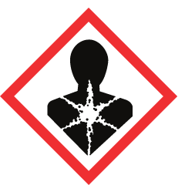 | 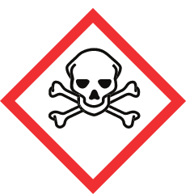 | 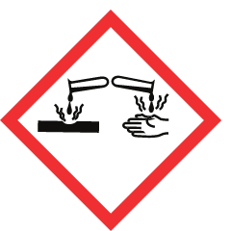 | 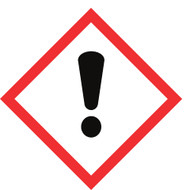 | 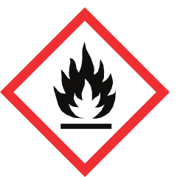 | 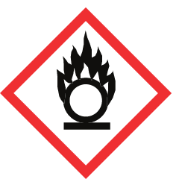 | 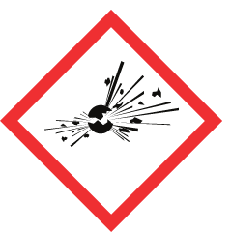 | 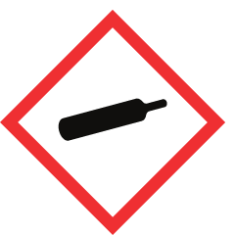 | 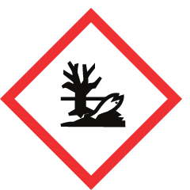
Serious Harm to Health | Toxic | Corrosive | Irritant | Flammable | Oxidiser | Explosive | Gas Under Pressure | Risk to Environment
 |  | X
Signal word | DANGER

Hazard Type
☐ Gas ☐ Vapour ☒ Mist ☐ Fume ☐ Dust ☒ Liquid ☐ Solid ☐ Other:

Hazard Statements
H314 – Causes severe skin burns and eye damage
Classification source: Regulation (EC) No 1272/2008 of the European Parliament and of the Council

Precautionary Statements
P260 – Do not breathe dust/fume/gas/mist/vapors/spray.
P264 – Wash hands [and ...] thoroughly after handling.
P280 – Wear protective gloves/protective clothing/eye protection/face protection/hearing protection/...
P301+P330+P331 – IF SWALLOWED: Rinse mouth. Do NOT induce vomiting.
P302+P361+P354 – IF ON SKIN: Take off Immediately all contaminated clothing. Immediately rinse with water for several minutes.
P304+P340 – IF INHALED: Remove person to fresh air and keep comfortable for breathing.
P305+P354+P338 – IF IN EYES: Immediately rinse with water for several minutes. Remove contact lenses if present and easy to do. Continue rinsing.
P316 – Get emergency medical help immediately.
P321 – Specific treatment (see ... on this label).
P363 – Wash contaminated clothing before reuse.
P405 – Store locked up.
P501 – Dispose of contents/container to ...

Main Route of Exposure
☒ Inhalation ☒ Skin ☒ Eyes ☐ Ingestion

Control Parameters: Exposure Limits and Monitoring
• ACGIH TLV: 8 hr Time Weighted Avg (TWA): 0.2 mg/cu m (thoracic particulate matter). (Hazardous Substances Data Bank (HSDB))
• OEL: EU-OEL: 0.05 mg/m³ (ILO-WHO International Chemical Safety Cards (ICSCs))
• NIOSH REL: REL-TWA (Time Weighted Average): 1 mg/m³ (Occupational Safety and Health Administration (OSHA))
• OSHA PEL: 1.0 [mg/m3] (Haz-Map, Information on Hazardous Chemicals and Occupational Diseases)
• IDLH: 15 mg/cu m (Hazardous Substances Data Bank (HSDB))
Monitoring: Work in a fume cupboard keeps exposure well below the limits above; no personal air monitoring is required for small-scale laboratory use. Check the fume cupboard airflow indicator before use.

Control Measures: Note engineering, ventilation and other requirements needed
Engineering Measures
• Handle in a fume cupboard (local exhaust ventilation, EN 14175); keep the sash as low as possible.
• Use a spill tray (secondary containment) and work with the smallest practical quantity.
• ICSC advice: Use ventilation, local exhaust or breathing protection.
• ICSC advice: NO contact with incompatible materials: See Chemical Dangers
Hygiene Measures
• Wash hands thoroughly after handling (P264).
• Do not eat, drink or smoke in the laboratory (P270).
• Clean the work area and equipment after use; clean up spills immediately.

Personal Protective Equipment (state type and standard)
 | Type | Standard | Notes
☒ | Laboratory coat | EN ISO 13688 (EN 13034 Type 6 for liquid chemicals) | Fully buttoned, long sleeves.
☐ | Safety glasses with side shields | EN 166 | Minimum eye protection in the laboratory.
☒ | Chemical splash goggles | EN 166 (marking 3) | Required when there is a splash risk to the eyes.
☒ | Face shield / visor | EN 166 | Wear over goggles when handling corrosive liquids.
☒ | Chemical-resistant gloves | EN ISO 374-1 | Nitrile is a common choice; check breakthrough time and material in the supplier SDS.
☐ | Dust mask (FFP2) | EN 149 | Only if dust cannot be controlled with extraction.
☐ | Respirator with gas/vapour filter | EN 14387 | Only if work outside a fume cupboard is unavoidable (e.g. spill clean-up).
☒ | Closed footwear | - | Standard laboratory requirement.

First Aid Measures
Inhalation | Fresh air, rest. Half-upright position. Artificial respiration may be needed. Refer immediately for medical attention.
Skin | Wear protective gloves when administering first aid. First rinse with plenty of water for at least 15 minutes, then remove contaminated clothes and rinse again. Refer immediately for medical attention.
Eyes | Rinse with plenty of water for several minutes (remove contact lenses if easily possible). Refer immediately for medical attention.
Ingestion | Rinse mouth. Give nothing to drink. Do NOT induce vomiting. Refer immediately for medical attention.

Fire Fighting
Suitable extinguishing media: Use water spray, alcohol-resistant foam, dry chemical, or carbon dioxide.

Storage and Incompatibilities
Dry. Separated from food and feedstuffs and incompatible materials. See Chemical Dangers. Store only in original packaging. Incompatible materials: Bases, halides, organic materials, carbides, fulminates, nitrates, picrates, cyanides, chlorates, alkali halides, zinc salts, permanganates, e.g. potassium permanganate, hydrogen peroxide, azides, perchlorates, nitromethane, phosphorous; Reacts violently with: cyclopentadiene, cyclopentanone oxime, nitroaryl amines, hexalithium disilicide, phosphorous(iii) oxide, powdered metals.

Spillage / Accidental Release
Evacuate danger area! Consult an expert! Personal protection: chemical protection suit including self-contained breathing apparatus. Do NOT let this chemical enter the environment. Do NOT absorb in saw-dust or other combustible absorbents. Collect leaking liquid in sealable containers. Absorb remaining liquid in dry sand or inert absorbent. Then store and dispose of according to local regulations. Cautiously neutralize remainder with lime or …

Waste Disposal
Dispose of as chemical waste according to local regulations and the laboratory waste procedure (P501). Do not pour down the drain unless permitted.

Physical and Chemical Properties (for reference)
Molecular formula | H2O4S
Molar mass | 98.08 g/mol
State at 20 °C | liquid
Melting point | 10.31 °C (Hazardous Substances Data Bank (HSDB))
Boiling point | 337 °C (Hazardous Substances Data Bank (HSDB))
Density | 1.8302 g/cu cm (Hazardous Substances Data Bank (HSDB))
Solubility in water | Solubility in water at 20 °C: miscible (ILO-WHO International Chemical Safety Cards (ICSCs))
Vapour pressure | Vapor pressure: 1 mm Hg at 145.8 °C (Hazardous Substances Data Bank (HSDB))

Risk Rating (with the control measures above in place)
Severity (1–3) | Likelihood (1–3) | Risk = Severity × Likelihood
3 – High | 1 – Unlikely | 3 – MEDIUM

Assessment
Assessed by | Date | Review date | Signature
 | 28-10-2026 | 28-10-2027

Sources
• PubChem CID 1118 – https://pubchem.ncbi.nlm.nih.gov/compound/1118
• GHS classification: Regulation (EC) No 1272/2008 of the European Parliament and of the Council – https://eur-lex.europa.eu/eli/reg/2008/1272/oj
• ILO-WHO International Chemical Safety Cards (ICSCs) – https://chemicalsafety.ilo.org/dyn/icsc/showcard.display?p_card_id=0362
• Hazardous Substances Data Bank (HSDB) – https://pubchem.ncbi.nlm.nih.gov/source/hsdb/1811
• Occupational Safety and Health Administration (OSHA) – https://www.osha.gov/chemicaldata/624
• Haz-Map, Information on Hazardous Chemicals and Occupational Diseases
• CAMEO Chemicals – https://cameochemicals.noaa.gov/chemical/5193
• GHS hazard and precautionary statement texts (UN GHS Rev. 10, via PubChem) – https://pubchem.ncbi.nlm.nih.gov/ghs/
Generated with Molecuul-uitlegger from public PubChem data. Always verify against the current supplier Safety Data Sheet (SDS) before starting the experiment.

