24)

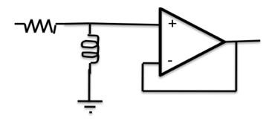

The above circuit will work as

A)Low pass filter \*B) High pass filter C) Band pass filter D) Band reject filter

25)

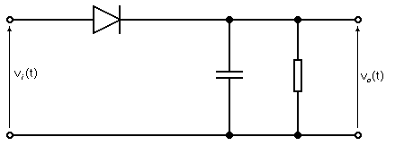

The above circuit will work as

A)Precision detector B) Trigger Detector \*C) Envelope detector D) None of these