1. What is the function of the following circuit? hard

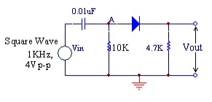

A)Voltage Clipper B)*Voltage Doubler C)Rectified Differentiator D)Precision Rectifier

20) What is the function of the following circuit? hard

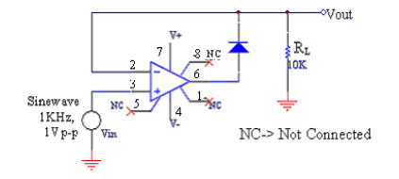

A)Voltage Clipper B)Voltage Doubler C)Rectified Differentiator D)*Precision Rectifier

21) What is the function of the following circuit?

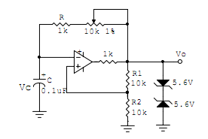

A)Schmitt Trigger B)*Astable Multivibrator C)Monostable Multivibrator D)Voltage Doubler

22)

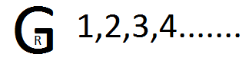

23)

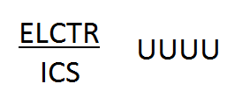

24)

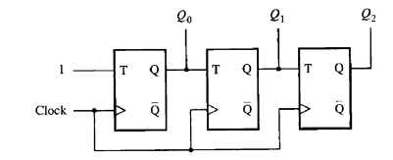

What is the sequence generated by the above circuit?(MSB is Q2)

A)000,001,010,011,100,101,110,111,...

B)000,010,101,111,...

* C)000,001,010,111,...

D)000,010,100,110,...

25)

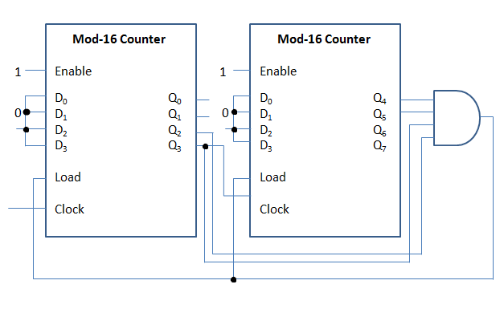

Two Mod-16 Counters are connected as shown in the figure. Output is taken from the pins Q7 (MSB) to Q0 (LSB). Then this circuit will work as a Mod __ Counter.

A)256 B) 60 C)64 *D)61