*Revised

U.S. Real Estate Market Analysis
BIS 470 Capstone Project

Noah Lopez
Southern Connecticut State University
Course: BIS 470
Tools: SQL Server Management Studio 20 | Microsoft Power BI Desktop
Data Source: Realtor.com (realtor-data.csv)
Due: April 26, 2026

Table of Contents
Table of Contents 2
Section 1: Introduction 3
Section 2: Data Cleaning 4
2.1 Dataset Overview 4
2.2 Loading Method 4
2.3 Cleaning Audit 4
2.4 IQR-Based Outlier Analysis 5
Section 3: Data Analysis 6
3.1 Question 2a: Median vs Average Price 6
3.2 Question 2b: Price by State 6
Top 3 Most Expensive States 6
Bottom 3 Most Affordable States 6
3.3 Question 2c: Price Drivers and Prediction 7
Impact of House Characteristics on Price 7
Can Price Be Predicted from These Characteristics? 7
Price Prediction Reference Guide 8
3.4 Question 2d: Correlations Between Characteristics 8
3.5 Question 2e: Florida Housing Market Deep Dive 9
Florida vs National Comparison 9
Florida Cities by Listing Volume 10
Florida Regression Analysis 10
Section 4: Power BI Dashboard 12
Section 5: Conclusion 13
Appendix: SQL Queries 14
Data Cleaning 14
Clean Table Creation 14
Regression Query Template 14

Section 1: Introduction
This report presents a comprehensive analysis of the U.S. real estate market using a dataset of 2,226,382 property listings from Realtor.com. The analysis was conducted for BIS 470 using Microsoft SQL Server Management Studio 20 for data storage and cleaning, and Microsoft Power BI Desktop for visualization. The dataset was loaded into a local SQL Server database, cleaned using structured query language, and connected to Power BI for analysis across eight dashboard tabs.

The dataset includes both active listings and recently sold properties. Price figures reflect both listing prices and final sale prices as provided in the source data. The analysis covers all five required questions, including median vs average price, price by location, price drivers, correlations between characteristics, and a detailed Florida market analysis. Additional statistical analysis, including linear regression, IQR-based outlier detection, and predictive modeling, was performed to provide deeper analytical rigor.

Section 2: Data Cleaning

2.1 Dataset Overview

The source dataset contains 2,226,382 records and 12 variables including price, bed, bath, acre_lot, house_size, city, state, zip_code, status, brokered_by, street, and prev_sold_date. Note that prev_sold_date represents the date the property was previously sold, not the current listing date.

2.2 Loading Method

The CSV file was moved from OneDrive to a local directory (C:\SQLData\Dataset\) to avoid SQL Server permission errors with synced cloud paths. The BULK INSERT command was used to load all records into a staging table named dbo.realtor_raw. Data types were set carefully, zip_code as NVARCHAR to preserve leading zeros, bed and bath as FLOAT to handle decimal and outlier values, and prev_sold_date as NVARCHAR(50) for inconsistent date formats.

2.3 Cleaning Audit
Each issue was identified and quantified before applying the final cleaning logic. Note that categories overlap; a single record may have multiple issues simultaneously, which is why individual counts cannot be summed to produce the total removed.

Issue Identified | Records Affected
NULL price values | 1,541
Zero or negative price | 280
Price above $50,000,000 (initial outlier filter) | 130
NULL or zero bedrooms | 481,317
NULL or zero bathrooms | 511,771
Bedrooms above 20 | 725
Bathrooms above 20 | 401
NULL or zero house size | 568,484
NULL or blank state | 8
Duplicate rows removed | 170,575
Total raw records | 2,226,382
Total clean records | 1,481,944
Net records removed | 744,438 (33.4%)

The high counts for null bedrooms, bathrooms, and house size reflect land-only or ready-to-build listings with no constructed structure. These records are not useful for analyzing house price relationships and were correctly excluded.

Duplicate records were identified using a ROW_NUMBER() window function partitioned by brokered_by, price, bed, bath, house_size, city, state, and zip_code. Only the first occurrence of each group was retained. The initial $50M price ceiling was applied as a basic filter; a statistically justified IQR-based approach was applied separately for regression analysis (see Section 3.7).

2.4 IQR-Based Outlier Analysis
For regression and predictive modeling purposes, a more rigorous outlier removal method was applied using the Interquartile Range (IQR) method. This approach is statistically defensible because boundaries are derived from the actual data distribution rather than arbitrary cutoffs. The IQR upper fence is calculated as Q3 + 1.5 × IQR.

Variable | Q1 | Q3 | IQR | Upper Fence
Price | $232,000 | $599,900 | $367,900 | $1,151,750
House Size | 1,296 sqft | 2,403 sqft | 1,107 sqft | 4,064 sqft
Bedrooms | 3 | 4 | 1 | 5
Bathrooms | 2 | 3 | 1 | 4

These IQR-based filters were applied exclusively to the Regression Analysis tab to ensure model accuracy. The fully cleaned dataset of 1,481,944 records was retained for all descriptive analysis to accurately represent the complete market, including luxury segments.

Section 3: Data Analysis

3.1 Question 2a: Median vs Average Price
Metric | Value | Total Records
Average Price | $576,549 | 1,481,944
Median Price | $375,000 | 1,481,944
Difference | $201,549 | —

The national average price is $576,549, while the median is $375,000, a gap of $201,549. This large difference indicates the price distribution is right-skewed, meaning a small number of extremely high-priced luxury properties pull the average upward. The median is the more accurate representation of what a typical buyer pays because it is not affected by extreme outliers.

However, average price is used as the primary metric throughout the remainder of this analysis for the following reasons: average price is required for linear regression modeling as it responds proportionally to changes in predictor variables; it is the standard metric for comparative market analysis across states and cities; and with 1,481,944 records, the law of large numbers means average price at the state and city level is less susceptible to individual outlier distortion than at the national level. Both metrics are presented where relevant to provide a complete context.

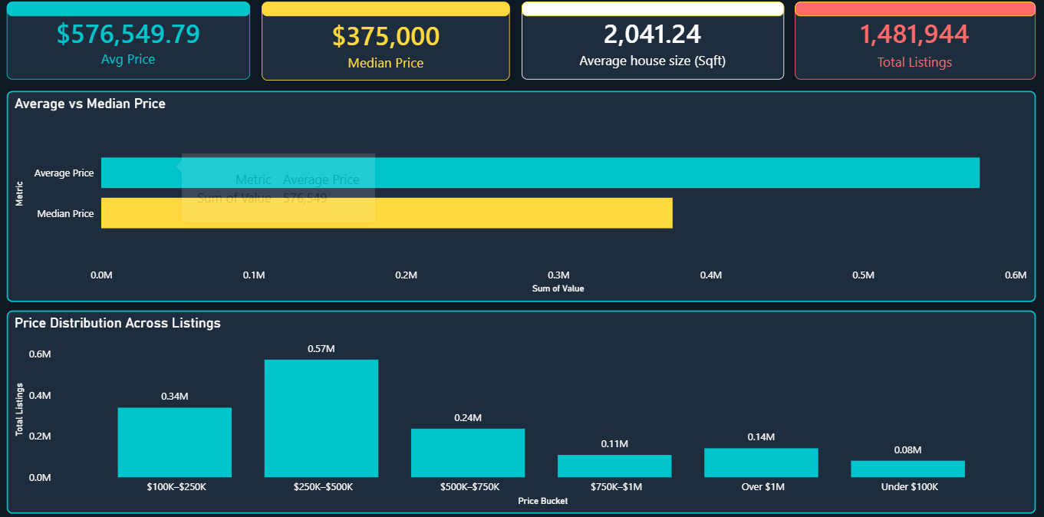

3.2 Question 2b: Price by State

Top 3 Most Expensive States
Rank | State | Avg Price | Median Price | Listings
1 | Hawaii | $1,414,882 | $800,000 | 4,927
2 | Virgin Islands | $1,298,464 | $604,500 | 202
3 | California | $1,031,607 | $699,000 | 173,955

Bottom 3 Most Affordable States
Rank | State | Avg Price | Median Price | Listings
1 | Ohio | $240,279 | $179,900 | 42,951
2 | West Virginia | $252,245 | $199,900 | 7,491
3 | Iowa | $257,565 | $218,000 | 17,221
Hawaii tops the list at $1,414,882 average due to geographic isolation, limited land, and luxury demand. California ranks third at $1,031,607 driven by tech industry concentration and constrained supply. On the affordable end, Ohio ($240,279), West Virginia ($252,245), and Iowa ($257,565) share characteristics of lower population density, abundant land, and lower costs of living. The difference between Hawaii and Ohio represents a 5.9x price gap, the largest spread in the dataset. Florida ranks 15th at $649,020, which is 12.6% above the national average.
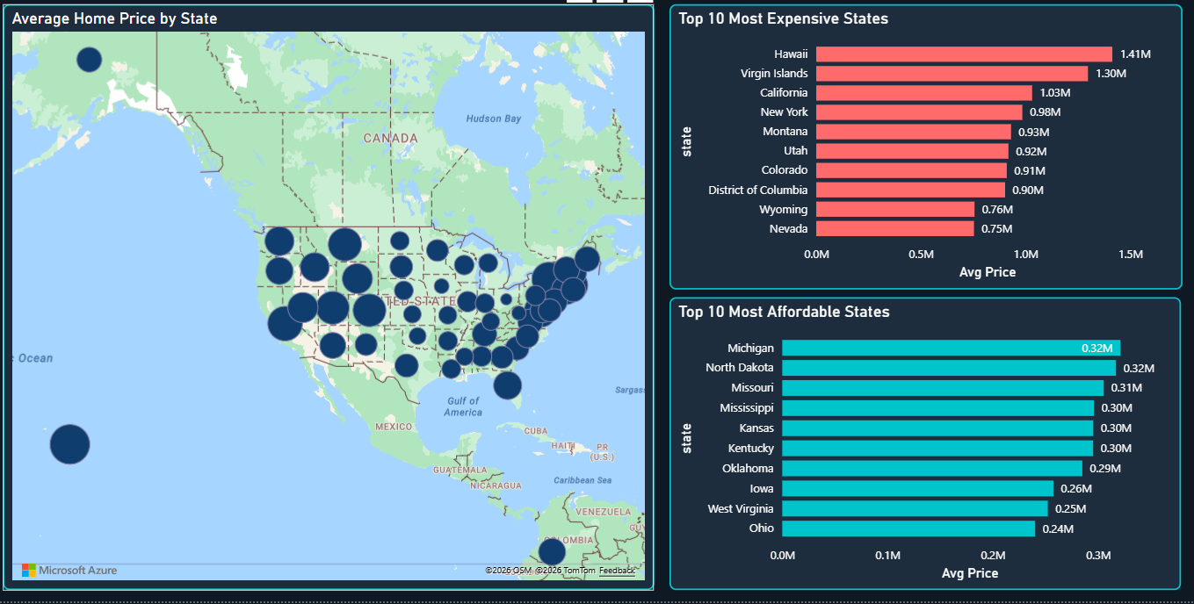

3.3 Question 2c: Price Drivers and Prediction

Impact of House Characteristics on Price
House Size | Listings | Avg Price | Bedrooms | Listings | Avg Price
Under 1,000 sqft | 144,094 | $280,325 | 1 bedroom | 52,279 | $368,540
1,000-1,999 sqft | 763,148 | $388,869 | 2 bedrooms | 263,664 | $394,889
2,000-2,999 sqft | 375,403 | $608,172 | 3 bedrooms | 646,742 | $451,706
3,000-4,999 sqft | 164,829 | $1,080,052 | 4 bedrooms | 374,444 | $662,498
5,000+ sqft | 34,470 | $3,217,947 | 5 bedrooms | 102,814 | $1,086,413

All three characteristics, bedrooms, bathrooms, and house size, show a clear positive relationship with price. House size demonstrates the most dramatic effect: homes over 5,000 sqft average $3,217,947 compared to $280,325 for homes under 1,000 sqft, an 11-fold difference. Bathrooms show a similarly strong pattern with price rising from $261,139 for one bathroom to $928,309 for four bathrooms.

Can Price Be Predicted from These Characteristics?
Yes, linear regression analysis was conducted to quantify these relationships. Single variable regression was run for each characteristic against price using the full cleaned dataset of 1,481,944 records
Predictor | Slope | Intercept | R | R² | T-Statistic | P-Value
House Size | $38.48/sqft | $497,995 | 0.1433 | 0.0205 | 176.30 | p < 0.001
Bedrooms | $224,179/bed | -$153,286 | 0.2439 | 0.0595 | 306.22 | p < 0.001
Bathrooms | $410,006/bath | -$445,604 | 0.4501 | 0.2026 | 613.54 | p < 0.001
All three predictors are statistically significant at p < 0.001, confirming the relationships are real and not due to chance. Bathrooms are the strongest predictor with R² = 0.2026, explaining 20.3% of price variance nationally. Bedrooms explains 6%, and house size explains 2.1%.

The relatively low R² values do not indicate that these characteristics are unimportant. Rather, they reflect geographic confounding; a 3-bedroom home in Ohio averages $180,000 while the same home in Hawaii averages over $1,000,000. When the same regression is run on Florida alone, house size R² jumps from 0.0205 to 0.3223, a 15.7x improvement, proving that within a single geographic market, these characteristics are stronger predictors. A multiple regression model incorporating location as a variable would substantially increase predictive power.

Price Prediction Reference Guide
Home Profile | Sqft | Beds | Baths | Expected National Price | Expected Florida Price
Small Starter | 900 | 2 | 1 | $280,325 | $236,098
Average Home | 1,500 | 3 | 2 | $388,869 | $399,808
Above Average | 2,500 | 4 | 3 | $608,172 | $760,654
Large Home | 3,500 | 4 | 3 | $1,080,052 | $1,809,342
Luxury Home | 5,000 | 5 | 4 | $3,217,947 | $6,719,148

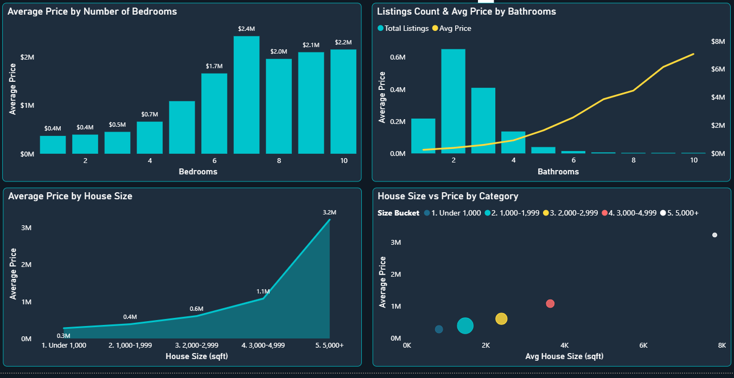
Prices in this table are based on observed market averages for each home profile rather than regression extrapolation, making them more reliable for practical prediction purposes. Florida homes cost more than the national average at every size level except small homes under 1,000 sqft, where the national average is actually higher.
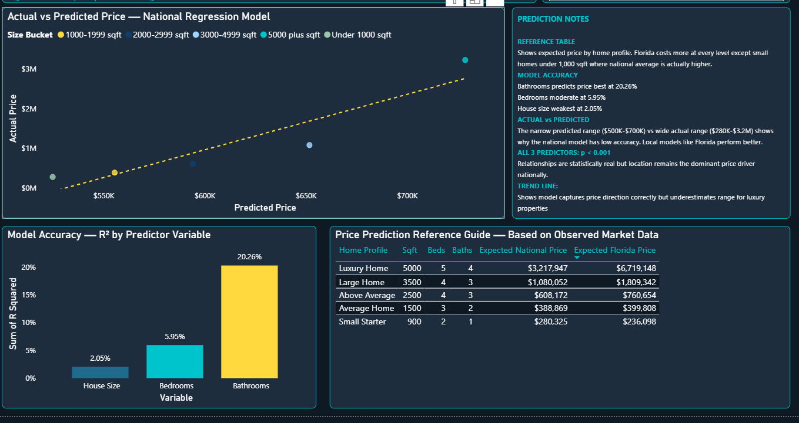
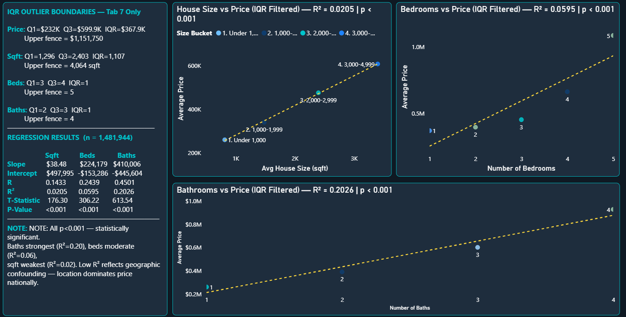

3.4 Question 2d: Correlations Between Characteristics
Bedrooms | Avg Bathrooms | Avg Sqft | Avg Acres | Avg Price | Listings
1 | 1.18 | 931 | 37.59 | $368,540 | 52,279
2 | 1.80 | 1,288 | 18.83 | $394,889 | 263,664
3 | 2.25 | 1,755 | 10.43 | $451,706 | 646,742
4 | 2.94 | 2,518 | 9.53 | $662,498 | 374,444
5 | 3.81 | 3,509 | 16.10 | $1,086,413 | 102,814
6 | 4.48 | 4,297 | 27.52 | $1,659,027 | 26,139
7 | 5.36 | 5,174 | 42.49 | $2,428,933 | 6,350

The data reveals strong positive correlations between bedrooms, bathrooms, square footage, and price. As the bedroom count increases, all other characteristics scale proportionally. This statistical phenomenon is called multicollinearity; all three characteristics are essentially measuring the same underlying attribute: overall property size and scale. Knowing one allows reasonable estimation of the others.

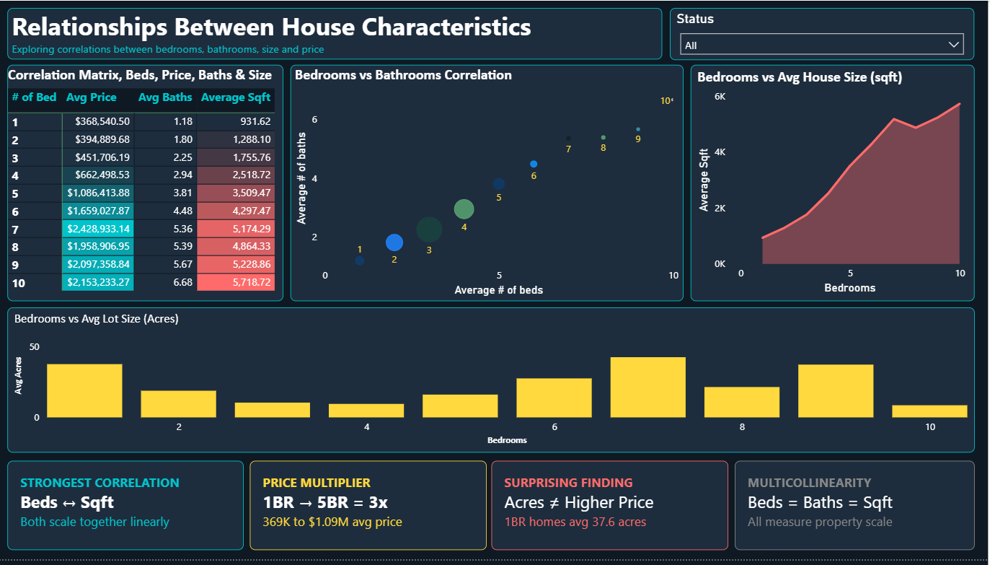
Acre lot size behaves differently and reveals a surprising inverse relationship. One-bedroom homes average 37.59 acres while three-bedroom homes average only 10.43 acres. This occurs because small single-bedroom structures are often found on large rural or agricultural parcels where the land is substantial but the dwelling is modest. This tells us that lot size does not follow the same scaling pattern as other characteristics and is not a reliable price predictor

3.5 Question 2e: Florida Housing Market Deep Dive

Florida vs National Comparison
Metric | Florida | National | Difference
Total Listings | 166,931 | 1,481,944 | 11.3% of all listings
Average Price | $649,020 | $576,549 | +$72,471 (+12.6%)
Median Price | $370,880 | $375,000 | -$4,120 (-1.1%)
Average House Size | 1,809 sqft | 2,041 sqft | -232 sqft (-11.4%)
Average Bedrooms | 3.0 | 3.3 | -0.3 bedrooms
Average Bathrooms | 2.4 | 2.5 | -0.1 bathrooms

Florida's average price of $649,020 is 12.6% above the national average despite offering homes that are 232 sqft smaller on average. This means Florida buyers pay more per square foot than the national average, a premium driven by climate, coastal access, retirement appeal, and strong in-migration from higher-cost states. The median price of $370,880 is slightly below the national median of $375,000, indicating that while Florida has many luxury properties pulling its average up, the typical Florida home is priced comparably to the rest of the country.

Florida Cities by Listing Volume
City | Listings | Avg Price | Avg Sqft
Jacksonville | 7,982 | $334,260 | 1,724
Miami | 7,836 | $844,746 | 1,584
Orlando | 5,939 | $409,197 | 1,733
Tampa | 5,013 | $547,774 | 1,801
Naples | 4,524 | $1,416,967 | 2,129
Saint Petersburg | 2,848 | $517,601 | 1,439
Miami Beach | 2,360 | $2,170,059 | 1,547
Sarasota | 1,968 | $1,111,002 | 1,965

Florida's market contains distinct submarkets. Jacksonville is the most active and affordable major city at $334,260 average with 7,982 listings. Miami combines high volume with luxury pricing at $844,746. Naples and Sarasota represent the high-volume luxury segment at $1.4M and $1.1M, respectively. Miami Beach is the most expensive at $2,170,059, reflecting its international luxury appeal and waterfront condominiums.

Florida Regression Analysis
Predictor | Florida Slope | Florida R² | National R² | Improvement
House Size | $751.62/sqft | 0.3223 | 0.0205 | 15.7x stronger
Bedrooms | $366,631/bed | 0.0842 | 0.0595 | 1.4x stronger
Bathrooms | $702,730/bath | 0.2973 | 0.2026 | 1.5x stronger

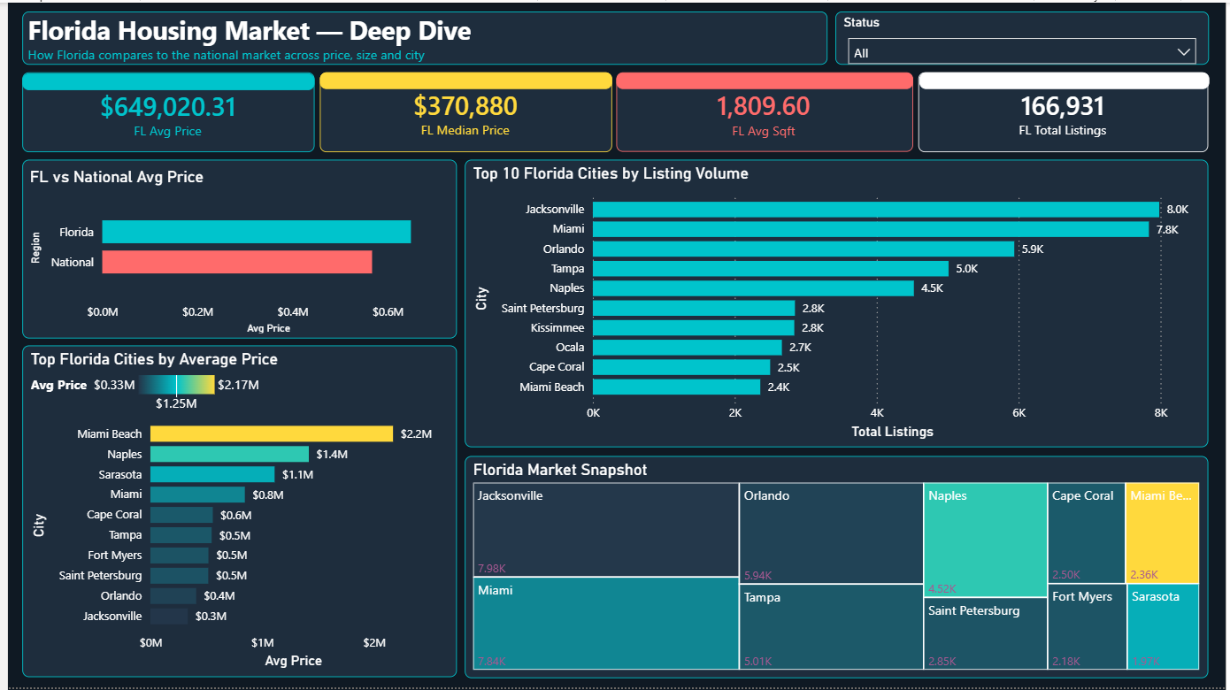
Running regression on Florida alone produces dramatically stronger models. House size R² jumps from 0.0205 nationally to 0.3223 in Florida, a 15.7x improvement. This directly proves that geographic variation is the primary cause of low national R² values. Within a single state with similar climate, tax structure, and economic conditions, house size becomes a much more reliable price predictor. The Florida slope of $751.62 per sqft versus $38.48 nationally reflects the premium Florida buyers pay per square foot.

Section 4: Power BI Dashboard
The Power BI report was built across eight tabs using a consistent dark navy theme. The color palette uses teal (#00C4CC), coral red (#FF6B6B), and amber yellow (#FFD93D) on a dark background (#0F1923) for maximum visual contrast and professional presentation.
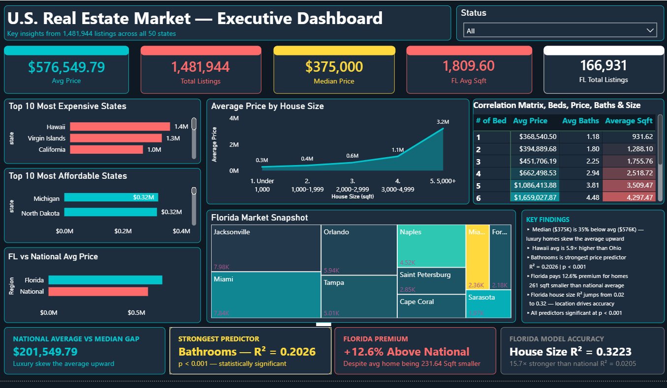
Tab | Name | Purpose | Assignment Question
1 | Overview | National price summary, KPI cards, price distribution | Q2a
2 | Price by Location | Bubble map and top/bottom state bar charts | Q2b
3 | Price Drivers | Bedroom, bathroom, and size effects on price | Q2c
4 | Correlations | Heatmap matrix, scatter plots, insight cards | Q2d
5 | Florida Analysis | Florida deep dive with city breakdowns | Q2e
6 | Regression Analysis | IQR-filtered scatter plots with R² and p-values | Q2c extended
7 | Predictive Modeling | Price prediction guide and model accuracy | Q2c extended
8 | Executive Summary | Summary dashboard of all key findings | All

Section 5: Conclusion
This analysis of 1,481,944 cleaned U.S. real estate listings produced several significant findings about the American housing market.

The national median home price of $375,000 is the most accurate representation of what a typical buyer pays. The $201,549 gap between median and average confirms a right-skewed distribution caused by luxury outliers. At the state level, Hawaii averages $1,414,882, nearly 6x more than Ohio at $240,279, demonstrating the extraordinary geographic range of housing costs.

All three house characteristics tested, bedrooms, bathrooms, and square footage, show statistically significant positive relationships with price (all p < 0.001). Bathrooms are the strongest single predictor nationally, with R² = 0.2026, followed by bedrooms at R² = 0.0595 and house size at R² = 0.0205. The low national R² values are explained by geographic confounding rather than weak relationships; when regression is run on Florida alone, house size R² improves 15.7x to 0.3223. This finding confirms the real estate industry maxim that location is the dominant price determinant.

Florida presents an interesting market dynamic, commanding a 12.6% price premium despite offering homes 232 sqft smaller than the national average. Florida's internal variation is substantial, ranging from affordable inland markets like Jacksonville ($334,260) to ultra-luxury coastal markets like Miami Beach ($2,170,059). The Florida house-size regression slope of $751.62 per sq ft, compared with $38.48 nationally, quantifies exactly how much more Florida buyers pay for each additional square foot.

The combination of SQL Server for data management and Power BI for visualization proved effective for this dataset. IQR-based outlier detection, linear regression with statistical significance testing, and both national and state-level predictive modeling provide a comprehensive analytical framework that goes beyond basic descriptive statistics.

Appendix: SQL Queries

Data Cleaning

BULK INSERT dbo.realtor_raw

FROM 'C:\SQLData\Dataset\realtor-data.csv'

WITH (FIRSTROW=2, FIELDTERMINATOR=',', ROWTERMINATOR='0x0a', TABLOCK,

MAXERRORS=1000);

Clean Table Creation

SELECT r.brokered_by, LTRIM(RTRIM(r.status)) AS status,

CAST(r.price AS BIGINT) AS price, CAST(r.bed AS INT) AS bed,

CAST(r.bath AS DECIMAL(4,1)) AS bath,

CAST(r.acre_lot AS DECIMAL(10,4)) AS acre_lot, r.street,

LTRIM(RTRIM(r.city)) AS city, LTRIM(RTRIM(r.state)) AS state,

LTRIM(RTRIM(r.zip_code)) AS zip_code,

CAST(r.house_size AS INT) AS house_size,

TRY_CAST(r.prev_sold_date AS DATE) AS prev_sold_date

INTO dbo.realtor_clean

FROM (

SELECT *, ROW_NUMBER() OVER (

PARTITION BY brokered_by, price, bed, bath, house_size, city, state, zip_code

ORDER BY (SELECT NULL)) AS rn

FROM dbo.realtor_raw

WHERE price IS NOT NULL AND price > 0 AND price <= 50000000

AND bed IS NOT NULL AND bed > 0 AND bed <= 20

AND bath IS NOT NULL AND bath > 0 AND bath <= 20

AND house_size IS NOT NULL AND house_size > 0

AND state IS NOT NULL AND LTRIM(RTRIM(state)) <> '' ) r WHERE r.rn = 1;

Regression Query Template
WITH base AS (
SELECT CAST([variable] AS FLOAT) AS x, CAST(price AS FLOAT) AS y
FROM dbo.realtor_clean
WHERE [variable] IS NOT NULL AND price IS NOT NULL
),
means AS (SELECT AVG(x) AS avg_x, AVG(y) AS avg_y, COUNT(*) AS n FROM base),
calcs AS (
SELECT m.n, m.avg_x, m.avg_y,
SUM((b.x - m.avg_x) * (b.y - m.avg_y)) AS ss_xy,
SUM(POWER(b.x - m.avg_x, 2)) AS ss_xx,
SUM(POWER(b.y - m.avg_y, 2)) AS ss_yy
FROM base b CROSS JOIN means m
GROUP BY m.n, m.avg_x, m.avg_y
),
results AS (
SELECT n, ss_xy / NULLIF(ss_xx, 0) AS slope,
avg_y - (ss_xy / NULLIF(ss_xx, 0)) * avg_x AS intercept,
ss_xy / NULLIF(SQRT(ss_xx * ss_yy), 0) AS r_value,
POWER(ss_xy / NULLIF(SQRT(ss_xx * ss_yy), 0), 2) AS r_squared
FROM calcs
),
final AS (
SELECT n, slope, intercept, r_value, r_squared,
ABS(r_value) * SQRT(n - 2) / NULLIF(SQRT(1 - r_squared), 0) AS t_stat
FROM results
)
SELECT n,
CAST(slope AS DECIMAL(10,2)) AS slope,
CAST(intercept AS DECIMAL(10,2)) AS intercept,
CAST(r_value AS DECIMAL(8,4)) AS r_value,
CAST(r_squared AS DECIMAL(8,4)) AS r_squared,
CAST(t_stat AS DECIMAL(10,2)) AS t_statistic,
'p < 0.001' AS p_value
FROM final;

