UML Diagram

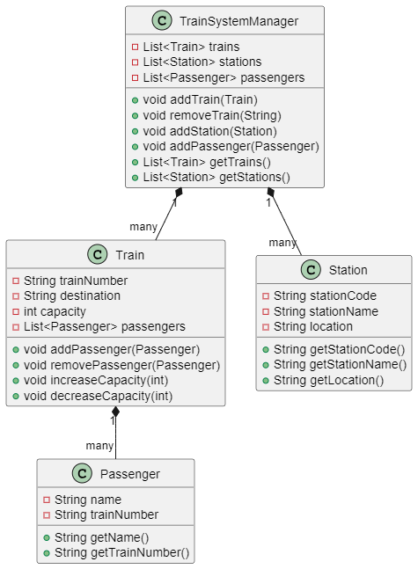

Sequence diagram
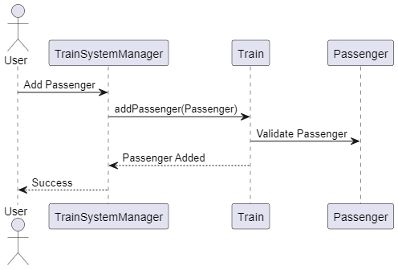

Skeloton code
import java.util.ArrayList;
import java.util.List;
import java.util.Scanner;

public class TrainManagementSystem {
private static List<Train> trains = new ArrayList<>();
private static List<Passenger> passengers = new ArrayList<>();
private static List<Station> stations = new ArrayList<>();
private static Scanner scanner = new Scanner(System.in);

public static void main(String[] args) {
boolean running = true;
while (running) {
System.out.println("\n===== Train Management System =====");
System.out.println("1. Add New Train");
System.out.println("2. Add Passenger");
System.out.println("3. Add Station");
System.out.println("4. List All Trains");
System.out.println("5. List All Passengers");
System.out.println("6. List All Stations");
System.out.println("7. Remove Train");
System.out.println("8. Exit");
System.out.print("Enter your choice: ");

int choice = scanner.nextInt();
scanner.nextLine(); // Consume newline

switch (choice) {
case 1 -> addTrain();
case 2 -> addPassenger();
case 3 -> addStation();
case 4 -> listTrains();
case 5 -> listPassengers();
case 6 -> listStations();
case 7 -> removeTrain();
case 8 -> running = false;
default -> System.out.println("Invalid choice! Please try again.");
}
}
System.out.println("Exiting system...");
}

private static void addTrain() {
// Implement logic to add a train
}

private static void addPassenger() {
// Implement logic to add a passenger
}

private static void addStation() {
// Implement logic to add a station
}

private static void listTrains() {
// Implement logic to list all trains
}

private static void listPassengers() {
// Implement logic to list all passengers
}

private static void listStations() {
// Implement logic to list all stations
}

private static void removeTrain() {
// Implement logic to remove a train
}
}

class Train {
private final String trainNumber;
private String destination;
private int capacity;
private List<Passenger> passengers;

public Train(String trainNumber, String destination, int capacity) {
// Initialize fields
}

public String getTrainNumber() {
// Return train number
}

public String getDestination() {
// Return destination
}

public int getCapacity() {
// Return capacity
}

public void setDestination(String destination) {
// Set destination
}

public void increaseCapacity(int amount) {
// Increase capacity
}

public void decreaseCapacity(int amount) {
// Decrease capacity
}

public void addPassenger(Passenger passenger) {
// Add passenger
}

public void removePassenger(Passenger passenger) {
// Remove passenger
}

@Override
public String toString() {
// Return string representation of the train
}
}

class Passenger {
private final String name;
private final String trainNumber;

public Passenger(String name, String trainNumber) {
// Initialize fields
}

public String getName() {
// Return name
}

public String getTrainNumber() {
// Return train number
}

@Override
public String toString() {
// Return string representation of the passenger
}
}

class Station {
private final String stationCode;
private final String stationName;
private final String location;

public Station(String stationCode, String stationName, String location) {
// Initialize fields
}

public String getStationCode() {
// Return station code
}
public String getStationName() {
// Return station name
}

public String getLocation() {
// Return location
}

@Override
public String toString() {
// Return string representation of the station
}
}

Business logic code
Adding Train

private static void addTrain() {
// Logic for adding a new train
System.out.print("Enter train number: ");
String trainNumber = scanner.nextLine();
System.out.print("Enter destination: ");
String destination = scanner.nextLine();
System.out.print("Enter capacity: ");
int capacity = scanner.nextInt();
scanner.nextLine(); // Consume newline

Train train = new Train(trainNumber, destination, capacity);
trains.add(train);
System.out.println("Train added successfully!");
}
Adding passenger

private static void addPassenger() {
// Logic for adding a new passenger
System.out.print("Enter passenger name: ");
String name = scanner.nextLine();
System.out.print("Enter train number: ");
String trainNumber = scanner.nextLine();

Train train = findTrain(trainNumber);
if (train == null) {
System.out.println("Train not found!");
return;
}

Passenger passenger = new Passenger(name, trainNumber);
train.addPassenger(passenger);
passengers.add(passenger);
System.out.println("Passenger added successfully!");
}

Adding stations

private static void addStation() {
// Logic for adding a new station
System.out.print("Enter station code: ");
String stationCode = scanner.nextLine();
System.out.print("Enter station name: ");
String stationName = scanner.nextLine();
System.out.print("Enter location: ");
String location = scanner.nextLine();

Station station = new Station(stationCode, stationName, location);
stations.add(station);
System.out.println("Station added successfully!");
}

Removing trains
private static void removeTrain() {
// Logic for removing a train
System.out.print("Enter train number to remove: ");
String trainNumber = scanner.nextLine();

boolean isRemoved = trains.removeIf(train -> train.getTrainNumber().equals(trainNumber));
if (isRemoved) {
passengers.removeIf(passenger -> passenger.getTrainNumber().equals(trainNumber));
System.out.println("Train removed successfully!");
} else {
System.out.println("Train not found!");
}
}

