BDA Project - Credit Risk Analysis
An Do, Nam Bui, Ayush Pradhan
November 2025

Introduction
Credit provision (handing out loans) is a fundamental function of banking institutions. A loan is essentially a sum of money or other assets provided to a borrower with the expectation of repayment in the future, including the original amount plus any interest or fees. Loans can take various forms and serve multiple purposes, such as financing consumption, business ventures, or investments. They also play a vital role in economic growth by increasing liquidity and supporting new business activities.
However, credit transactions inherently carry the risk that borrowers may fail to meet their repayment obligations, a phenomenon known as credit default or credit risk (Altman & Saunders, 1997). When a bank receives a loan application, it must decide whether to approve or reject it based on the applicant’s profile. This decision involves two key risks: if a good credit risk is rejected, the bank loses a business opportunity; if a bad credit risk is approved, the bank faces potential financial loss. Accurate assessment of credit risk is therefore crucial, as misjudgment can lead to significant financial losses, institutional instability, and broader systemic consequences, as seen during the 2007–2008 financial crisis (Crouhy et al., 2014).
We chose this project because effective risk management is vital for the stability and profitability of banking institutions. Optimizing the process of detecting high-risk borrowers can help minimize losses and maximize returns, therefore, making lending decisions faster and more reliable.
Our project addresses the binary classification problem of credit risk assessment: determining whether a loan application should be classified as low-risk or high-risk (default) based on borrower characteristics and loan features. To model this, we employ both pooled logistic regression and hierarchical logistic regression, which are well-suited to the binary nature of loan outcomes.

Data Description

Data Overview
Firstly, the histograms of the feature variables with regards to the target variable Risk are examined.

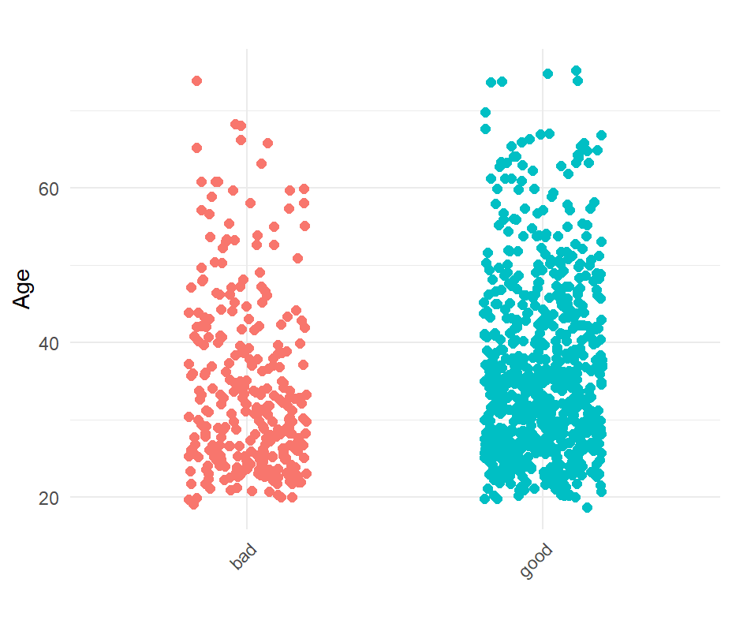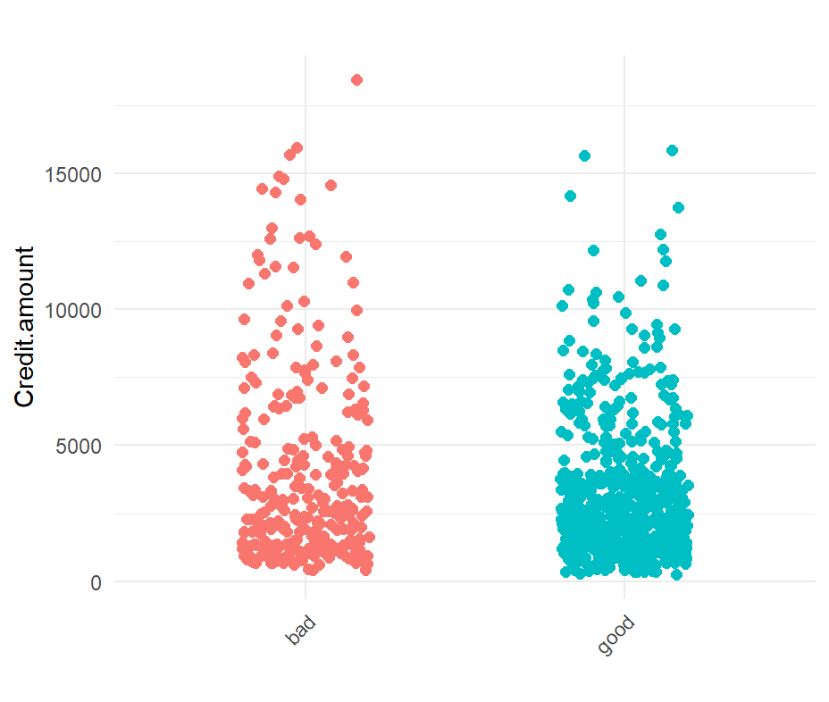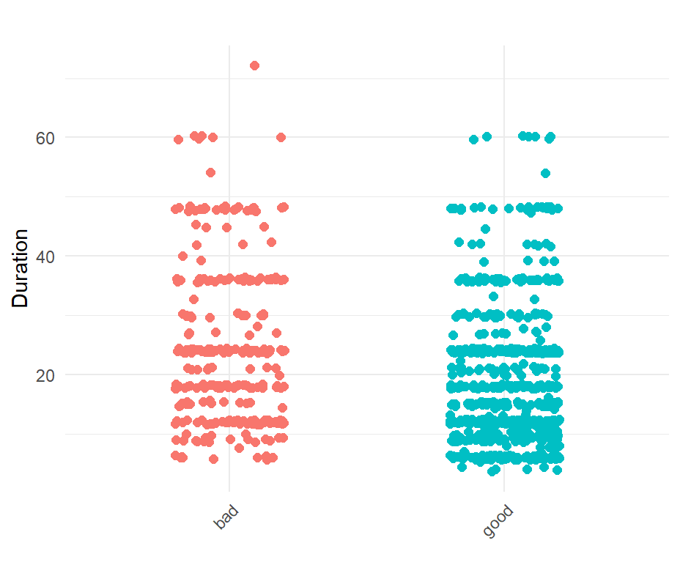

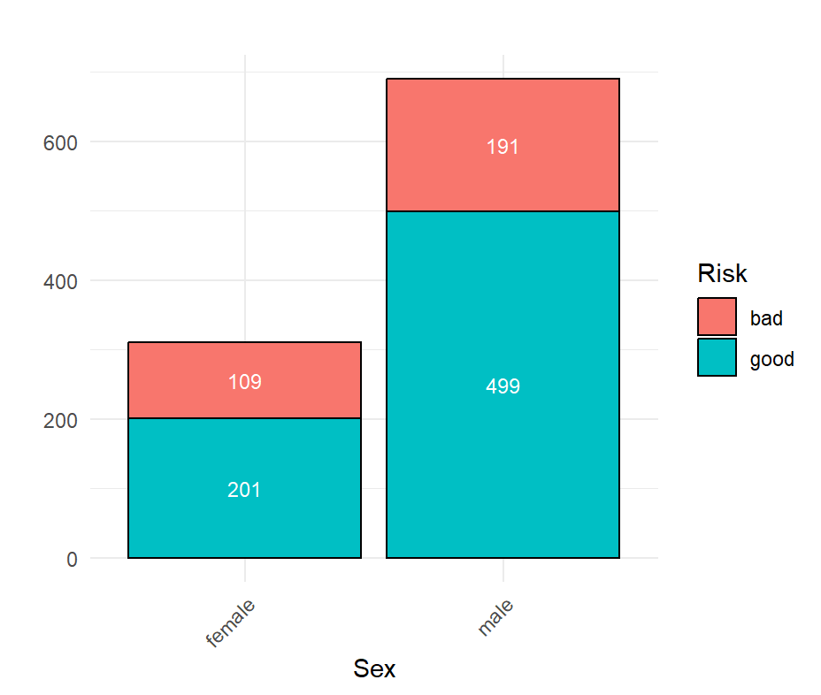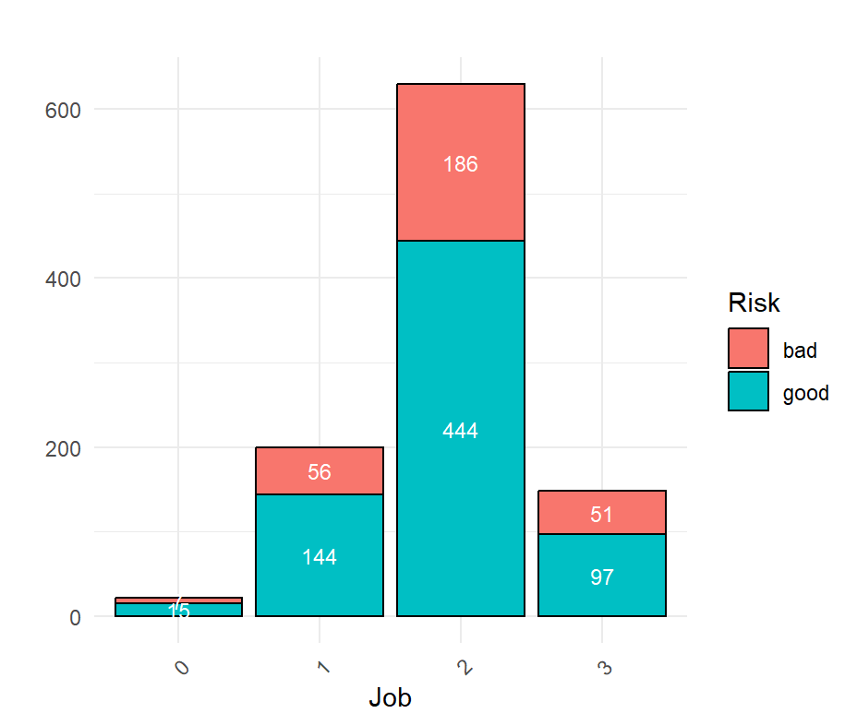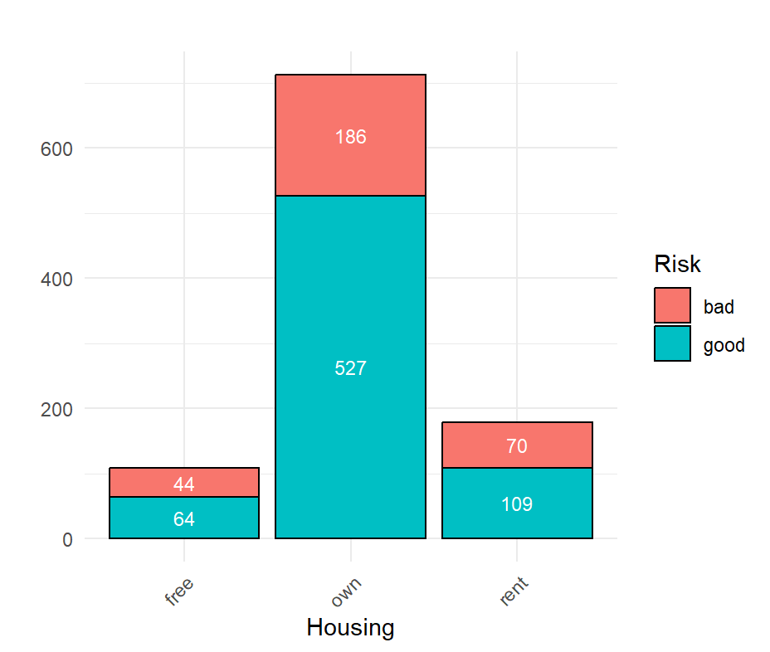

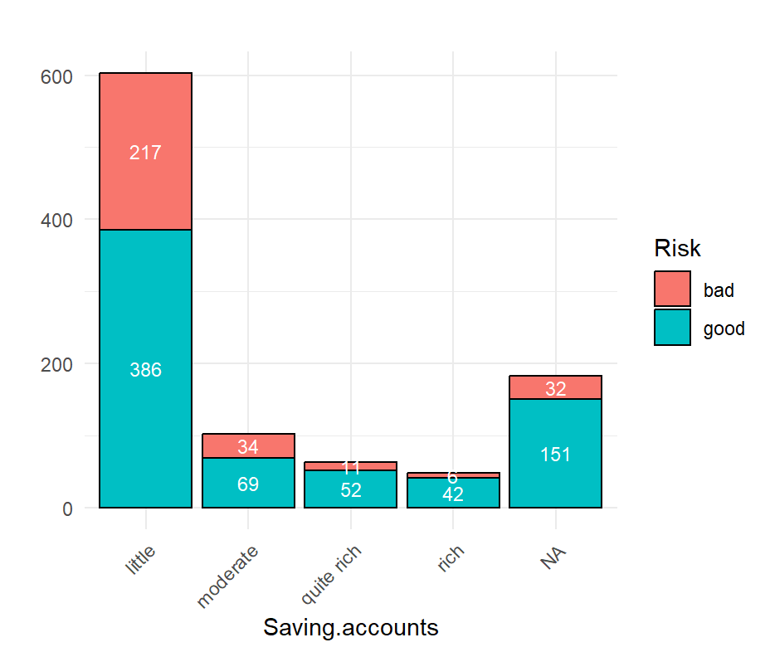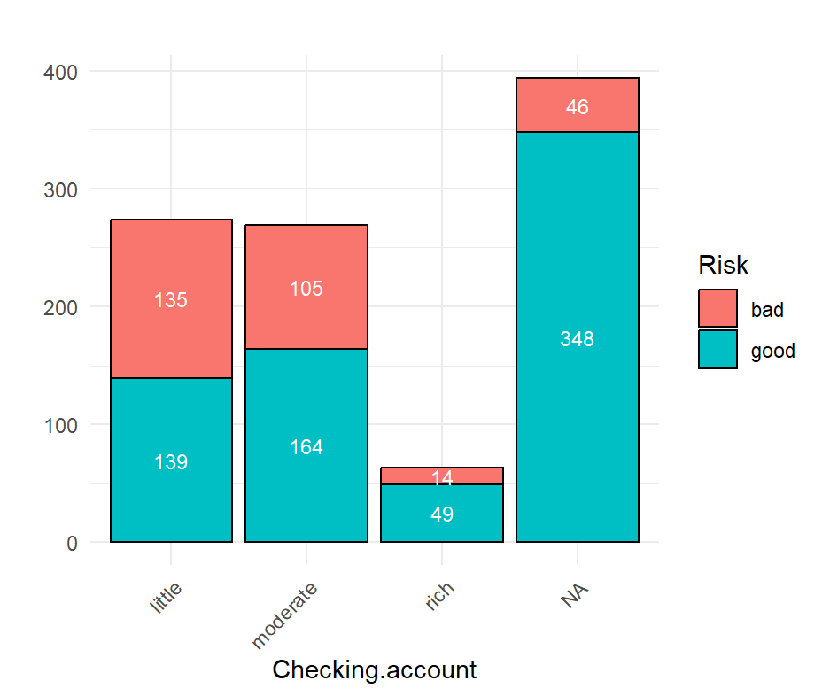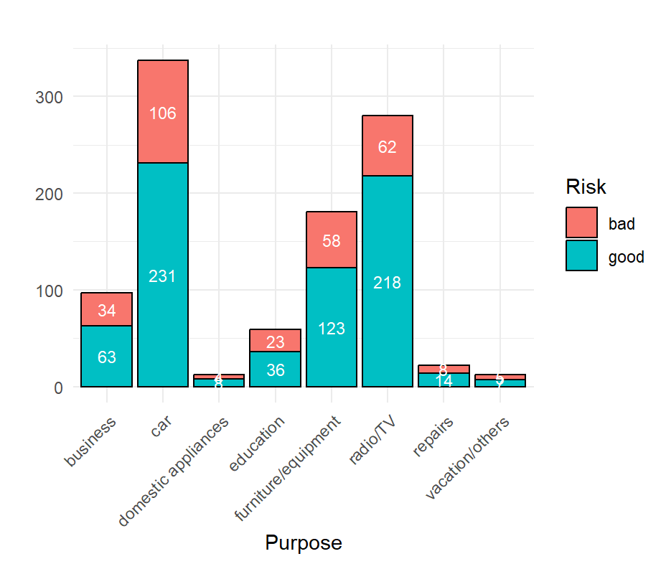
The data also contains some missing values.
Variable | Proportion Missing
X | 0.000
Age | 0.000
Sex | 0.000
Job | 0.000
Housing | 0.000
Saving.accounts | 0.183
Checking.account | 0.394
Credit.amount | 0.000
Duration | 0.000
Purpose | 0.000
Risk | 0.000
From the histograms, three main issues were identified in the dataset: missing values in Saving.accounts and Checking.account, category mismatches between these two columns, and dispersed data in Purpose.
The dataset contains 18.3% missing values in Saving.accounts and 39.4% in Checking.account. Deleting these entries or imputing them with the mode could distort the data distribution and remove potentially important information, as missing accounts may predict credit risk. To address this, k-Nearest Neighbors (kNN) imputation was applied which estimates missing values based on the similarity to other observations, preserving the underlying patterns in the data.
In terms of category mismatches, both Saving.accounts and Checking.account share the categories 'little', 'moderate', and 'rich', but Saving.accounts includes an additional 'quite rich' category. All 'quite rich' values were recoded as 'rich' to ensure consistency.
The Purpose column is highly dispersed, with several low-population categories such as 'repairs' and 'domestic appliances'. To reduce sparsity, these categories were merged into 'furniture/equipment', creating more balanced groups.
To improve model performance and ensure comparability across features, we perform standardization. To standardize, we transform all variables (including the target) to numerical. Then, we scale the explanatory variables them so that their mean = 0 and standard deviation = 1.

Explanatory Variables Analysis
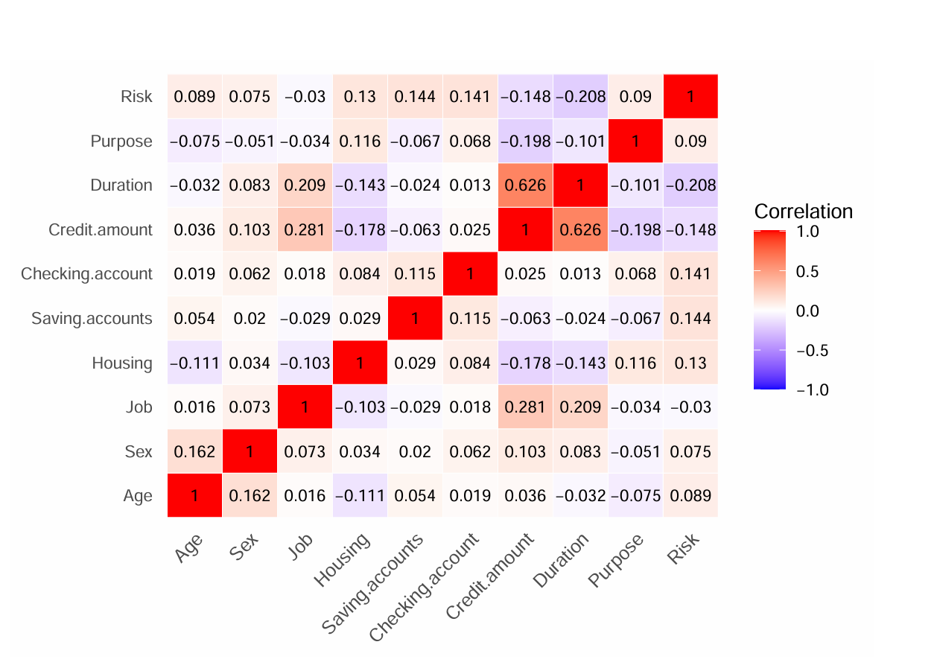

Models Description

Pooled Logistic Regression

Formula

Priors justification
For the $β$ coefficients, a common choice is to use Normal distributions as priors due to their mathematical convenience and their theoretical justification via the central limit theorem. A typical form is
$$β_{i}∼N\left(0,σ^{2}\right),$$
where $σ^{2}$ controls the degree of prior uncertainty.
In this project, we specify a Normal prior with mean 0 and variance 1 for most of the coefficients. This choice reflects weak prior information: we do not have strong knowledge about how each predictor influences the outcome, so we adopt a broad prior that allows the data substantial flexibility while still preventing extreme parameter values.

Hierarchical Logistic Regression

Formula
The hierarchical model, though resembling the pooled model in its use of Logistic Regression, is a relatively more complex model. As mentioned in the Explanatory variables analysis section, the data is categorized into $L$ groups using the categorical data in the Job variable. The coefficients $β_{0},β_{1},…,β_{k}$ are then sampled separately for each of the $L$ groups using their own hyper-parameters $μ$ and $σ^{2}$. The structure of the model can be represented as follows:
With each of the $L$ groups having their own sampled coefficients $β_{0},β_{1},…,β_{k}$, we can specify the Logistic Regression model for the target variable:
$$y_{n}∼\text{Bernoulli}\left({\text{logit}}^{−1}\left(β_{0,L\left(n\right)}+β_{1,L\left(n\right)}x_{n,1}+⋯+β_{k,L\left(n\right)}x_{n,k}\right)\right),$$
where $L\left(n\right)$ denotes the group membership of the $n^{\text{th}}$ observation.

Priors justification
We can estimate the coefficients $β_{0,L\left(n\right)},β_{1,L\left(n\right)},…,β_{k,L\left(n\right)}$ using a Normal prior with hyper-parameters $μ$ and $σ^{2}$:
$$β_{i,L\left(n\right)}∼N\left(μ_{i},σ_{i}^{2}\right), i=1:k.$$
For the hyper-parameter $μ_{i}$, we assume the same generic weakly informative prior:
$$μ_{i}∼N\left(0,1\right).$$
Because all predictors were standardized, this prior is considered weakly informative enough to avoid introducing bias. The justification for this choice has already been provided in the pooled model section.
For the hyper-parameter $σ_{i}^{2}$, we assume a weakly informative inverse-gamma prior:
$$σ_{i}^{2}∼\text{InvGamma}\left(0.5, 1\right).$$
In hierarchical modeling, the inverse-gamma distribution is a common prior for hyper-variance estimation. The shape of the distribution $\text{InvGamma}\left(0.5,1\right)$ has a wide and heavy right tail, ensuring positivity and weak informativeness, which makes it suitable for estimating $σ_{i}^{2}$.

Result Analysis

Convergence Diagnostics

$\hat{R}$ Diagnostics
The $\hat{R}$ values for the models are plotted as histograms.
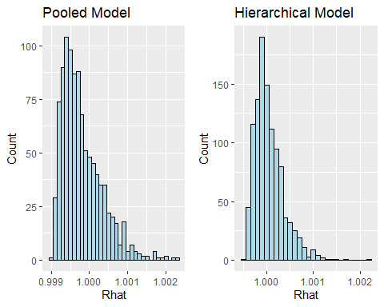
The histograms clearly show that all $\hat{R}$ values are below 1.05, and their distributions are tightly concentrated around 1.00. This indicates that the MCMC chains for both models have converged well.

ESS diagnostics
The Effective Sample Size (ESS) values of the parameters for the two models are plotted in the histograms below.
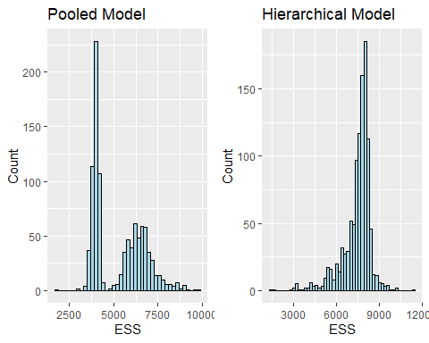
For both the pooled and hierarchical models, all ESS values exceed 100 times the number of chains. This indicates that the Markov chains mixed well, providing a sufficiently large number of effective posterior draws for reliable inference. Overall, the high ESS values across all parameters suggest strong precision in our posterior estimates.

Divergence
We find no evidence of divergence; the ESS values are sufficiently large and stable across all chains which is a sign of good mixing and reliable posterior estimates.
## Pooled model
## accept_stat__ stepsize__ treedepth__ n_leapfrog__ divergent__
## Min. :0.3526 Min. :0.5188 Min. :2.000 Min. : 3.00 Min. :0
## 1st Qu.:0.8572 1st Qu.:0.5317 1st Qu.:3.000 1st Qu.: 7.00 1st Qu.:0
## Median :0.9387 Median :0.5535 Median :3.000 Median : 7.00 Median :0
## Mean :0.9050 Mean :0.5506 Mean :2.943 Mean : 6.94 Mean :0
## 3rd Qu.:0.9827 3rd Qu.:0.5724 3rd Qu.:3.000 3rd Qu.: 7.00 3rd Qu.:0
## Max. :1.0000 Max. :0.5764 Max. :4.000 Max. :15.00 Max. :0
## energy__
## Min. :270.8
## 1st Qu.:276.1
## Median :277.9
## Mean :278.3
## 3rd Qu.:280.3
## Max. :290.8
## Hierarchical model
## accept_stat__ stepsize__ treedepth__ n_leapfrog__
## Min. :0.3685 Min. :0.01003 Min. :8.000 Min. : 255.0
## 1st Qu.:0.8945 1st Qu.:0.01032 1st Qu.:8.000 1st Qu.: 255.0
## Median :0.9564 Median :0.01137 Median :8.000 Median : 511.0
## Mean :0.9250 Mean :0.01131 Mean :8.431 Mean : 408.5
## 3rd Qu.:0.9871 3rd Qu.:0.01236 3rd Qu.:9.000 3rd Qu.: 511.0
## Max. :1.0000 Max. :0.01246 Max. :9.000 Max. :1023.0
## divergent__ energy__
## Min. :0 Min. :257.3
## 1st Qu.:0 1st Qu.:284.4
## Median :0 Median :291.0
## Mean :0 Mean :291.4
## 3rd Qu.:0 3rd Qu.:298.1
## Max. :0 Max. :338.6

Posterior predictive check

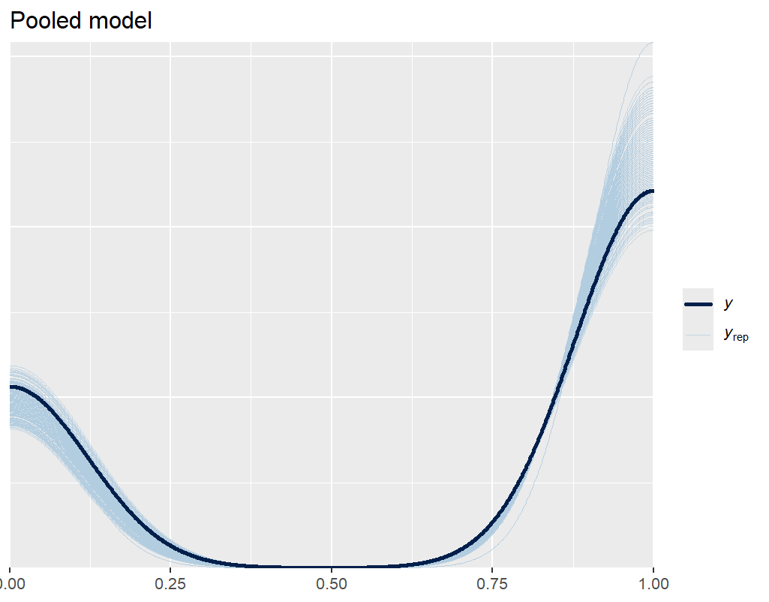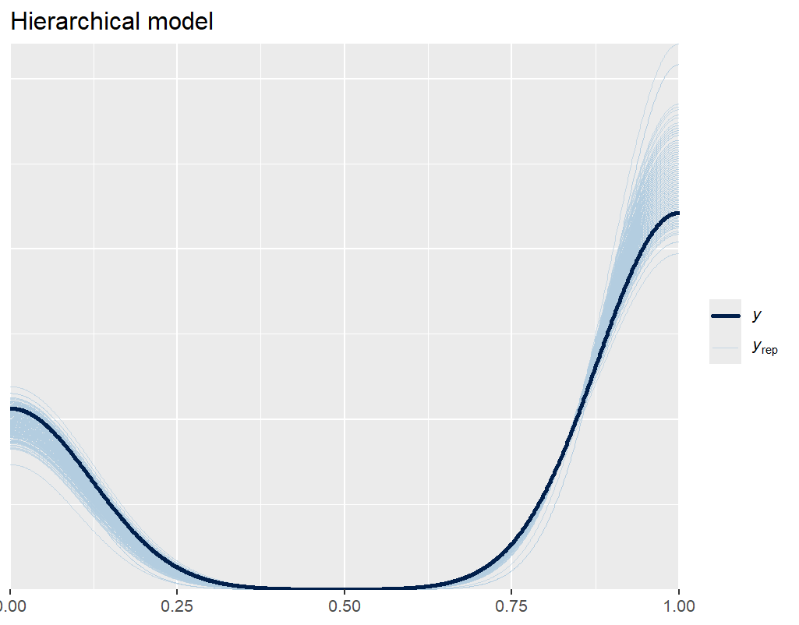

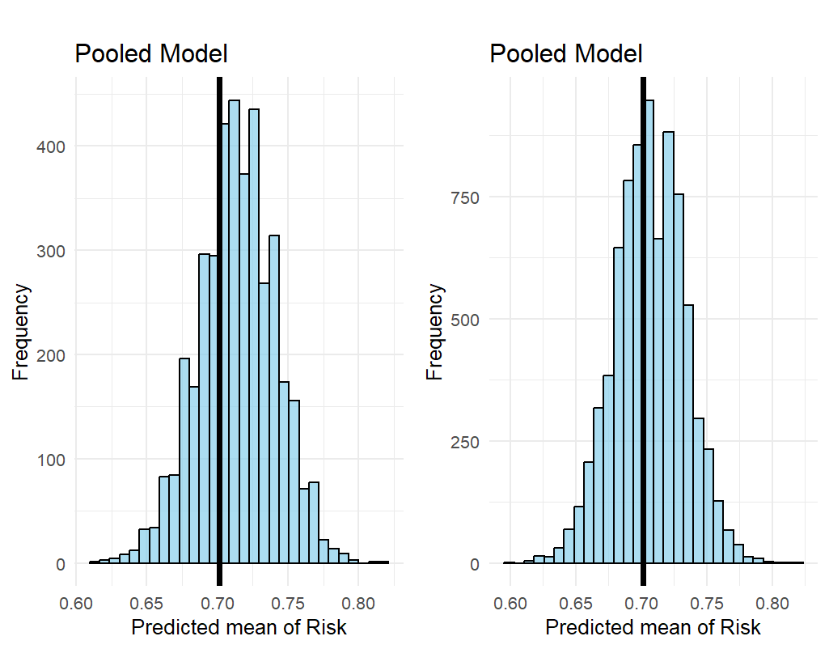
The posterior predictive check (PPC) plots show a strong alignment between the observed data and the simulated predictions in terms of central tendency. The posterior predictive means closely match the true mean which indicates that the model captures the main patterns in the risk defaulting data.

Comparison

Conclusion

Summary

Challenges and potential improvements

Self reflection

