NOTES ON Project 4:

* ~~Figure out how to make the text bigger~~
* Currently drawing 16 different rectangles versus drawing a big rect and then drawing lines
  + Theoretically then we can attach the text to the rectangle, and make the rectangles move with the text
  + This sounds the most possible
  + Otherwise, have to redraw numbers and move them around based on click without a rectangle basis
  + Im not sure what’s easier
* Things need to do:
  + Make sure it gives a solvable orientation
  + Make it so when you click on a square thats able to move, it’ll move
    - Making this work sounds hard!!!
  + I think I can handle this
  + Watch youtube videos if stuff is confusing!
* Idea:
  + Attaching QLabels to the QRects to move the text
    - Adjustable text size then as opposed to drawText?

NOTES 11/11/19

* Figured out how to change text size and position (qp.setFont and wanna use Qt.AlignCenter)
* When creating the rectangles, gotta give the names in the list so we can iterate through and say this is r1, r2, r3.. etc
  + This is so that the numbers can be attached to them correspondingly, right now the list just has a bunch of unnamed rectangle objects which are being drawn which is pretty dummo.
  + The stupid way is to assign 16 QRect by hand, which I could do with copy and paste, but there has to be an easier way with iteration.
* Plan of Attack:
  + Get the rectangles names
  + Say that r1 gets “1” drawn on it
  + Make it so they get scrambled up:

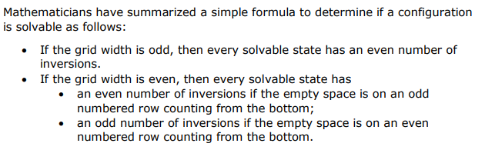

* + When mouse is clicked:
    - Check if the click is in a square, and if it’s a square that has an open spot next to it (this will have to be done with the two dimensional list shit)
    - If that spot is open, then we switch the rect and number that has value with

the empty spot.