Escape Room

By: **Noaman Elsayed**

**Genre**: Adventure game

**Target audience**: Teenagers

**Main characters**:

**Characters**: Freddy, guards, wiseman

Freddy(player): a good man lives in the city who was poor. He has a daughter that he takes care of and dedicated his life to help her achieving her dreams after his wife's death.

Guards(enemies): guards who work for Jason that are preventing Freddy from escaping the house. they are strong and kill people in cold blood. They are armed and always carrying swords.

Wiseman (NPC): an old man who used to teach Freddy in his childhood and helped him gaining a lot of knowledge and skills. He appears to assist him if he needs help.

**Game Flow Summary**: The player walks in four directions. The player presses on the lock then the passcode screen increases in size so he can enter the pin code or word to solve the riddle.

**Boundaries**: The player starts in an isolated room, and it ends in a room full furniture and car parts.

**Challenges**: The main task to the player is to solve the puzzles to set himself free. If he faces a guard he will need to kill him or just escape.

**Sequence of events:** the player starts in a room looks like a prison with 2 guards

Then he enters a 2-floor room with four guards he must think smart to not get caught and the riddles gets harder, then he gets in a room full of furniture and car parts and 1 big guard guarding it and this is the final level and the hardest one.

**Hint:** the player has 3 hints in each level he must reach the speaker that is on top corner of the wall to get his hint, the player clicks on the speaker so the wisman can he give him the hint the wiseman helps him to solve the puzzle by telling him to look under somthing or on top of something or he gives him the first part of the riddle's solving

**Behavior and relationships**:

The player uses the doors to go from level to another, he uses the locks to open the doors the player uses the map to go to the next level, the player uses the calendar which is the last level to escape the house.

**Rules:** the player can’t go to the next level without solving the riddles right or find the right directions he also can’t kill the guards with his hands he must use a weapon

**Cut scenes**: Freddy fights the guards they fight back if he solved somthing wrong in the end they kill him.

the wiseman talks to freddy to give him hints Freddy: "wiseman i need your help" ,wisman:"freddy look under the table", freddy replied "thank you wiseman".

The guards told freddy: "you think you will escape in your dreams ", freddy said to himself: "i must escape this house".

**Story**:

In the countryside, Freddy was a hard worker who does his work as efficient as possible. Freddy had a nice reputation and was friendly and a lovely person. Someday Jason asked him to do a work for him. Freddy welcomed him and worked hard as possible as he can. Afterwards Freddy finished his work and after he asked him to pay him, Jason refused to pay him and stole Freddy's money. After Freddy gave up he wanted to expose him, so Jason kidnaped Freddy and imprisoned him in a an old abandoned creepy house full of riddles and levels last floor is a room like a prison second floor is room with a map first floor is a room with a calendar. He wanted kill and burry Freddy so no one can find him. Jason puts Freddy in a room like a prison inside this house, Freddy tries to escape by solving the riddles of the unlocked box so he can get the prison's key and escape from this floor then he gets to the second floor Freddy needs to solve a puzzle to get the password of the safe and get the map’s room key. He needs to find the right directions to unlock the next level’s lock. in the end Freddy gets to the last floor which is the first floor, Freddy Enters a room full of furniture and car parts he needs to look around the whole room to find the calendar and needs to look for the first letter of every month on the calendar and switch it to its number and rearrange the numbers to get the right pin of the lock to set himself free.

**Missions**:

Level 1: Freddy finds himself in a black painted small room with a small window and some scratches on the wall and a metal door with a lock. Freddy needs to look around him and find the answers to unlock the lock and take the key and open the door. At the same time, he tries to hide from the guards who are trying to prevent him from escaping. there are 2 guards located in front of the room’s door carrying swords. He tries to use the stuff around him to escape from the room

Level 2: He’s located in a 2 floors room, and he needs to solve a puzzle to get the password of the safe and get the map’s room key. He needs to find the right directions to unlock the next level’s lock. Four guards are in the hallway, so Freddy needs to solve the puzzle without being seen.

Level 3(Final level): Freddy Enters a room full of furniture and car parts he needs to look around the whole room to find the calendar and needs to look for the first letter of every month on the calendar and switch it to its number and rearrange the numbers to get the right pin of the lock to set himself free. One guard is located in front of the last room’s door.

**Mechanics**:

**Player interaction pattern:** The player uses the locks to unlock them and he uses the doors to

go to the next level he also uses the ladder to go down to the second floor in the two floors room

the enemies uses the swords to kill freddy (main character).the wisman tells freddy hints.

**Movement**: The player can hold stuff to build a sequence he can use to escape from the enemies. The player (Freddy) moves in 4 directions (up, down, right, left).

**Actions**: Freddy can perform several actions like jumping, carrying, picking up, pushing hitting, reading and dropping.

**Opening doors and pressing Buttons:**

If Freddy is near a door the player hits the Action key, the door will be opened if the door was closed.

**Pushing objects:**

Freddy can push some objects he can use to make a small sequence he can use to help him escaping the place.

**Reading:**

The player may see different signs or posters displayed on the walls. In order to quickly zoom in and read these signs, the player can hit the Action key. These signs may include maps, which can help the player navigate the levels.

**Picking Up, Carrying, and Dropping:**

Freddy can pick up some objects like big boxes and small chairs to help him reach the far places. Once the player picks up the object he has to keep pressing on the action button so they can keep carrying the object among the place. Once the player releases the button the object will automatically drop the object. The game allows the player to put the objects over each other.

**Audio and sound effect:**

Background music once the game starts, Background sounds, guards shouting sounds, sword sound effect, opening sound effect, lock sound effect walking sound effect, running sound effect, jumping sound effect, pain sound when dying, key sound, hint sound**.**

**Controls:**

Move **- Arrows**

Sprint **– Left shift**

Fire **– A**

Jump **– Spacebar**

**Characters**

1. 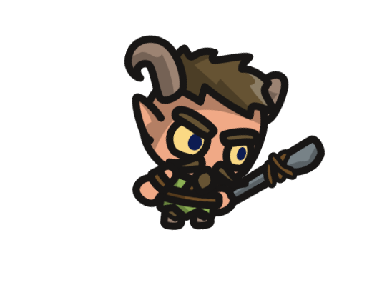Master guard (Enemy)

Abilities: Walk, Attack (close range)

1. Freddy (Player)

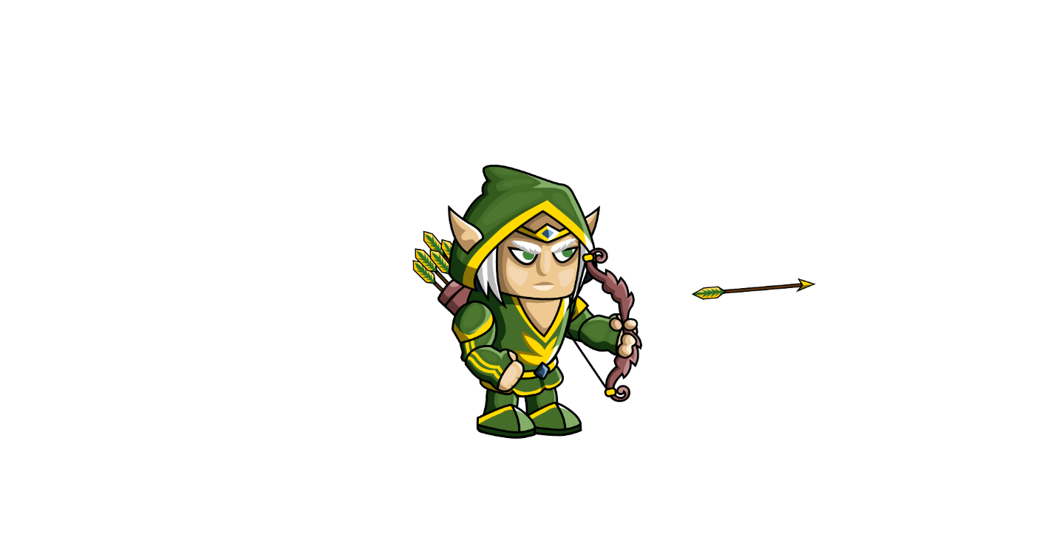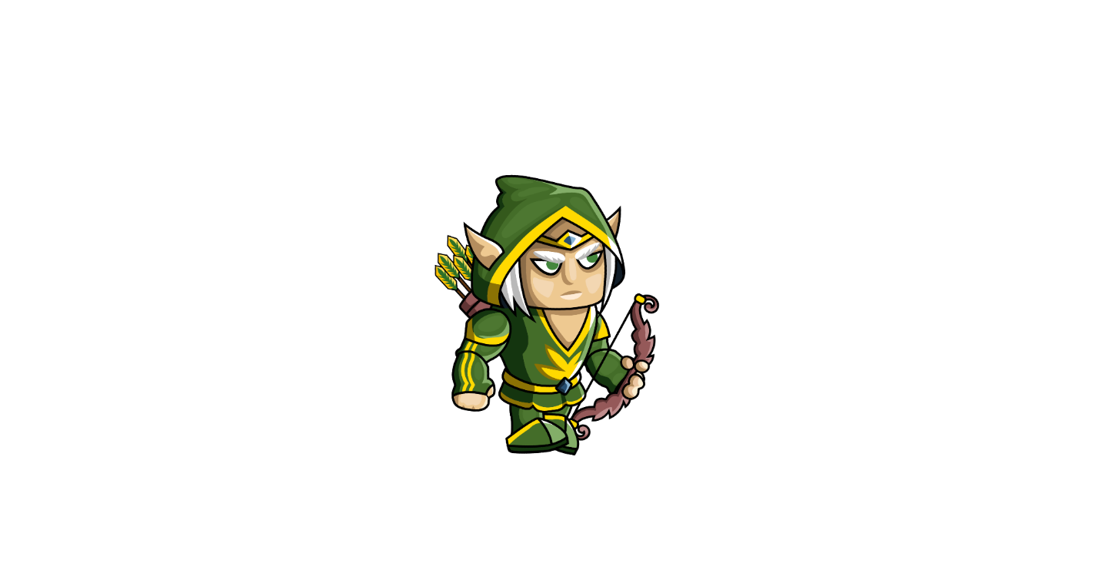

Abilities: Walk, Run, Jump, Arrow attack (far range)

1. Wiseman (Friend)



Abilities: Provide hints

1. Guard (Enemy)

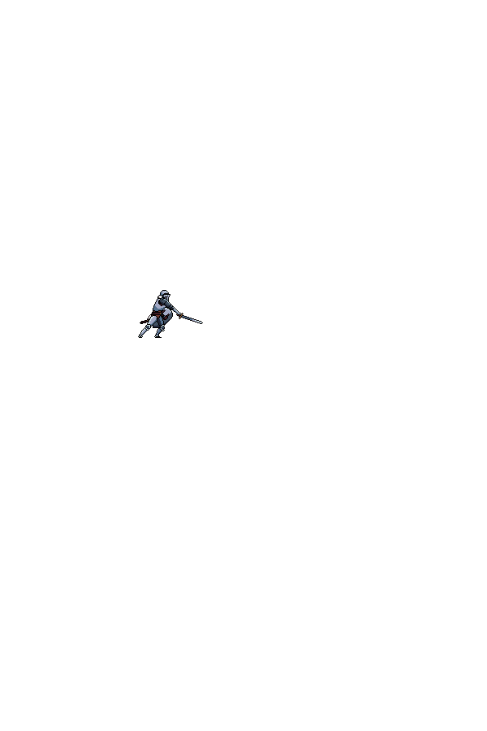

Abilities: Walk, Run, Attack (close range)

**Scene**

Level 1-

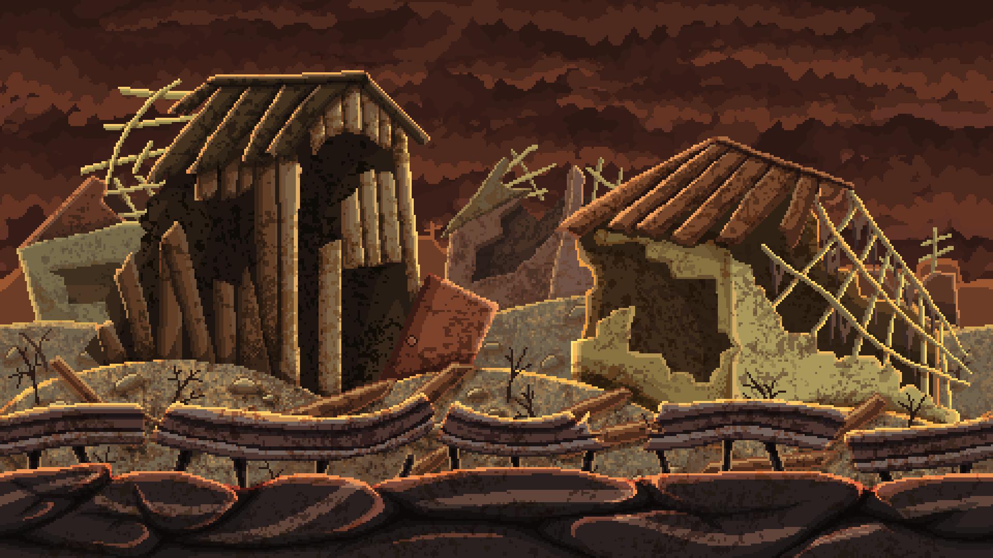

Level 2 - 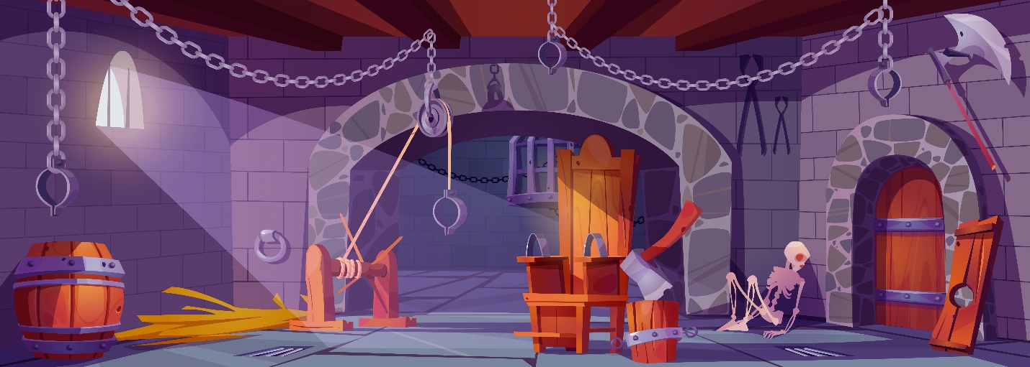

Level 3-

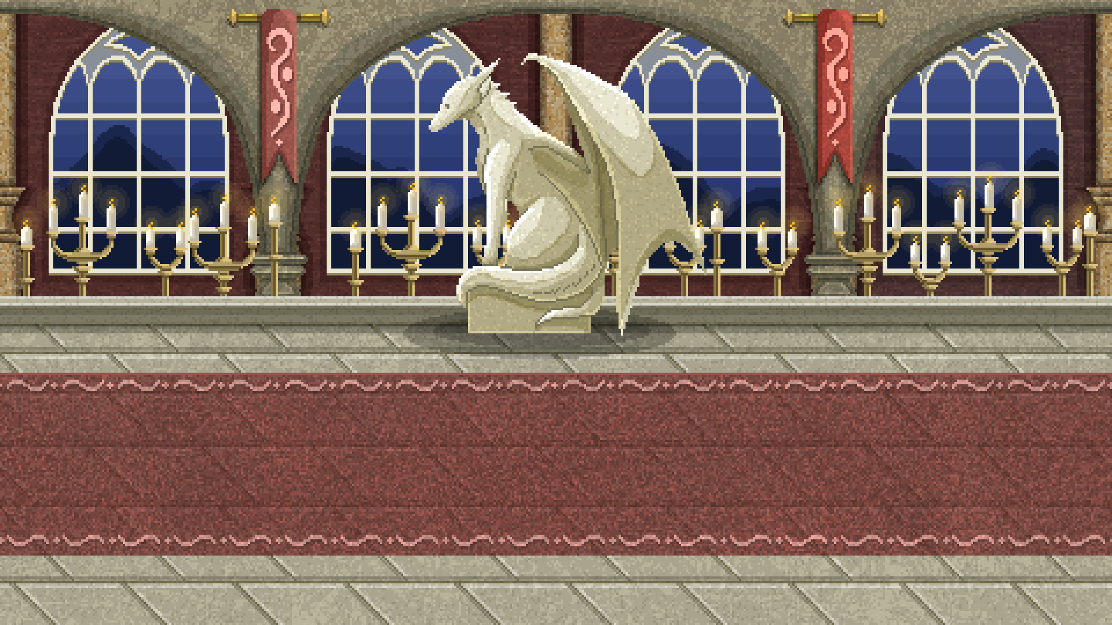

**Flowcharts**

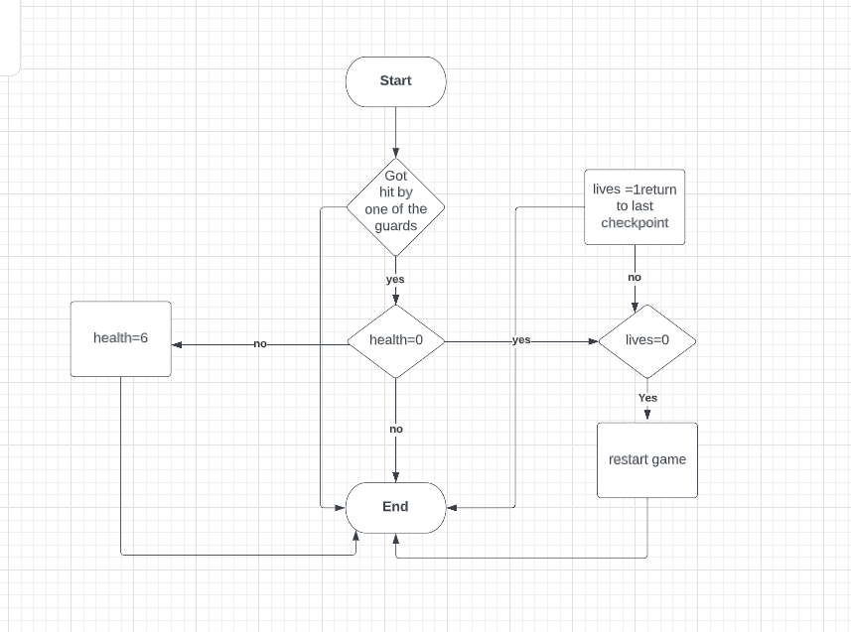

**Resources**

Player:

<https://craftpix.net/freebies/2d-fantasy-elf-free-sprite-sheets/?utm_campaign=SocialNetwork&utm_source=Dribbble&utm_medium=Free-2D-Fantasy-Elf-Sprite>

Wiseman:

<https://craftpix.net/freebies/wizard-character-free-sprite/?utm_campaign=SocialNetwork&utm_source=Dribbble&utm_medium=2d-Wizard-Character>

Enemy 1:

<https://craftpix.net/freebies/free-satyr-tiny-style-2d-sprites/?utm_campaign=SocialNetwork&utm_source=Dribbble&utm_medium=Free-Satyr-2D-Sprites>

Enemy 2:

<https://craftpix.net/freebies/free-knight-character-sprites-pixel-art/>

backgrounds:

<https://craftpix.net/freebies/free-post-apocalyptic-pixel-art-game-backgrounds/>

<https://craftpix.net/freebies/free-pixel-art-fantasy-2d-battlegrounds/?utm_campaign=SocialNetwork&utm_source=Dribbble&utm_medium=Free-Pixel-Art-Fantasy-Game-Battlegrounds>

Animation:

<https://craftpix.net/freebies/free-animated-explosion-sprite-pack/>

**Critical path:**

In each level the player will have to solve the puzzle in a right way to open the lock and move to the next level. At the same time he might use some objects to help him moving to the next levels until he gets out of the house.

**Implicit rule:**

The player must solve the puzzle to finish the game until he reaches the last level.

**Explicit rule:**

In the way to the gates the player might face guards, he can just run from them or kill them. Killing them is not a must but it will give him bonus points.